

Project title

Name:
Group:

Table of Contents
Deliverable 1 3
Project Specification 3
Functional Requirements 3
Use Case Model 3
Use Cases Identification: 3
UML Use Case Diagrams 3
Supplementary Specification 3
Non-functional Requirements 3
Design Constraints 3
Glossary 3
Deliverable 2 3
Domain Model 3
Architectural Design 3
Conceptual Architecture 3
Package Design 4
Component and Deployment Diagram 4
Deliverable 3 4
Design Model 4
Dynamic Behavior 4
Class Diagram 4
Data Model 4
System Testing 4
Future Improvements 4
Conclusion 4
Bibliography 4

Deliverable 1

Project Specification
The "Fix My Street" application is a civic engagement web platform designed to bridge the communication gap between citizens and local government administration. The system allows citizens to seamlessly report local infrastructure problems—such as potholes, graffiti, and broken streetlights—by submitting categorical details and geographical location data (e.g., neighborhoods in Cluj-Napoca). The application implements a Role-Based Access Control (RBAC) architecture, providing citizens with a streamlined reporting tool while offering City Workers a secure, interactive dashboard. To optimize municipal operations, the system features a smart dispatch algorithm that automatically assigns new reports to city workers based on geographical proximity and current active workload, alongside a strict state machine to manage the lifecycle of each issue from discovery to resolution.

Functional Requirements
- Issue Reporting: The system shall allow citizens to submit a new infrastructure issue containing an issue type, description, and geographical zone/address.
- User Authentication: The system shall allow users to securely log in by providing an email and password, utilizing Role-Based Access Control to distinguish between Citizens and City Workers.
- Smart Geospatial Auto-Assignment: The system shall automatically evaluate both the active workload and the geographical zone of all on-duty City Workers, assigning newly reported issues to the optimal candidate to minimize worker overload and travel time.
- State Lifecycle Management: The system shall enforce a strict lifecycle for reported issues (e.g., PENDING → IN_PROGRESS → RESOLVED), allowing assigned workers to transition the state of an issue only in a logically sequential order.
- Worker Dashboard: The system shall provide a dedicated view for City Workers to retrieve, view, and manage their assigned tasks.

Use Case Model

Use Cases Identification:
Use-Case 1: Report an Issue
- Level: User Goal
- Primary Actor: Citizen
- Main success scenario: The Citizen navigates to the reporting page, fills out the issue type, description, and location, and clicks submit. The system saves the report to the database and displays a success message.
- Extensions: If mandatory fields are left blank, the system prevents submission and highlights the missing fields in the UI.
Use-Case 2: User Authentication
- Level: User Goal
- Primary Actor: Citizen, City Worker
- Main success scenario: The user enters their credentials and selects their role. The system validates the credentials against the database and grants access, routing the user to the appropriate section of the application based on their role.
- Extensions: If the user enters an incorrect email or password, the system displays an "Invalid credentials" error and denies access.
Use-Case 3: Geospatial Auto-Assign Issue
- Level: Sub-function
- Primary Actor: System
- Main success scenario: Upon a Citizen submitting a new issue, the backend system queries the database for active City Workers. It filters workers based on their assigned city zone (e.g., Mărăști, Zorilor) and calculates their active task count. The system assigns the issue to the worker in the matching zone with the lowest workload.
- Extensions: If no workers are available in that specific geographical zone, the system expands the search to neighboring zones or falls back to a global "UNASSIGNED" queue.
Use-Case 4: Update Issue Status (Lifecycle)
- Level: User Goal
- Primary Actor: City Worker
- Main success scenario: The City Worker opens their dashboard and selects a "PENDING" issue. They click "Start Work," prompting the system to update the state to "IN_PROGRESS". Upon completion, the worker clicks "Resolve," moving the state to "RESOLVED" and closing the ticket.
- Extensions: If the worker attempts to bypass a state (e.g., clicking "Resolve" on a pending issue), the system prevents the database update and displays a workflow error.

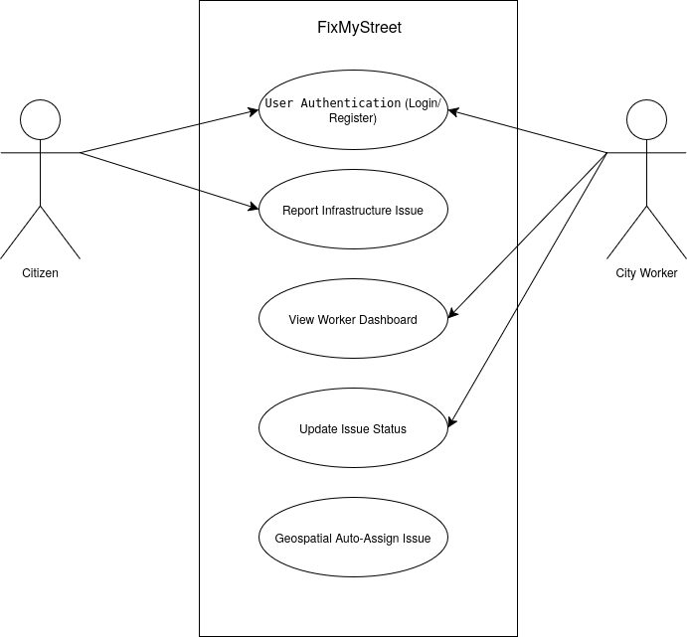
UML Use Case Diagrams

Supplementary Specification

Non-functional Requirements
- Usability & Aesthetics: The user interface must provide a modern, visually appealing experience and incorporate an interactive map component, while remaining fully responsive across mobile and desktop devices. Motivation: Citizens need an intuitive, map-driven interface to accurately pinpoint the geographical location of an issue. Furthermore, a visual map is essential for City Workers to easily identify issue clusters and plan efficient dispatch routes.
- Security: The system must restrict administrative dashboard access and task modification strictly to authenticated City Workers. Motivation: To prevent malicious actors from altering the status of municipal tasks or viewing internal city operations, RBAC is mandatory.
- Performance: The backend REST API must process form submissions and return an HTTP response in under 2 seconds. Motivation: Fast response times are critical to prevent users from clicking "Submit" multiple times, which would create duplicate database entries and skew municipal data.
- Reliability: The backend must safely handle concurrent database transactions. Motivation: During a severe weather event, multiple citizens might attempt to report the same fallen tree simultaneously; the system must not crash under a sudden spike in traffic.

Design Constraints
- Frontend Architecture: The user interface must be developed using React.js scaffolded with Vite, utilizing Bootstrap for CSS styling and responsive layout.
- Backend Architecture: The server must be implemented as a RESTful API using Java and the Spring Boot framework.
- Data Persistence: The application is constrained to use the H2 in-memory SQL database for local development and testing, interfaced via Spring Data JPA and Hibernate for Object-Relational Mapping (ORM).
- Communication Protocol: The frontend and backend must communicate strictly via HTTP requests sending and receiving JSON payloads, implemented via the Axios library.

Glossary
- Citizen: A standard user of the application who interacts with the system to report civic issues.
- City Worker: An administrative user responsible for monitoring, reviewing, and physically resolving the reported issues assigned to their dashboard.
- RBAC (Role-Based Access Control): A security mechanism that restricts system access and functionality to authorized users based on their assigned role.
- REST API: Representational State Transfer Application Programming Interface; the standard architecture by which the frontend and backend communicate via HTTP requests.
- State Machine: A behavioral model implemented in the backend to govern the allowed lifecycle stages of a reported issue, preventing invalid workflow transitions.
- Geospatial Routing: The algorithmic process of assigning tasks based on the physical distance or zonal location between the reported issue and the city worker.
- Composite Assignment Strategy: A design approach where multiple rules (e.g., shortest distance plus lowest workload) are combined to determine the final task assignment.

Deliverable 2

Domain Model
[Define the domain model and create the conceptual class diagrams]

Architectural Design

Conceptual Architecture
[Define the system’s conceptual architecture; use an architectural style and pattern - highlight its use and motivate your choice.]

Package Design
[Create a package diagram]

Component and Deployment Diagram
[Create the component and deployment diagrams.]

Deliverable 3

Design Model

Dynamic Behavior
[Create the interaction diagrams (2 sequence) for 2 relevant scenarios]

Class Diagram
[Create the UML class diagram; apply GoF patterns and motivate your choice]

Data Model
[Create the data model for the system.]

System Testing
[Describe the testing methides and some test cases.]

Future Improvements
[Present some features that apply to the application scope.]

Conclusion

Bibliography

