Bottle Cap Law

The Constitution

THE LUCOZARNO PACT

**Article 34:** From now until the end of time (or according to TOS change), these clauses will apply to any bottle cap collector, otherwise known as, Bottle Cappers, within the bounds of the Bottle Capping [Bottle Cap Collecting] Competition.

# Clause 1: Conditions of Piracy (CP)

**Article 35:** Piracy from Cappers will hereby be considered cap-legal in this competition.

**Article 36:** Small-scale piracy of up to 2 cap-legal caps per day from non-Cappers including those who do not sign this act is also hereby considered cap-legal for competition purposes

**Article 36:** Piracy from anyone is also hereby allowed even if those caps were Capiferated, but those Capiferated caps will still count as having been Capiferated. If a team has plausibly tricked another team into pirating capiferated caps then the team who originally held the capiferated caps are subject to *Punishment Of Objecting Powers*.

# Clause 2: Forevermore Objective Oath (FOO)

**Article 35:** Any Capper that signs this document hereby agrees to swear an oath of Capping [Bottle Cap Collecting] and the other clauses in this document.

# Clause 3: Punishments of objecting Powers (PP)

Any Team [Power] that defies the TOS can be punished by other teams [Power] that are not at that time in conflict with the rules of the Lucozarno Pact.

This can also be invoked if another team Capiferates and tries to pass those Capiferated caps as cap-legal.

Punishments Include:

* **Article 36:** Warrant for any team to search the conflicting team by force or otherwise.
* **Article 37:** If a majority of teams agree, then the team that defied the Pact team can be nerfed [Evicted / Ejected] from the competition [And be banned forevermore]
* **Article 38:** An uncapbiased [Unbiased in relation to the capping competition] party can decide on a suitable punishment

# Clause 4: Warrant Of Photo Evidence (WOPE)

Anyone who agrees to this pact hereby agrees to provide photo evidence at a maximum of 1 per day if any Capper asks them for it.

# Clause 5: Cap Reporting

* **Article 39:** Cappers must report at least once a week if that week is active [active weeks are weeks when the capper’s [Bottle Cap Collector’s] cap count increases]
* **Article 40:** The reported bottle cap amount may not be more than ten caps above or 30 caps below absolute cap-legal accuracy
* **Article 41:** The reported cap number must be an integer (it can be negative if the capper in question is in debt)

The Bottle Cap Non-Proliferation Protocol

February 2023

This paper hereby clarifies the cap-legal standard for Bottle Cap collecting from now, until the *END OF TIME ITSELF*.

1. Bottle Caps

From here on, the cap-legal definition of a ‘Bottle Cap’ is an object that meets the following criteria:

* **Article 42:** The item is intended to be disposable
* **Article 43:** The item was designed to be used as a bottle cap and is designed in such a way that is plausible to be used as such.
* **Article 44:** The item MUST be a connecting piece that connects via a knurled screw mechanism or snap-fit or other mechanical means. It must not be only a stopper as these items do not qualify as cap-legal Bottle Caps. Corks and such are **STRICTLY NOT** cap-legal.

Notable criteria:

* The item may be made of any material, including metal which is commonly used for beer caps.
* The item may be of any size.
* The item may not be manufactured by the capper [Bottle Cap Collector] and it will not be cap-legal.

1. Bottle Cap Standard

From here on, cap-legal caps will be the only standard allowed in competitions of any kind tracked on websites such as <https://captrack.netlify.app> or similar.

Cap-Legal caps may also be referred to as Match-Caps, Kaps, Capper Caps or Good Caps.

Terms of Bottle-Caps And Generalisations of Service

# Clause 1: Automatic Renewal Of New Terms

**Article 44.5:** Any updated terms will be displayed on the following URL: <https://ligmaspoons.tk/CAPS/TOS>. The date that the TOS [Terms of Service] was last updated will be displayed at the top of the front page of <https://ligmaspoons.tk/CAPS>. Anyone who agrees to this act will forever be held accountable to its updates and changes.

# Section 2: **TOS** Signatures:

## [The Cap Cartel]

Ethan Martin: ________________________________

Eilam Rosenfeld: ______________________________

Noah Fowlie: _________________________________

## [The CCCCCP]

Matthew Easton (Farmer): ______________________________

## [IMPOSTER]

Dylan Colligan [DC]: ___________________________________

Sufficiently Transparent Definitions

This clause will outline the definition of a bottle cap in further detail than the definition clause earlier in the document. This short section is meant as a rule book to account for any type of bottle cap possible.

# Clause 1: Definition Of Removable Kaps (DORK)

Conditions for a **Bottle Cap** to be considered **cap-legal**:

* Cannot be severely deformed as such it is unrecognizable as a bottle cap
* Cannot be originally an attached part of the bottle, that isn’t intended to be removed

The Rosnian Oligarchs, Captains of Kennetia, Sutherland, Cattleria and Pollockese (and Clarkistani Leaders) Settlement (ROCKS+CAPS)

# Article 45

* This settlement is named hereby twinned with ROCKS+CAPS and CAPS ROCK.

# Article 46

* This settlement hereby declares that any captain or oligarch of any school house has to follow the following laws:
  + Changes to the house in question’s terms that infringe on cap collecting in any plausible way that is in part made by a cap collector: their power in the decision must be outsourced to the wider capping [Bottle Cap Collecting] community.

Decision & Choice Policy (DC Policy)

# Article 47

* Choices will buy ‘n’ large be decided through a democratic coalition consortium of bottle cap collecting cap-government [Bottle Cap Collecting Government] that will come together to make decisions.

# Article 48

* Individual teams are permitted to make plausibly small decisions but they can be contested by other members of the DCCBCCCG [Democratic Coalition Consortium of bottle cap collecting Cap-Government [Bottle Cap Collecting Government] or *DCBG* for short]. If teams have plausibly made decisions

Extra Definitions Policy (EDP)

# Clause 1: Capiferation

## Important Definitions:

### Capiferation

noun, manufacture, proliferation, purchase, or otherwise illicit gain other than Piracy of any amount of cap-legal caps for cap-legal competitive purposes. Capiferation must be declared to all other teams, failure to do so will result in a Punishment (see Punishments of objecting Powers (PP))

**Article 49:** Capiferation is STRICTLY prohibited in the Capping [Bottle Cap Collecting] Competition. Cap-Illegal caps, otherwise known as Capiferated-Caps, Bad-Caps, Crap-Caps, Brokey-Caps, or Trash-Caps are allowed to be manufactured or used by a Capper [Bottle Cap Collector] as long as it is not intended for cap-legal purposes and is not used in the competition, for example, as a commemorative item.

**Article 50:** Caps Capiferated before the first formal TOS release **are** cap-legal.

**Article 51:** The formal TOS release is agreed to be the 8th of March 2023 A.D.

## Requirements for Capship for any Cap-Legal Cap:

* **Article 51:** Must not be a foil or wrapper e.g. on most yogurt containers or similar
* **Article 52:** Must not be manufactured for cap-legal competition purposes
* **Article 53:** Must not be manufactured by a Capper or someone in contact with a Capper
* **Article 54:** Must not be Capiferated by anyone in the competition or in contact with anyone in the competition
* **Article 55:** Must not be broken that would hinder its use in its intended use case in any meaningful way
* **Article 56:** Must not have holes that would cause noticeable leakage or spillage
* **Article 57:** Must be for the purpose of suitably containing a liquid inside or preventing contamination of an environment due to the substance inside
* **Article 58:** May not be Capiferated in any way by Cappers, relatives of, or contacts of Cappers or by request or for a Capper

Signatures:

## [The Cap Cartel]

Ethan Martin: ________________________________

Eilam Rosenfeld: ______________________________

Noah Fowlie: _________________________________

## [The CCCCCP]

Matthew Easton (Farmer): ______________________________

## [IMPOSTER]

Dylan Colligan [DC]: ___________________________________

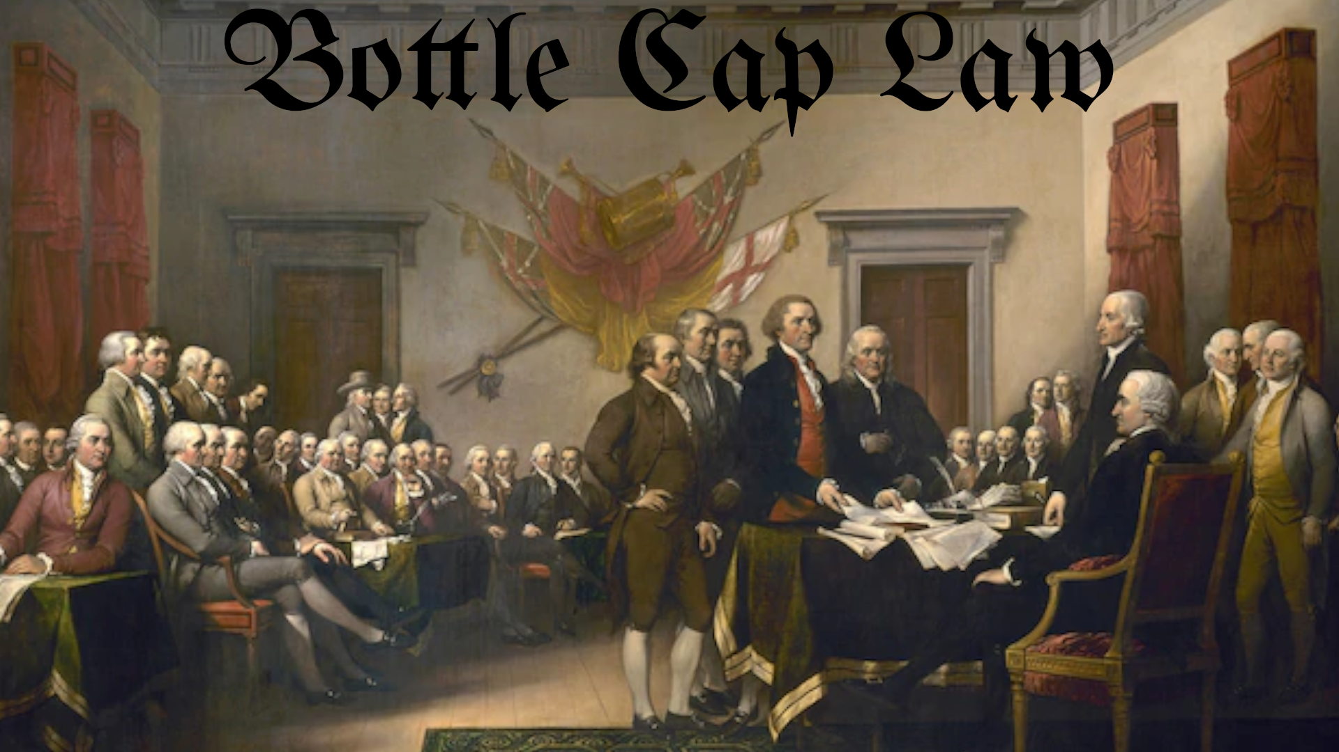

* **Article 69:** This image and the associated text including styling will be the only permitted pieces of official artwork and branding for *Bottle Cap Laws, The Bottle Cap Judicial System, The Bottle Cap Supreme Court and the Democratic Coalition Consortium of Bottle Cap Collecting Cap-Government.*
* **Article 70:** No team shall be permitted to have a duplicate official political orientation. The following are laid out here: (as of the 7th of March 2023 CE)
  + Cap Cartel
    - Capitalist **$**
  + IMPOSTER
    - Laissez-Faireist 💸
  + The CCCCCP
    - Communist **☭**