Global Computer Solutions

Global Computer Solutions (GCS) is an information technology consulting company with many offices located throughout the United States. The company’s success is based on its ability to maximize its resources—that is, its ability to match highly skilled employees with projects according to region. To better manage its projects, GCS has contacted you to design a database so that GCS managers can keep track of their customers, employees, projects, project schedules, assignments, and invoices.

The GCS database must support all of GCS’s operations and information requirements. A basic description of the main entities follows:

* The employees working for GCS have an employee ID, an employee last name, a middle initial, a first name, a region, and a date of hire.
* Valid regions are as follows: Northwest (NW), Southwest (SW), Midwest North (MN), Midwest South (MS), Northeast (NE), and Southeast (SE).
* Each employee has many skills, and many employees have the same skill.
* Each skill has a skill ID, description, and rate of pay. Valid skills are as follows: data entry I, data entry II, systems analyst I, systems analyst II, database designer I, database designer II, Cobol I, Cobol II, C++I, C++II, VB I, VB II, ColdFusion I, ColdFusion II, ASP I, ASP II, Oracle DBA, MS SQL Server DBA, network engineer I, network engineer II, Web administrator, technical writer, and project manager. Table P1 shows an example of the Skills Inventory.

**Table P1**

|  |  |
| --- | --- |
| SKILL | EMPLOYEE |
| DataEntryI | SeatonAmy;WilliamsJosh;Underwood Trish |
| DataEntry II | WilliamsJosh;SeatonAmy |
| SystemsAnalyst I | CraigBrett;SewellBeth;RobbinsErin;BushEmily;ZebrasSteve |
| SystemsAnalyst II | ChandlerJoseph;BurklowShane;RobbinsErin |
| DBDesigner I | Yarbrough Peter;SmithMary |
| DBDesigner II | Yarbrough Peter;PascoeJonathan |
| Cobol I | Kattan Chris;EphanorVictor;SummersAnna;Ellis Maria |
| Cobol II | Kattan Chris;EphanorVictor;BattsMelissa |
| C++I | SmithJose;RogersAdam;CopeLeslie |
| C++II | RogersAdam;Bible Hanah |
| VBI | ZebrasSteve;Ellis Maria |
| VBII | ZebrasSteve;NewtonChristopher |
| ColdFusion I | DuarteMiriam;BushEmily |
| ColdFusion II | BushEmily;Newton Christopher |
| ASP I | DuarteMiriam;BushEmily |
| ASP II | DuarteMiriam;Newton Christopher |
| Oracle DBA | SmithJose;PascoeJonathan |
| SQL Server DBA | Yarbrough Peter;SmithJose |
| NetworkEngineer I | BushEmily;SmithMary |
| NetworkEngineerII | BushEmily;SmithMary |
| WebAdministrator | BushEmily;SmithMary;Newton Christopher |
| Technical Writer | Kilby Surgena;BenderLarry |
| ProjectManager | PaineBrad;MuddRoger;Kenyon Tiffany;ConnorSean |

* GCS has many customers. Each customer has a customer ID, customer name, phone number, and region.
* GCS works by projects. A project is based on a contract between the customer and GCS to design, develop, and implement a computerized solution. Each project has specific characteristics such as the project ID, the customer to which the project belongs, a brief description, a project date (that is, the date on which the project’s contract was signed), a project start date (an estimate), a project end date (also an estimate), a project budget (total estimated cost of the project), an actual start date, an actual end date, an actual cost, and one employee assigned as the manager of the project.
* The actual cost of the project is updated each Friday by adding that week’s cost (computed by multiplying the hours each employee worked by the rate of pay for that skill) to the actual cost.
* The employee who is the manager of the project must complete a project schedule, which is, in effect, a design and development plan. In the project schedule (or plan), the manager must determine the tasks that will be performed to take the project from beginning to end. Each task has a task ID, a brief task description, the task’s starting and ending dates, the types of skills needed, and the number of employees (with the required skills) required to complete the task. General tasks are initial interview, database and system design, implementation, coding, testing, and final evaluation and sign-off. For example, GCS might have the project schedule shown in Table P2

**Table P2**

|  |  |  |  |  |  |
| --- | --- | --- | --- | --- | --- |
| **PROJECT ID: 1**  **COMPANY: SEE ROCKS**  **START DATE: 3/1/2010** | | **DESCRIPTION: SALES MANAGEMENT SYSTEM**  **CONTRACT DATE: 2/12/2010**  **END DATE: 7/1/2010** | | **REGION: NW**  **BUDGET: $15,500** | |
| **START DATE** | **END DATE** | **TASK DESCRIPTION** | **SKILL(S) REQUIRED** | | **QUANTITY REQUIRED** |
| 3/1/2010 | 3/6/2010 | Initial Interview | ProjectManager  SystemsAnalyst  DBDesigner I | | 1  1  1 |
| 3/11/2010 | 3/15/2010 | Database Design | DBDesigner I | | 1 |
| 3/11/2010 | 4/12/2010 | System Design | SystemsAnalyst II  SystemsAnalyst I | | 1  2 |
| 3/18/2010 | 3/22/2010 | Database Implementation | Oracle DBA | | 1 |
| 3/25/2010 | 5/20/2010 | System Coding&Testing | Cobol I  Cobol II  Oracle DBA | | 2  1  1 |
| 3/25/2010 | 6/7/2010 | System Documentation | Technical Writer | | 1 |
| 6/10/2010 | 6/14/2010 | Final Evaluation | ProjectManager  SystemsAnalyst II  DBDesigner I  Cobol II | | 1  1  1  1 |
| 6/17/2010 | 6/21/2010 | On-Site System Online and  DataLoading | ProjectManager  SystemsAnalyst II  DBDesigner I  Cobol II | | 1  1  1  1 |
| 7/1/2010 | 7/1/2010 | Sign-Off | ProjectManager | | 1 |

* Assignments: GCS pools all of its employees by region, and from this pool, employees are assigned to a specific task scheduled by the project manager. For example, for the first project’s schedule, you know that for the period 3/1/2010 to 3/6/2010, a Systems Analyst II, a Database Designer I, and a Project Manager are needed. (The project manager is assigned when the project is created and remains for the duration of the project.) Using that information, GCS searches the employees who are located in the same region as the customer, matching the skills required and assigning them to the project task.
* Each project schedule task can have many employees assigned to it, and a given employee can work on multiple project tasks. However, an employee can work on only one project task at a time. For example, if an employee is already assigned to work on a project task from 2/20/2010 to 3/3/2010, (s)he cannot work on another task until the current assignment is closed (ends). The date on which an assignment is closed does not necessarily match the ending date of the project schedule task, because a task can be completed ahead of or behind schedule.
* Given all of the preceding information, you can see that the assignment associates an employee with a project task, using the project schedule. Therefore, to keep track of the assignment, you require at least the following information: assignment ID, employee, project schedule task, date assignment starts, and date assignment ends (which could be any date, as some projects run ahead of or behind schedule).Table P3 shows a sample assignment form.

**Table P3**

|  |  |  |  |  |  |  |  |
| --- | --- | --- | --- | --- | --- | --- | --- |
| **PROJECT ID: 1**  **COMPANY: SEE ROCKS** | | | **DESCRIPTION: SALES MANAGEMENT SYSTEM**  **CONTRACT DATE: 2/12/2010** | | | **AS OF: 03/29/2010** | |
| **SCHEDULED** | | | | | **ACTUAL ASSIGNMENTS** | | |
| **Project Task** | **Start Date** | **End Date** | | **Skill** | **Employee** | **Start Date** | **End Date** |
| Initial Interview | 3/1/2010 | 3/6/2010 | | ProjectMgr.  Sys.Analyst II  DBDesigner I | 101—ConnorS.  102—BurklowS.  103—SmithM. | 3/1/10  3/1/10  3/1/10 | 3/6/10  3/6/10  3/6/10 |
| Database Design | 3/11/2010 | 3/15/2010 | | DBDesigner I | 104—SmithM. | 3/11/10 | 3/14/10 |
| System Design | 3/11/2010 | 4/12/2010 | | Sys.Analyst II  Sys.Analyst I  Sys.Analyst I | 105—BurklowS.  106—BushE.  107—ZebrasS. | 3/11/10  3/11/10  3/11/10 |  |
| Database | 3/18/2010 | 3/22/2010 | | Oracle DBA | 108—SmithJ. | 3/15/10 | 3/19/10 |
| Implementation | 3/25/2010 | 5/20/2010 | | Cobol I  Cobol I  Cobol II  Oracle DBA | Cobol I  Cobol II  Oracle DBA | 3/21/10  3/21/10  3/21/10  3/21/10 |  |
| System Coding &  Testing | 3/25/2010 | 6/7/2010 | | Tech. Writer | 109—SummersA.  110—Ellis M.  111—EphanorV.  112—SmithJ. | 3/25/10 |  |
| Final Evaluation | 6/10/2010 | 6/14/2010 | | ProjectMgr.  Sys.Analyst II  DBDesigner I  Cobol II | 113—Kilby S. |  |  |
| On-Site System  Online and Data  Loading | 6/17/2010 | 6/21/2010 | | ProjectMgr.  Sys.Analyst II  DBDesigner I  Cobol II |  |  |  |
| Sign-Off | 7/1/2010 | 7/1/2010 | | ProjectMgr. |  |  |  |

(Note: The assignment number is shown as a prefix of the employee name; for example, 101, 102.) Assume that the assignments shown previously are the only ones existing as of the date of this design. The assignment number can be whatever number matches your database design.)

* The hours an employee works are kept in a work log containing a record of the actual hours worked by an employee on a given assignment. The work log is a weekly form that the employee fills out at the end of each week (Friday) or at the end of each month. The form contains the date (of each Friday of the month or the last workday of the month, if it doesn’t fall on a Friday), the assignment ID, the total hours worked that week (or up to the end of the month), and the number of the bill to which the work-log entry is charged. Obviously, each work-log entry can be related to only one bill. A sample list of the current work-log entries for the first sample project is shown in Table P4.

**Table P4**

|  |  |  |  |  |
| --- | --- | --- | --- | --- |
| EMPLOYEE NAME | WEEK ENDING | ASSIGNMENT NUMBER | HOURS WORKED | BILL NUMBER |
| BurklowS. | 3/1/2010 | 1-102 | 4 | xxx |
| ConnorS. | 3/1/2010 | 1-101 | 4 | xxx |
| SmithM. | 3/1/2010 | 1-103 | 4 | xxx |
| BurklowS. | 3/8/2010 | 1-102 | 24 | xxx |
| ConnorS. | 3/8/2010 | 1-101 | 24 | xxx |
| SmithM. | 3/8/2010 | 1-103 | 24 | xxx |
| BurklowS. | 3/15/2010 | 1-105 | 40 | xxx |
| SmithJ. | 3/15/2010 | 1-106 | 40 | xxx |

Note: xxx represents the bill ID. Use the one that matches the bill number in your database.

* Finally, every 15 days, a bill is written and sent to the customer, totaling the hours worked on the project that period. When GCS generates a bill, it uses the bill number to update the work-log entries that are part of that bill. In summary, a bill can refer to many work-log entries, and each work-log entry can be related to only one bill. GCS sent one bill on 3/15/2010 for the first project (SEE ROCKS), totaling the hours worked between 3/1/2010 and 3/15/2010.Therefore, you can safely assume that there is only one bill in this table and that that bill covers the work-log entries shown in the above form.

The minimum required entities are EMPLOYEE, SKILL, CUSTOMER, REGION, PROJECT, PROJECT SCHEDULE, ASSIGNMENT, WORK LOG, and BILL. (There are additional required entities that are not listed.)

EER:

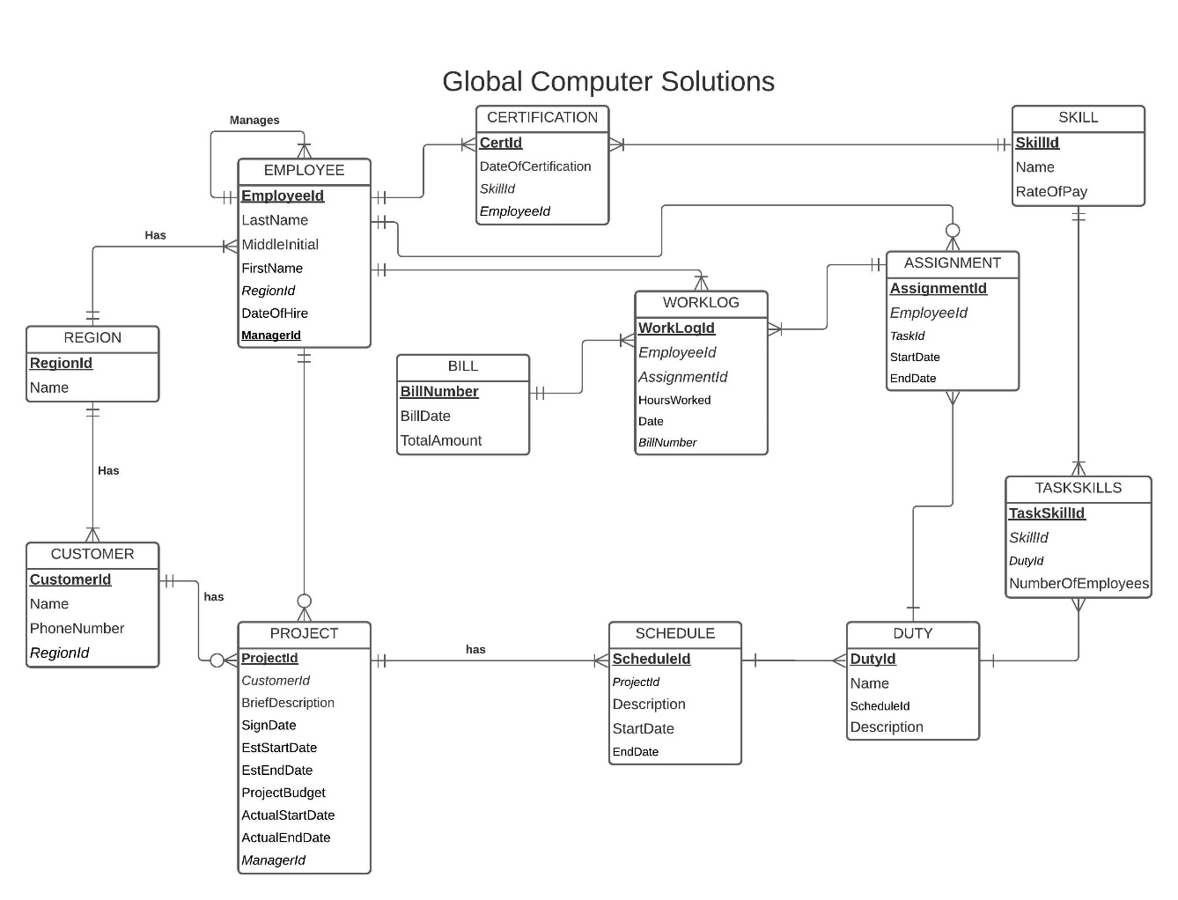

3NF Schema:

Base on the EER and the SQL program there are no attributes that would have transitive dependency and mostly the tables are formed as their own individual outputs due that most of them are dependent.

|  |  |  |  |  |  |  |
| --- | --- | --- | --- | --- | --- | --- |
| Employees | | | | | | |
| ID | LastName | MiddleName | FirstName | RegionID | DateofHire | ManagerID |

|  |  |  |  |
| --- | --- | --- | --- |
| Certification | | | |
| CertID | SkillID | EmployeeID | DateofCertification |

|  |  |
| --- | --- |
| Region | |
| RegionID | Name |