**Starter Report (Prototype)**

**Moudhaffer BOUALLEGUI**

**Ali BOUHDIBA**

**Wassim GHAMGUI**

**Eya JARY**

**Everyone : Environment & Core Platform Setup**

1. **Tool Installation & Repo Setup**
   * Install and configure Python, Flask, MySQL, Git.
   * Initialize the Git repository with a sensible branching model.
2. **Database Design**
   * Define the schema
   * Set up the MySQL database
3. **Basic Features**
   * Build the initial Flask app structure

**Ali+Moudhaffer : Secure Authentication & Role Management**

1. **Authentication System**
   * Integrate Flask-Login for user sessions
   * Build registration/login flows, password hashing
2. **Authorization & Roles**
   * Enforce Rôle Permissions on all routes
   * Create middleware to guard sensitive endpoints.
3. **Exception Handling**
   * Global error handlers for authentication/authorization failures
   * Securely log stack traces or sensitive info

### Eya+Moudhaffer : Input Validation & Data Protection

1. **Input Validation**
   * Implement server-side validation for all forms/APIs (WTForms).
   * Sanitize inputs to prevent SQL injection and XSS.
2. **Data Encryption**
   * Encrypt sensitive fields in the database (personally identifiable info) at rest.
   * Manage encryption keys securely (environment variables).
3. **Secure Exception Handling**
   * Wrap critical database/encryption operations in try/except blocks.
   * Ensure no sensitive data leaks in error messages.

### Wassim : Quality Assurance, Testing & Documentation

1. **Automated Code Reviews**
   * Configure SonarLint and Flake8 in the CI pipeline (pre-commit hooks or GitHub Actions).
   * Establish and enforce style/security rules.
2. **Security Testing**
   * Write and run pentests (ZAP).
   * Patch any discovered vulnerabilities.

1 Project Architecture

|  |  |  |
| --- | --- | --- |
| **Layer** | **Technology** | **Characteristics** |
| Presentation / UI | • HTML + Jinja2 templates • Bootstrap-inspired CSS kits | – Page flow (home → signup / login → booking → payment → invoice) – How templates are reused (e.g., flash-banner partial, base.html) |
| Application | **Flask** (single main.py) | – Blueprint-like grouping by feature (auth, booking, admin, etc.) – Validators in separate *_validation.py modules to keep routes clean |
| Persistence | MySQL via MySQLdb | |  | | --- | |  |  |  | | --- | | – Connection pooling kept simple (global conn) for the prototype | |
| Services / Utilities | • Flask-Mail (MailHog dev SMTP) • WeasyPrint (PDF invoices) • Custom crypto_utils.py | – Diagram how helpers (mail, pdf, crypto) plug into routes |

car_rental/

├── .env

├── .gitattributes

├── app/

│ ├── main.py

│ ├── requirements.txt

│ ├── static/

│ └── templates/

│ ├── about.html

│ ├── addadmin.html

│ ├── addcar.html

│ ├── addcustomer.html

│ ├── adddriver.html

│ ├── admindetails.html

│ ├── adminpage.html

│ ├── allbooked.html

│ ├── booking.html

│ ├── changecarstatus.html

│ ├── changedriverstatus.html

│ ├── contact.html

│ ├── deleteadmin.html

│ ├── deletecars.html

│ ├── deletedriver.html

│ ├── deleteuser.html

│ ├── displaybooking.html

│ ├── displaycars.html

│ ├── displaycustomers.html

│ ├── displaydrivers.html

│ ├── displaystatuscar.html

│ ├── displaystatusdriver.html

│ ├── feedback.html

│ ├── feedbackdisplay.html

│ ├── final.html

│ ├── index.html

│ ├── invoice.html

│ ├── loginhistory.html

│ ├── payment.html

│ ├── resetpassword.html

│ ├── signin.html

│ ├── signup.html

│ └── Status.html

├── db/

│ └── car_rental_db.sql

├── docker-compose.yml

├── Dockerfile

└── README.md

2 Database Schema & Data Structure

|  |  |  |
| --- | --- | --- |
| **Table** | **Key columns** | **Notes** |
| Cust_User | userId PK | hashed password, encrypted security answer |
| Admin_User | idem | same structure as Cust_User |
| Car | Car_id PK | status ENUM(Available/Booked) |
| Driver | driverId PK | status likewise |
| Booking | bookingId PK | links user, car, driver, route |
| Payment | payment_id PK | metadata only – no PAN stored |
| Feedback | ratings + comments |  |
| Login_History | audit trail |  |

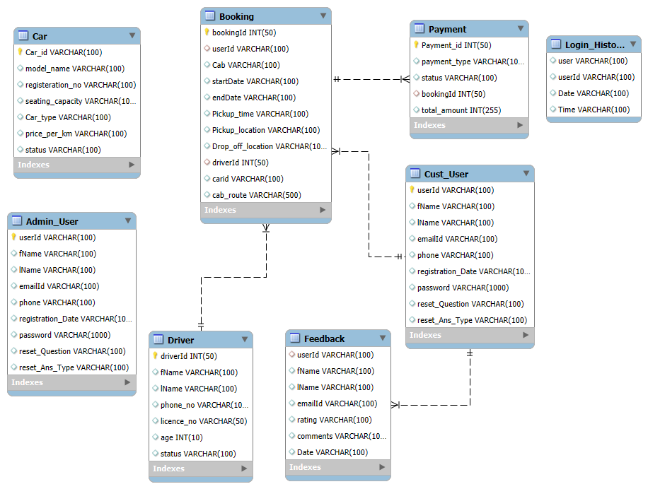

## 3 Dummy Data

We seeded :

* **2 Admins** (admin_alice, admin_bob)
* **3 Customers** (carol_j, davidl, emma_s)
* **4 Cars** (Sedan, Hatchback, SUV)
* **3 Drivers**
* **1 Booking** + corresponding **Payment** + **Invoice**

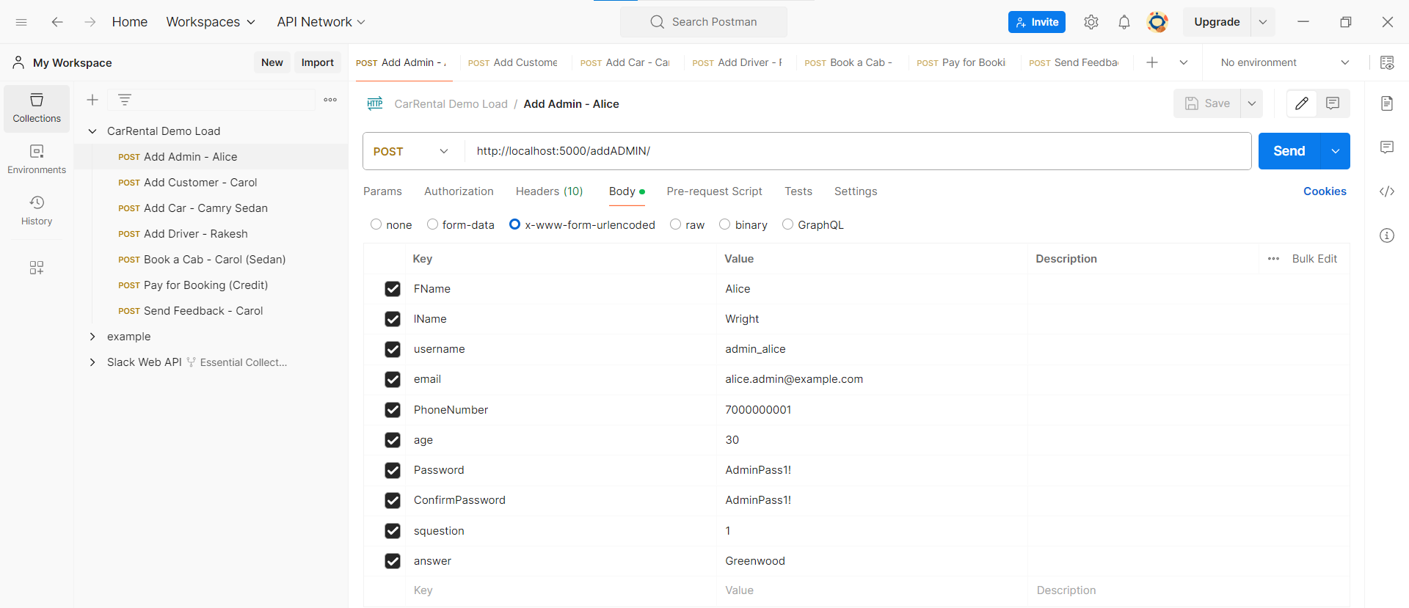

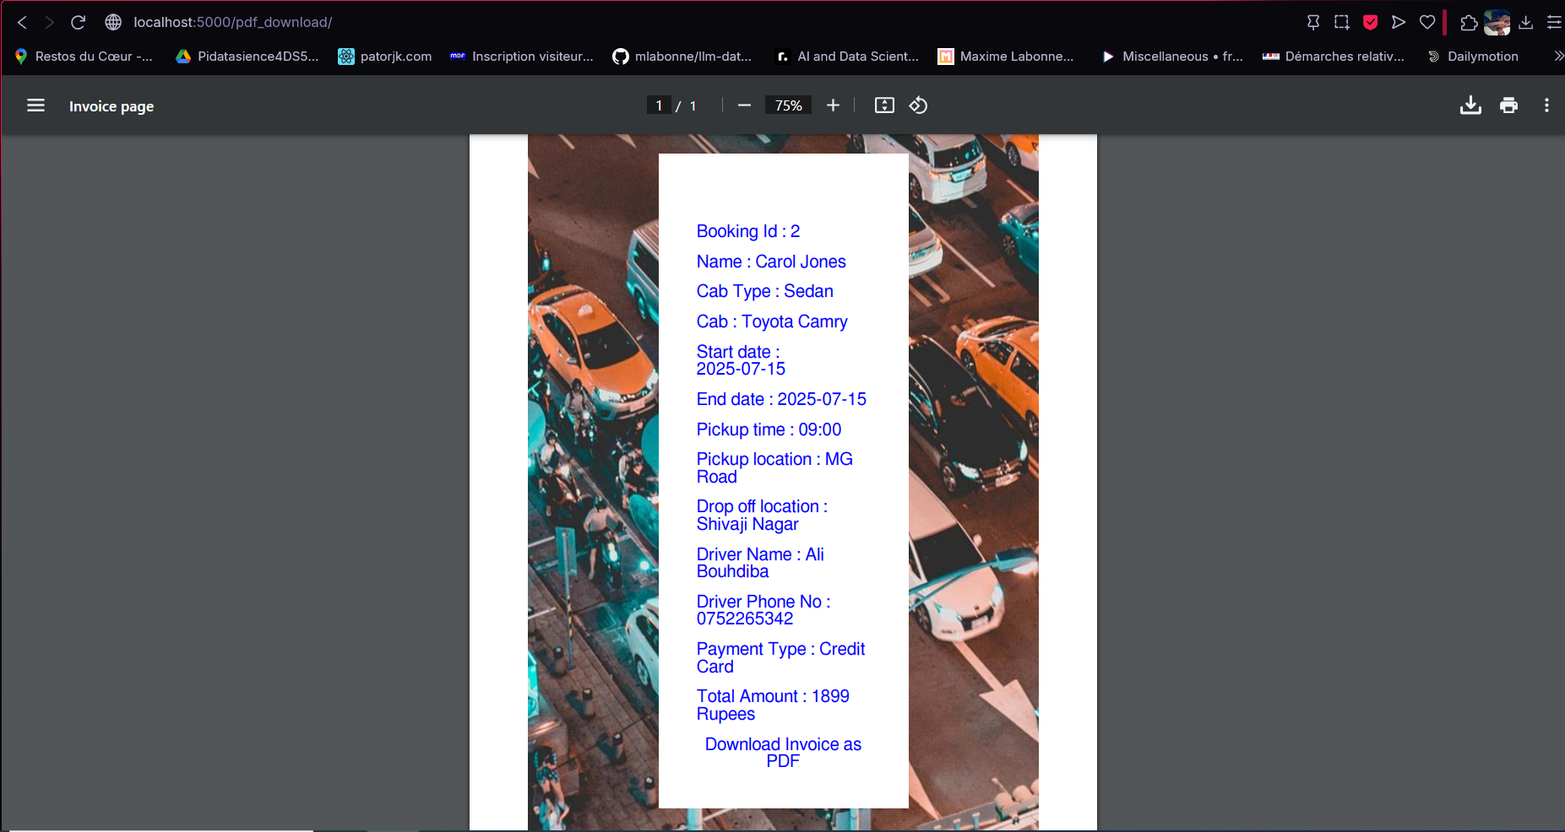

4 Implemented Functionalities

|  |  |
| --- | --- |
| **Role** | **Feature** |
| **Visitor** | Landing & About pages |
| **Customer** | Registration → Login → Booking → Payment → Invoice (PDF) → Feedback |
| **Admin** | Add/List/Delete users, cars, drivers; change statuses; dashboards |
| **System** | Sends e-mails, records login history, calculates revenue & most-used route |

5 Security Measures in the Prototype

|  |  |
| --- | --- |
| **Area** | **Implementation** |
| **Passwords** | PBKDF2-SHA256 via passlib (configurable rounds) |
| **Security Q&A** | **AES-128-CBC** with random IV (encrypt_answer, decrypt_answer) – key loaded from the AES_SECRET_KEY environment variable. |
| **Input Validation** | Dedicated validator classes for **every** form (RegistrationForm, BookingForm, LoginForm, etc.) – rejects bad input before DB access. |
| **SQL Safety** | All queries are parameterized (%s placeholders). |
| **Email & Phone** *(planned)* | Road-mapped for hashed lookup + encrypted at rest (GDPR alignment). |
| **Session Hardening** | Flask’s secret_key set; no sensitive data in cookies. |
| **Error Handling** | Routes return proper HTTP 400/401/404 with flashed messages—prevents information leakage. |

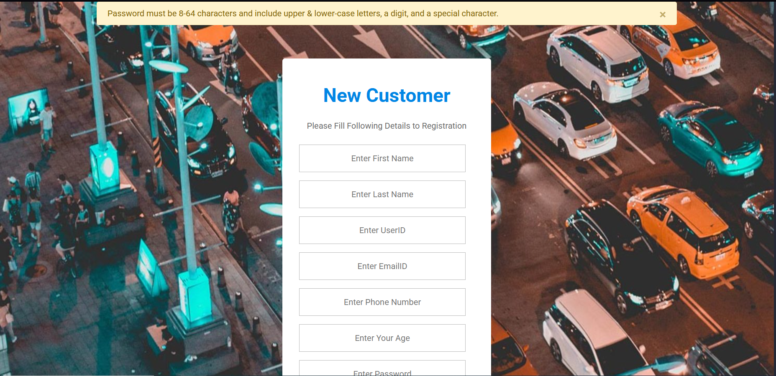

## 6 Next Steps / Road-map

1. **Encrypt remaining PII** (email, phone) with hash-lookup strategy.
2. Move master_password and other secrets to a vault.
3. Add CSRF tokens (Flask-WTF).
4. Unit / integration tests (pytest + FactoryBoy).
5. Docker-Compose for one-click spin-up (web, db, mailhog).
6. CI pipeline (GitHub Actions) to lint, test, and build images.