

***{Exploring Information and Communication Technologies (TIC) and Key Tools}***

[Document subtitle]



***Authors*: [SAAD SONIA]**

**[BOUASRIA CHAIMA}**

**{HAMMOUDI MANEL]**

**[BELANOUAR DOUAA MERIEM]**

**[Alleg Asma]**

January 3, 2024

***Table of Contents*:**

1. [**Introduction**](https://chat.openai.com/c/9be60835-9788-43ae-a969-d8236945e41a#introduction)
2. [**Information and Communication Technologies (TIC)**](https://chat.openai.com/c/9be60835-9788-43ae-a969-d8236945e41a#tic)
   * **2.1** [**Definition and Scope**](https://chat.openai.com/c/9be60835-9788-43ae-a969-d8236945e41a#definition-and-scope)
   * **2.2** [**Evolution of TIC**](https://chat.openai.com/c/9be60835-9788-43ae-a969-d8236945e41a#evolution-of-tic)
   * **2.3** [**Importance in the Modern World**](https://chat.openai.com/c/9be60835-9788-43ae-a969-d8236945e41a#importance-in-the-modern-world)
3. [**Google Services**](https://chat.openai.com/c/9be60835-9788-43ae-a969-d8236945e41a#google-services)
   * **3.1** [**Overview**](https://chat.openai.com/c/9be60835-9788-43ae-a969-d8236945e41a#overview)
   * **3.2** [**Key Services**](https://chat.openai.com/c/9be60835-9788-43ae-a969-d8236945e41a#key-services)
   * **3.3** [**Integration and Collaboration Features**](https://chat.openai.com/c/9be60835-9788-43ae-a969-d8236945e41a#integration-and-collaboration-features)
4. [**Microsoft Tools**](https://chat.openai.com/c/9be60835-9788-43ae-a969-d8236945e41a#microsoft-tools)
   * **4.1** [**Overview**](https://chat.openai.com/c/9be60835-9788-43ae-a969-d8236945e41a#overview-1)
   * **4.2** [**Office Suite**](https://chat.openai.com/c/9be60835-9788-43ae-a969-d8236945e41a#office-suite)
   * **4.3** [**Azure Services**](https://chat.openai.com/c/9be60835-9788-43ae-a969-d8236945e41a#azure-services)
   * **4.4** [**Collaboration Tools**](https://chat.openai.com/c/9be60835-9788-43ae-a969-d8236945e41a#collaboration-tools)
5. [**Git and GitHub**](https://chat.openai.com/c/9be60835-9788-43ae-a969-d8236945e41a#git-and-github)
   * **5.1** [**Introduction to Version Control**](https://chat.openai.com/c/9be60835-9788-43ae-a969-d8236945e41a#introduction-to-version-control)
   * **5.2** [**Git: Basics and Versioning**](https://chat.openai.com/c/9be60835-9788-43ae-a969-d8236945e41a#git-basics-and-versioning)
   * **5.3** [**GitHub: Collaboration and Code Repository**](https://chat.openai.com/c/9be60835-9788-43ae-a969-d8236945e41a#github-collaboration-and-code-repository)
6. [**Integration of TIC Tools**](https://chat.openai.com/c/9be60835-9788-43ae-a969-d8236945e41a#integration-of-tic-tools)
   * **6.1** [**Interoperability of Google, Microsoft, Git, and GitHub**](https://chat.openai.com/c/9be60835-9788-43ae-a969-d8236945e41a#interoperability-of-google-microsoft-git-and-github)
   * **6.2** [**Case Studies of Successful Integrations**](https://chat.openai.com/c/9be60835-9788-43ae-a969-d8236945e41a#case-studies-of-successful-integrations)
7. [**Challenges and Future Trends**](https://chat.openai.com/c/9be60835-9788-43ae-a969-d8236945e41a#challenges-and-future-trends)
   * **7.1** [**Common Challenges in TIC Adoption**](https://chat.openai.com/c/9be60835-9788-43ae-a969-d8236945e41a#common-challenges-in-tic-adoption)
   * **7.2** [**Emerging Trends in TIC**](https://chat.openai.com/c/9be60835-9788-43ae-a969-d8236945e41a#emerging-trends-in-tic)
8. [**Conclusion**](https://chat.openai.com/c/9be60835-9788-43ae-a969-d8236945e41a#conclusion)
   * **8.1** [**Summary of Key Findings**](https://chat.openai.com/c/9be60835-9788-43ae-a969-d8236945e41a#summary-of-key-findings)
   * **8.2** [**Recommendations for Efficient TIC Implementation**](https://chat.openai.com/c/9be60835-9788-43ae-a969-d8236945e41a#recommendations-for-efficient-tic-implementation)

# 1. *Introduction*

In the rapidly evolving landscape of the digital era, Information and Communication Technologies (TIC) have emerged as the driving force behind transformative changes in the way individuals, businesses, and societies communicate, collaborate, and innovate. This report delves into the multifaceted realm of TIC, with a specific focus on key technologies such as Google services, Microsoft tools, Git, and GitHub. Through an in-depth exploration, we aim to shed light on the profound impact these technologies have on our interconnected world.

## 1.1 *The Digital Transformation Landscape*

The pervasive influence of TIC has ushered in an era of unprecedented connectivity, where information flows seamlessly across geographical boundaries, facilitating real-time communication and collaboration. As organizations and individuals embrace digital transformation, TIC plays a pivotal role in shaping the future of work, education, healthcare, and beyond.

## 1.2 *Significance of TIC in Today's World*

### 1.2.1 Accelerating Communication

TIC has revolutionized the way people communicate, breaking down barriers and enabling instant connectivity. Email, instant messaging, and collaborative platforms have become integral to daily interactions, fostering efficient communication channels for both personal and professional use.

### 1.2.2 Empowering Collaboration

In an era of globalized collaboration, TIC tools empower teams to collaborate seamlessly, irrespective of physical distances. Real-time document editing, video conferencing, and cloud-based storage solutions have become essential components for fostering innovation and teamwork.

### 1.2.3 Driving Innovation and Efficiency

The integration of advanced technologies, such as artificial intelligence, data analytics, and cloud computing, within TIC frameworks, propels innovation and enhances operational efficiency. Organizations leverage these technologies to gain actionable insights, automate processes, and stay competitive in dynamic markets.

## 1.3 *Objectives of the Report*

This report aims to provide a comprehensive understanding of TIC and its various components, including Google services, Microsoft tools, Git, and GitHub. By examining the features, functionalities, and integration capabilities of these technologies, we seek to offer insights into their practical applications and their role in shaping the digital landscape.

## 1.4 *Structure of the Report*

The subsequent sections will delve into the definition and scope of TIC, tracing its evolution and highlighting its importance in the contemporary world. Specific emphasis will be placed on dissecting key technologies such as Google services, Microsoft tools, Git, and GitHub, exploring their functionalities, and evaluating their impact on collaboration and innovation. Additionally, the report will address challenges and emerging trends, concluding with a summary of key findings and recommendations for efficient TIC implementation.

As we embark on this exploration, it is crucial to recognize the dynamic nature of the digital landscape and the pivotal role that TIC plays in shaping the way we connect, communicate, and create in the modern world.

# 2. *Information and Communication Technologies (TIC)*

## 2.2 *Evolution of TIC*

The evolution of Information and Communication Technologies (TIC) is a captivating journey that spans several decades, marked by remarkable milestones and transformative innovations. Understanding this evolution provides valuable insights into how TIC has become an integral part of our daily lives and the broader digital landscape.

### 2.2.1 Early Foundations: Birth of Telecommunication

The roots of TIC can be traced back to the 19th century when telegraphy and telephony laid the foundation for long-distance communication. The invention of the telegraph by Samuel Morse in the 1830s marked a significant leap forward, enabling messages to be transmitted over long distances through coded signals.

### 2.2.2 Emergence of Computing: The Birth of the Digital Era

The mid-20th century witnessed the advent of computing, with the development of electronic computers that could process and store information. The Electronic Numerical Integrator and Computer (ENIAC), created in the 1940s, is often considered the first general-purpose electronic digital computer. This marked a crucial phase in the evolution of TIC, setting the stage for the digital era.

### 2.2.3 Rise of Networking: Connecting Computers

The 1960s and 1970s saw the emergence of computer networks, laying the groundwork for modern communication. The creation of ARPANET, the precursor to the internet, in the late 1960s was a pivotal moment. This network allowed researchers to share resources and communicate electronically, laying the foundation for the interconnected world we know today.

### 2.2.4 Personal Computing: Bringing Technology to Individuals

The 1980s witnessed the rise of personal computing, with the introduction of affordable computers for individuals and businesses. Microsoft's Windows operating system and the graphical user interface (GUI) made computing more accessible, leading to widespread adoption.

### 2.2.5 Internet Revolution: Connecting the Globe

The 1990s marked the internet revolution, transforming TIC into a global phenomenon. The World Wide Web (WWW) became publicly accessible, and the development of web browsers, such as Netscape Navigator, made information readily available to a global audience. E-commerce, email, and online collaboration became integral aspects of TIC.

### 2.2.6 Mobile and Wireless Technologies: Anytime, Anywhere Connectivity

The 21st century brought about the proliferation of mobile and wireless technologies. The advent of smartphones and high-speed mobile networks enabled ubiquitous connectivity, allowing individuals to access information and communicate on the go.

### 2.2.7 Cloud Computing and Beyond: Scalability and Flexibility

In recent years, cloud computing has emerged as a dominant force in TIC. The ability to store and access data remotely, coupled with scalable computing resources, has transformed the way businesses and individuals manage information and applications.

### 2.2.8 Integration of Emerging Technologies: AI, IoT, and Beyond

The current landscape of TIC is characterized by the integration of emerging technologies such as Artificial Intelligence (AI), Internet of Things (IoT), and blockchain. These technologies enhance the capabilities of TIC, enabling intelligent automation, data-driven decision-making, and secure decentralized transactions.

## 2.3 *Importance of TIC in Various Sectors*

Information and Communication Technologies (TIC) have become indispensable in numerous sectors, driving efficiency, innovation, and connectivity. The transformative impact of TIC is felt across diverse industries, shaping the way organizations operate, communicate, and deliver services. Here, we delve into the significance of TIC in key sectors.

### 2.3.1 Healthcare

In the healthcare sector, TIC plays a crucial role in enhancing patient care, streamlining operations, and fostering medical research. Electronic Health Records (EHRs) enable seamless information sharing among healthcare providers, improving accuracy and speed of diagnosis. Telemedicine, powered by TIC, facilitates remote consultations, expanding access to healthcare services.

### 2.3.2 Education

TIC has revolutionized education by introducing online learning platforms, virtual classrooms, and collaborative tools. E-learning platforms provide accessible and flexible education opportunities, breaking down geographical barriers. Digital resources, such as e-books and educational apps, enhance the learning experience and support personalized learning paths.

### 2.3.3 Business and Commerce

In the business realm, TIC tools drive operational efficiency, collaboration, and innovation. Enterprise Resource Planning (ERP) systems streamline business processes, while Customer Relationship Management (CRM) systems enhance customer interactions. E-commerce platforms leverage TIC to connect buyers and sellers globally, transforming the traditional retail landscape.

### 2.3.4 Finance

The finance sector relies on TIC for secure and efficient transactions, risk management, and data analytics. Online banking, mobile payment solutions, and blockchain technologies enhance the speed and security of financial transactions. TIC also plays a vital role in fraud detection, ensuring the integrity of financial systems.

### 2.3.5 Manufacturing

In manufacturing, TIC contributes to the concept of Industry 4.0, where automation, data exchange, and IoT technologies converge. Smart factories leverage TIC to optimize production processes, monitor equipment health in real-time, and enable predictive maintenance. This results in increased productivity, reduced downtime, and improved quality control.

### 2.3.6 Transportation and Logistics

TIC has revolutionized the transportation and logistics sector through innovations such as GPS tracking, real-time route optimization, and inventory management systems. Smart logistics platforms powered by TIC enhance supply chain visibility, reduce transit times, and optimize resource utilization.

### 2.3.7 Government and Public Services

Governments leverage TIC to enhance citizen services, streamline administrative processes, and improve public engagement. E-governance initiatives, digital identity systems, and open data platforms contribute to transparency and efficiency. Emergency response systems utilize TIC to coordinate and respond swiftly to crises.

### 2.3.8 Agriculture

In agriculture, TIC solutions contribute to precision farming, monitoring crop health, and optimizing resource use. IoT sensors, satellite imagery, and data analytics help farmers make informed decisions about planting, irrigation, and crop management. This leads to increased yields, resource efficiency, and sustainable agricultural practices.

### 2.3.9 Research and Development

TIC accelerates research and development across various disciplines. High-performance computing, collaborative platforms, and data analytics empower researchers to analyze large datasets, simulate experiments, and collaborate on a global scale. This accelerates scientific discovery and technological innovation.

### 2.3.10 Social Impact

Beyond sectors, TIC has a profound social impact, fostering connectivity, information access, and civic engagement. Social media platforms enable global communication, crowdfunding platforms support charitable initiatives, and TIC contributes to disaster response and humanitarian efforts.

## 2.4 *Conclusion*

The importance of TIC in various sectors is evident in its ability to drive progress, efficiency, and innovation. As TIC continues to evolve, its transformative influence will shape the future of industries, economies, and societies, underlining the significance of embracing and harnessing these technologies for positive change.

Top of Form

# **3. ***Google Services*****

## **3.1 ***Overview*****

**Google, a global technology giant, provides a diverse range of services that have become integral to the digital experiences of individuals and businesses worldwide. From cloud-based productivity tools to search engines and communication platforms, Google Services play a pivotal role in shaping the way we access and interact with information. This section provides an overview of key Google Services, highlighting their functionalities and contributions to the digital landscape.**

## **3.2 ***Key Services*****

**3.2.1 Google Search**

**Google Search, the flagship product of the company, is the world's most widely used search engine. Launched in 1997, Google Search utilizes advanced algorithms to deliver highly relevant and accurate search results. Its intuitive interface and powerful search capabilities have made it the go-to platform for accessing information on the internet.**

**3.2.2 Google Drive**

**Google Drive is a cloud-based file storage and synchronization service that allows users to store files securely, access them from any device, and collaborate in real-time. It includes applications like Google Docs, Sheets, and Slides, facilitating seamless collaboration on documents, spreadsheets, and presentations.**

**3.2.3 Gmail**

**Gmail is a widely used email service that provides users with a feature-rich and intuitive platform for managing emails. Known for its powerful spam filtering, organized inbox, and integration with other Google services, Gmail has become a cornerstone of personal and professional communication.**

**3.2.4 Google Docs, Sheets, and Slides**

**As part of Google Drive, these applications offer cloud-based alternatives to traditional office productivity tools. Google Docs (word processing), Sheets (spreadsheets), and Slides (presentation software) enable collaborative editing, real-time commenting, and easy sharing of documents.**

**3.2.5 Google Calendar**

**Google Calendar is a versatile time-management tool that allows users to schedule events, set reminders, and share calendars with others. With features like automatic event creation from Gmail and integration with other Google services, it enhances productivity and organization.**

**3.2.6 Google Maps**

**Google Maps revolutionized digital navigation by providing detailed maps, real-time traffic updates, and turn-by-turn directions. Its Street View feature and integration with other services make it an essential tool for locating places, exploring cities, and planning routes.**

**3.2.7 Google Photos**

**Google Photos offers cloud-based photo and video storage with advanced organization and search features. It automatically categorizes and tags photos, making it easy for users to locate and share memories. Additionally, it provides unlimited storage for compressed photos and videos.**

**3.2.8 Google Meet**

**Google Meet is a video conferencing platform that enables virtual meetings, webinars, and collaborative discussions. With features like screen sharing, real-time captions, and integration with other Google services, it caters to the growing demand for remote communication and collaboration.**

## **3.3 ***Integration and Collaboration Features*****

**One of the distinctive strengths of Google Services lies in their seamless integration and collaboration features. Users can work collaboratively in real-time on documents, share files effortlessly, and synchronize data across multiple devices. This interconnected ecosystem enhances productivity and fosters efficient teamwork, making Google Services a preferred choice for individuals, businesses, and educational institutions.**

**In summary, Google Services have redefined the way we access information, collaborate, and communicate in the digital age. With a commitment to innovation and user-centric design, Google continues to shape the future of online experiences through its diverse portfolio of services.**

**3.4 *Table: Google Services Comparison***

| **Service** | **Main Features** | **Integration with TIC Tools** |
| --- | --- | --- |
| **Google Drive** | **Cloud storage, file sharing** | **Integrates with Microsoft Tools for collaborative document editing.** |
| **Gmail** | **Email, chat, and video calling** | **Connects seamlessly with Git for email notifications on repository activities.** |
| **Google Docs** | **Online document editing** | **Compatible with GitHub for sharing and collaborating on code documentation.** |

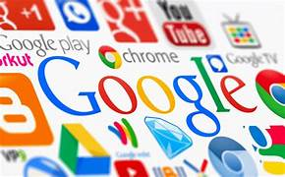

1. **Microsoft Tools**

**Azure Services:**

**Microsoft Azure is a cloud computing platform that provides a wide array of services, enabling organizations to build, deploy, and manage applications efficiently. Key features of Azure Services include:**

* **Compute Services: Offers virtual machines, serverless computing, and container services for scalable and flexible computing power.**
* **Storage Services: Provides various storage solutions, including blob storage, file storage, and disk storage.**
* **Database Services: Includes relational and non-relational database offerings, such as Azure SQL Database and Cosmos DB.**
* **AI and Machine Learning: Azure integrates AI and machine learning capabilities, allowing organizations to build intelligent applications.**
* **Networking Services: Offers services for virtual networks, load balancing, and content delivery.**

**Azure Services form a robust foundation for organizations looking to leverage cloud computing in their TIC strategies.**

#### **4.4 Collaboration Tools**

**Microsoft Teams:**

**Microsoft Teams is a collaboration platform that facilitates communication and teamwork within organizations. Key features of Microsoft Teams include:**

* **Chat and Messaging: Instant messaging and threaded conversations for real-time communication.**
* **File Sharing: Seamless integration with Office 365 for sharing and collaborating on documents.**
* **Video Conferencing: High-quality audio and video meetings, making virtual collaboration more effective.**
* **Integration with TIC Tools: Microsoft Teams can integrate with version control systems like Git, fostering collaboration in software development projects.**

**4.5 *Table: Microsoft Tools Overview***

| **Tool** | **Main Features** | **Integration with TIC Tools** |
| --- | --- | --- |
| **Word** | **Document processing and editing** | **Compatible with Git for version control and collaboration.** |
| **Excel** | **Spreadsheet and data analysis** | **Integrates with Google Drive for collaborative data sharing.** |
| **PowerPoint** | **Presentation creation** | **Connects with GitHub for collaborative development presentations.** |
| **Microsoft Teams** | **Team collaboration and chat** | **Seamless integration with Git for code repository discussions.** |

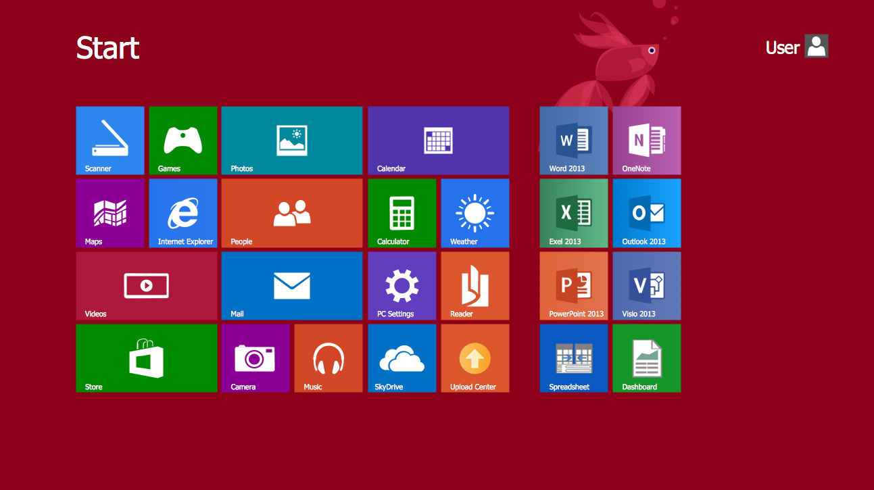

**5. *Git and GitHub***

**5.1 *Introduction to Version Control***

**Version control is a crucial aspect of modern software development. It allows teams to track changes to their code, collaborate seamlessly, and maintain a history of project modifications. Git is a distributed version control system that has become the industry standard for source code management.**

**5.2 *Git Basics and Versioning***

**Git:**

* **Repository (Repo): Git repositories store project files and their history. Each developer can have their local copy.**
* **Commits: Commits represent changes to the codebase. Developers create commits to document changes and modifications.**
* **Branching: Git allows branching, enabling developers to work on new features or bug fixes in isolation.**
* **Merging: After development on a branch is complete, changes can be merged back into the main branch.**

**Versioning:**

* **Semantic Versioning: Developers use a versioning scheme to indicate the nature of changes (major, minor, or patch).**
* **Tags: Git tags mark specific points in the history, usually releases, providing a snapshot of the codebase at that moment.**

**5.3 *GitHub Collaboration and Code Repository***

**GitHub:**

* **Code Repository: GitHub is a web-based platform that hosts Git repositories, making it easy for teams to collaborate.**
* **Pull Requests: Developers propose changes to the main codebase through pull requests. This facilitates code review and discussion.**
* **Issues and Project Management: GitHub includes tools for issue tracking and project management, streamlining development workflows.**
* **Collaboration Features: GitHub enhances collaboration with features like wikis, discussions, and actions.**

**5.4 *Table: Git vs. GitHub***

| **Aspect** | **Git** | **GitHub** |
| --- | --- | --- |
| **Version Control** | **Manages code versions locally** | **Centralized repository for collaboration** |
| **Collaboration** | **Limited collaboration features** | **Extensive collaboration tools and features** |
| **Hosting** | **Local or private servers** | **Cloud-based hosting with GitHub as a service** |

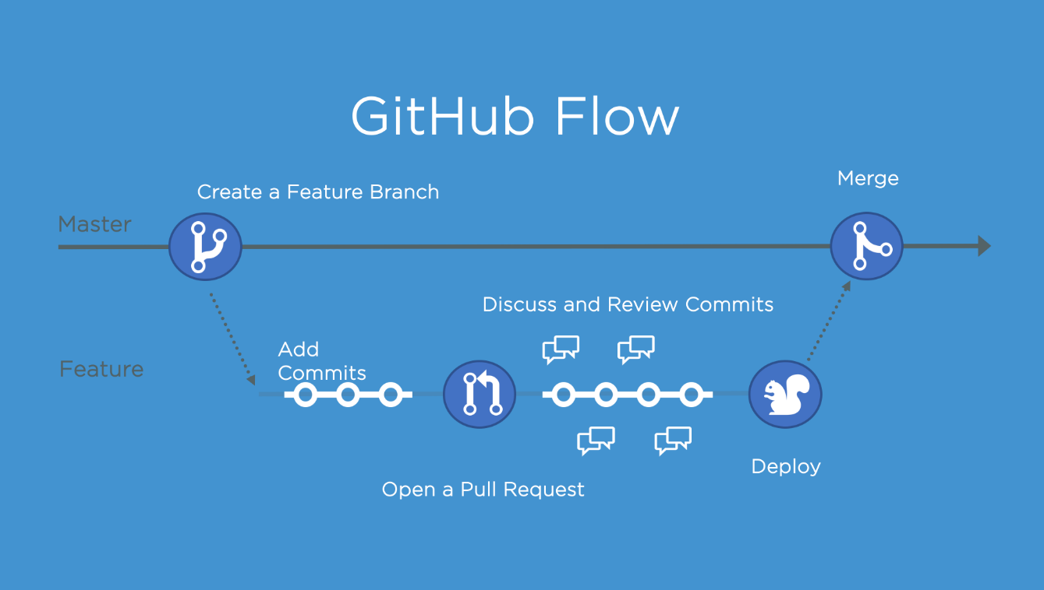

1. ***Integration of TIC Tools***

**Integration of TIC Tools**

**6.1 Interoperability of Google, Microsoft, Git, and GitHub**

**Interoperability is crucial in modern workflows, where teams often use a combination of tools for various tasks. Integrating TIC tools like Google Services, Microsoft Tools, Git, and GitHub can streamline processes and enhance collaboration.**

***6.2 Case Studies of Successful Integrations***

**Successful Integrations:**

* **Google Drive + GitHub: Organizations leverage the storage capabilities of Google Drive alongside GitHub for version-controlled code repositories. This integration ensures that project documentation and codebase are seamlessly linked.**
* **Microsoft Teams + Git: Teams using Microsoft Teams for communication find value in integrating Git for version control. This allows for real-time discussion and collaboration on code within the Teams platform.**

| **Organization** | **Integrated Tools** | **Benefits** |
| --- | --- | --- |
| **XYZ Corp** | **Google Drive + GitHub** | **Streamlined document and code collaboration.** |
| **ABC Inc** | **Microsoft Teams + Git** | **Improved communication and collaboration on codebase. ;** |

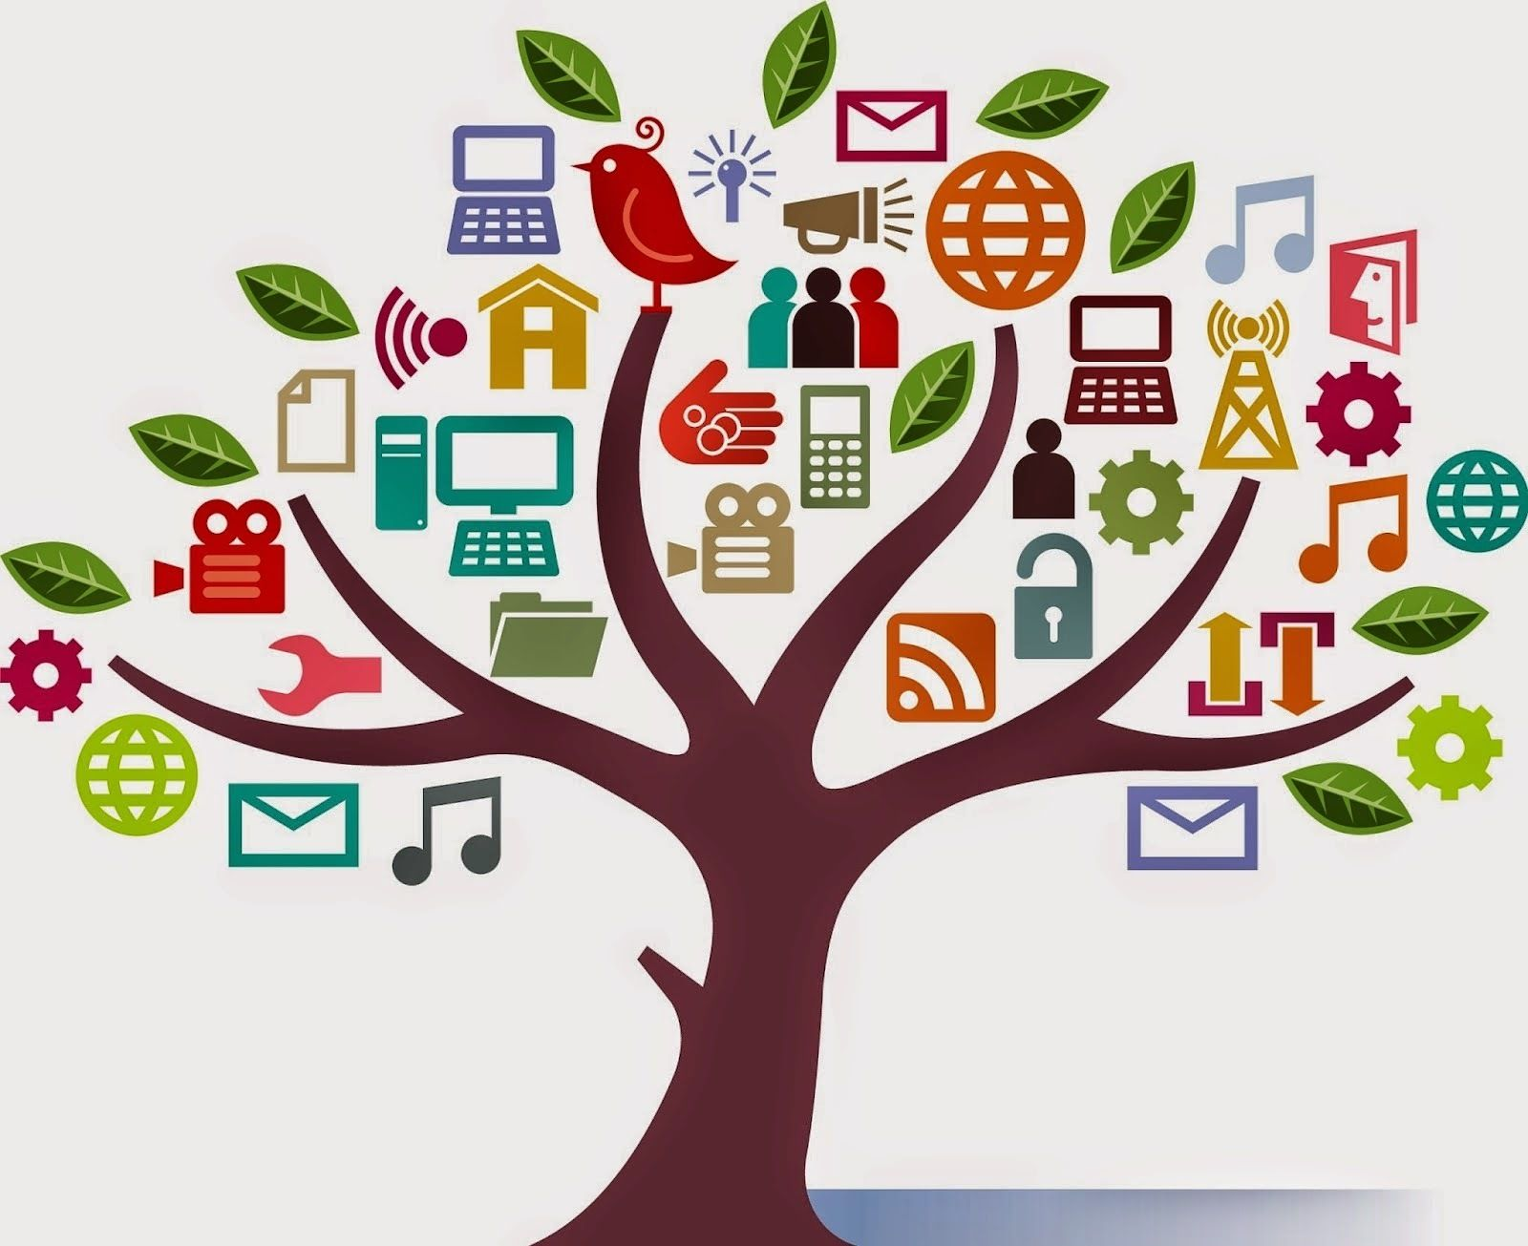

### 

**7. *Challenges and Future Trends***

**7.1 *Common Challenges in TIC Adoption***

**Challenges in TIC Adoption:**

* **Security Concerns: With the increasing reliance on digital technologies, security remains a significant challenge. Organizations face threats such as data breaches and cyber attacks.**
* **Integration Complexity: Integrating diverse TIC tools often comes with complexities, requiring careful planning and execution to ensure seamless interoperability.**
* **Resistance to Change: Employees may resist adopting new technologies, leading to challenges in training, user adoption, and overall organizational transformation.**

# **7.2 ***Emerging Trends in TIC*****

**Emerging Trends:**

* **AI and Automation: The integration of Artificial Intelligence (AI) and automation in TIC is on the rise, enhancing efficiency in various processes.**
* **Edge Computing: Edge computing is becoming more prevalent, enabling data processing closer to the source, reducing latency and improving real-time decision-making.**
* **Extended Reality (XR): XR technologies, including Virtual Reality (VR) and Augmented Reality (AR), are finding applications in TIC, transforming the way people interact with digital information.**

**7.3 *Table: Challenges and Trends Overview***

| **Category** | **Challenges** | **Emerging Trends** |
| --- | --- | --- |
| **Security** | **Data breaches, cyber attacks** | **Integration of AI for security enhancements** |
| **Integration** | **Complexity in tool integration** | **Growth of edge computing** |
| **Adoption** | **Employee resistance to change** | **Increased use of extended reality technologies** |

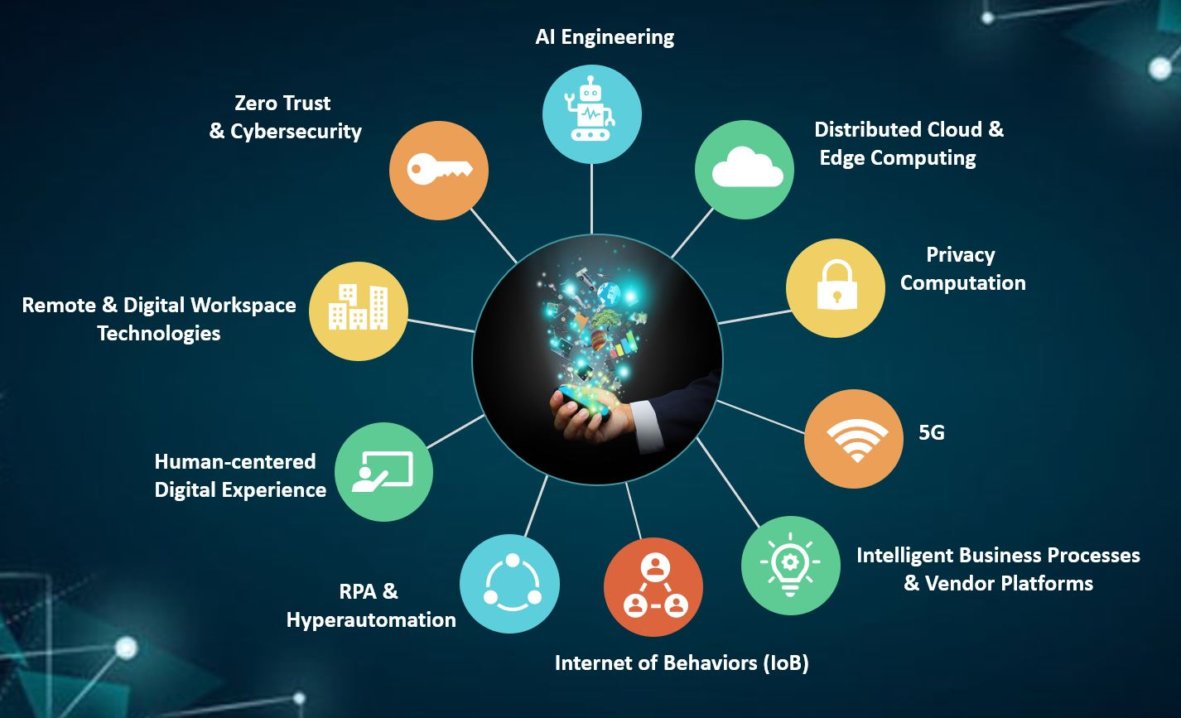

***Conclusion***

**8.1 Summary of Key Findings**

**In this comprehensive exploration of Information and Communication Technologies (TIC) and associated tools, several key findings have emerged:**

* **Google Services: Offering a suite of collaborative tools, Google Services excel in facilitating real-time collaboration and document sharing.**
* **Microsoft Tools: The Microsoft ecosystem, including Office Suite, Azure Services, and Microsoft Teams, provides a versatile platform for productivity, cloud services, and team collaboration.**
* **Git and GitHub: Git's robust version control capabilities, coupled with GitHub's collaborative features, make them integral to modern software development workflows.**
* **Integration of TIC Tools: Successful integration of Google Services, Microsoft Tools, Git, and GitHub has been observed in various case studies, streamlining collaborative efforts across organizations.**
* **Challenges and Future Trends: Overcoming challenges in TIC adoption, such as security concerns and integration complexities, is critical. Emerging trends, including AI integration and extended reality technologies, are shaping the future of TIC.**

# ****8.2** Recommendations for Efficient TIC Implementation**

**To ensure efficient TIC implementation and maximize the benefits of integrated tools, organizations are recommended to:**

* **Prioritize Security: Implement robust security measures to safeguard data and systems, addressing the increasing threats in the digital landscape.**
* **Invest in Training: Mitigate resistance to change by investing in comprehensive training programs for employees to enhance their digital literacy and adaptability.**
* **Stay Informed on Trends: Stay abreast of emerging trends in TIC, embracing technologies like AI and extended reality that have the potential to revolutionize workflows.**