IEEE RAS × AESS Tunisia · TSYP14 Technical Challenge · Phase 1
The Living Map: Spatial Memory for Emergency Robots
Short Technical Report — Architecture, Data Flow, Failure Cases and Implementation Plan
Team: PICTOGRAMME · Track 3 (Dashboard & Documentation) · Repository: GitHub repo + Docker Compose (see §9) · Status: end-to-end software chain working in simulation; hardware integration planned for Phase 2.

1. Problem and approach
In collapsed buildings, mines or contaminated zones a robot that fails takes its knowledge with it. We give the space a persistent spatial memory: a Writer robot explores and leaves small RF beacons (what was found, where, when); an Outside Network Area (ONA) bridges the disconnected zone to the world; a Command Post shows a live map and briefs an Executor robot that enters later and navigates using the inherited beacons. No robot ever talks to the Command Post directly: every message crosses the ONA.
Scenario. Urban Search & Rescue in a collapsed building, with two event types: victim (critical) and hazard (warning). Both are produced by the simulation and are the types the dashboard, alerts and missions are built around. Scope of this report. Our team owns the Command Post software chain (ROS 2 bridge, MQTT, backend, dashboard, Foxglove, documentation). The Writer, beacon hardware and ONA radio link belong to other tracks; sections 3 to 5 describe the interfaces we depend on and the design we propose, and mark what is simulated.

2. System architecture and data flow
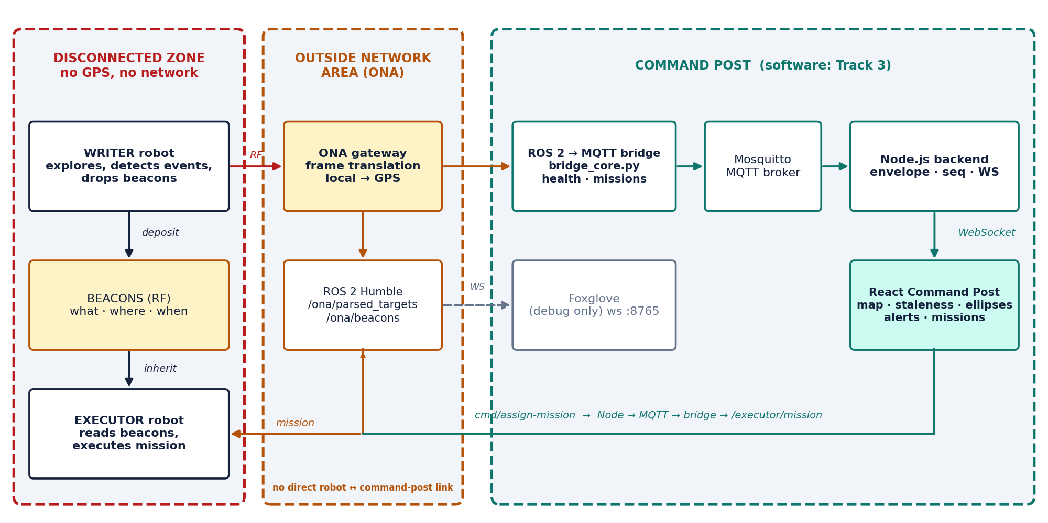
Figure 1 — System architecture. Solid arrows: production data path. Dashed: debugging branch (Foxglove). The command path returns through the same chain.
Uplink (robot → operator). Writer events and beacons reach the ONA by RF; the ONA publishes parsed data on ROS 2 (/ona/parsed_targets, /ona/beacons, plus health topics). Our ros_mqtt_bridge converts each message into a normalised MQTT message (targets/<id>, robots/<id>, events/<id>, beacons/<id>, missions/<id>); Mosquitto distributes it; the Node.js backend wraps it in an envelope {kind, id, seq, ts, source, payload} and pushes it over WebSocket to the React dashboard. Downlink (operator → Executor). A click on “Send Executor” becomes cmd/assign-mission; the bridge resolves the beacon position, publishes /executor/mission on ROS 2, and tracks mission state (pending → active → done | cancelled | failed).
Foxglove is a debugging branch, not the dashboard. It subscribes to the same ROS 2 graph through foxglove_bridge (ws:8765). It answers “is the data correct and arriving?”; the dashboard answers “how do we present it to the operator?”. This separation is what makes faults diagnosable (§7).

3. Writer autonomy, event detection and beacon deposition
Autonomy (proposed). Frontier-based exploration on an occupancy grid built from the 2D LiDAR and odometry, with a reactive obstacle-avoidance layer (stop/turn when range < 0.4 m) underneath. Without GPS, the Writer localises by odometry plus scan matching in a private frame whose origin is its start pose; all positions are therefore expressed in that private frame until the ONA translates them (§4).
Events and the decision to drop a beacon. Victim candidates (thermal or sound cue) and hazards (gas, heat, blocked passage) are detected by thresholded sensors with a minimum persistence of three consecutive readings to reject noise. A beacon is dropped only when (a) the event class is new within a 3 m radius, (b) the confidence exceeds 0.6, and (c) the Writer still has beacons left, so the limited payload is spent on information that changes the Executor’s mission. In the simulation these steps are replaced by a scripted publisher that emits one victim (critical) and one hazard (warning) beacon.

4. Beacon message, signal design and frame translation
The beacon is a compact broadcast frame (target ≤ 24 bytes, fits a low-rate RF packet) carrying what / where / when, plus an ageing field so the receiver can judge how far to trust it:
Field | Size | Meaning
ver / type | 1 B | Protocol version (4 bits) + event type (victim, hazard, junction, …)
beacon_id | 2 B | Unique id; the Writer increments a counter, so duplicates are dropped
sev | 1 B | Severity: info / warn / critical
x, y | 2 × 2 B | Position in the Writer’s private frame, signed centimetres (±327 m range)
t_write | 4 B | Seconds since the Writer’s clock epoch (the “when”); basis of the ageing mechanism
conf, σ | 1 B + 1 B | Confidence (0–255 → 0–1) and position uncertainty in decimetres
ttl / crc | 2 B + 2 B | Validity horizon in minutes and CRC-16; frames failing the CRC are discarded

Message ageing. The Command Post never trusts a beacon at face value: its current probability of detection decays as PoD = conf · exp(−λ·(t_read − t_write)) and its ellipse grows (§5). The Executor applies the same rule, so an old victim beacon triggers a re-scout instead of blind navigation.
Frame translation (implemented). The ONA holds one real GPS anchor (lat₀, lon₀) corresponding to the Writer’s origin and a heading offset. Local metres convert to WGS-84 with the equirectangular approximation, accurate to centimetres over a building-scale site: lat = lat₀ + (y / R)·180/π, lon = lon₀ + (x / (R·cos lat₀))·180/π, R = 6 378 137 m. The inverse is used by the bridge to turn a clicked beacon back into Executor coordinates. Both directions are unit-tested (latlon_to_local, local_to_latlon). The anchor is configurable (default: Tunis, 36.8065° N, 10.1815° E) and is the open item to be set from the real ONA GPS fix.

5. Command Post: bridge, backend and dynamic staleness engine
Bridge (ros2/bridge_core.py). All logic is pure Python and unit-tested (19 tests), with a thin ROS 2 node around it. It accepts several field spellings (target_id|id, timestamp|ts in seconds, milliseconds or ISO-8601, lat/lon or local x/y), and — importantly — preserves the source timestamp, so a target that stops being published genuinely ages instead of being refreshed by every relay. Malformed messages are dropped without crashing the node.

Message contract (MQTT topics and ROS 2 inputs)
MQTT topic | Source (ROS 2) | Content
targets/<id> | /ona/parsed_targets | Position (lat/lon), confidence, σx, σy, orientation, source timestamp
robots/writer, robots/executor | /odom, /battery_state, /executor/odom | Pose, battery %, derived state (exploring, degraded, fault, node-down)
events/<key>-<ms> | /diagnostics, /scan, /ona/beacons | Sensor faults, battery warnings, victim/hazard sightings, mission done
beacons/<id> | /ona/beacons | Beacon id, type, severity, position, info, timestamp
missions/<id> | /executor/status | Mission id, target, status, progress
cmd/<action> | → /executor/mission | assign-mission, cancel-mission (full WebSocket command envelope as payload)

Staleness engine (dashboard). Age is computed against the source timestamp. Three layers make ageing visible at a glance: a state (LIVE ≤ 5 s, STALE ≤ 15 s, LOST beyond), a continuously decaying probability of detection PoD = conf·e^(−λ·age) with λ = 0.05 s⁻¹ (half-life ≈ 14 s), and an uncertainty ellipse that grows from σ₀ towards 5σ₀ as the data ages. When PoD falls below 0.25 (about 25 s for a 0.87-confidence target) the target is flagged RE-SCOUT. λ, growth and threshold are build-time variables (VITE_DECAY_LAMBDA, VITE_ELLIPSE_GROWTH, VITE_RESCOUT_POD) so the jury or operators can tune them.
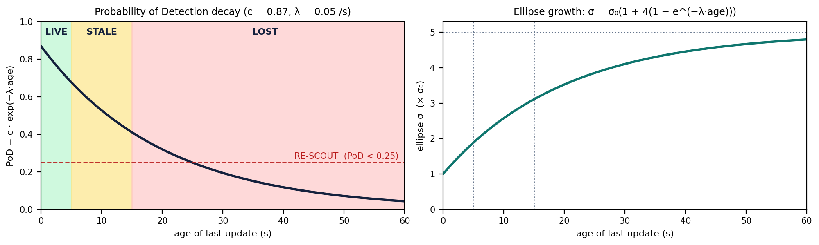
Figure 2 — Left: PoD decay with LIVE/STALE/LOST bands and the RE-SCOUT threshold. Right: ellipse growth factor.
Dashboard. An OpenLayers map shows targets with PoD labels and growing ellipses, the Writer and Executor, beacons and the mission line; side panels list targets, alerts and robot health. The Critical counter shows unresolved alerts only: events are grouped by key and a later info event (for example “mission done”) resolves the matching alert.

Validation
The bridge logic has 19 pytest tests (coordinate round-trip, tolerant parsing, timestamp preservation, level decoding, watchdog classification, mission lifecycle). The dashboard has unit tests for the staleness engine and the WebSocket client (reconnect, dedupe), and the backend has tests for normalisation, the gateway, WebSocket delivery and an MQTT round trip. The full chain was run in Docker on Windows against the simulated Writer, ONA and Executor: targets aged with growing ellipses, a LiDAR fault and a frozen node were reported differently, and two missions (one completed, one cancelled) were executed from the dashboard.

6. Executor robot and mission flow
The operator selects a beacon (e.g. the victim) and presses “Send Executor”. The bridge creates mission M-<seed> with the beacon’s local coordinates and publishes it to /executor/mission through the ONA. Proposed hardware behaviour: the Executor loads the mission, navigates towards the beacon coordinates using Nav2 (or a waypoint follower), refines its approach from the beacon RF signal strength when within range, inspects for a fixed dwell time, then reports done. In the simulation a kinematic Executor (executor_logic.py: start at HOME, 0.7 m/s, arrival radius 0.35 m, 4 s inspection) drives in a straight line and publishes /executor/odom and /executor/status; the dashboard shows the live progress, supports Cancel, and resolves the victim alert on completion. Nav2 integration and obstacle avoidance are Phase 2 items.

7. Failure cases and degradation behaviour
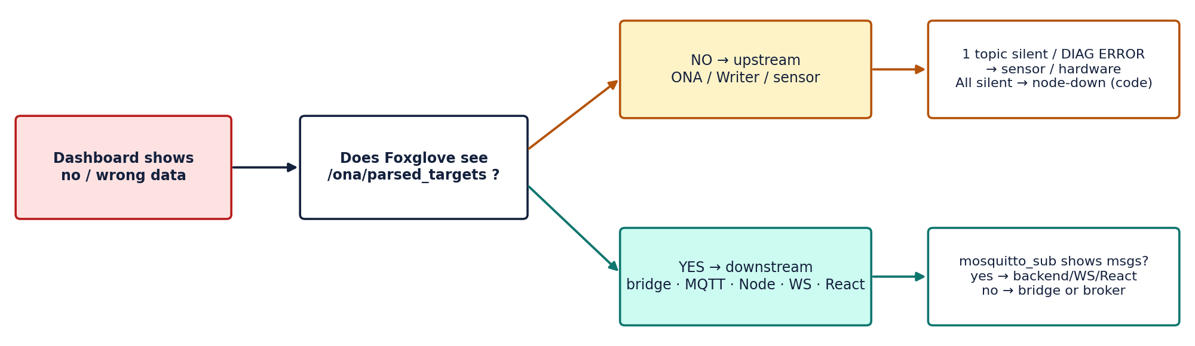
Figure 3 — Fault isolation: Foxglove tells whether the problem is upstream (robot/sensor) or downstream (our software).
Failure | Detection | System response
Single sensor fails (e.g. LiDAR) | Diagnostics ERROR and/or one topic silent beyond its timeout | Event “sensor/hardware”; Writer state fault(lidar); other data keeps flowing; alert raised once, resolved on recovery
Writer software frozen | All Writer topics silent at once (watchdog, 1 s tick) | State node-down (code fault, not hardware); single alert; targets age to LOST; one recovery event
Target stops updating (out of RF range) | Age against source timestamp | LIVE → STALE → LOST; ellipse grows; PoD < 0.25 → RE-SCOUT
Battery low | BatteryState → WARN / ERROR levels | Warning then critical event; Executor can be dispatched to replace the Writer
Malformed or duplicate message | Parser returns none; dedupe on envelope id | Message dropped, node keeps running (guarded callbacks)
MQTT broker restarts | Client disconnect callback | Bridge reconnects automatically (connect_async), re-subscribes to cmd/#, keepalive republishes state
Backend / WebSocket drop | Missing messages, socket close | Dashboard reconnects with backoff and shows a “LINK LOST — data frozen” banner instead of stale-looking live data
Bridge process crash | Container exits | Container restarts; known limit: one crashing process restarts all (per-process supervision planned)
Mission cannot complete | No done status; operator timeout | Operator cancels (cmd/cancel-mission); alert stays unresolved until an info event closes it

Because a frozen node and a dead sensor look identical on the dashboard (“no data”), the bridge classifies them at the source: one silent topic ⇒ sensor/hardware; all silent ⇒ node-down. Foxglove’s diagnostics and raw-message panels let an engineer confirm this in seconds.

8. Implementation plan
Window | Milestone | Deliverable / exit criterion
Done (Phase 1) | Software chain in simulation | Docker Compose runs ROS 2 + bridge + Mosquitto + backend + dashboard; targets, beacons, events, missions and fault injection demonstrated; unit tests green
05/10 → 20/10 | Contract freeze with other tracks | Final /ona/parsed_targets type and fields, beacon frame, anchor GPS and thresholds agreed; bridge adapted in under a day thanks to tolerant parsing
20/10 → 10/11 | Hardware integration | Real ONA (radio link + gateway) feeding ROS 2; Writer pose and beacons visible in Foxglove, then on the dashboard; Command Post laptop/tablet provisioned
10/11 → 24/11 | Executor and field test | Nav2 or waypoint Executor driven by the dashboard mission; end-to-end run with real beacons; latency and loss measured
24/11 → 01/12 | Final polish | User manual, pitch, 30-second “kill” demo rehearsed; repository cleaned; final submission 01/12

Main risks and mitigations. (1) Contract drift from other tracks — mitigated by tolerant parsing and a documented contract (docs/ona-contract.md). (2) RF link quality — the ageing engine degrades gracefully instead of failing. (3) Single-process container restart — per-process supervision. (4) Demo-day networking — everything runs locally in Docker with no internet dependency except map tiles.

9. Reproducibility and open questions
docker compose up --build starts the full chain; the dashboard is on port 5173 and Foxglove connects to ws://localhost:8765 (layout in foxglove/). The README describes ports, topics, tuning variables, debugging steps and tests. Open questions to settle with the other tracks: the final message type of /ona/parsed_targets (JSON String today, custom message preferred); where the ONA, broker and backend physically run; the final LIVE/STALE/LOST thresholds and λ; the GPS anchor and heading offset; and the Writer-side values quoted in §3 and §4, which are proposals until the hardware is characterised.

