Hello, this is frontend docs:

User Interface :
Dashboared that lists all books :
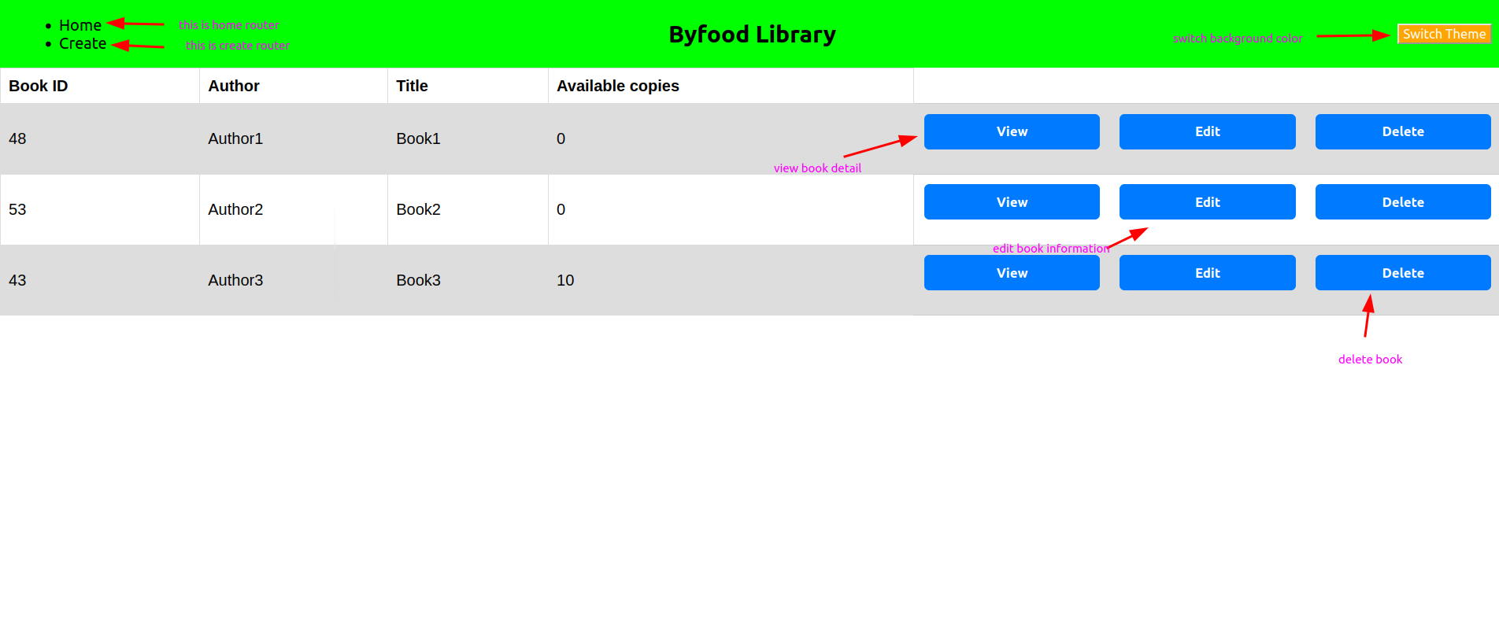

This is the form for creating/editing books:
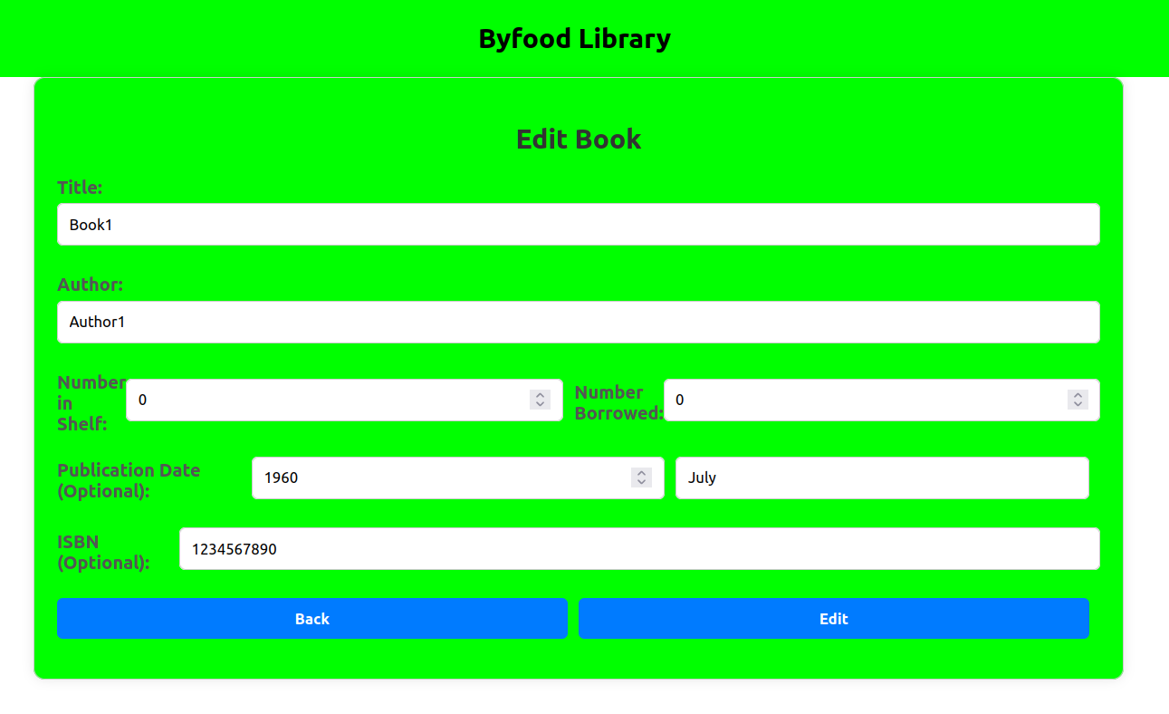

This is modal dialog to confirm submission, I sued one in book creation too:
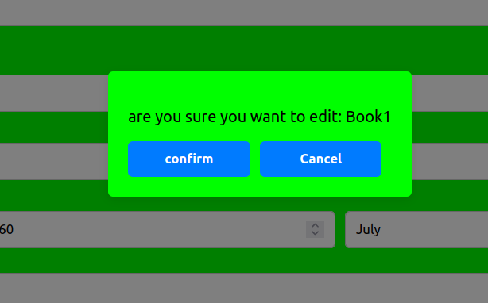

I used toast for success and error messages:

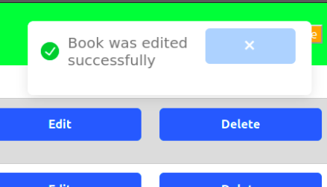

And I used context api to switch between background colors across components:
