***Rules:*** *This final exam is closed book and closed notes. You are allowed two sides of one and a half sheet of 8.5” x 11” paper on which you can write whatever notes you wish. You are* ***not*** *allowed to use calculators of any type, and any cellular phones must remain off and in your bags for the duration of the exam.* ***Any violation of these rules constitutes an act of academic dishonesty, and will be treated as such.***

***Numerical calculations:*** *This exam consists of six problems, and each one is worth 25 points. Two of the problems ask you to calculate numbers. I have chosen the parameters in this problem so that the answers can be expressed in terms of rational and irrational numbers. If you find that in your calculation of these problems you end up with an expression which you cannot evaluate numerically—such as one containing an irrational number—simplify the expression as much as you can and leave it.* ***However, if you choose, you can do any or all of these problems using only variables and still receive full credit for it.***

***We will give partial credit on this midterm****, so if you are not altogether sure how to do a problem, or if you do not have time to complete a problem, be sure to write down as much information as you can on the problem. This includes any or all of the following: Drawing a clear diagram of the problem, telling us how you would do the proble3m if you had the time, telling us why you believe (in terms of physics) the answer you got to a problem is incorrect, and telling us how you would mathematically solve an equation or set of equations once the physics is given and the equations have been derived.* ***Don’t get too bogged down in the mathematics****; we are looking to see how much physics you know, not how well you can solve math problems.*

***If at any point in the exam you have any problems, just raise your hand, and we will see if we are able to answer it.***

|  |  |
| --- | --- |
| *Name: ______________________________* | *Disc Sec Number:______________________ _______________________* |
| *Signature: ___________________________* | *Disc Sec GSI:_________________________* |
| *Student ID Number: ___________________* | *Disc Sec Time:_________________________* |

|  |  |
| --- | --- |
| **1** |  |
| **2** |  |
| **3** |  |
| **4** |  |
| **5** |  |
| **6** |  |
| **Total** |  |

***You must show your student ID when you hand in your exam!***

1. The figure to the right shows a small black with mass $m$ sliding up a triangle-shape block with mass $M$ with $θ={45}^{°}$ that is placed on top of a table. The coefficient of *kinetic* friction between the two blocks is $μ_{k}=1/2,$ while the coefficient of *static* friction between the triangular block and the table is $μ_{s}=1$.
   1. Draw the free body diagram for both blocks.
   2. What is the $smallest$ that $M/m$ can be if the triangular block does not move?
2. The figure on the right shows a disk with mass $m$ that has a very thin string wrapped around the outer rim. The disk is sitting on a plank with mass $M=2m$, and it rests on a frictionless table. Both the plank and the disk start at rest. The other end of the string is then pulled upward by Tom with a force $F$. There is static friction between the disk and the plank. The disk never loses contact with the plank, and it always rolls without slipping on it.
   1. What is the work done by Tom after the string was pulled upward a distance $H$? Express it in terms of $F$ and $H$.
   2. What is the speed $v$ of the disk after this much string has unwound from the disk? Express your answer in terms of $F, H,$ and $m$.
3. The figure on the right shows an iron cylinder with height $H$ and cross-sectional area $A$ that is suspended a distance $h$ in water by a wire that has length $L$ and mass $m$. The density of water is $ρ,$ and take the density of iron to be $ρ_{Fe}=8ρ$
   1. Neglecting the mass of the wire, what is the tension on the wire? Express it in terms of , , , and .

* 1. Wind blows across the wire, and it starts vibrating with a fundamental frequency $f_{0}$. What is $f_{0}$? Express it in terms of $V, A, H, h, m, L,$ and $ρ.$

1. The figure below shows two identical springs, each with spring constant $k$, connected to the center of a disk with mass $M$. *There is friction between the disk and the* table, and *the disk always rolls without slipping.*



* 1. Draw the free body diagram for the disk.
  2. What is the oscillation frequency $ω$ of the disk?

1. A heat engine has an efficiency of $η$, and *in each cycle* an amount of heat $Q_{H}$ flows into the system. The heat the flows out of the engine is used to melt a block of ice with mass $m_{ice}$ and at temperature $T_{ice}=0 ℃$.
   1. How many cycle $N$ are needed to melt the ice? Express it in terms of $m_{ice}, Q_{H}$, $η,$ and the latent heat of fusion $L_{ice}$ for ice.
   2. What is the *total amount* of heat $Q_{Total}$ that has to be used to power the heat engine in order to melt the ice? Express it in terms of $m_{ice}, η,$ and $L_{ice}$.
   3. What is the total amount of work $W_{Total}$ done by the heat energy when melting the ice? Express it in terms of $m_{ice}, η,$ and $L_{ice}$.
2. The figure to the right shows two containers. Container A is *sealed*, no side of the cylinder can move, and it is *not* open to the atmosphere. Container B is a cylinder with a moveable piston on top, and it is open to the atmosphere. The piston can move up and down without friction. The gas in each container is the same, and consists of a mixture of helium, $He$, and molecular nitrogen, $N_{2}$. The total number of moles of particles in the gas is $n$, while the ratio of the number of moles of $He$ to $N_{2}$ is $n_{He}/n_{N_{2}}=2$. The two components of the gas are in thermal equilibrium with each other, and the temperature of the system is not large enough to excite the vibrational degrees of freedom of the $N_{2}$ molecules.

A

B

* 1. Using the thermodynamics and physical concepts covered in this course, explain why the pressure exerted by the He atoms and the pressure exerted by the $N_{2}$ molecules each obey the ideal gas law:
 $$P_{He}V=n_{He}RT, P_{N_{2}}V=n_{N_{2}}RT.$$

 2. What is $n_{He}$ and $n_{N_{2}}$? Express your answers in terms of $n$.
  3. The temperature of the gas in the container A is changed *quasi-statically* by $∆T$. How much heat $Q_{B}$ flows into or out of the gas? Express your answer in terms of $n, R$ and $∆T$. (I would recommend that you use the first law of thermodynamics.)
  4. The temperature of the gas in the container B is changed *quasi-statically* by $∆T$. How much heat $Q_{A}$ flows into or out of the gas? Express your answer in terms of $n, R$ and $∆T$. (I would recommend that you use the first law of thermodynamics. I would also recommend that you look at the forces that act on the piston.)
  5. Then what is the adiabatic constant $γ$ for the gas? (You will get a number.)

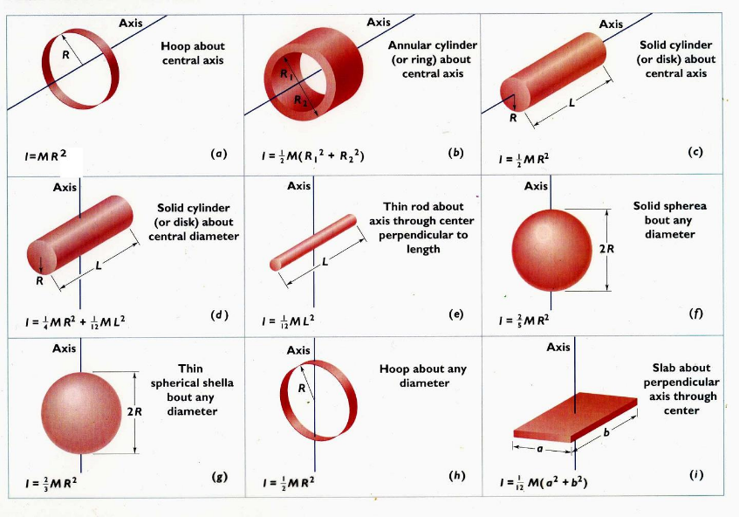

Physics 8A Math Info Sheet

*Various equations that may or may not be of use:*

$$\frac{d^{2}u}{dt^{2}}=-ω^{2}u, u\left(t\right)=u_{0}\cos{ωt}+ {\left.\frac{du}{dt}\right|}_{0}\sin{ωt}, v=\sqrt{\frac{T}{μ}},$$

$$\frac{dQ}{dt}=-kA\frac{ΔT}{L}, ΔQ=mcΔT, ΔQ=mL, η=\frac{W}{Q_{in}},$$

$$C.O.P.=\frac{Q_{in}}{\left|W\right|} C.O.P.=\frac{\left|Q_{out}\right|}{\left|W\right|}$$

$$\sum{{\vec{F}}_{ext}}=M{\vec{a}}_{cm}, {\vec{V}}_{cm}=\frac{\vec{P}}{M}, {\vec{r}}_{cm}=\frac{1}{M}\sum{m_{i}{\vec{r}}_{i}}, I_{p}=I_{cm}+Md^{2}$$

*Quadratic Equations:*

The solution of the quadratic equation $ax^{2}+bx+c=0$ is

$$x=\frac{1}{2a}\left(-b±\sqrt{b^{2}-4ac}\right)$$

Derivatives:

$$\frac{d\left(x^{n}\right)}{dx}=nx^{n-1}$$

Integrals:

$$\int{x^{n} dx}=\frac{x^{n+1}}{n}$$