**Course Number: AIT 524**

**Shane Armstrong**

**Homework Assignment 7**

**ERD**

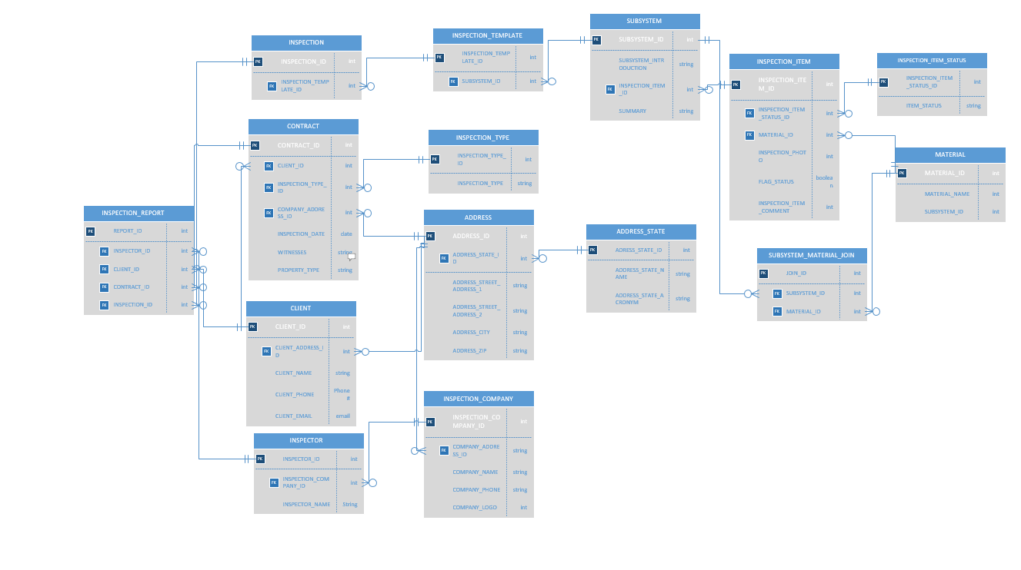

1. INSPECTION_REPORT

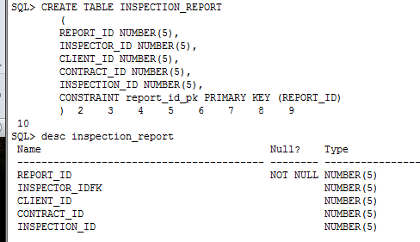

1. INSPECTOR

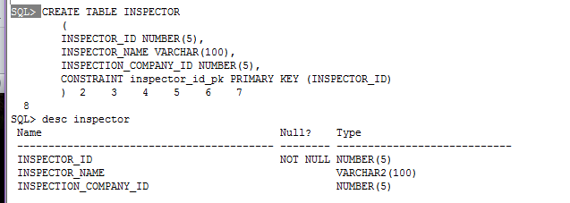

1. INSPECTION_COMPANY

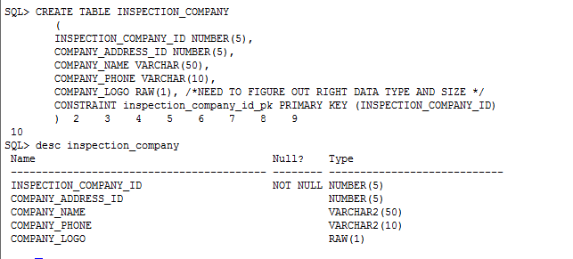

1. CONTRACT

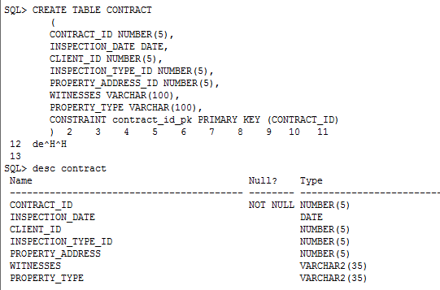

1. INSPECTION_TYPE

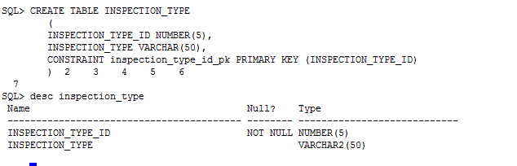

1. CLIENT

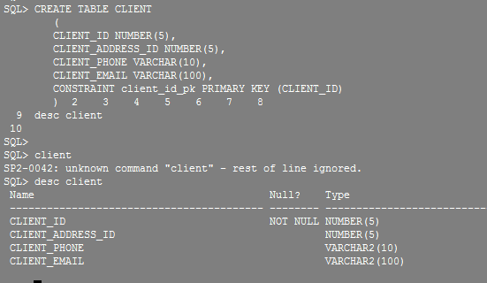

1. ADDRESS

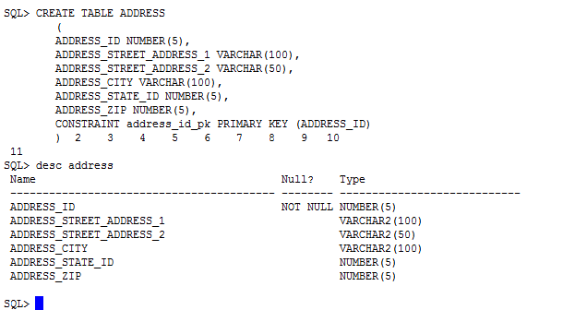

1. ADDRESS_STATE

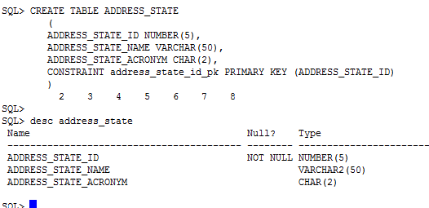

1. INSPECTION

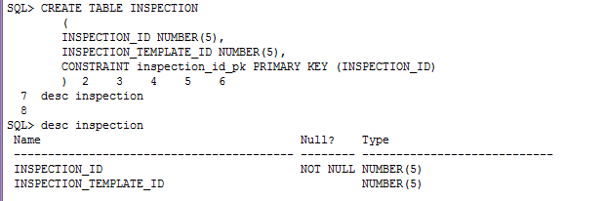

1. INSPECTION_TEMPLATE

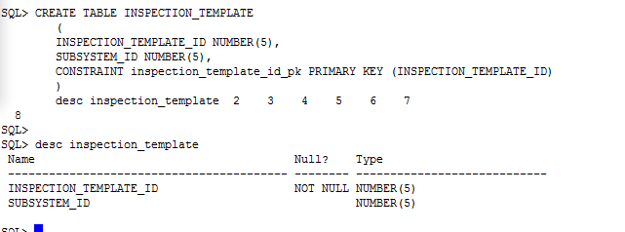

1. SUBSYSTEM

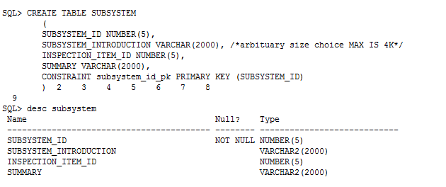

1. INSPECTION_ITEM

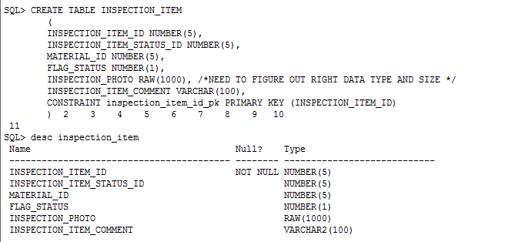

1. INSPECTION_ITEM_STATUS

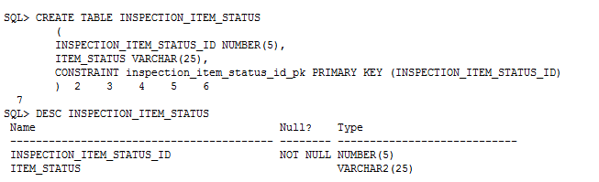

1. MATERIAL

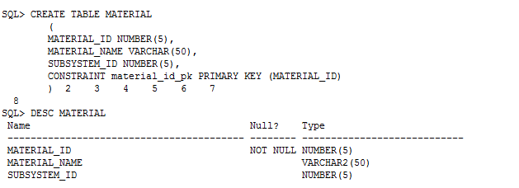

1. MATERIAL_JOIN

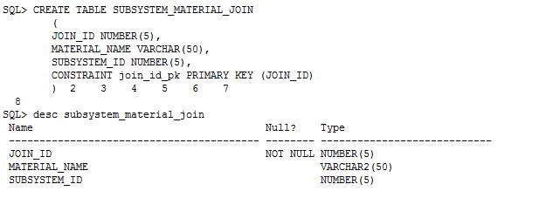

1. Relationships

