Regression plots for AAPL (Daily sentiment score vs close price)

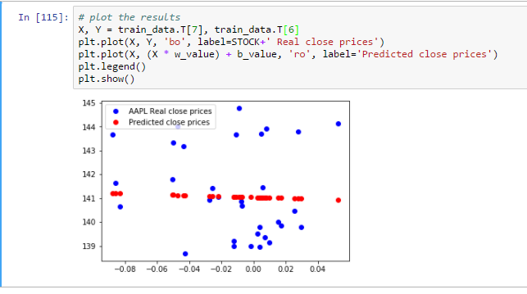

Loss function

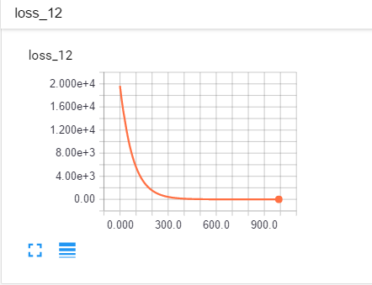

Tensorboard graph for GradientDescentOptimizer training.

