AndrewId: jingyual

Name: Jingyuan Liu

Contact: jingyual@andrew.cmu.edu

# Part A

1. Show three trees:
2. Tree from “titanic.arff” data

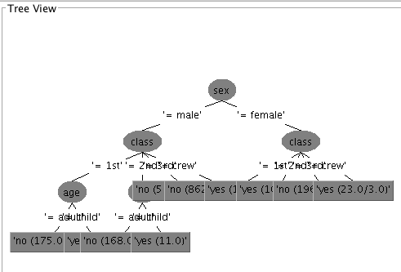

1. Tree from “titanic-numeric-age.arff” data

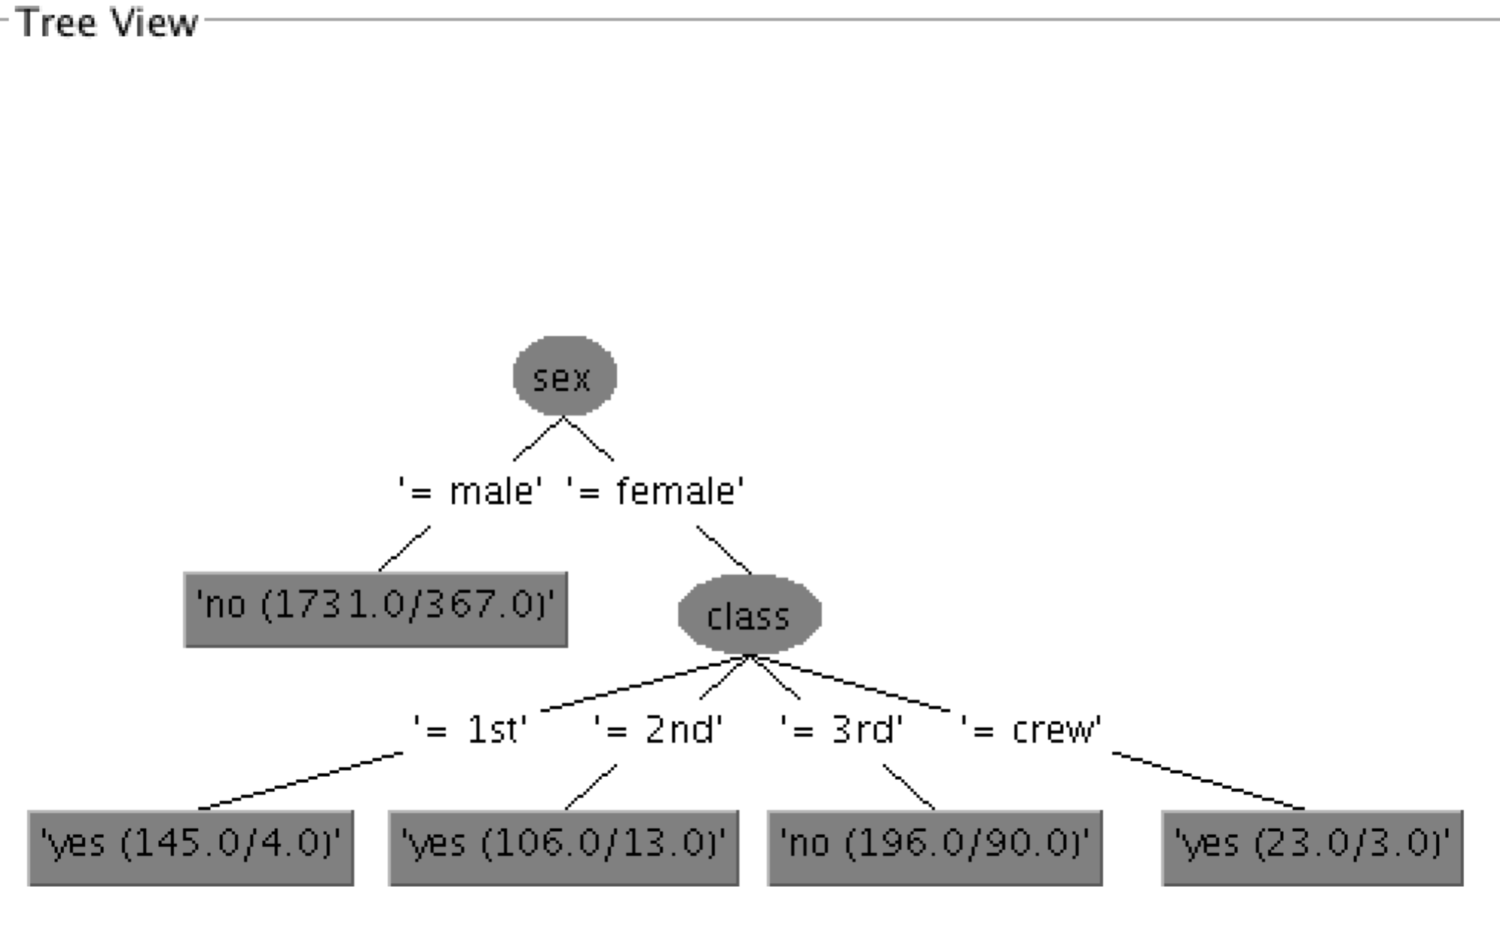

1. Tree from “titanic-noise.arff” data

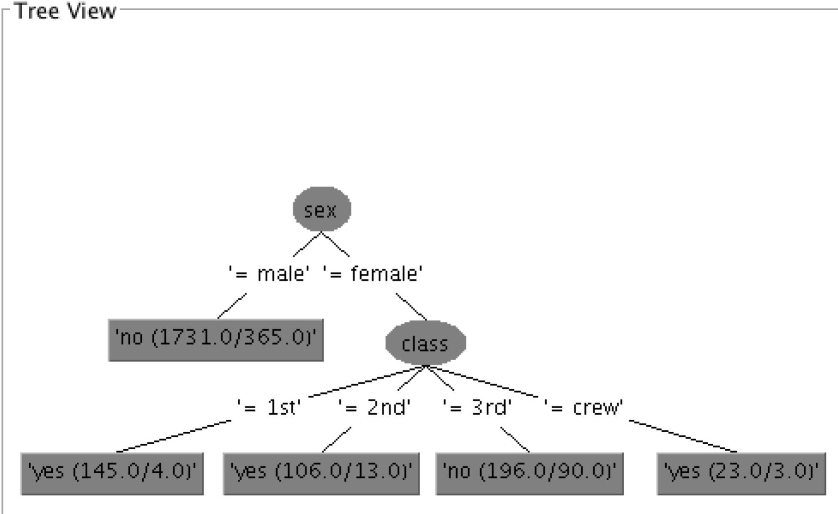

2. Compare nominal attribute and numeric attribute