Assignment 7

Jingyuan Liu
AndrewId: jingyual email: jingyual@andrew.cmu.edu

Step-by-Step Guide:

- Complete the readings through week 10.

- Use the experimenter to determine whether you get significantly different performance from J48 (tree based learning) and JRIP (rule based learning) when you use a feature selection wrapper that selections the top 50 features on each fold. Give screen shots and explain your results.

Solution:
At first, we can set up the JRip:
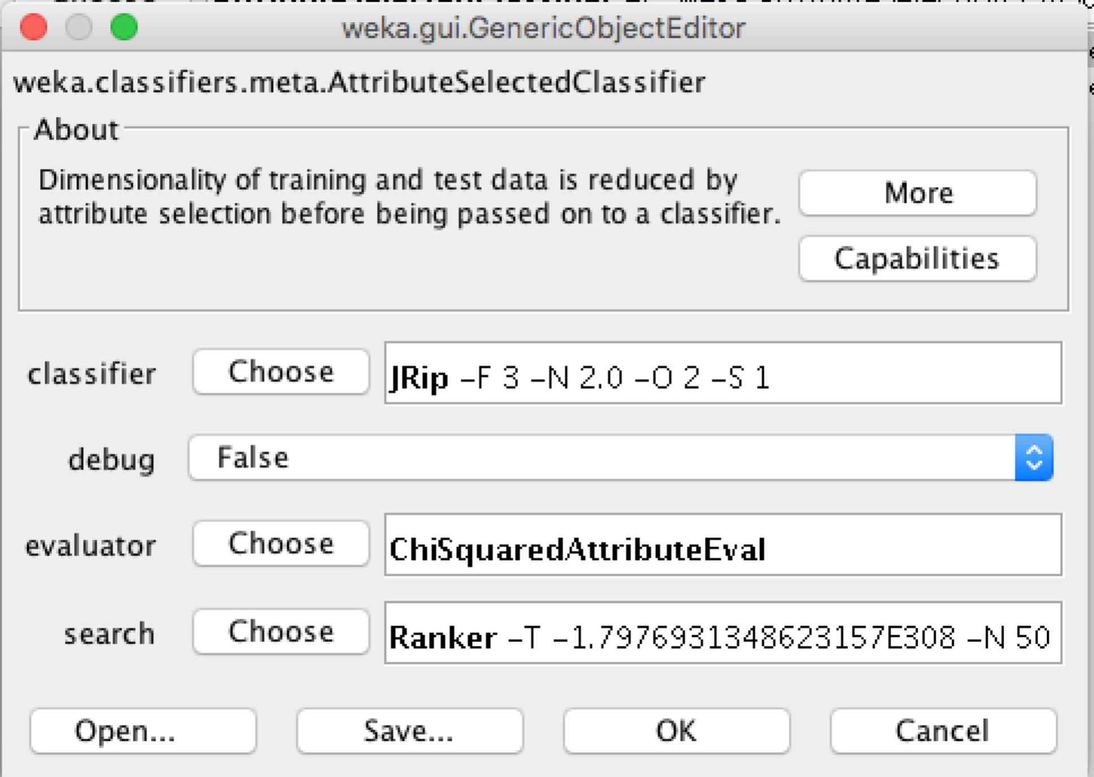

The result is:
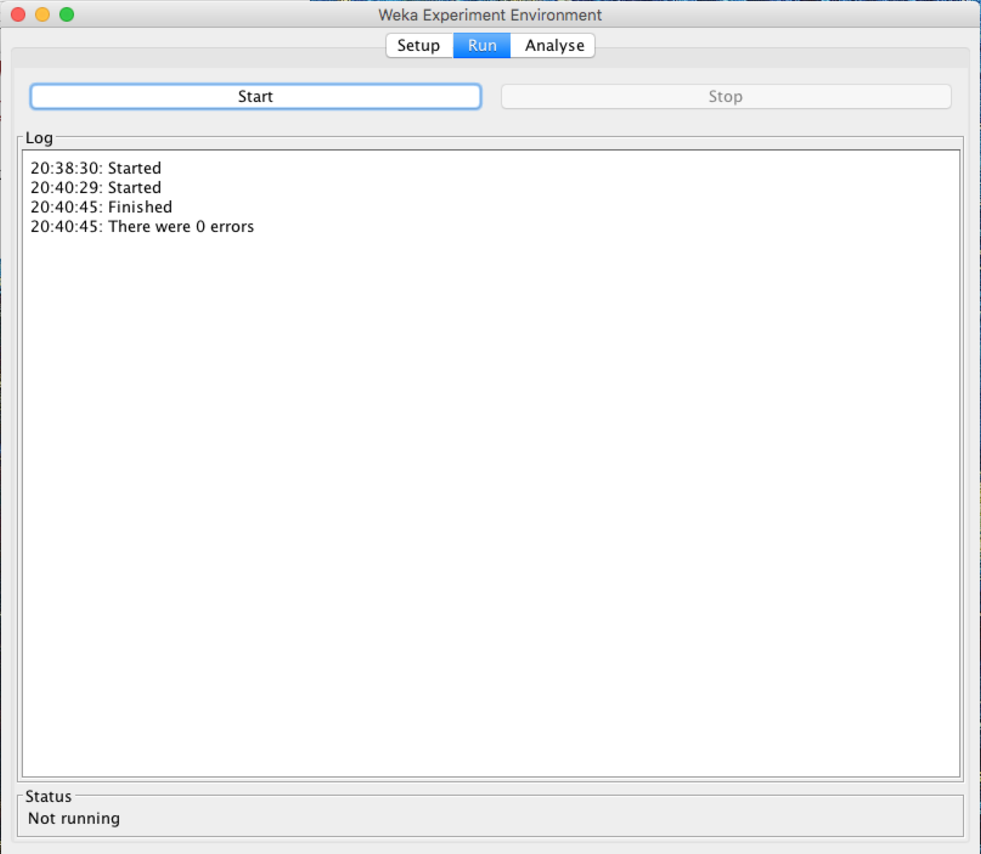

Then we can set up the J48:

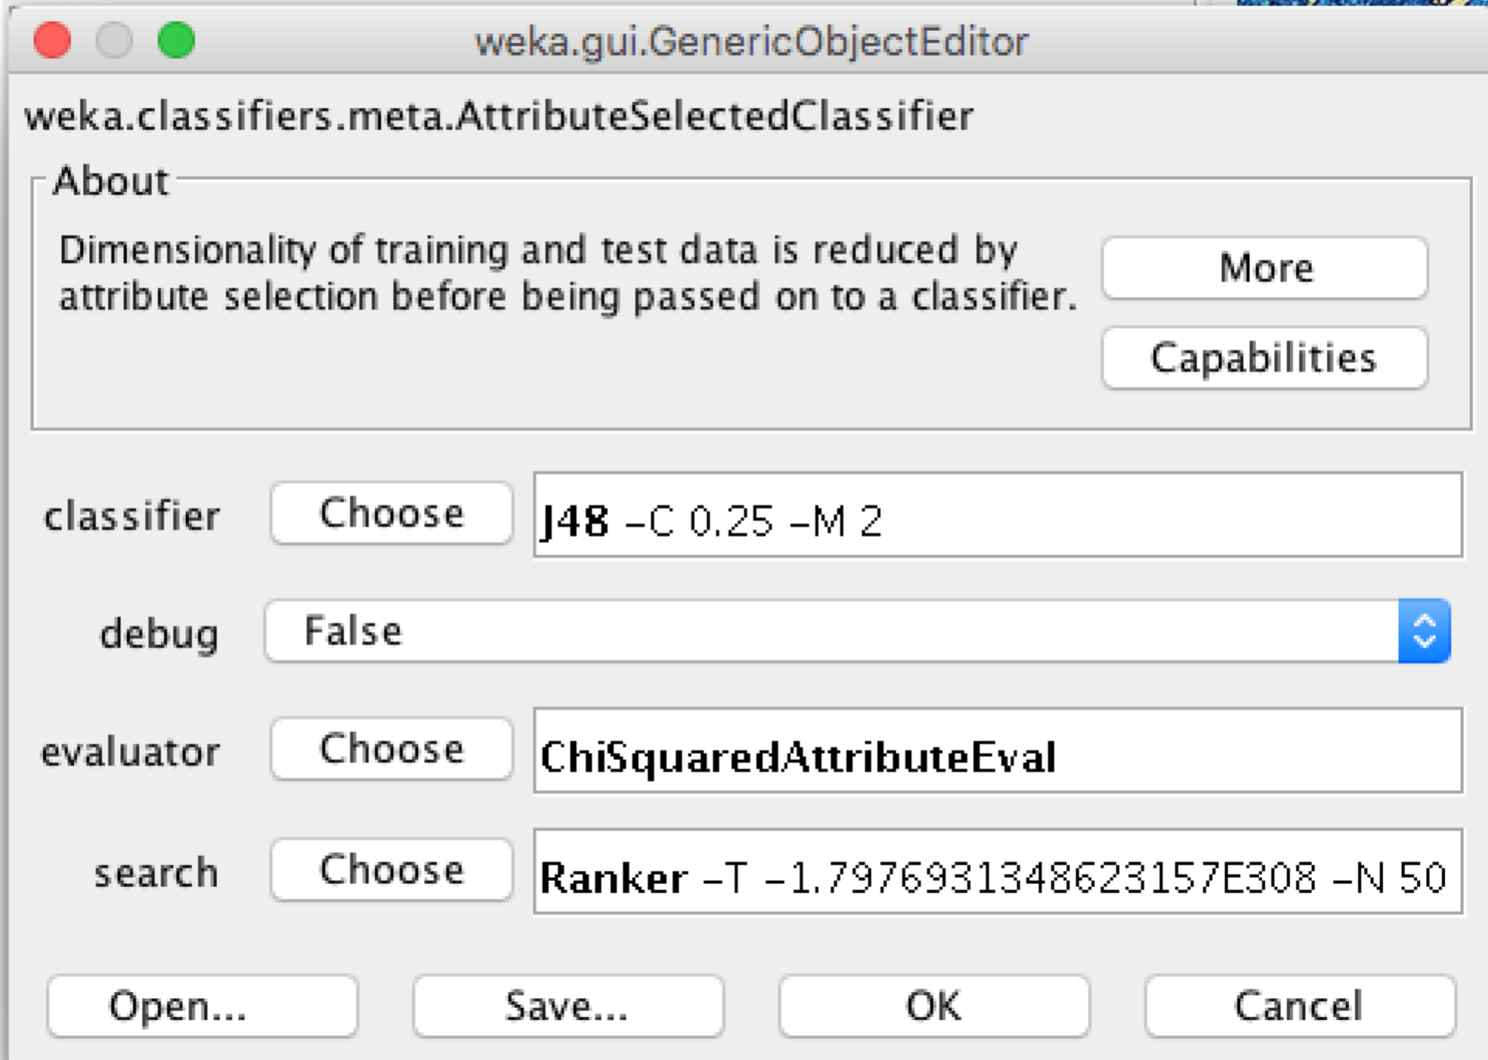

Then we can run the experimenter and got the result:

- Troubleshoot your results so that you understand why performance was or was not different between tree and rule based learning. The point here is not to identify where the feature space is weak but to investigate why the algorithms did or didn’t perform differently. This can be thought of as a more advanced version of what you did with the Titanic dataset earlier in the semester. It should be doable since you will only be considering around 50 features. You may need to be creative. Now explain your results using what you understand about tree and rule based learning and what you found in your error analysis.

- Are the results surprising given the discussion about tree and rule based learning in the book? Why or why not?

