Applied Machine Learning - Midterm 1

Name: Jingyuan Liu; AndrewId: jingyual; email: jingyual@andrew.cmu.edu

Part 1: Thought Questions (10 points each)

1. What is the difference between weights and per feature conditional probabilities in terms of how they function in a trained model (i.e., a weight based model vs a probabilistic model, respectively)? What is an argument for using probabilities instead of weights? What is an argument against using probabilities instead of weights?
Solution:
The major difference between weights and per feature conditional probabilities in terms of how they function in a trained model is the “scaling”. Basically, weight based model would compose the model likelihood and try to optimize the weights to maximize the likelihood. On the other hand, the conditional probabilistic models are computed from likelihoods by scaling in such a way that the sum of probabilities for all possible events within a model will sum to 1
These two models are suitable for different scenarios. For the probabilistic models, it would give statistical models their nice forms because the sum of probabilities sum to 1.
The disadvantage of probabilistic statistical model is that they always depend on assumptions that are not in general true. Besides, in practice, they don’t work better than “ad-hoc” methods.

2. Explain the smoothing method we discussed in class in connection with Naïve Bayes. What is the problem with using this form of smoothing with small datasets?
Solution:
Smoothing is to add a pseudo count to each case in the Naïve Bayes counting step. Naïve Bayes model is based on counting, therefore, smoothing is to add “1” to each counts. With this method, Naïve Bayes would be smoothed, which can also be known as adding a prior.
When smoothing with small datasets, it would cause some problems, especially when the prior probabilities are highly skewed. We would simply add 1 to those small datasets (0).
3. Review the slides from Week 5 Lecture 1 where we discussed the Tic Tac Toe dataset. Note that you can find this dataset on blackboard in the Lecture Slides folder near the slides for that lecture. Explain why you think linear models worked better than the other two algorithms.
Solution:
The decision tree model is trained based on splitting features. Basically, in this case, we would have too many “features” and “cases” to split. Therefore, the model is very much likely to be over-fitting. So the model classification performances would not be very high.
Another model is the probabilistic model, Naïve Bayes. This model assumes that the features are conditionally independent on labels. This assumption would not agree with the realistic case in the Tic Tac Toe Game. Because it is easily known that each step is highly related with other steps in a game,
The linear model, like SVM, would be perfect fit to this game. This is very reasonable to use SVM here. Basically, SVM is to maximize the margin of the classifier and is majorly influenced by those “support vectors”. In this case, we would know that the “middle point” is the key “support vectors”. Therefore, SVM could achieve good performances in this case.

4. Is it valid to do supervised feature selection over your whole data set prior to doing cross validation for evaluating the model building? Why or why not? What should you do instead?
Solution:
No. Feature selection is part of the model building. So doing supervised feature selection over the whole data set prior to doing cross validation would give the model building an unfair advantage by narrowing the space of model considered to those that are more likely to perform well on test data. To conclude, this would give us better performances on cross validation data, but not able to make sure that the test data would be better.
Instead, we should do feature selection over the training data on each fold separatelu.

5. In class we looked at a multi-layer (i.e., nonlinear) model for modeling A XOR B. We discussed why a linear model can not compute A XOR B if your feature space is two inputs, one of which represents A and the other of which represents B. What would be a different feature space representation that would allow you to model A XOR B with a linear model?
Solution:
We could use hidden layers and activation threshold to allow feature with more complexity. This would transfer those complex features, like “A XOR B”, to a different feature space representation for a linear model.

Part 2: Test of Practical Competence
As you do your work with this data set, refer to the LightSide Manual and the lecture slides.
Part A: File setup.
- Start with the midtermdata.csv file that you downloaded with these instructions. Notice that the file has 1569 instances from 771 students. You should divide the data into a development set with 100 students and a cross validation set with the remaining students. Call the development set midtermdata-dev.csv and call the cross validation set midtermdata-cv.csv. You should include these two csv files when you submit your midterm.

Part B: Investigate the use of text features.
- On the first (“Extract Features”) panel, load midtermdata-cv.csv and configure the panel so that you are using only unigram features. Under “Basic Features”, make sure “Unigrams” and “Track Feature Hit Location” are checked. Uncheck “Include Punctuation”.
  - Save the unigram feature table as an ARFF file called baseline.arff. You should include this file when you submit your midterm.

- Build a baseline model.
  - On the “Build Models” panel under “Learning Plugins”, select the LibLINEAR SVM (under “Support Vector Machines”) as your machine learning algorithm.
  - In the center pane, make sure you’re set up for leave-subpopulations-out 10-fold cross-validation (“by annotation”) where StudID is the subpopulation. (See lecture slides from Week 9 Lecture 1)
  - Press the “Train” button to start training and evaluating the model.
  - When training is done, you’ll see the results at the bottom of the pane.
Record the baseline performance (Accuracy and Kappa),
under “Model Evaluation Metrics”.

Solution:
The result is:
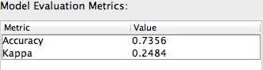

- You’re going to prepare to do an error analysis, to determine where the machine learning model is making mistakes. We want to avoid “cheating” by analyzing the training data directly, so you’ll train on the cross-validation set, and test on the development set. You’ll perform the error analysis on the test results from the development set. Make sure you document your process as you observe in the answer key from assignment 6.
  - Under the center pane of “Build Models”, set up the evaluation to use the “Supplied Test Set” option. Load the development set as the test set.
  - Press the “Train” button. The result should be similar to what you saw when you did the cross-validation, but it won’t be exactly the same.

Solution:
First open the dev.csv file, and load into LightSide.

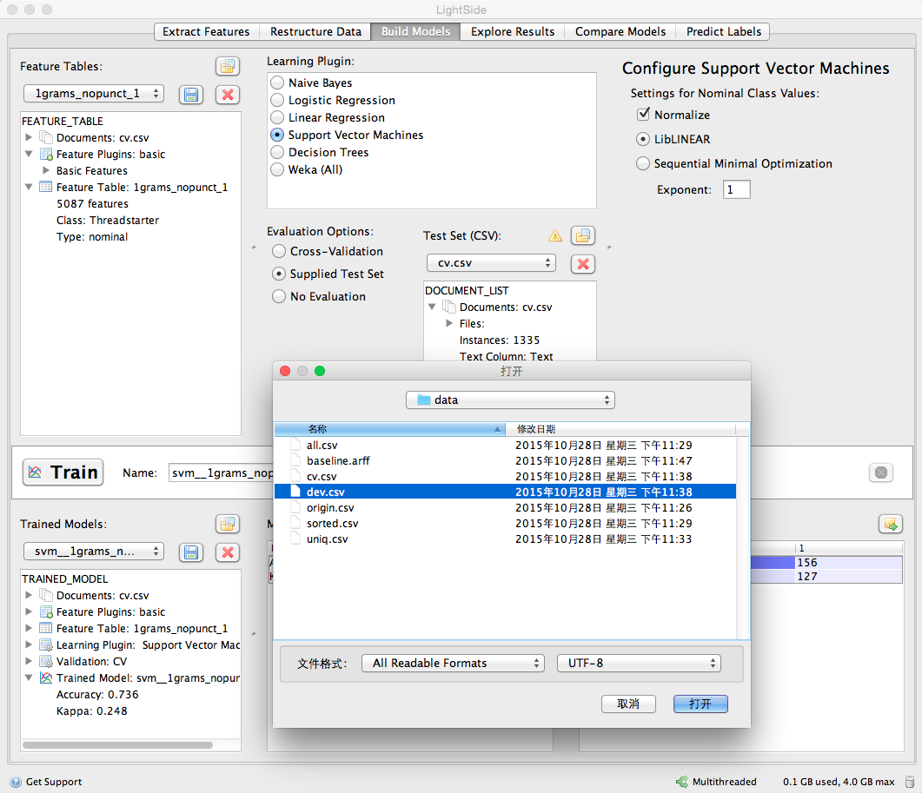

First, under the center pane of “build models”, set up the “supplied test set” option. Load the development dataset. Note that the “dev” data contains different students from “cv”.

Then, press the “train” button to train the model.

The result is different on “cv” data. I got accuracy of 72.22 % and kappa of 0.2984.

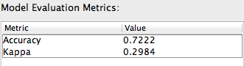

- Switch to the “Explore Results” panel to do your error analysis on these test results.
  - Make sure the second trained model is selected in the top-left pane.
  - Use the error analysis methodology demonstrated in class and in the Assignment 6 answer key. This includes using horizontal and vertical comparisons to identify problematic features, then using additional tests to try to identify the reasons why these features are problematic.
  - The Explore Results pane (including all of the built-in error analysis metrics) is described in Chapter 7 of the LightSide manual.
  - Describe the problematic features you identified, and explain how you determined they were problematic. Describe also the qualitative analysis you did when you went back to the text to see how those features were potentially used differently between cells of the confusion matrix, or what other things were going on in those texts that might be the real problem that needs to be solved.

Solution:
The panel is here:
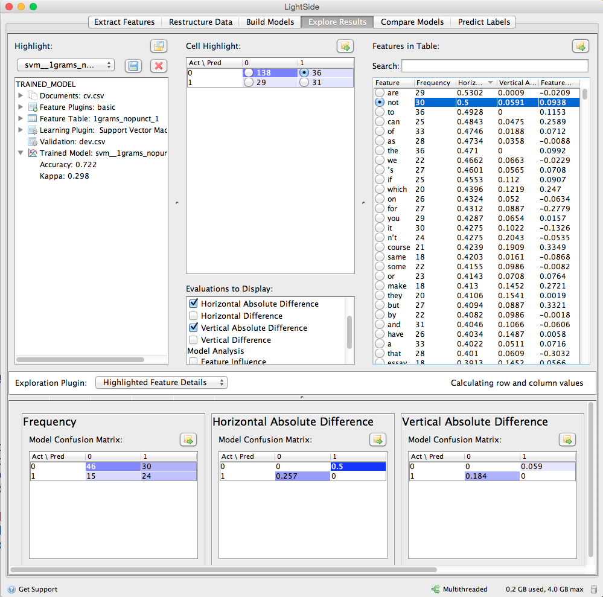

I went to the Explore Results panel to see the result. And selected the second created morel in the upper left. Looking the confusion matric in the “Cell Highlight” panel, I choose the bottom left error cell because it was the biggest error one. I selected that and selected a list of features came up in the Features in Table Panel.

I choose both the horizontal and vertical errors and analyze the horizontal at first. I selected Frequency, Horizontal Absolute Difference, Vertical Absolute Difference, and Feature Weight. I clicked to sort it. In the sorted result, we could find “n’t”, “can”, are of high frequency and Horizontal errors. One thing we know about LightSide is that it would break “don’t” into “do” and ‘’n’t”. This would cause confusion, since the “n’t” could result from different combinations.

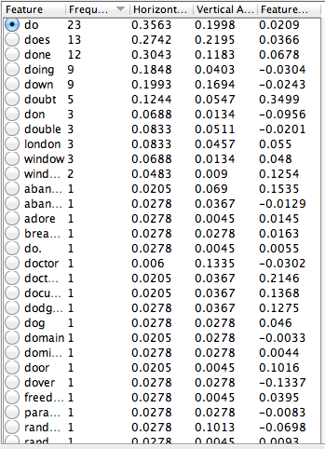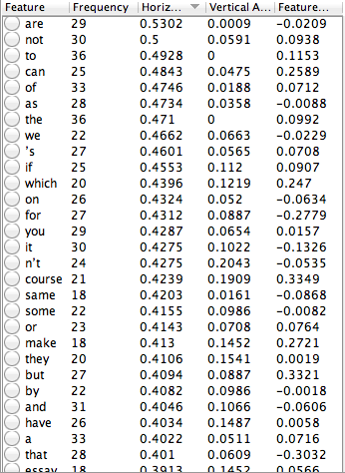

Then in the vertical part, I also clicked the button to sort the result. we would still found that “do” has a high frequency and Vertical Absolute Error. This means that the “don’t” might indeed cause confusions for our classifiers.

Besides, another thing worth noting is that we could see many words without significant meaning, like “the”, “of”, and “a”, which is called stop words, have very high frequency, we could try to filter the stop words for higher performances.

What’s more, some word combinations are separated into several different words due to the unigram model, so we could try to use the “bigram” model to test if would lead to better performances.

- Based on what you learned from the error analysis, come up with some ideas for new features that you think might help the machine learning algorithm overcome the errors you found. For this section, use only text-based features – ignore the extra columns in the dataset for now. Explain your proposed features and why you think they will solve the problems you noticed.

Solution
Based on my found problems, I could use “do + n’t” to introduce a new feature. This could easily be achieved by the regular expression. This would allow me to use the new feature “don’t” rather than “do” + “n’t” separately“.

Besides, LightSide also offers choices to filter the stop words, which could help improve the performances.

What’s more, the LightSide also offers choices to build bigram word features. We could test whether bigram could be a good idea.

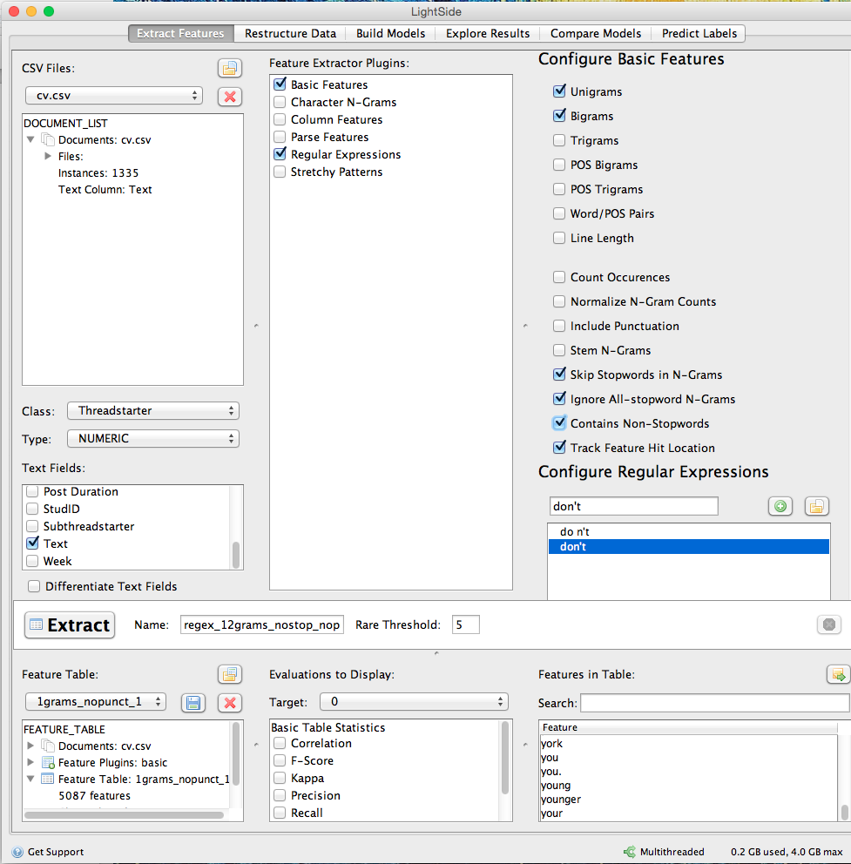

- Test whether your ideas are effective at addressing the problems you found. You will evaluate the effect on the cross-validation set.
  - Return to “Extract Features” panel and set up the feature extraction using the ideas you listed under #6. See Chapter 4 of the LightSide manual for more information on advanced feature extraction. In addition to the options under Basic Features, Regular Expressions may be especially useful.
  - Extract the features and then save the new feature table as an ARFF file named new.arff. You will turn this file in with your midterm.
  - Return to the Build Models pane. Reset the options in the center pane for leave-one-subpopulation-out 10-fold cross-validation with StudID as the subpopulation
  - Train and evaluate a cross-validated model to test the performance of the new feature space. Record the new performance values (Accuracy and Kappa).

Solution:

We can see the result:

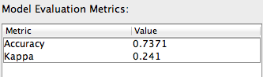

The accuracy is 73.71% and the Kapp is 0.241. This is better than the previous result.

- Compare the results.
  - Switch to the “Compare Models” pane. Make sure the baseline model is selected on the left and the final model is selected on the right. See Chapter 8 of the LightSide manual for more information.
  - Test whether the performance difference is statistically significant.
  - Try to determine (and describe) the kinds of instances on which the two models perform differently.

Solution:
The result is here:
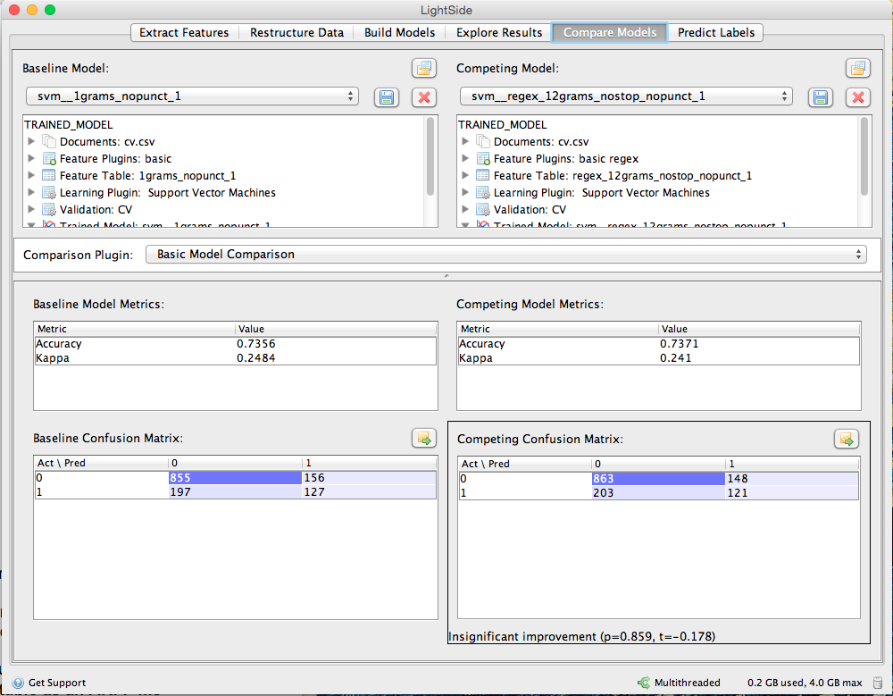

We could see that the new feature is not significant important. But we did have performances improvement.
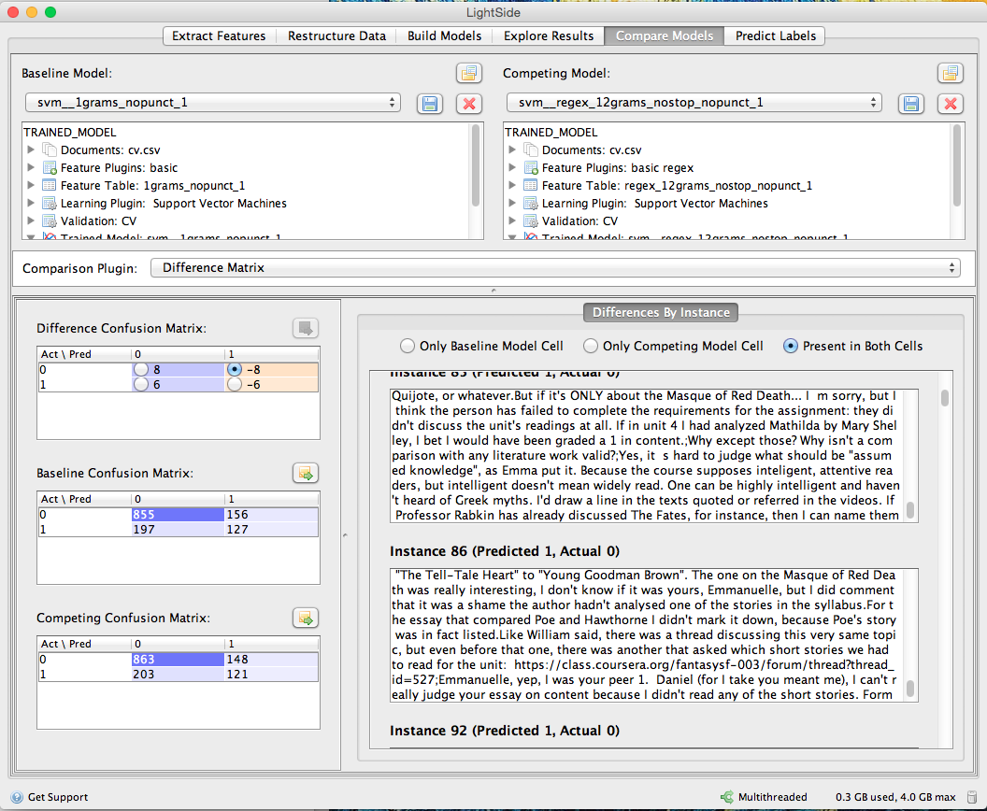

We could see that in the new model, those instances with many “don’t” words, and with many “stop words” would be correctly classified, while in the previous model, the result would be wrong.

Part C: Investigate the use of meta-data features.
- On the first (“Extract Features”) panel, load midtermdata-cv.csv and configure the panel so that you are using only column features. Make sure that you do not include StudID as one of the column features you extract.
  - Save the metadata-only feature table as an ARFF file called baseline-meta.arff. You should include this file when you submit your midterm.

- Build a baseline model just as you did in #2 in Part B.
  - Record the baseline performance (Accuracy and Kappa),
under “Model Evaluation Metrics”.

Solution:
The result is:
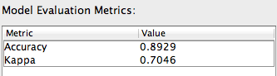
We can see that the accuracy is 0.89289 and the Kappa is 0.7046.

- You’re going to prepare to do an error analysis the same way you did in #3 in Part B. Make sure you document your process as you observe in the answer key from assignment 6.

Solution:
To do error analysis, we first should use the “dev” data test the model performances.
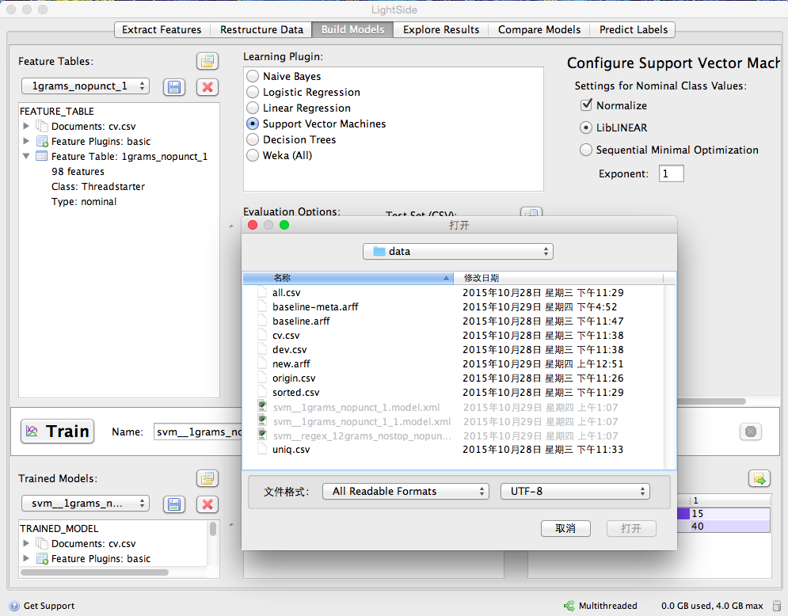

And the result is:
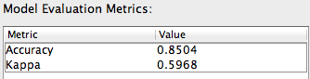

- Switch to the “Explore Results” panel to do your error analysis on these test results.
  - Make sure the last trained model is selected in the top-left pane.
  - Use the error analysis methodology demonstrated in class. This includes using horizontal and vertical comparisons to identify problematic features, then using additional tests to try to identify the reasons why these features are problematic. You may find it useful to export a csv from the error analysis panel with the extra columns that it provides.
  - The Explore Results pane (including all of the built-in error analysis metrics) is described in Chapter 7 of the LightSide manual. But recall what we discussed in class regarding doing an error analysis when you have not extracted any text features. You can refer to the slides for Week 9 Lecture 1.
  - Describe the problematic features you identified, and explain how you determined they were problematic.
Solution:
First, we need to go to the explore result table for next step.

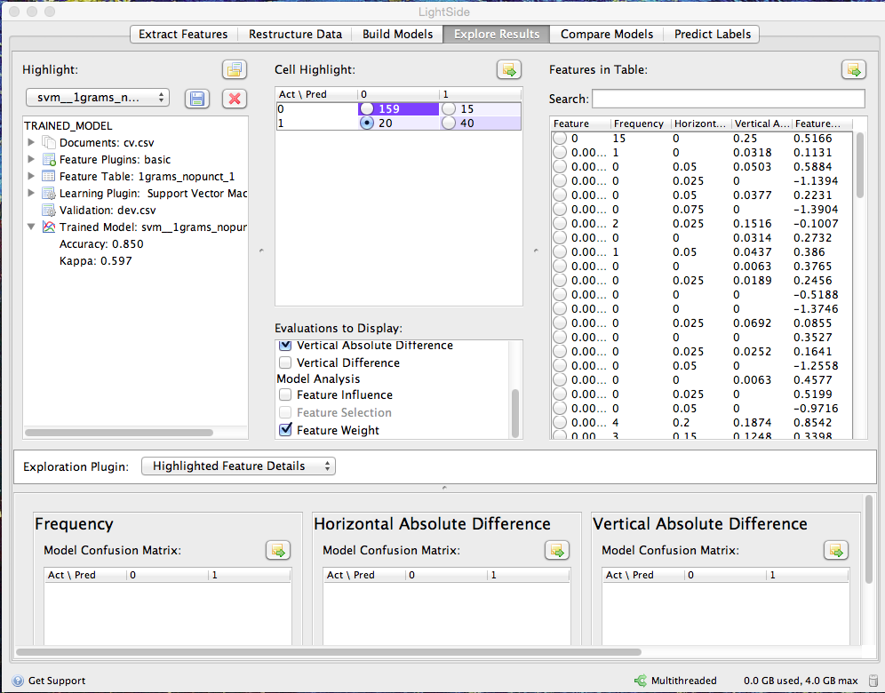

We choose the right bottom feature, because it has the most wrong cases. The following is the detailed result graph:
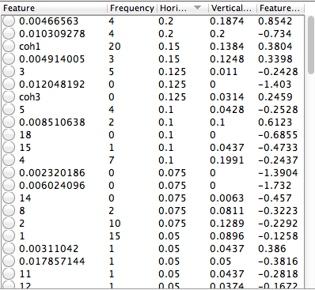

I click to sort the table and fond those with specific numbers are very much likely to cause the trouble.
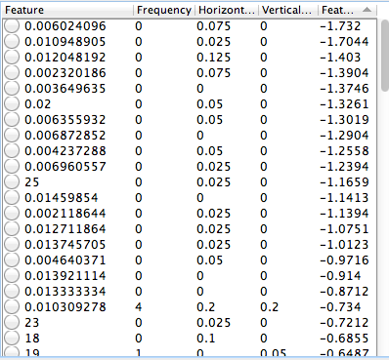

- Based on what you learned from the error analysis, come up with some ideas for new metadata-based features that you think might help the machine learning algorithm overcome the errors you found. In this case, you may need to create new features in your spreadsheet editor (Excel, etc) by computing formulas over the metadata attributes. Remember the discussions about transforming features we had early in the semester in connection with the Opinion Poll dataset. Explain your proposed features and why you think they will solve the problems you noticed.

Solution:
I would delete the feature of Authority and Hub. Because this two feature are numeric features, we are using them as the nominal value. Besides, based on our error analysis, we should try to get rid of the bad effects from those “bad” features.

- Test whether your ideas are effective at addressing the problems you found. You will evaluate the effect on the cross-validation set.
  - Add extra columns for your proposed features to your CSV (in your spreadsheet editor, etc). Make sure to add any new columns to both datasets. Select the column features you want in the Extract Features pane.
(Alternatively, you can combine existing column features by using the Combine Features plugin in the Restructure Data pane – see Section 5.2 of the LightSide manual)
  - Extract (or restructure) the features and save the new feature table as an ARFF file named new-meta.arff. You will turn this file in with your midterm.
  - Return to the Build Models pane. Reset the options in the center pane for leave- subpopulations-out (“by annotation”) 10-fold cross-validation with StudID as the subpopulation.
  - Train and evaluate a cross-validated model to test the performance of the new feature space. Record the new performance values (Accuracy and Kappa).
Solution:
The result is
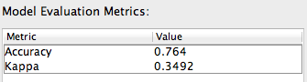
- Compare the results.
  - Switch to the “Compare Models” pane. Make sure the baseline model is selected on the left and the final model is selected on the right. See Chapter 8 of the LightSide manual for more information.
  - Test whether the performance difference is statistically significant.
  - Try to determine (and describe) the kinds of instances on which the two models perform differently.

Solution:
We could it is statistically significant
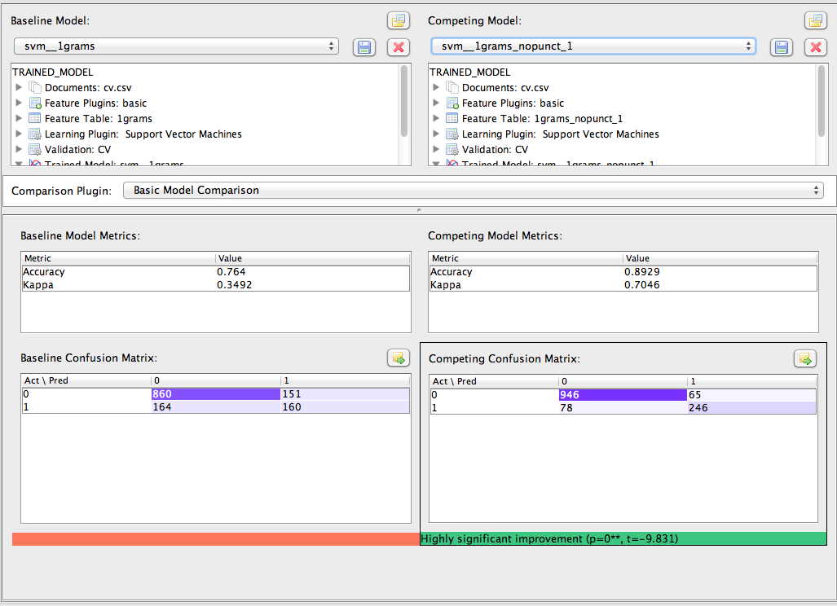

Part D: Final Model.
- Go back to the “Compare Models” pane now and compare the performance of best model you built in Part B with the best model you built in Part C. Which was better?
Solution:
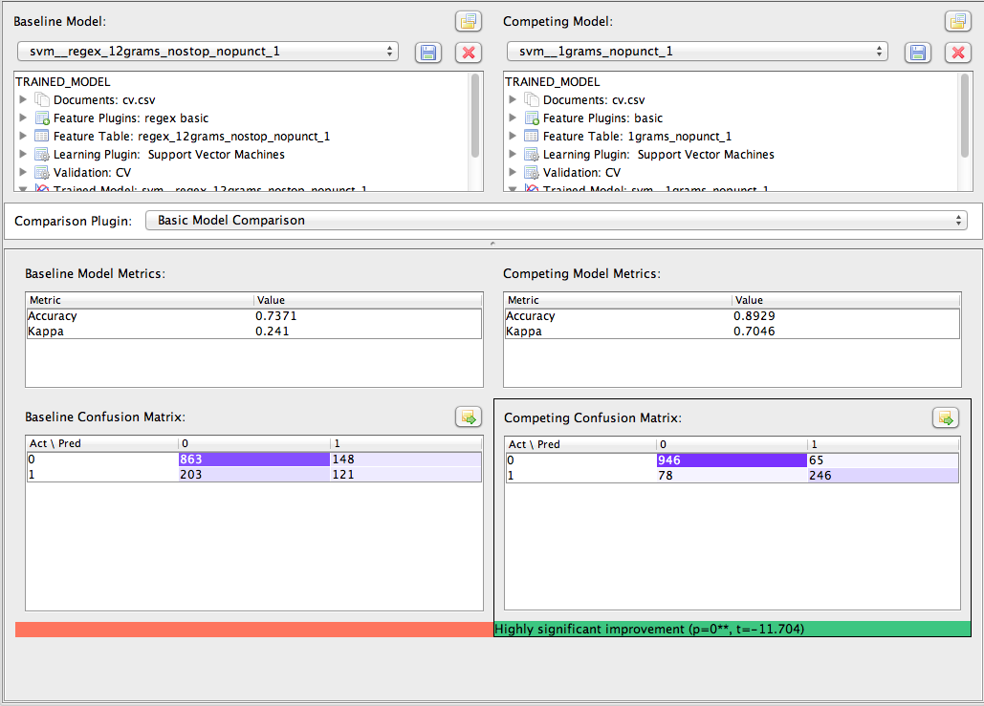
We could find that the model of Part C is better. Prediction with Metadata is better than predicting with text.
- Create a new feature space that combines the features from the two models you compared in Part D #1. Now evaluate its performance. How does the performance of the combined model compare with each of the other two? Is any difference you found statistically significant in either case.
Solution:
We could find the result here:
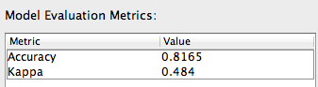
We could see that it is much better than the Part B model, and a little bit worse than the Part C model.
We can see that the Part D model is significant better than the Part B model, and Part C model is significant better than Part D Model.

- Extra Credit: For the model that worked best, why do you think its features worked better? Which ones were most important? What kinds of instances were classified differently by the three models, and why do you think they performed differently on those examples?
I think the last model feature should work better, because it contains all the well designed features, both the metadata feature and the text features. We know that Probabilistic models are better at Word Features than Linear model like SVM. SVM always performs best in those common used models.

