Part 2 for Mid-Term 2
Jingyuan Liu
jingyual
jingyual@andrew.cmu.edu

Answer the thought questions in Part 1 and save your answers to a .doc file. Then do the test of practical competence in Part 2 and place the answers to the questions for that in a separate .doc file. Bundle these files into a single zip file and turn them in to blackboard.

You should work independently. You will have 24 hours to complete this take-home mid-term, but it should really only take you approximately 2 hours altogether, which would be best accomplished in a single block of time. You can use your book, your notes, and anything you find on blackboard including the lecture slides, video lectures, answer keys, extra readings, etc., but you will not have the opportunity to ask questions of the instructor. However, you may contact the instructor for technical support if the software crashes or behaves unexpectedly.

Part 2: Test of Practical Competence

For the test of practical competence, you will tune a classifier for the diabetes dataset. You simply need to go through the mechanical process of doing the tuning. You should not use CVParameterSelection. You should tune two different algorithms. One of those algorithms will be JRIP where you tune minNo and Optimizations. The other algorithm you can choose yourself, although it must be an algorithm with at least one parameter that needs tuning. Your answers to the following questions must clearly demonstrate your understanding of the concepts we have discussed in class for the three stage tuning procedure. Note that you must demonstrate understanding of the 3 stages of tuning as we discussed them in class. It must be possible to verify that you have observed proper methodology. You need to show that you have done all three stages of the tuning process.

You will need to create your own train/test pairs using the remove folds filter as you have done in the past in the Evaluation unit. Please indicate in your write up whether you chose to use stratified or non-stratified and why. You should do a 5-fold cross validation.

- What did you choose as your second algorithm?
Solution:
I would choose the SVM (SMO) as the second algorithm.

- What is your baseline performance for each algorithm using default settings?
Solution:
For the JRIP algorithm, I would use minNo = 2, Optimization = 2 as default.
For the SVM algorithm, I would use C = 1, Exponential = 1 as default.

(3) Describe the tuning procedure (all three stages). Don’t forget to describe the thinking that goes into setting up the data for tuning as well as what settings you choose to tune and why.
Soultion:
We could use these two tables to record the tuning process results as following:
For JRIP
JRIP1 minNo=2 Optimization=2 | JRIP2 minNo=3 Optimization=3 | JRIP3 minNo=4 Optimization=4 | Optimal Setting | Test set performance
0.7595 | 0.7567 | 0.7528 | JRIP1 | 0.6803
0.7446 | 0.7475 | 0.7495 | JRIP3 | 0.7991
0.7382 | 0.7365 | 0.7389 | JRIP3 | 0.7228
0.7462 | 0.7446 | 0.7519 | JRIP3 | 0.6992
0.7395 | 0.7372 | 0.7408 | JRIP3 | 0.7292

For SVM
SVM1 C = 1  Exponential=1 | SVM2 C = 1.5  Exponential=1.5 | SVM3 C = 2  Exponential=2 | Optimal Setting | Test set performance
0.7782 | 0.7833 | 0.7926 | SVM3 | 0.67
0.7581 | 0.7606 | 0.7639 | SVM3 | 0.8160
0.7657 | 0.7662 | 0.7649 | SVM3 | 0.7559
0.7712 | 0.7756 | 0.7709 | SVM2 | 0.7631
0.7678 | 0.7774 | 0.7867 | SVM3 | 0.7380

Basically, the 3 stages are similar for the two different algorithms:
For Stage1, I would separate data into different folds, and change the parameter setting for the algorithms. Specifically, for JRIP, I would test the minNo=2, 3,4, and Optimization = 2,3,4; for SMO, I would test C=1,1.5,2, and Exponential = 1,1.5,2. Then I would run all the algorithms with different settings on each fold to see their performances.

For Stage2, I would build only 1 model, which is the model with settings of the best performances on each fold. For JRIP, I would see that in most cases JRIP3 would have the base performances, so I would use minNo=4 and Optimization=4 for JRIP. Similarly, I would use C=2 and Exponential=2 for SMO.

For Stage3, I would use the optimal chosen setting, which is the tuned model, on the test dataset to see its performances. This could be the estimate of the tuned model on unseen data.
(4) What is the final tuned performance for each algorithm?
Solution:
We could see the final tuned performances for each algorithm in Test set Performance column in the above tables.

(5) In either case, did the result come out significantly better than the baseline (explain how you made that determination and show a screen shot if possible)?
Solution:
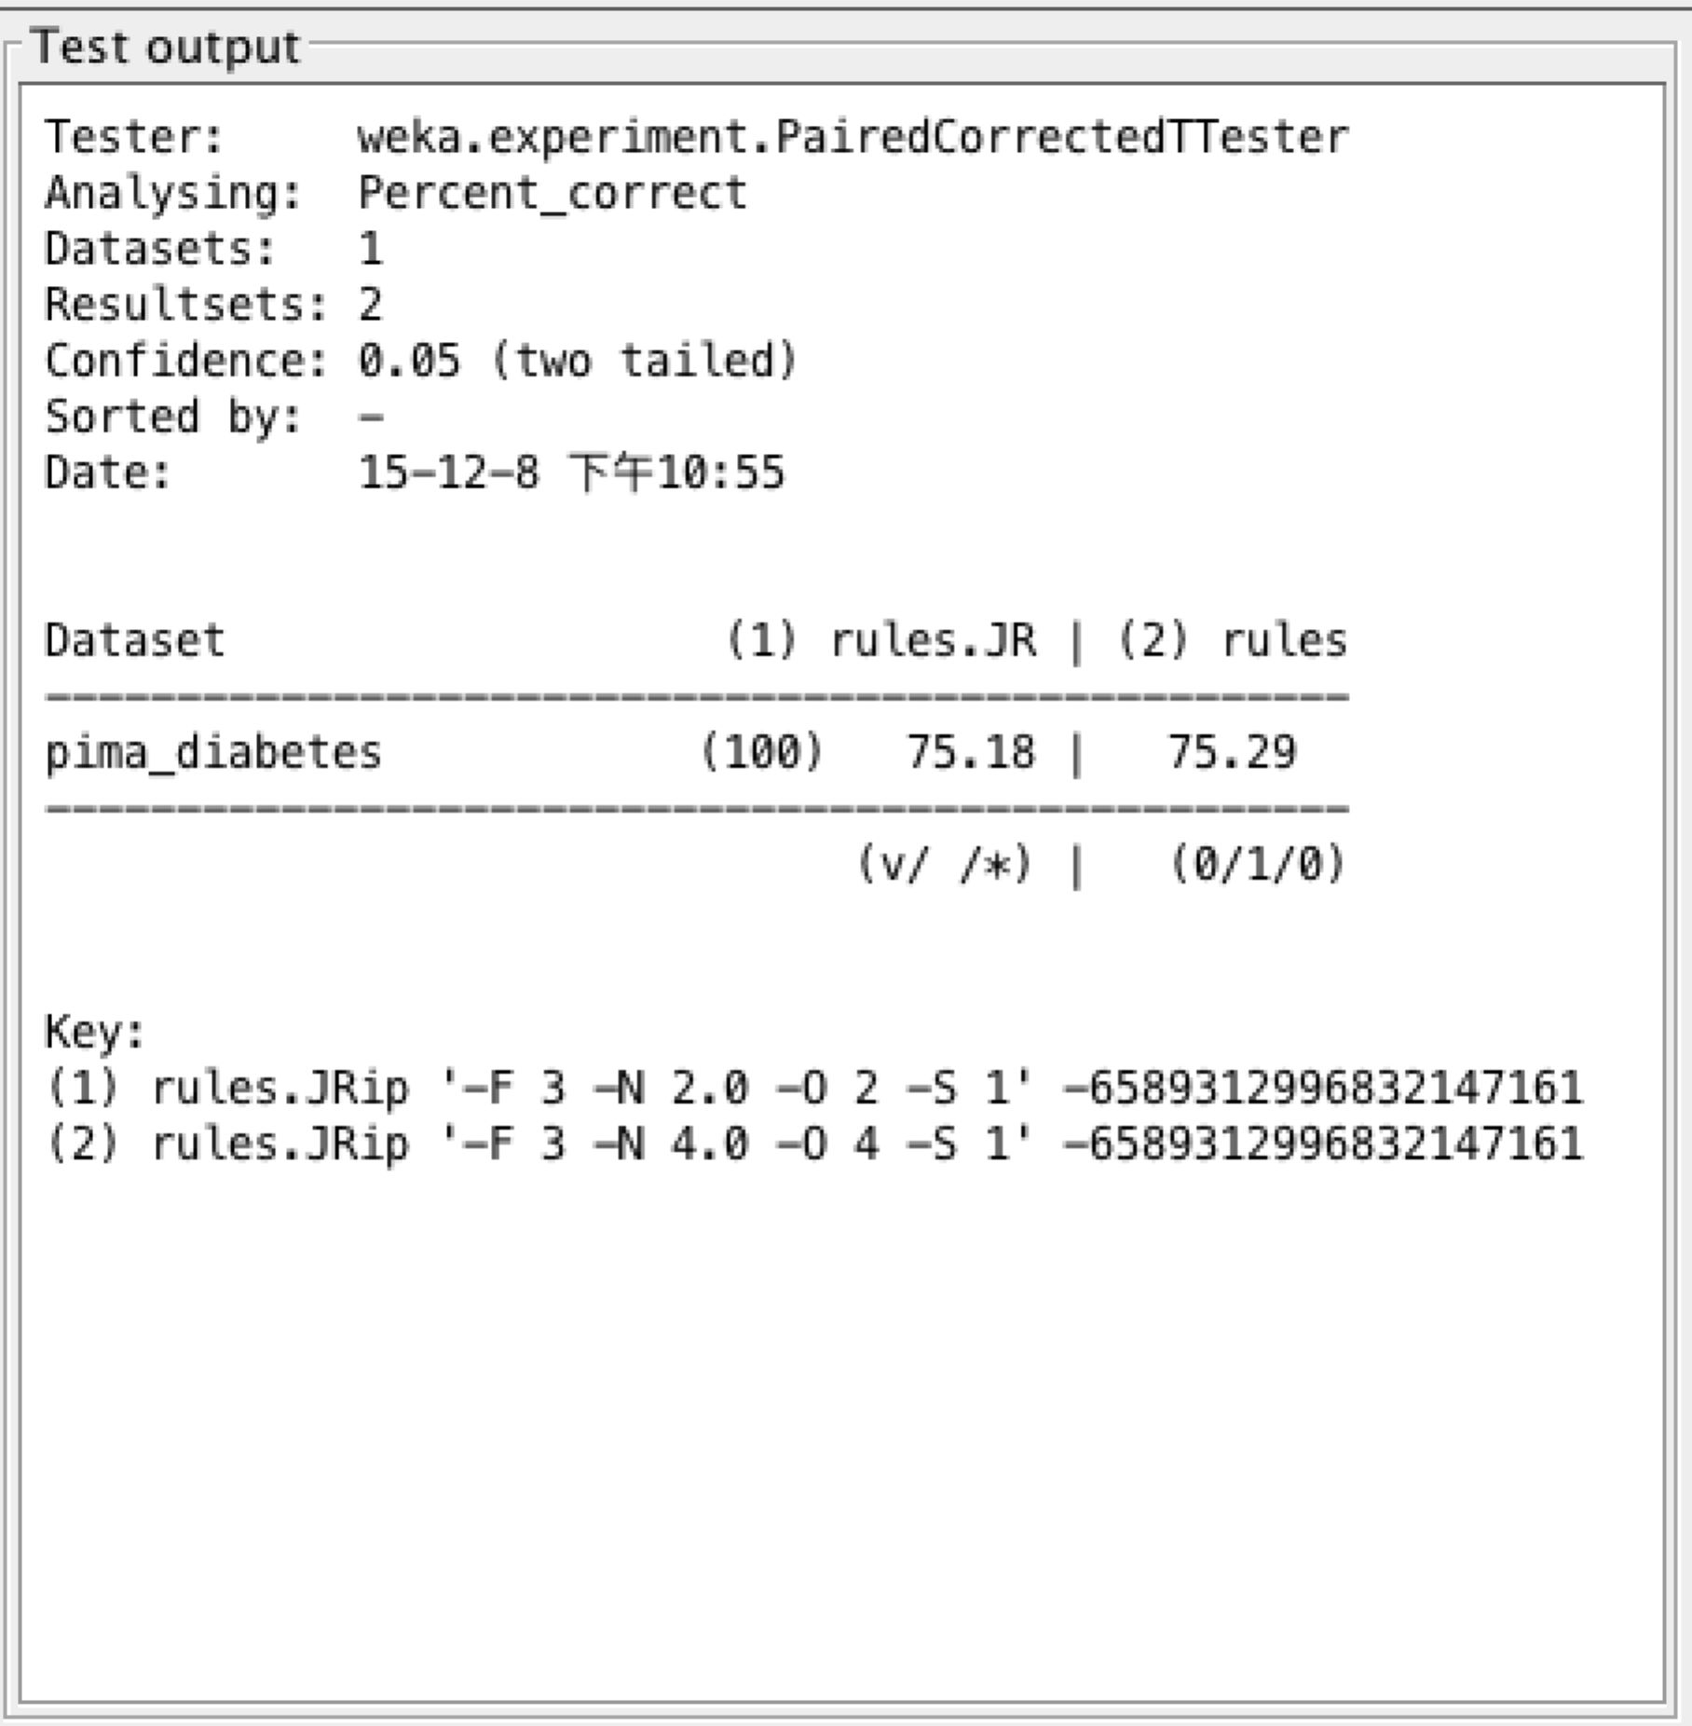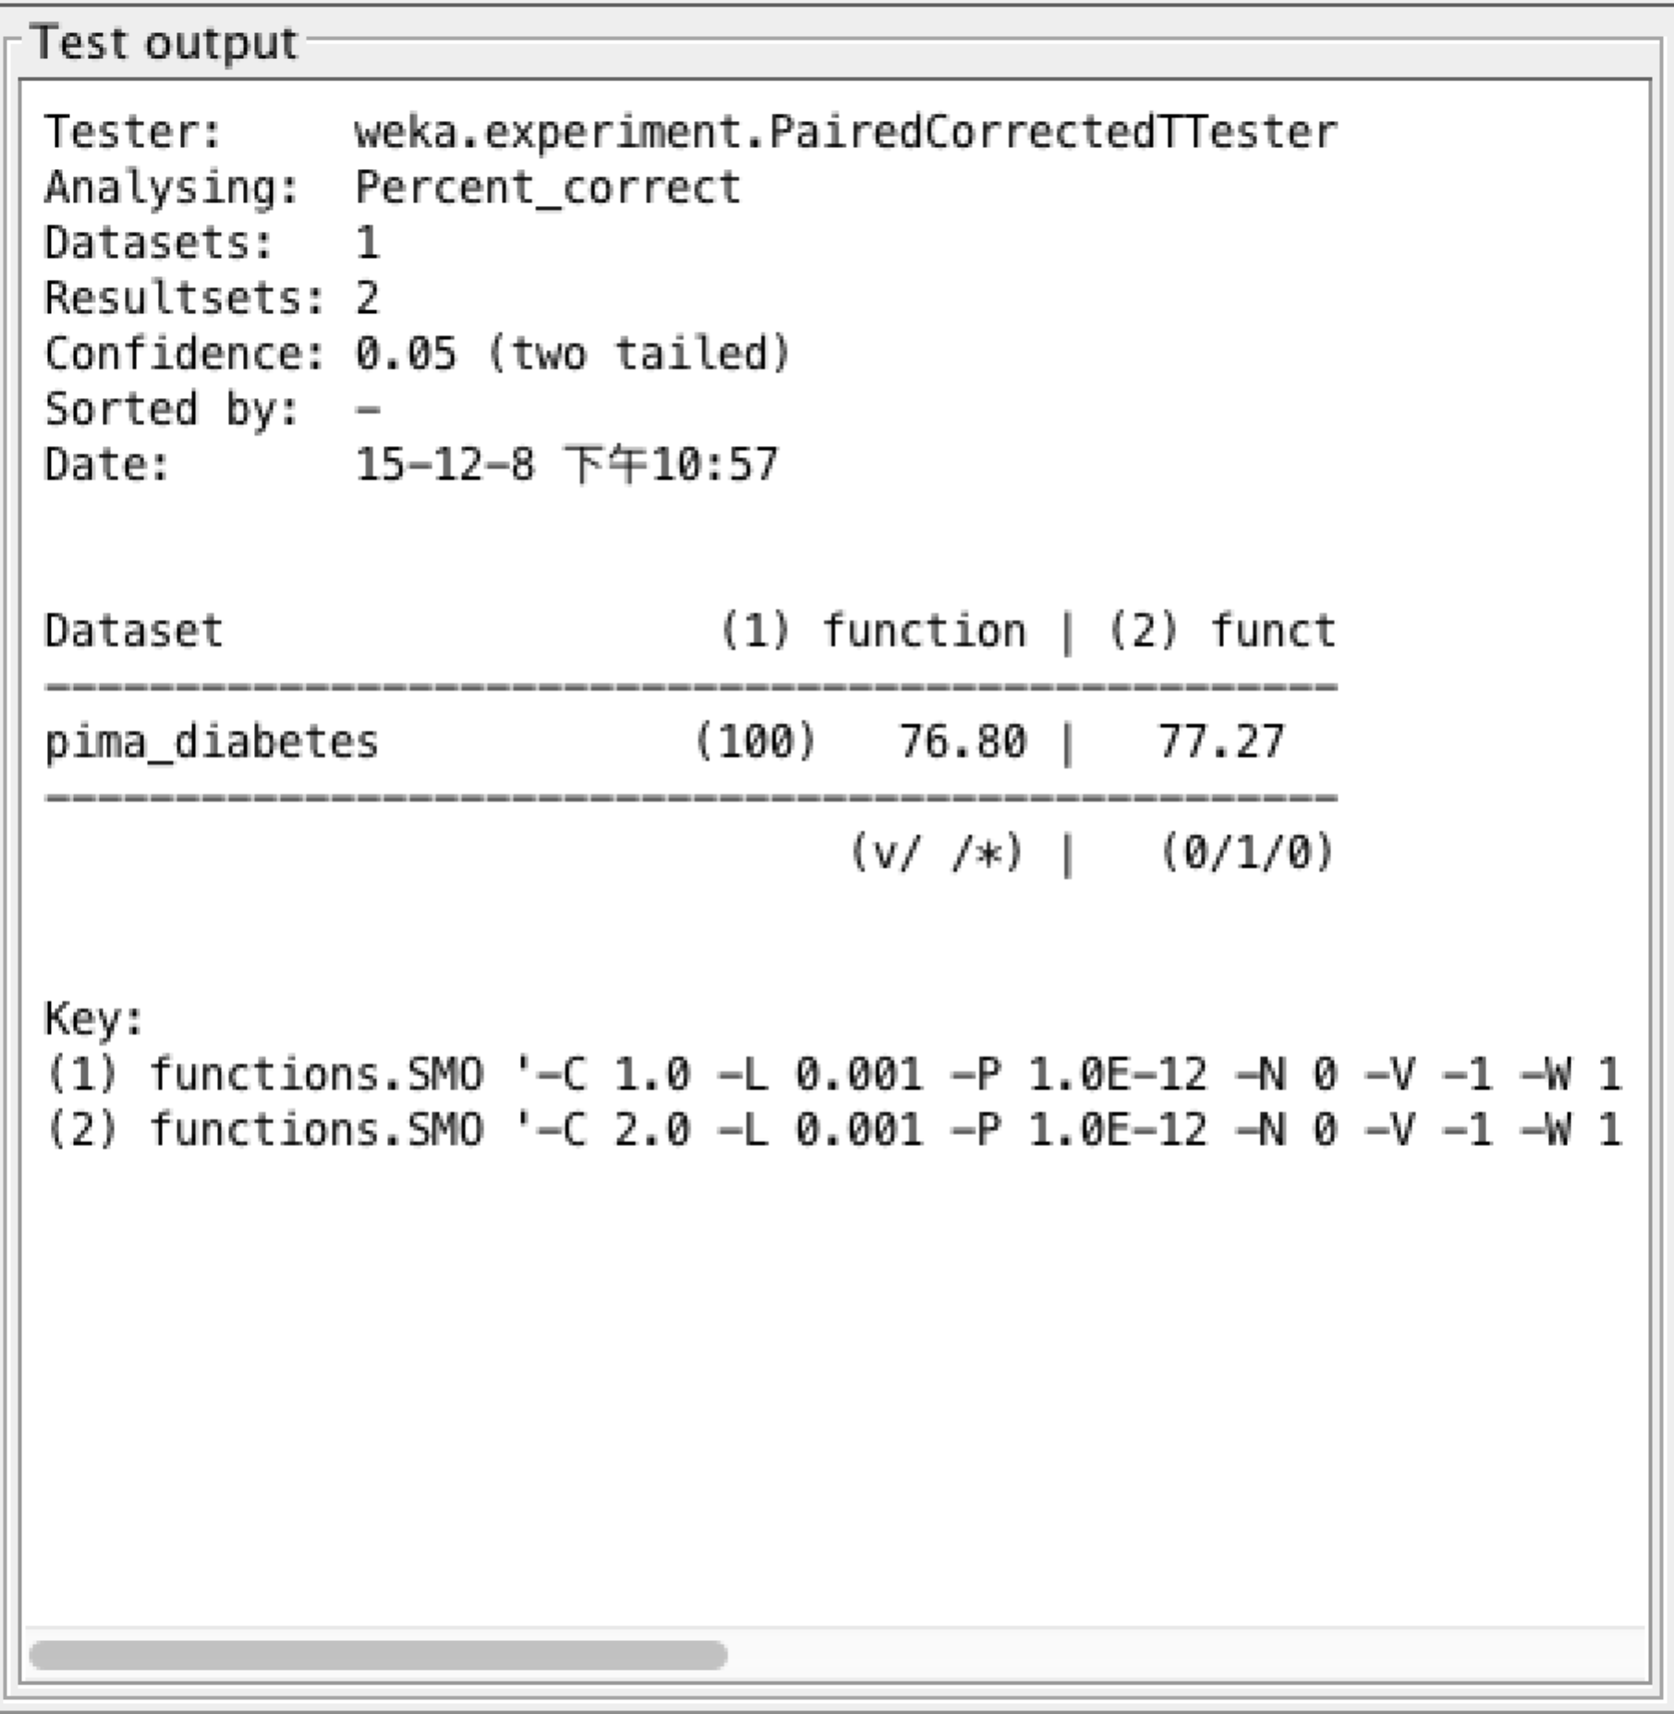

As we could from see from the above table, the performance of Tuned model of JRIP was very close the default setting of JRIP. It is slightly better but not significantly better than the baseline.

For the SMO, we could see that the Tuned model was significantly better than the baseline.

(6) And which approach would you pick to create the tuned model that you would use on unseen data, and explain how you made that decision as well as what you estimate would be that model’s performance on unseen data?
Solution:
I would use the Tuned Model of SMO with default setting of C = 2, and Exponential = 2 as the model to predict unseen data.

The reason is that the average performance from stage1 and stage3 was better than all other algorithms with different parameter settings. I would estimate the model performance with 0.77, which is the performance over all datasets.

