Assignment 6
Jingyuan Liu
jingyual@andrew.cmu.edu
Deliverables:

Question 3
The training result is as following:
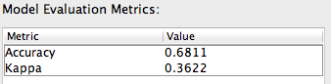

Figure 1. Cross-validation Data Model performances

Question 4
The training result is as following:

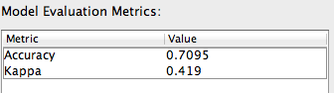
Figure 2. Development Data Model performances

Question 5
Using the comparing result from LightSide, we can navigate the features to see which feature would have comparatively “big” horizontal absolute difference and vertical absolute differences. The result is as follows:

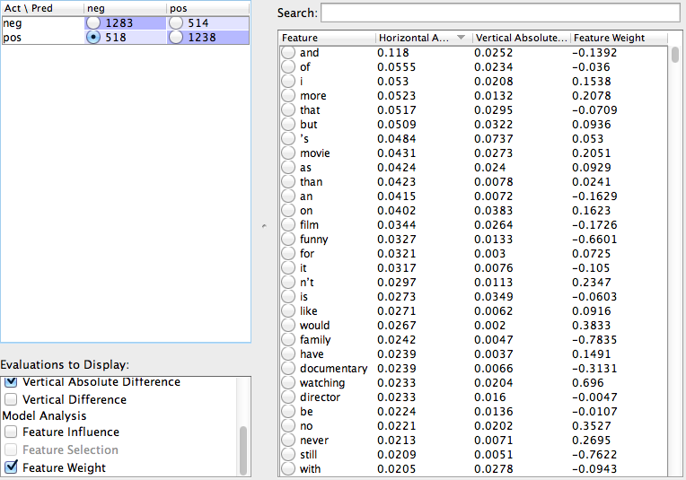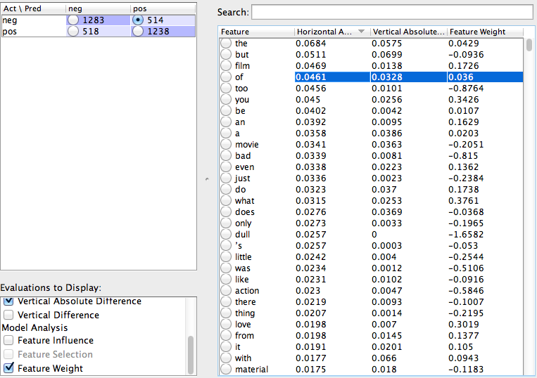
We can see from these two tables that the features, like “the”, “but”, and “of” are problematic features. These features are the “stop-words” which appeared a lot but do not have significant meanings.

Question 6
I would propose two features:
- Removing stop words from input dataset
- Bigram features

These two features should be better than current features.
- It removed stop words, thus would not be influenced by the problematic features.
- Bigram features would contain more information than unigram features.

Question 7
The training result based on the new features:

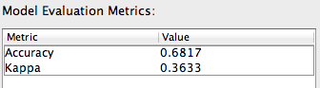
Figure 3. Cross-validation Data Model performances based on new features

We can it is slightly better than the past model

Question 8
The improvement is insignificant with p = 0.949

