Assignment 9

Learning Objectives:

- Practice doing optimization.

Description:
The data set you will be working with for this assignment is the CPU dataset that comes with Weka. The purpose of this assignment is to practice doing optimization. You can use the same train/test pairs included with the assignment.

Step-by-Step Guide:

You should optimize two different algorithms. One of those algorithms will be locally weighted learning (LWL) with Linear Regression as the base classifier. The other one you can choose yourself, although it must be a numeric prediction algorithm, and it must be an algorithm with at least one parameter that needs tuning. Your answers to the following questions must clearly demonstrate your understanding of the concepts we have discussed in class. It must be possible to verify that you have observed proper methodology.

(1) What is your baseline performance for each algorithm using default settings?

I picked M5P as my alternative algorithm and computed the baseline performance using default settings in a cross validation over the whole set. I evaluated the performance using the correlation coefficient, which is labeled as R.

LWL baseline R=.99
M5P baseline R=.98

(2) For each algorithm, describe your optimization procedure and results using the prompts below as a guide.

First, here are some screen shots:

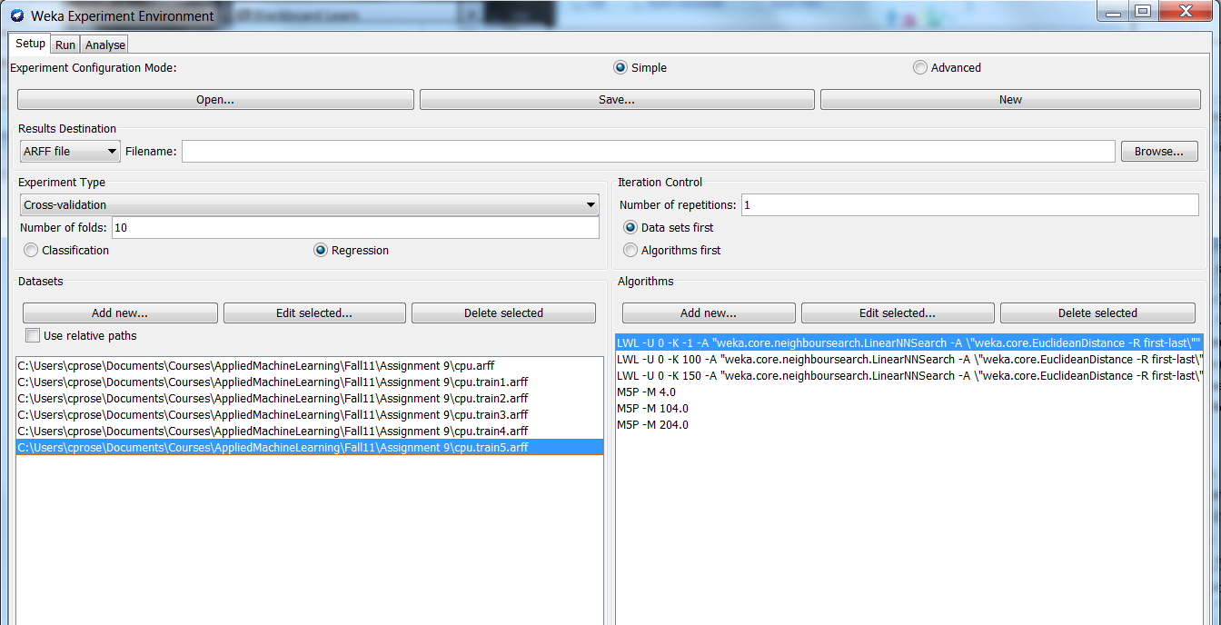

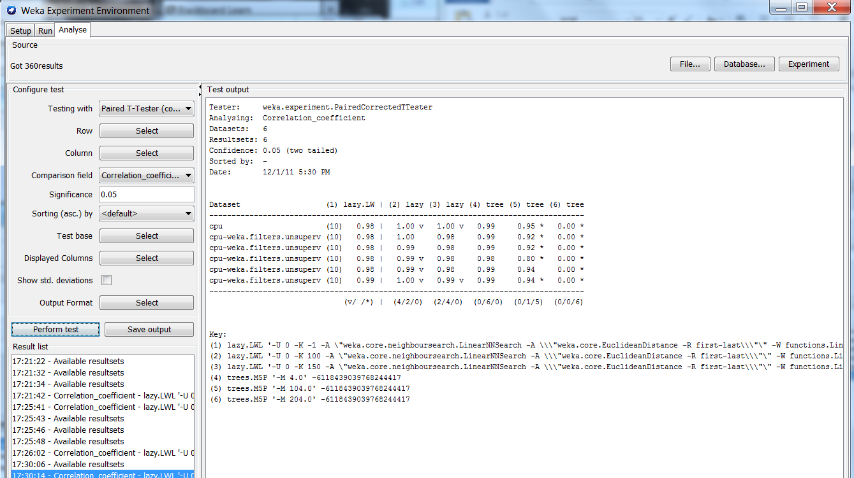

Algorithm 1:
Stage 1: What setting did you determine you would use to build your model and why?

For LWL I picked the number of instances within a neighborhood as the parameter to tune. Default is to select all. I tried 100 and 150 as alternatives because it seemed like a big enough neighborhood to compute a reasonable regression model, and yet it benefits from being specific to the neighborhood around the target instance. Based on the cross validation results over the whole set of data, I would pick a neighborhood of 100 since it was the highest ranking option.

Stage 3: What do you estimate will be that model’s performance on a new set of data?

LWL (k = -1) | LWL (k = 100) | LWL (k = 150) | Optimal Setting | Test set performance
.98 | 1.0 | .99 | 100 | .99
.98 | .99 | .99 | 100 | .99
.98 | .99 | .98 | 100 | 1.0
.98 | .99 | .99 | 100 | 1.0
.99 | 1.0 | .99 | 100 | .93
Average = .98

Algorithm 2:
Stage 1: What setting did you determine you would use to build your model and why?

For M5P I picked the minimum number of instances at a leaf node to vary. I tried default, which is 4, and in addition tried 104 and 204. 204 turned out to be too big, and so the models turned out degenerate and gave 0 correlations. The default setting was always the best.

Stage 3: What do you estimate will be that model’s performance on a new set of data?

M5P (M = 4) | M5P (M = 104) | M5P (M = 204) | Optimal Setting | Test set performance
.99 | .92 | 0 | 4 | .99
.99 | .92 | 0 | 4 | .77
.98 | .80 | 0 | 4 | .98
.99 | .94 | 0 | 4 | .98
.99 | .94 | 0 | 4 | .86
Average = .92

(3) Based on your results, was it worth it to do the optimization? Or should you just use default settings? How did you make that determination?

In the case of M5P, the default was picked on every fold, so in that case, I don’t have any evidence that doing optimization was worth it.

In the case of LWL, on every fold I picked 100 as k. Since I made the same decision on every fold, then I can do the significance test between the optimized performance estimate and the baseline using the experimenter, attending to the row corresponding to the whole dataset (Otherwise I would need to note the test set performance for default setting in the Explorer on each fold so I could do the t-test in excel or R or Matlab). And I see that 100 as k is significantly better than the default. So in this case, it was indeed worth doing the optimization (If the difference was not significant, I would need to conclude that it was not worth it, and I would just stick with default settings for building the model that I would use). Note that the reason why the cross validation over the whole set in the experimenter came out differently than the cross validation with the train/test pairs is because the train/test pairs were created using the unsupervised remove folds filter.

Deliverables: Your write up for the questions above.

