Machine Learning in Practice / Applied Machine Learning
Week 7 Quiz

Note that these questions may require some creative problem solving! Don’t expect to simply be able to recall the answer from the readings.

Name:________________________________________

- Match the following activities [a-f] with the following kinds of data [1-3] by drawing lines:

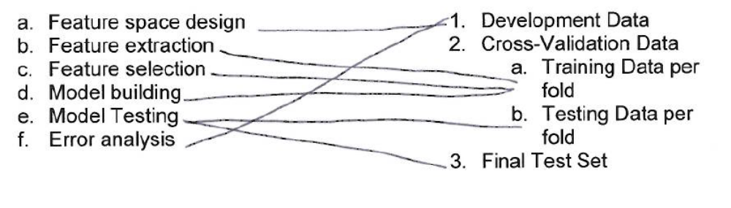

2. What is one potential advantage and one potential disadvantage of including trigrams as a type of feature for classification along with unigrams (in comparison with a baseline of just using unigrams)?

Trigrams have the advantage of giving some limited context around a word, which offers the possibility to partly disambiguate between different usages of a word. However, it comes at the cost of a huge increase in the size of the feature space. In general, there are many more unique trigrams in a corpus than unigrams. They will also be correspondingly more sparse. So then unless the corpus is very large, it’s likely that a model would not be able to benefit from the added specificity of the features.

