Assignment 2 Report

Anton Sitkovets

**Step 1**

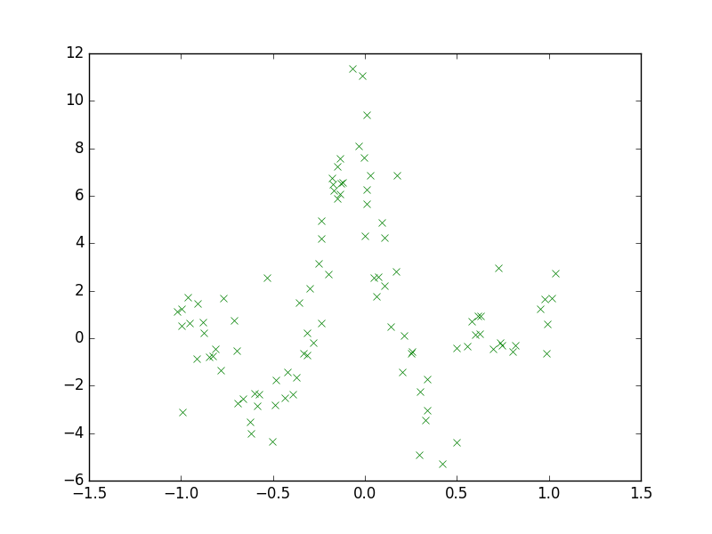

**Step 2**

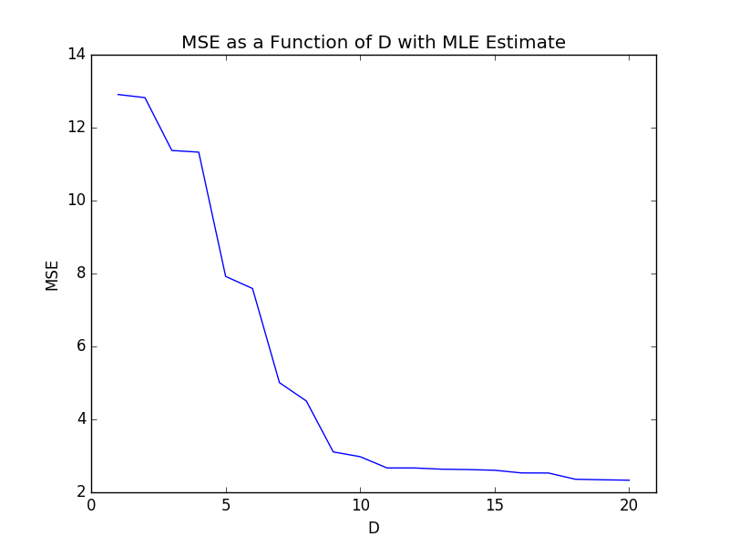

Based on the values we can see that when D = 20 gives the best result as it has the smallest error when comparing the predicted values to the actual values. Although the data shows that this is the best value, I would say that using a polynomial of (20 – 1) = 19, to be very complicated and could potentially cause overfitting. As discussed in class, a good way to avoid overfitting is to use simpler basis functions, so I think the best bet would be to use D = 11 to 16.

**Step 3**

