Ain Shams University

Faculty of Engineering

Computer & Systems dep.

May 2018



**User Guide**

**Team members:**

|  |  |
| --- | --- |
| Group (27) | |
| Peter Rateb Mamlouk | **33757** |
| Beshoy Anwar Malak | **33758** |
| Boula Nashaat Thabet | **33779** |
| Menna't-Allah Mohamed Abdallah | **33907** |
| Mina Mourice Mohareb | **33915** |

**Contents:**

|  |  |
| --- | --- |
| **Used languages** | **3** |
| **How to run** | **4** |
| **Registration** | **5** |
| **Login** | **6** |
| **Quick Start** | **7** |
| **How to start a session as administrator** | **11** |
| **Added Features** | **12** |
| **Some test cases for added features** | **13** |

**Used languages :**

* **Python 3 with Kivy framework.**



**Some expressions:**

* **Dock 🡪 Profile.**
* **Sea 🡪 Group.**
* **Ship 🡪 Post, Comment or reply.**

1. **How to run :**

* Open a power shell session in the same directory as the source files
* Run “python3 frontend.py”

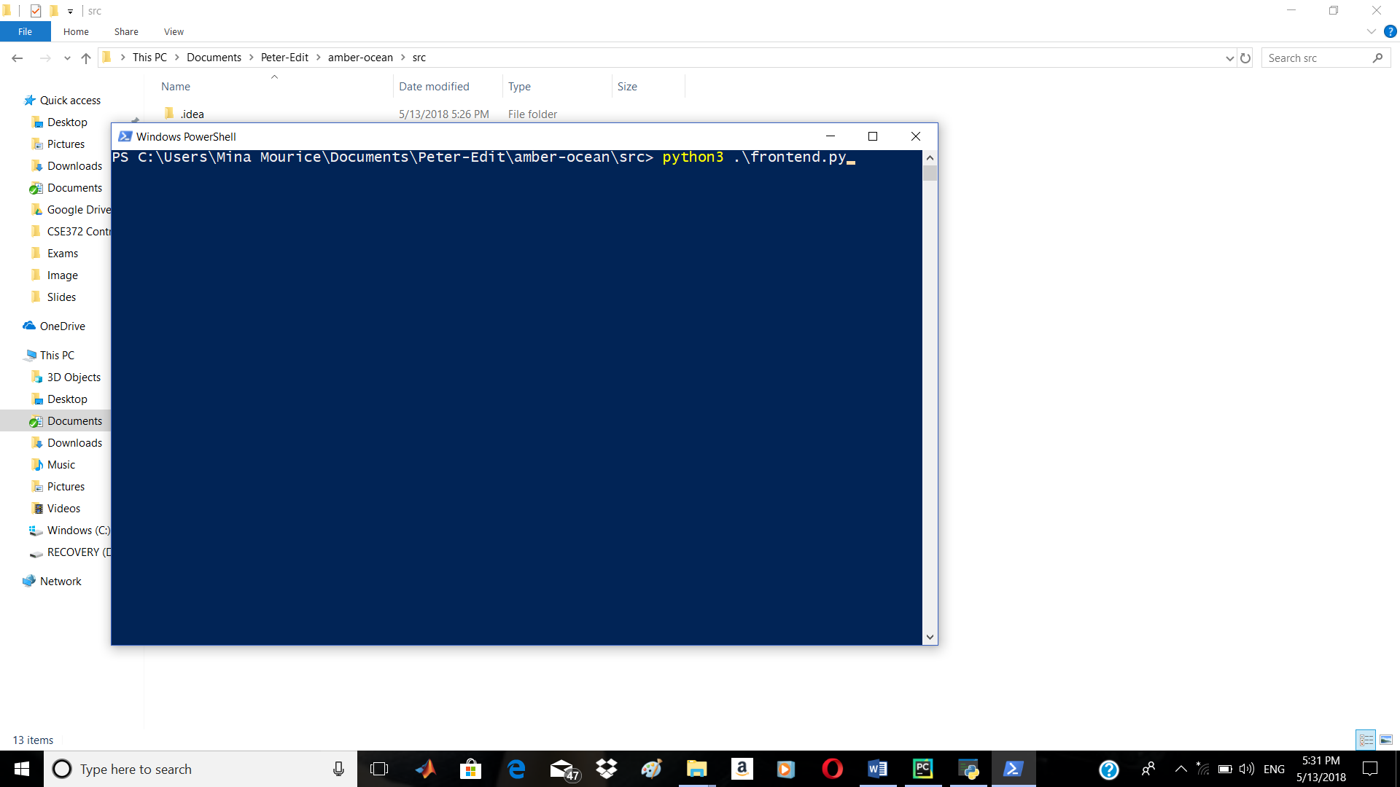

1. **Registration:**

* The login page will open

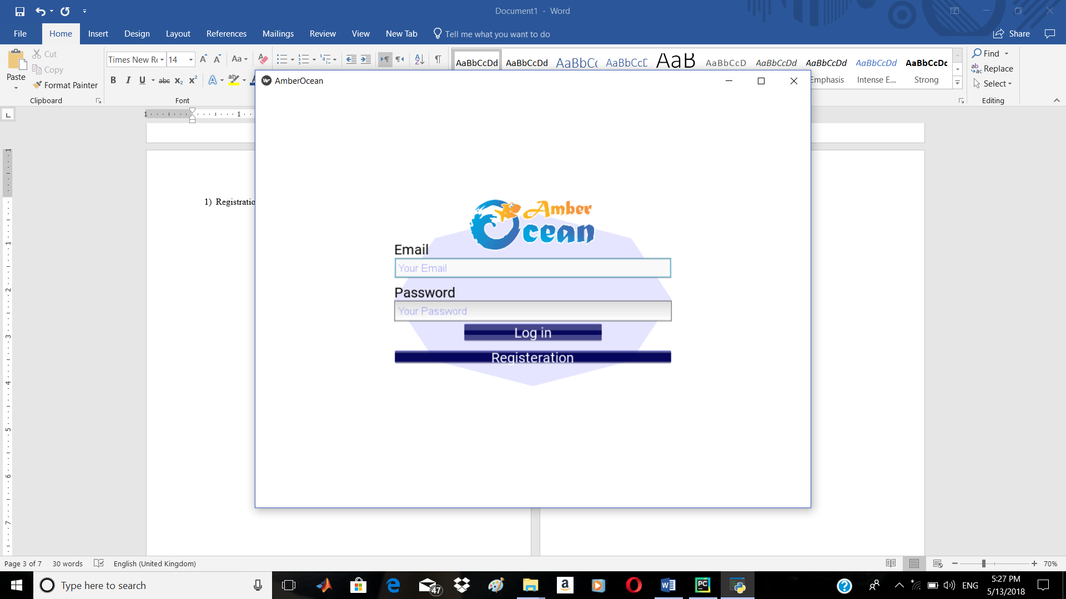

* Register if you new user , fill your data and press submit

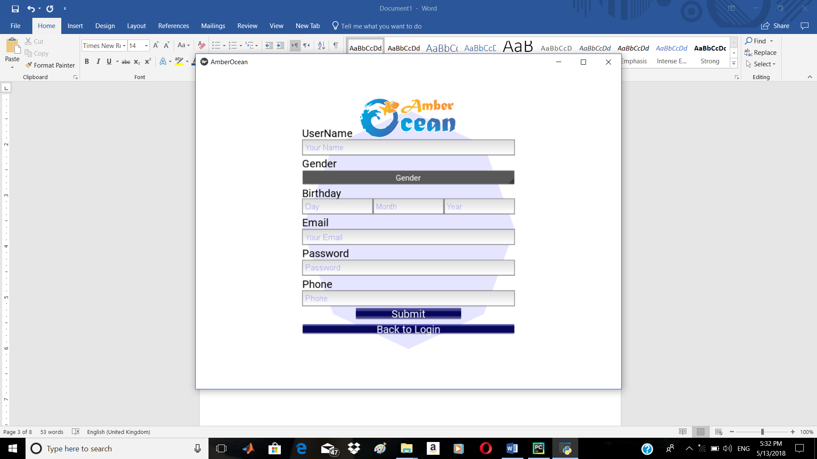

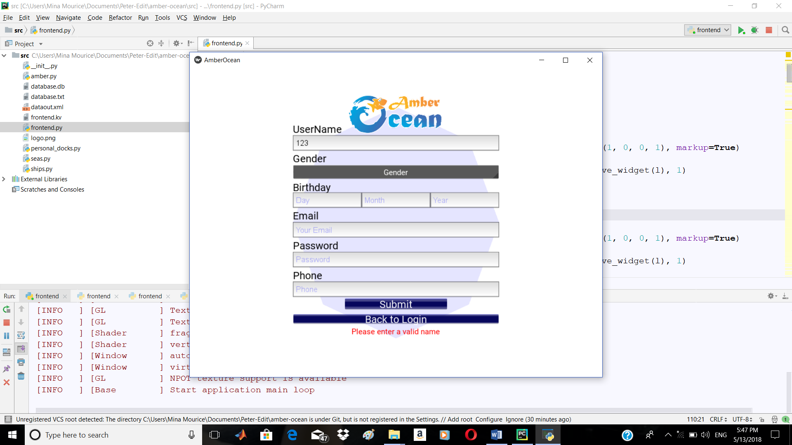“Hint: you must write valid data”

1. **Login:**

* Login with your registered Master Email and your password.



* Press login , your home page will be appeared.

1. **Quick Start:**
2. Home page:

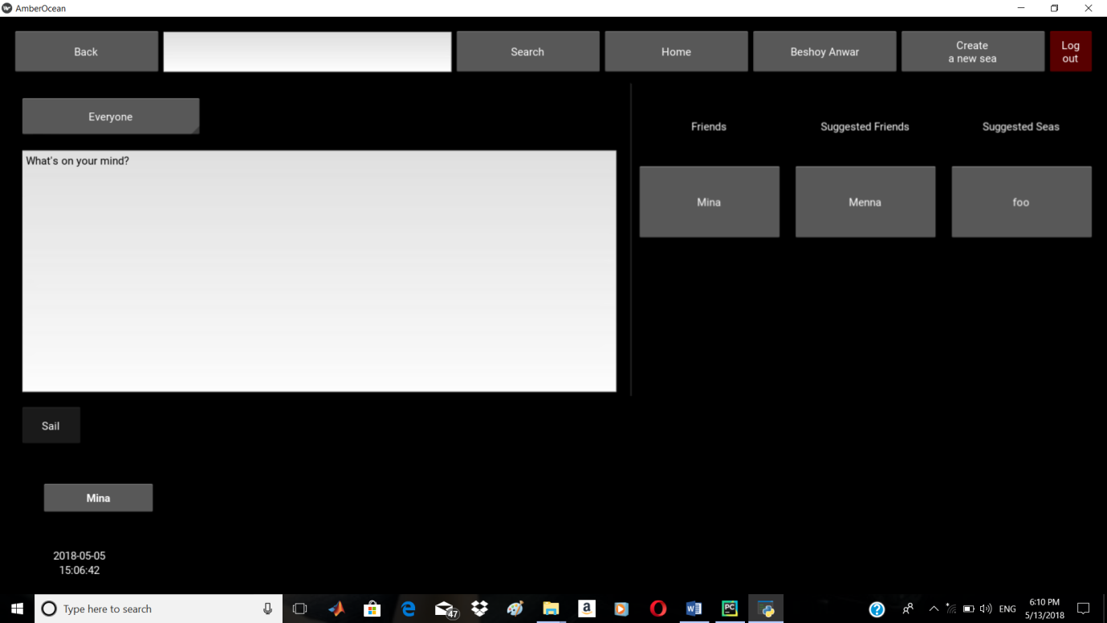

8

1

2

7

4

6

5

3

1. Search textbox : write an email of a dock or sea name to search.
2. Ship textbox : write the body of your ship.
3. Home : press to return to your home page
4. Personal dock: open your personal dock.
5. Create new sea : press to create new sea.
6. Logout : press to end your session
7. Social section : contains your friends , followees , joined seas , suggested friends and suggested seas if any is found.
8. 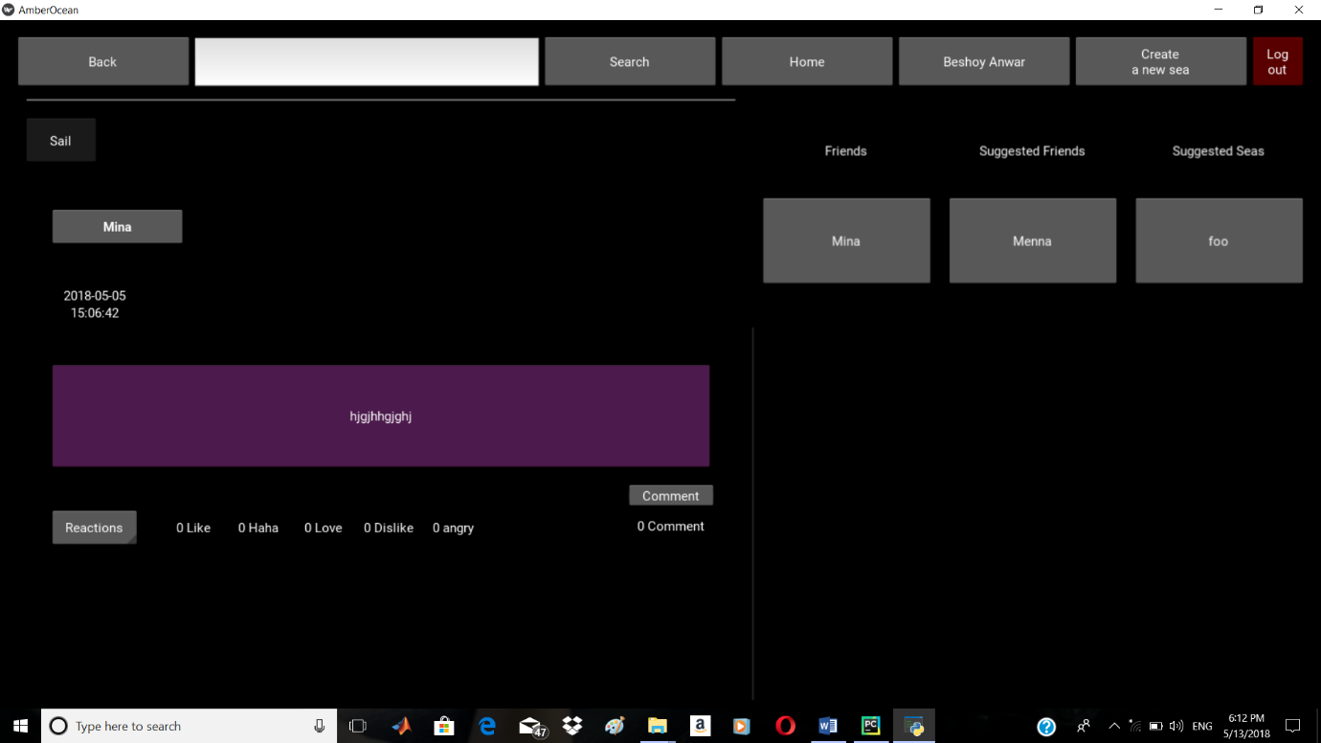news feed : include sailed ships of your friends and seas.

8

“you can comment and give an reaction”

1. Personal Dock:

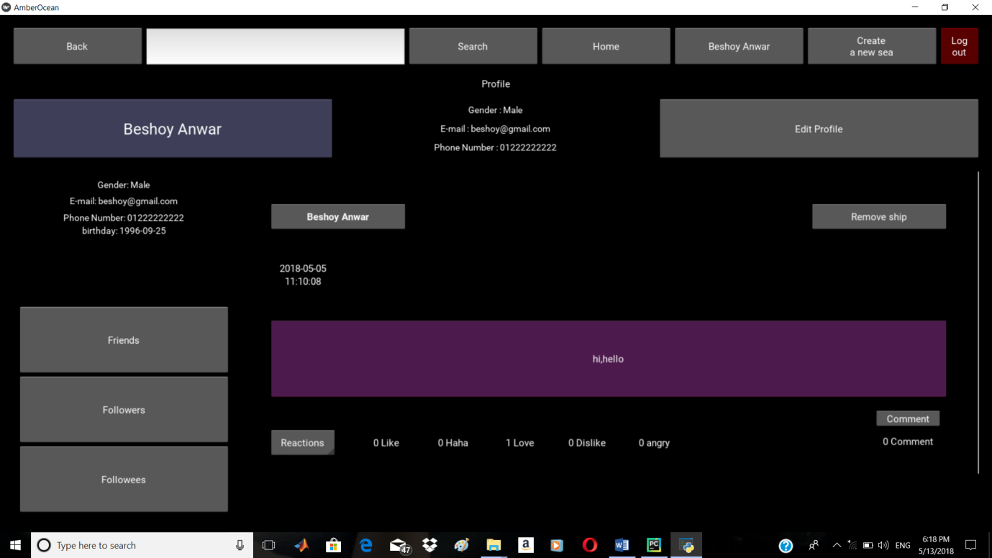

3

2

1

1. 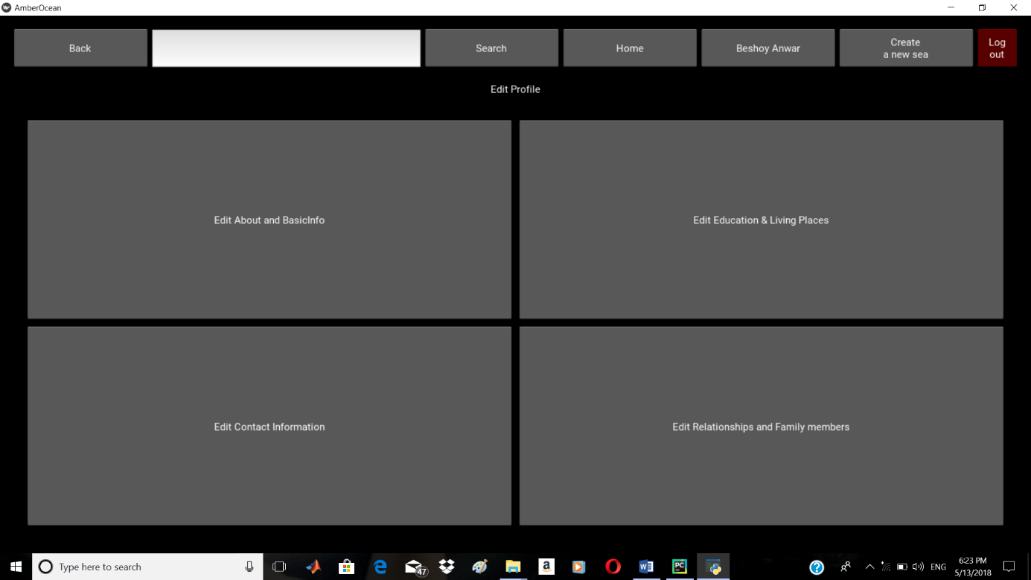Edit Profile: press to edit, add or remove your personal data.

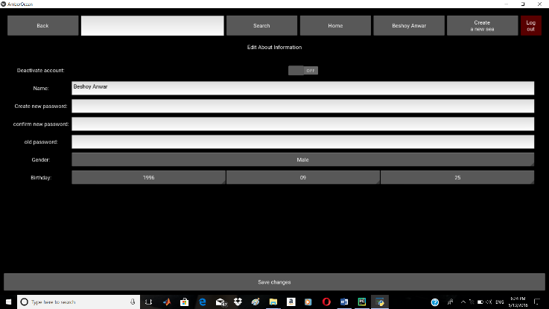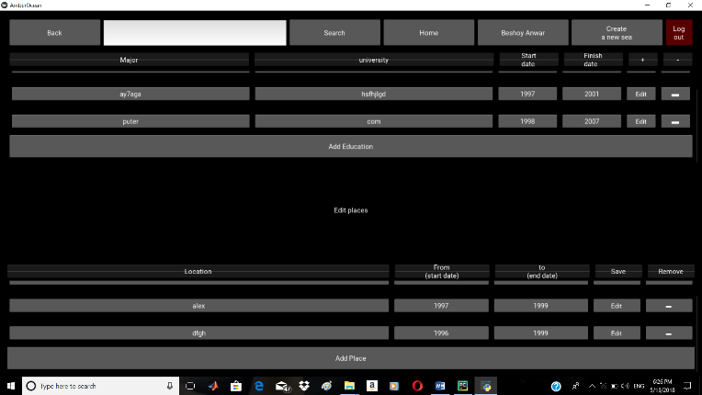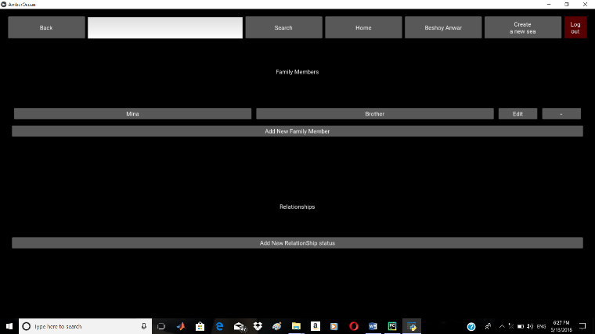

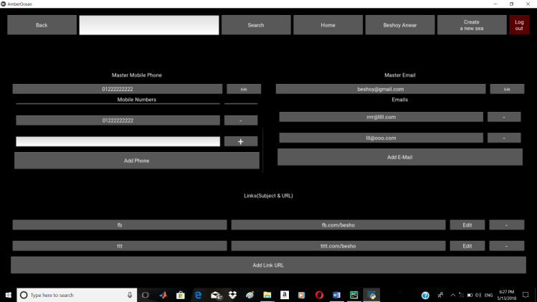

1. Social section: contains friends, followers and followees pages links.
2. Personal sailed ships : your previous sailed ships.
3. Seas:

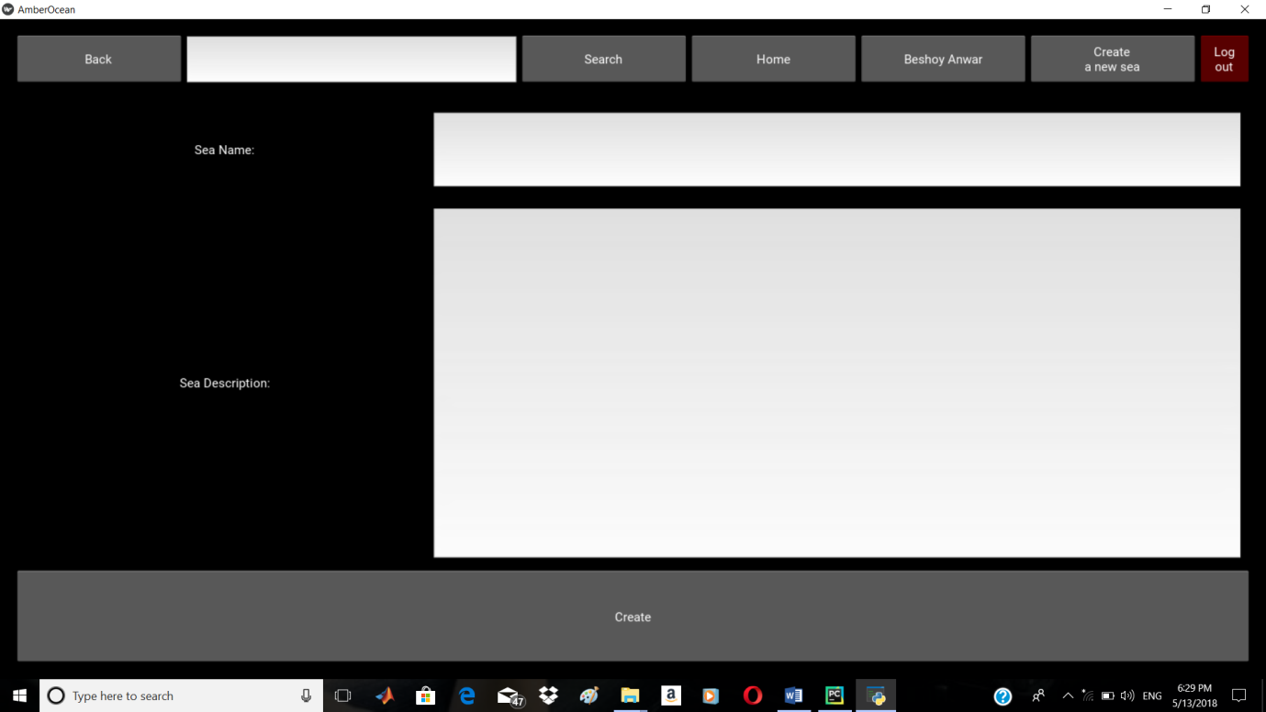

1

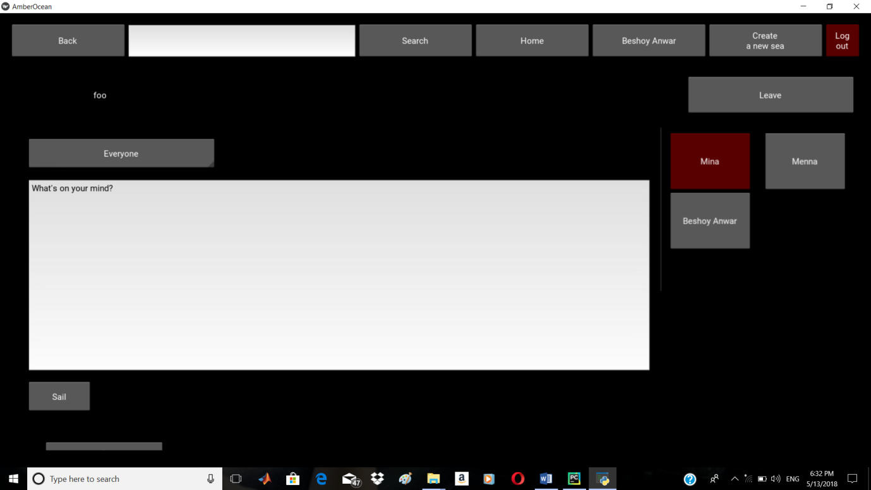

2

3

1. Sea data : enter new sea name and description.
2. Sea sailed ships : can sail new ship and contains sailed ships.
3. Sea members : contains the members of the sea “the admin with red colour”
4. **How to start a session as administrator:**

* Open powershell window in the same directory as the code source files.
* Run “python frontend.py admin”.
* Write the admin password “default: admin”.
* Write any of the following functions to execute it.

**print_members_have_max_friends**

**print_members_have_max_followers**  
**print_members_have_max_ships**  
**print_ship_have_max_reactions_for_each_member  
print_ship_have_max_comments_for_each_member  
print_seas_have_max_members**  
**print_seas_have_max_ships**  
**print_ship_have_max_reactions_for_each_sea  
print_ship_have_max_comments_for_each_sea**

**database**

**export id**

**#id is object unique id, file will be found in the same path of project.**

**import objecttype xmlfilepath**

**#objecttype can be personaldock, ship or sea.**

**#xmlfilepath is the path of file import from.**

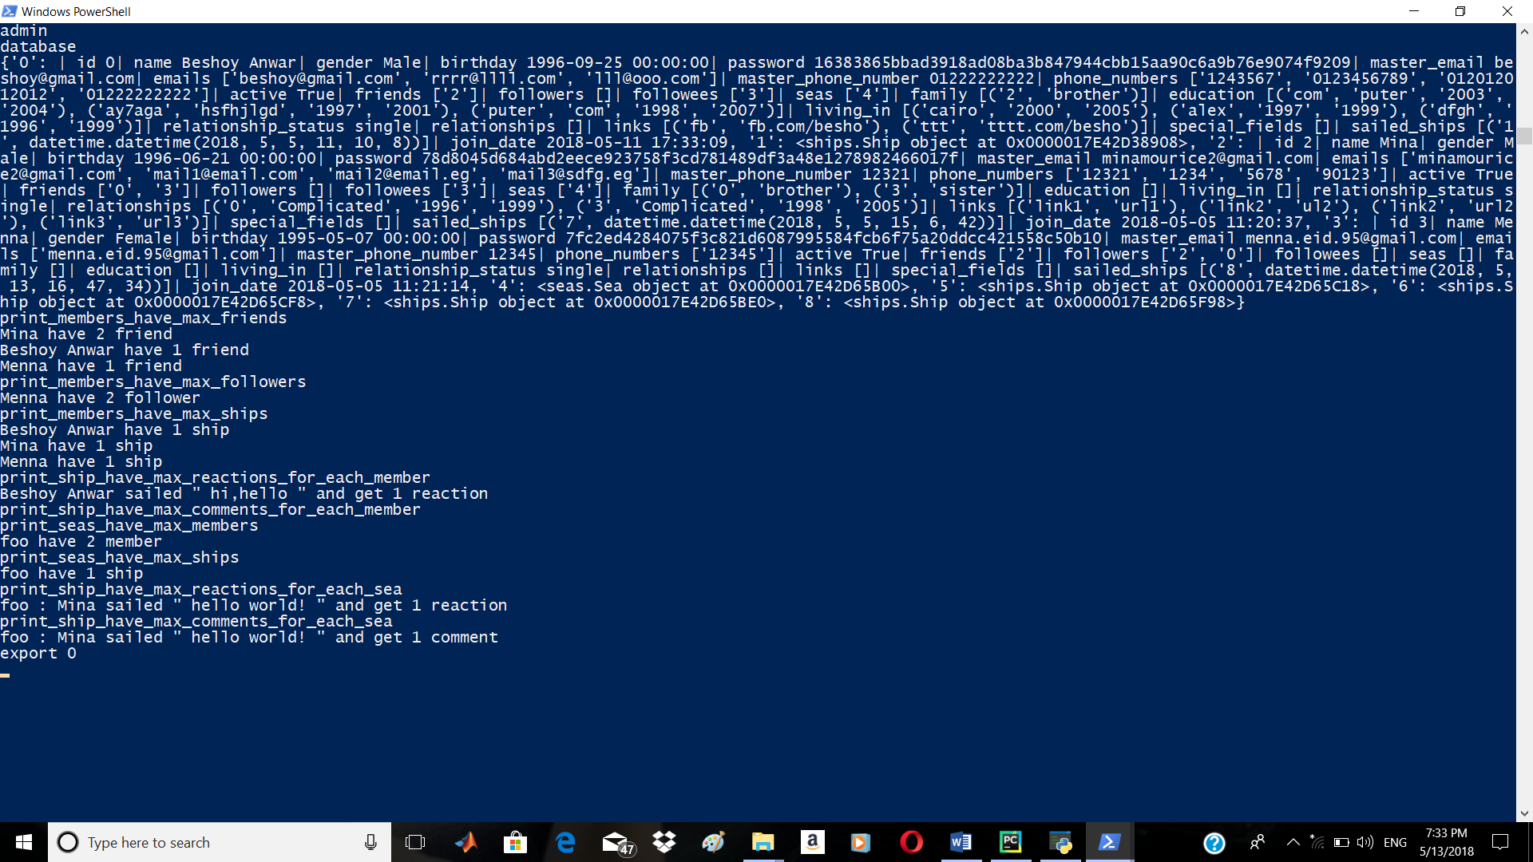

**6)Added Features:**

1-added two functions to print the influence members in seas-which have max friends/followers

**print_members_have_max_friends_per_sea**

**print_members_have_max_followers_per_sea**

2-visualize the data out from the previous algorithms with plotting it in charts

**members_have_max_friends**

**members_have_max_followers**

**members_have_max_ships**

**ship_have_max_reactions_for_each_member**

**ship_have_max_comments_for_each_member**

**seas_have_max_members**

**seas_have_max_ships**

**ship_have_max_reactions_for_each_sea**

**ship_have_max_comments_for_each_sea**

3-modify the friends graph to be a weighted one

any edge between two members has a value = 50- common friends between those two members

4-Implementation of dijkstra algorithm and use it to calculate the shortest path between two members

**shortest_path sourceId destinationId**

**note: if no path between the source and the destination, ”NO path” message will appeared**

**7)Some test cases for added features:**

**-shortest_path test**

