**Mount C Drive to docker toolbox step by step guide.**

**3 Steps:**

**A.) Mount Windows C drive to VirtualBox file.**

**B.) Mount Docker Container to VirtualBox file.**

**C.) Verify successful mount (see this for result)**

**A.) Mount Windows C drive to VirtualBox file.**

1

Search Oracle VM and open it.

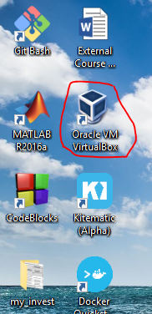

2

Click Settings -> Shared Folders

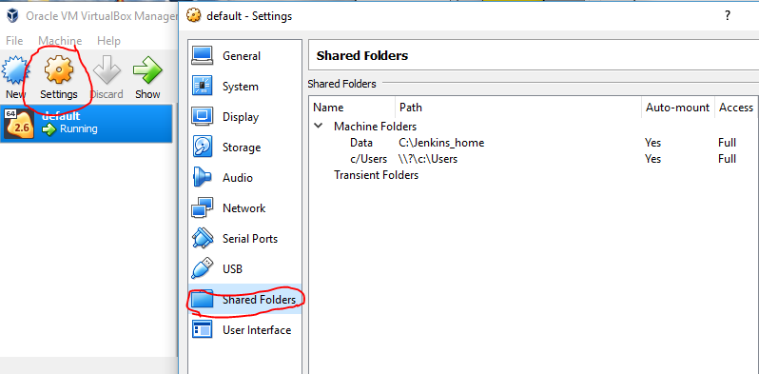

3

To share folder from host (windows) to guest (virtualbox)

a.) Folder Path and Name is decide by user, for my case:

Folder Path: C:\Jenkins_home

Folder Name: Data

b.) Check Auto-mount and Make Permanent.

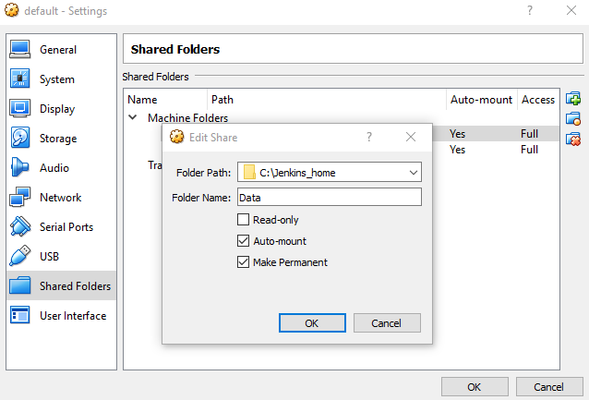

3

Right Click on red circle -> Close -> Power Off

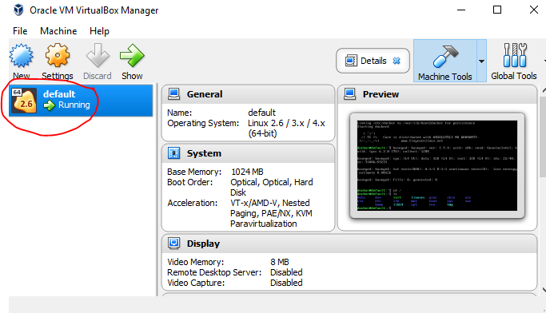

4

After power off -> right click than start-

Booting will take some time. If success , kernel will shown as follow.

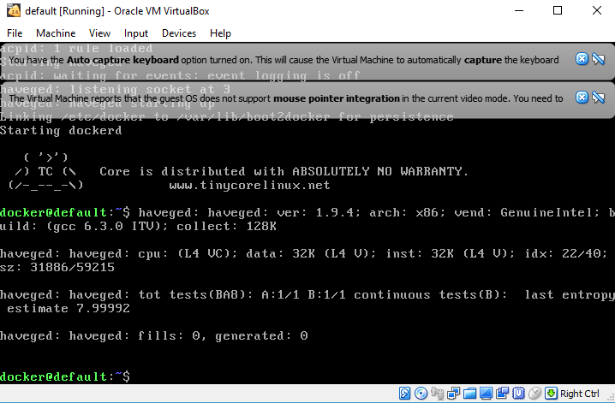

5

Change directory to root

cd /

list all directories

ls

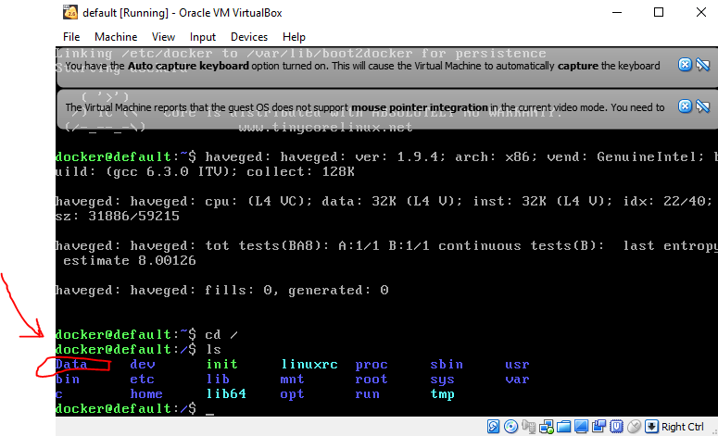

Data folder is successfully created in root.

**B.) Mount Docker Container to VirtualBox file.**

Please specify your own

<virtualbox dir>

<container dir>

<image>

In command as follows:

docker run -it --mount src=/<virtualbox dir>,target=/<container dir>,type=bind <image>

my case:



Explaination: this command mount /Data in Vbox to the newly created var/database in container together

**C.) Verify successful mount**

I add docss and ngrok folder in C:/Jenkins_home

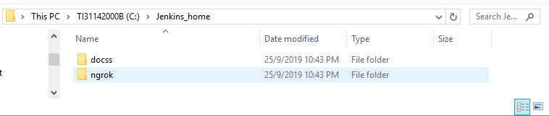

If you see the corresponding folder in /var/database , you are successful too!

You will float tool! : )

