
pROJECT MILESTONE 1
SEN 381

September 17, 2026

FREERK VAN DEN BOS 602074
PAUL EDWARD VAN ZYL 601731
REGARDT OSLER 601626
GitHub Repo
Contents
Problem Statement & business need 1
Stakeholder analysis 1
Scope baseline 1
In scope 1
Request submission & tracking 1
Staff assignment and status management 2
Management reporting & oversight 2
Access control 2
Out of scope 2
Deferred / future scope 2
Exclusion defence 3
Requirements & acceptance criteria 3
Functional Requirements (FRs) 3
Non-Functional Requirements (NFRs): 6
Acceptance criteria: 8
Constraints 10
Scope constraint 10
Schedule constraint 10
Cost/Resources constraint 10
Quality constraint 10
Security Constraint 10
Trade-off 10
Initial RTM 10
Example of an end-to-end trace: 11
Initial risk register 12
Forward engineering considerations 14
ASR’s & quality drivers 15
NFR-002 (Performance: staff list view response time) 15
NFR-003 (Security: data in transit/credentials, nothing sensitive in repo) 15
NFR-005 (Auditability: immutable action log) 15
NFR-007 (Scalability: data model/queries hold up as volume grows) 16
NFR-008 (Compliance/Data Handling: role-gated sensitive data) 16
Architecture diagrams 16
Justifications 17
Why not a standard monolith 17
Why not microservices 17
Why modular monolith 17
Architecture diagram 18
Architecture vs. technology, logical modules vs. physical deployment tiers 18
Architecture Decision Record(ADR) 19
Decision ID: ADR-001 19
Decision ID: ADR-002 20
Data and persistence baseline 21
Data Entities, Relationships and Ownership 21
Foreign key structure 21
Lifecycle implications 21
ERD diagram 22
Persistence model classification 22
Structure and relationships 22
Access patterns 23
Integrity and consistency 23
Sensitivity 23
Expected growth 23
Conclusion 23
A2-Informed Transaction and Validation Strategy 24
Database-Level SPOF, Scalability, Availability and Backup/Recovery 24
Scalability 25
Availability 25
Backup/recovery 25
Engineering decision log 25
Decision ID: DEC-001 25
Decision ID: DEC-002 26
Decision ID: DEC-003 27
References 28
AI usage Register 28
Sign off 29

Problem Statement & business need
The current problem is that various types of service requests are currently handled using different un-optimal methods, this causes many problems, including but not limited to lost or duplicated records. Thus, a significant need for a functioning system exists.
The organisation needs a managed digital platform that provides a reliable, traceable and usable way to submit, manage, monitor and report on various service requests. The solution must increase visibility and accountability whilst maintaining a sustainable technical, operational and financial impact.

Stakeholder analysis
From the scenario we can identify 3 stakeholders namely requesters, staff & management.
Stakeholder | Needs | Influence | Interest | Conflicts
Requester | Submit a request easily and get status updates. | Low | High | Frequent updates conflicts with staff’s need to avoid update overhead
Staff | Fast acknowledgment, possible escalation path, discretion for sensitive reports,  clear work assignment, | Medium | High | Wants minimal mandatory fields, conflicts with managers need for granular reporting
Management | Reliable, auditable, information on work | High | Medium | Wants detailed reporting, conflicts with Staff’s need for lightweight logging
Lecturer | Good work that follows the project baseline and relative milestone requirements. | High | High | None at present.

Scope baseline

In scope

Request submission & tracking
- Requesters can submit a new service request with category, description, and relevant details
- Requesters can categorise a request using a controlled (fixed) category list
- Requesters can view status of their own submitted requests
- Requesters can view a history/list of their previously submitted requests
- Requesters receive automated notification when a request is accepted, rejected, updated, or completed (in-app/email — not SMS)

Staff assignment and status management
- Staff can view requests relevant to their authorised role
- Staff can search, filter, and sort requests (by status, category, date, etc.)
- Staff can view full request details
- Staff can assign or accept responsibility for a request
- Staff can update request status through defined, controlled transitions (e.g. New → Assigned → In Progress → Resolved → Closed)
- Staff can record comments/actions/resolution notes against a request
- Staff can resolve or close requests where authorised

Management reporting & oversight
- Management can view service activity summaries (open/overdue/resolved/closed counts)
- Management can filter/view requests by category, status, and other basic dimensions
- Management has access to enough information to support basic accountability and performance review

Access control
- Basic role-based access control separating Requester/Staff/Management views

Out of scope
- SMS/push notifications- excluded on cost grounds. SMS gateway pricing carries per-segment charges plus recurring monthly number-rental fees regardless of volume tier (Twilio, 2026), making it an ongoing operational cost incompatible with the project's free/low-cost constraint.
- Native mobile application- excluded on schedule and team-capability grounds. Native development typically costs two to four times more than an equivalent web product and requires separate platform-specific codebases, increasing both build time and team learning curve beyond what the milestone schedule allows (MayaLogic, 2026).
- Multi-language support- excluded on schedule grounds
- Advanced analytics/BI dashboards — excluded as beyond core business need for this project.

Deferred / future scope
- SLA-based auto-escalation of overdue requests
- Integration with external helpdesk systems
- Fine-grained, configurable category management

Exclusion defence
SMS notifications were excluded because they require a paid gateway service to run, this directly conflicts with the constraint that free tools must be used to create the system. An in-app and email notification must satisfy the same underlying requester need “I know my request was not lost”, without introducing a recurring cost or an external service dependency.

Requirements & acceptance criteria

Functional Requirements (FRs)
Each FR below maps to exactly one of the three capability groups in the SEN381 Master Brief document under section 3 namely Requester, Staff and Management and a cross-cutting access control requirement. This access control requirement exists because sections 4 and 16 of the same master brief document treats security as a lifecycle-wide constraint and not just as an afterthought and because a request-management platform handling potentially sensitive information cannot be meaningfully evaluated without knowing who is allowed to view or act on each FR below.
The question, “Does the platform lose its core value proposition without this?” was used to determine priorities. It is necessary for a requester, staff or manager to have everything they need to finish the basic request lifecycle namely submit --> assign --> action --> resolve --> report. Filtering, overdue flagging and grouping are examples of convenience features that enhance the experience but are not essential. The team could still present a functional platform without these, but they provide significant stakeholder value at a low cost.
ID | Requirement | Source/ Stakeholder | Priority
FR-001 | When a requester submits a new service, the system must at least record the category, description, location and requester’s contact information. | Requester | Must
FR-002 | The system should require the requester to choose a category from a predetermined, controlled list. | Requester | Must
FR-003 | A requester should be able to see the status of every request they have submitted through the system. | Requester | Must
FR-004 | A requester should be able to view a list or history of all the requests they have made in the past. | Requester | Must
FR-005 | When a request is approved, denied, amended or finished the system must alert the requester or provide them with other relevant feedback. | Requester | Must
FR-006 | Only authenticated, authorised users should be able to read and respond to service requests in accordance with their roles. | Security Constraint | Must
FR-007 | The system should permit authorised staff to access service requests that are specific to them. | Staff | Must
FR-008 | Staff should be able to search, filter or arrange requests using practical criteria. | Staff | Should
FR-009 | The system should enable staff to see every element of a particular request, including the requester’s submitted information and the requester’s action history. | Staff | Must
FR-010 | The system will should enable staff to either take responsibility for a request or allocate it to themselves or another permitted staff member. | Staff | Must
FR-011 | Only a limited number of legitimate transactions should let staff change a request’s status. | Staff | Must
FR-012 | Staff members should be able to document actions, remarks or resolution notes in response to a request using the system. | Staff | Must
FR-013 | Authorised staff should be able to close or resolve a request through the system. | Staff | Must
FR-014 | Managers should be able to view aggregate service activity data across requests. | Manager | Must
FR-015 | Based on a predetermined age/SLA threshold, the system should enable managers to identify past-due requests. | Manager | Should
FR-016 | Managers should be able to view requests filtered or aggregated by category, status or other appropriate parameters. | Manager | Should
FR-017 | In order to facilitate accountability and service-performance analysis, the system should give managers sufficient request-level and aggregated data. | Manager | Should

Non-Functional Requirements (NFRs):
Even though this milestone is not yet permitted to make architectural and construction decisions, milestones 1 discreetly begins to restrict those decisions in NFRs (section 5, Explicit Milestone 1 Boundaries, Master Brief document). Each of the NFRs listed below can be traced either directly to a specific pain point in the business requirements or to an explicit restriction in the Master Brief (section 4).
All the NFRs in this section are constructed so that they may eventually be proven true or false using evidence rather than claims.
ID | Category | Requirement | Source/ Stakeholder | Priority
NFR-001 | Usability | A valid service request can be submitted by a first-time requester without outside assistance. | Requester/ business need | Must
NFR-002 | Performance | Under typica demand, the request list view must return results to staff within a predetermined response time. | Constraint | Should
NFR-003 | Security | No sensitive information is kept in the repository, all request data in transit and saved credentials must be secured using industry-standard techniques. | Constraint | Must
NFR-004 | Availability | Requesters and staff should be able to access the system during scheduled business hours and aby scheduled outages should be announced. | Business need | Should
NFR-005 | Auditability | Every staff action and status change on a request must be recorded, along with the person who made the change and when. This history must not be able to be edited. | Traceability/ business need | Must
NFR-006 | Maintainability | For a new team member to find the request-submission, staff-action and reporting logic within a reasonable review, the codebase must adhere to a consistent, defined structure. | Constraint | Could
NFR-007 | Scalability | As the volume of requests exceed the initial testing dataset, the data model and queries must be made to continue to be functional. | Constraint/ business need | Should
NFR-008 | Compliance/ Data Handling | In accordance with FR-006, only authorised roles may view private or sensitive requester data. | Constraint/ business need | Must

Acceptance criteria:
ID | Acceptance Criteria
FR-001 | A new request is created with a unique reference number and an initial status of “Submitted” when a requester who is logged in completes all the required information and presses submit. Submission is blocked with a field-level error message when required fields are missing.
FR-002 | A request cannot be submitted without selecting a category from the approved list because the category field is a constrained selector rather than free text.
FR-003 | The status is shown when a requester reads a particular request they own and it corresponds to the most recent status noted by staff.
FR-004 | When a requester logs in, a list of all their own requests, each with a reference number, category, submission date and status is displayed, requests from other requesters are not.
FR-005 | When a staff member modifies the status of a request, the requester can see the change within a predetermined window of time, and the feedback details they changed.
FR-006 | When a user without staff privileges tries to access management or staff views or actions, access is refused. Only request and actions relevant to that role are accessible if the staff login is genuine.
FR-007 | When a staff member logs in, they can see a list of requests that are relevant to their role or queue, leaving out requests that are not authorised.
FR-008 | Only requests that match are shown when a staff member applies a filter.
FR-009 | All submitted fields and a chronological action/ status history are shown when a staff member opens a request.
FR-010 | When a staff member assigns or accepts an unassigned request, the action is timestamped and assigned to that staff member, and the request’s “owner” filed is updated.
FR-011 | When a staff member tries and invalid transaction given a request in a specific status, the system stops them, legitimate transactions are successful and are recorded with a timestamp and staff ID.
FR-012 | When a staff member adds a comment or resolution note, it is recorded, timestamped, assigned to that staff member and displayed in the history of the request.
FR-013 | When a staff member marks a request as “Resolved” or “Closed”, the system updated appropriately, the change is recorded and the requester can view the updated status (see FR-005).
FR-014 | Counts of requests by status are shown and match the underlying request data when a manager examines the oversight dashboard ore report.
FR-015 | A request is marked as “overdue” in the management view if it has stayed in an open status for longer than the specified timeframe.
FR-016 | The view only displays requests that match that dimension with accurate counts if a manager applies a grouping or filter.
FR-017 | The responding staff member and timestamps for significant status changes are visible and exportable when a manager reviews a request or report.
NFR-001 | A first-time user completes and sends a legitimate request on their own during a usability test, and they can describe what happens next.
NFR-002 | Throughout multiple test runs, the measured page-load/ query time for a staff request list remains within the predetermined threshold, the threshold and test conditions are recorded.
NFR-003 | Passwords are not kept in plaintext, the repository scan reveals no committed credentials, secure login are used.
NFR-004 | The uptime/availability strategy is recorded and every outage that occurs during demo or testing phase is noted along with the reason.
NFR-005 | There is no UI path to update previous history entities, instead viewing a request’s history displays and unchangeable, timestamped, attributed log of all status changes and actions.
NFR-006 | Within a predetermined amount of time, a walkthrough by someone other than the original creators finds the three areas (see NFR-006’s requirement in NFR table) using just the repository structure and documents.
NFR-007 | A simple load test with a larger dataset in a later milestone verifies that there are no fixed-size assumptions after reviewing the schema and queries.
NFR-008 | At no point in the user interface or API answers are other requesters or unauthenticated users able to see or access a requester’s contact information.

Constraints

Scope constraint
Scope must be baselined and controlled once agreed. Any feature proposed after baseline must go through a formal change-request and impact-analysis process, not be silently added to work in progress.

Schedule constraint
The project must progress through 4 fixed milestones, each with its own presentation/defence date, with no flexibility to shift work across milestones after the fact.

Cost/Resources constraint
The team must prefer free or low-cost services where practical and must identify the limitations of those services rather than assume "free" carries and no trade-off.

Quality constraint
Quality attributes must be defined early and later supported by measurable evidence, not asserted after implementation.

Security Constraint
Security is a lifecycle-wide responsibility. Security-relevant decisions such as which stakeholders can see which requests must be identified at the foundation stage, before architecture or technology choices are made.

Trade-off
Preferring free-tier hosting limits which security protections are available by default most free tiers don't include a web application firewall or advanced traffic protection services. This pushes security responsibility from the infrastructure layer to the application layer. We've recorded the reduced infrastructure-level protection as a residual risk rather than assuming the free tier is safe by default.

Initial RTM
Source/ Stakeholder | Requirement ID | Requirement Summary | Acceptance Criteria (AC) | Design | Issue/PR
Requester | FR-001 | Submit new request | See FR-001 AC | Pending M2 | Pending M3
Requester | FR-002 | Controlled category selection | See FR-002 AC | Pending M2 | Pending M3
Requester | FR-003 | View own request status | See FR-003 AC | Pending M2 | Pending M3
Requester | FR-004 | View own request history | See FR-004 AC | Pending M2 | Pending M3
Requester | FR-005 | Feedback on status change | See FR-005 AC | Pending M2 | Pending M3
Security Constraint | FR-006 | Role-based access control | See FR-006 AC | Pending M2 | Pending M3
Staff | FR-007 | View relevant requests | See FR-007 AC | Pending M2 | Pending M3
Staff | FR-008 | Search/filter/sort | See FR-008 AC | Pending M2 | Pending M3
Staff | FR-009 | View full request details | See FR-009 AC | Pending M2 | Pending M3
Staff | FR-010 | Assign/accept request | See FR-010 AC | Pending M2 | Pending M3
Staff | FR-011 | Controlled status transitions | See FR-011 AC | Pending M2 | Pending M3
Staff | FR-012 | Record actions/comments | See FR-012 AC | Pending M2 | Pending M3
Staff | FR-013 | Resolve/close request | See FR-013 AC | Pending M2 | Pending M3
Manager | FR-014 | Aggregate activity view | See FR-014 AC | Pending M2 | Pending M3
Manager | FR-015 | Overdue request flagging | See FR-015 AC | Pending M2 | Pending M3
Manager | FR-016 | Filter/group by dimension | See FR-016 AC | Pending M2 | Pending M3
Manager | FR-017 | Accountability/performance info | See FR-017 AC | Pending M2 | Pending M3
Constraints | NFR-001->008 | Non-functional quality attributes | See NFR AC | Pending M2 | Pending M3

Example of an end-to-end trace:
FR-001 (Make a new service request):
- Source: Business need: The organisation wants a dependable method of submitting requests.
- Stakeholder: The main user of this feature, as determined by the stakeholder analysis, is the requester (member of the community).
- Requirement: FR-001 prioritised as “Must” meaning everything below (see FR table) depends on it, without it the platform has no entry point.
- Acceptance criteria: “Submitted” is the first status, a unique reference number is generated and mandatory fields are enforced.
- Current M1 evidence: FR-001 is linked in the RTM and recorder as a task or issue in the repository backlog.
- Later additions: Include M2- data model/UI design for the submission form. M3- implementation PR and automated test demonstration. M4- proof that the feature functions in the deployed environment.

Initial risk register
1. Initial Risk Register
ID | Risk Description | Category | Prob | Imp | Priority | Mitigation | Contingency
RSK-001 | Team member unavailability (illness, exams, dropout) disrupts delivery of a milestone component | Team/Schedule | M | H | High | Cross-training via shared PED reviews; no single-owner knowledge silos; weekly sync with visible task board | Redistribute open issues; extend internal deadline buffer
RSK-002 | Requirements drift — client/lecturer feedback introduces scope not covered by current baseline | Scope | H | M | High | Explicit scope baseline with in/out/deferred; change-request note added to Decision Log before any requirement is altered | Log as deferred/future scope item; re-baseline only via team review
RSK-003 | Weak or broken traceability between requirements -> RTM -> future test evidence, discovered late | Quality/Traceability | M | H | High | RTM built and populated from M1 onward; each new FR/NFR gets an RTM row at creation time | Dedicated traceability audit session before next milestone gate
RSK-004 | Sensitive citizen data (location, contact/reporter details) mishandled, creating security exposure | Security | M | H | High | NFR mandating data minimisation and access control recorded now; constraint documented | Treat as a P0 defect if discovered later; restrict field collection to minimum necessary
RSK-005 | Repository history is bulk-uploaded or reconstructed just before assessment, failing authentic progression | Governance | M | H | High | Weekly minimum commit/issue/PR cadence from Week 1; protected main + 2-reviewer rule | Document the cause transparently in the AI Usage/Decision Log rather than concealing it
RSK-006 | Undisclosed or unverified AI-generated content submitted as own work | Academic Integrity | L | H | Medium | AI Usage Register maintained live, per contribution, with verification notes | Immediate correction and re-attribution before submission; team review catches unregistered AI
RSK-007 | Over-scoping M1 into premature technology/architecture decisions, violating milestone boundaries | Process | M | M | Medium | Explicit 'deferred pending M2' tagging in Decision Log; review Section 5 of brief before sessions | Flag and roll back any premature implementation artefact found in the repo
RSK-008 | Modular monolith architecture creates a single point of failure. if the deployed instance goes down, all modules (request submission, staff actions, reporting) all become unavailable. | Architecture/Availability | L | M | Medium | Free-tier hosting platform's uptime/restart behaviour documented (NFR-004), modules kept loosely coupled internally so a future split to microservices remains possible if justified later, deployment/rollback approach recorded in deployment compatibility section | If downtime becomes a recurring issue, evaluate extracting the highest-risk module (e.g. request submission) into a separately deployed service logged as a controlled architecture change via ADR, not a deliberate fix
RSK-009 | Single free-tier database instance with no backup/recovery strategy creates risk of permanent data loss if the instance fails, expires, or is corrupted | Architecture/Data | M | H | High | Document free-tier provider's data retention/expiry policy explicitly (e.g. Render's 30-day free Postgres limit); avoid relying on free-tier database beyond its stated retention window without a migration/backup plan | Establish a manual or automated backup/export routine before M3 staging deployment; treat any pre-M3 data loss as acceptable since M1–M2 data is baseline/test data, not production data
2. Highest-priority risk to defend (recommend RSK-004 or RSK-005):
- RSK-004 (data handling): worth defending because it's the risk most likely to produce a genuinely defensible NFR-to-risk trace, and it demonstrates forward-thinking without violating the "no architecture yet" boundary.
- RSK-005 (repo authenticity): worth defending because it's the risk most directly under your control as the governance owner, and shows you understand GitHub as an engineering control environment.

Forward engineering considerations
ID | Concern | Why it matters now | Later decision / activity it influences | Information still missing | Risk of ignoring it
FEC-01 | Security & access control | Citizen reports and staff roles imply differentiated access from day one | M2 architecture (authN/authZ approach), data model | Whether municipal staff need role-based access vs single admin tier | Retrofitting access control later is expensive and risks exposing citizen data
FEC-02 | Data migration & integrity | Legacy or pilot data collected early must be portable into whatever schema M2 selects | Database technology choice, schema design | Format and volume of any existing/pilot data | Locked-in choices made for convenience now could block a sound M2 schema decision
FEC-03 | Observability & tracking | Citizens need to see report status; this is a functional expectation, not just an ops concern | Logging/monitoring approach, status-change audit trail | Whether status history needs to be query able/reportable for municipal accountability | Without early NFRs on this, status tracking risks being bolted on rather than designed in
FEC-04 | Scalability under uneven load | Report volume will spike after major weather events or infrastructure failures, not evenly | Deployment environment, architecture (M2) | Expected peak vs baseline volumes (no real data yet) | Under-provisioning is a public-facing failure mode — visible and reputationally costly
FEC-05 | Automated testing & CI | Requirements must be written testable now so M2/M3 CI can actually verify them | Test strategy, CI pipeline design | Which NFRs are realistically automatable vs manual | Untestable requirements written now become unverifiable requirements later
FEC-06 | Deployment constraints | Municipal/government hosting may carry compliance, uptime or procurement constraints unknown yet | Hosting/infrastructure decision (M2+) | Whether the client has a mandated hosting environment or budget ceiling | Committing to assumptions now may not survive client constraints later
FEC-07 | Maintainability post-handover | The client (a municipality) will operate this after the team graduates/moves on | Documentation depth, architecture simplicity vs sophistication trade-off | Client's technical capacity to maintain the system long-term | Building something only the current team can maintain creates unsustainable technical debt

ASR’s & quality drivers

NFR-002 (Performance: staff list view response time)
Here we have a measurable aspect in that staff request-list page-load/query time stays within a defined threshold across multiple test runs, with the threshold and test conditions recorded. As evidenced by the Problem Statement ("Staff have difficulty prioritising requests..."); FR-008 (filtering must return only matching requests).
This influences the architecture by requiring an indexed filterable read path for the staff queue. It also influences the data by indexing on status/category/assigned-to fields, sized for query patterns not just storage. Furthermore, it also influences technology by constraining the database choice toward one with efficient indexed filtering at the expected data volumes. Lastly, it influences design by ruling out client-side-only filtering of an unbounded dataset.

NFR-003 (Security: data in transit/credentials, nothing sensitive in repo)
A measurable aspect here is that no plain text passwords are kept, the repository scan reveals no committed credentials, and secure login mechanisms are used. This is evidenced by RSK-004 (sensitive citizen data mishandled, creating security exposure), FEC-01 (security & access control implied from day one), FR-006 (only authenticated, authorised users can read/respond to requests).
This influences the architecture by requiring credentials and secrets to live outside source control, informing the deployment/environment design. It also influences the data by requiring passwords to be stored hashed. Furthermore, it also influences technology by constraining the auth library/framework choice toward one that supports secure hashing and HTTPS by default. Lastly, it influences design by requiring the trust boundary to sit server-side rather than being assumed from client input.

NFR-005 (Auditability: immutable action log)
The measurable expectation is that there is no UI path to update previous history entries, and viewing a request's history displays an unchangeable, timestamped, attributed log of all status changes and actions. This is evidenced by FEC-03 (status-change audit trail as a functional expectation, not just an ops concern), FR-011 (only legitimate transactions succeed and are recorded with a timestamp and staff ID).
This influences the architecture by requiring an append-only event/log structure as a first-class architectural component, not an afterthought. It also influences the data by requiring a separate RequestHistory/AuditLog table that is insert-only, with no UPDATE/DELETE permitted at the schema level. Furthermore, it also influences technology by constraining the ORM/database choice toward one that can enforce insert-only access cleanly. Lastly, it influences design by requiring status changes to go through a controlled transition function rather than a direct field write.

NFR-007 (Scalability: data model/queries hold up as volume grows)
What makes this measurable is that a load test with a larger dataset, conducted in a later milestone, confirms there are no fixed-size assumptions in the schema or queries. This is evidenced by FEC-04 (report volume spikes unevenly after major events, under-provisioning is a public-facing failure mode), FR-015 (overdue-threshold queries must remain efficient as request volume grows).
This influences the architecture by requiring query and data-access patterns to be designed for volume growth from the outset. It also influences the data by ruling out hardcoded row-count or pagination assumptions in the schema. Furthermore, it also influences technology by constraining database tier selection toward one where scaling isn't blocked by free-tier hard limits. Lastly, it influences design by ruling out patterns like unindexed joins that degrade non-linearly with volume.

NFR-008 (Compliance/Data Handling: role-gated sensitive data)
The measurable condition is that at no point in the user interface or API responses can other requesters or unauthenticated users see or access a requester's contact information. This is evidenced by RSK-004, FEC-01, FR-006 (role-based access enforcement).
This influences the architecture by requiring access control to be enforced server-side at the data-access layer, not only hidden in the UI. It also influences the data by requiring field-level access rules on sensitive fields like contact information, not just table-level restrictions. Furthermore, it also influences technology by constraining the API layer design toward one that can enforce field-level authorization checks per response. Lastly, it influences design by ruling out a single unrestricted endpoint serving all roles identically.

Architecture diagrams
The decision was made to use a modular monolith architecture, the following will expand on why this choice was made, evidence supporting this choice, and why another architecture was not chosen and more.

Justifications

Why not a standard monolith
Without enforced internal module boundaries, nothing stops a dev from writing code elsewhere in the codebase that directly updates a history row (which would silently violate NFR-005's insert-only requirement). A modular monolith solves this by giving the audit/history logic its own module with a controlled interface (e.g. only exposing an “appendHistoryEntry()” function, never an UPDATE/DELETE path), so the immutability constraint is enforced by the module boundary itself, not just by developer discipline.

Why not microservices
Splitting into separate deployable services means separate hosting instances, separate free-tier limits, network calls between services (latency working against NFR-002's performance requirement), and distributed-transaction complexity for a 3-person team with a fixed milestone schedule. Cost evidence already shows free-tier platforms carry real constraints (Render's 750 hrs/month, Railway's peak-hour deploy restrictions) — multiplying that across several independently-deployed services multiplies the operational risk for no corresponding benefit at CivicConnect's expected scale.

Why modular monolith
One deployable unit (simple for free-tier hosting, one team to manage) but internally organized into clearly bounded modules (e.g. Requests, Users/Auth, AuditLog, Reporting) each with a defined interface. This gives the structural enforcement NFR-005 needs (audit module only allows inserts), the access-control isolation NFR-003/008 needs (auth/permissions logic centralized in one module rather than scattered) and keeps deployment and hosting cost proportionate to the team size on a fixed schedule.
The team's strongest shared skill is C#, with working proficiency in Java, HTML, CSS & JavaScript. A modular monolith aligns with this capability: ASP.NET Core provides built-in support for organizing a single deployable application into clearly bounded modules (e.g. via project structure, namespaces, or feature folders) without requiring the team to Given the fixed schedule, committing to an architecture the team can implement reliably within known tooling reduces schedule risk compared to an architecture requiring new skills to be learned under deadline pressure.
A modular monolith deploys as a single unit, which fits cleanly within a single free-tier hosting instance (e.g. Render's 750 free web-service hours), avoiding the cost and configuration overhead of provisioning multiple services across free-tier limits. This does introduce a single point of failure, if the one deployed instance goes down, all modules become unavailable simultaneously, unlike microservices where a failure in one service can be isolated. This risk is accepted given the team's schedule and hosting-cost constraints and is recorded in the risk register as a residual architectural risk rather than ignored.

Architecture diagram
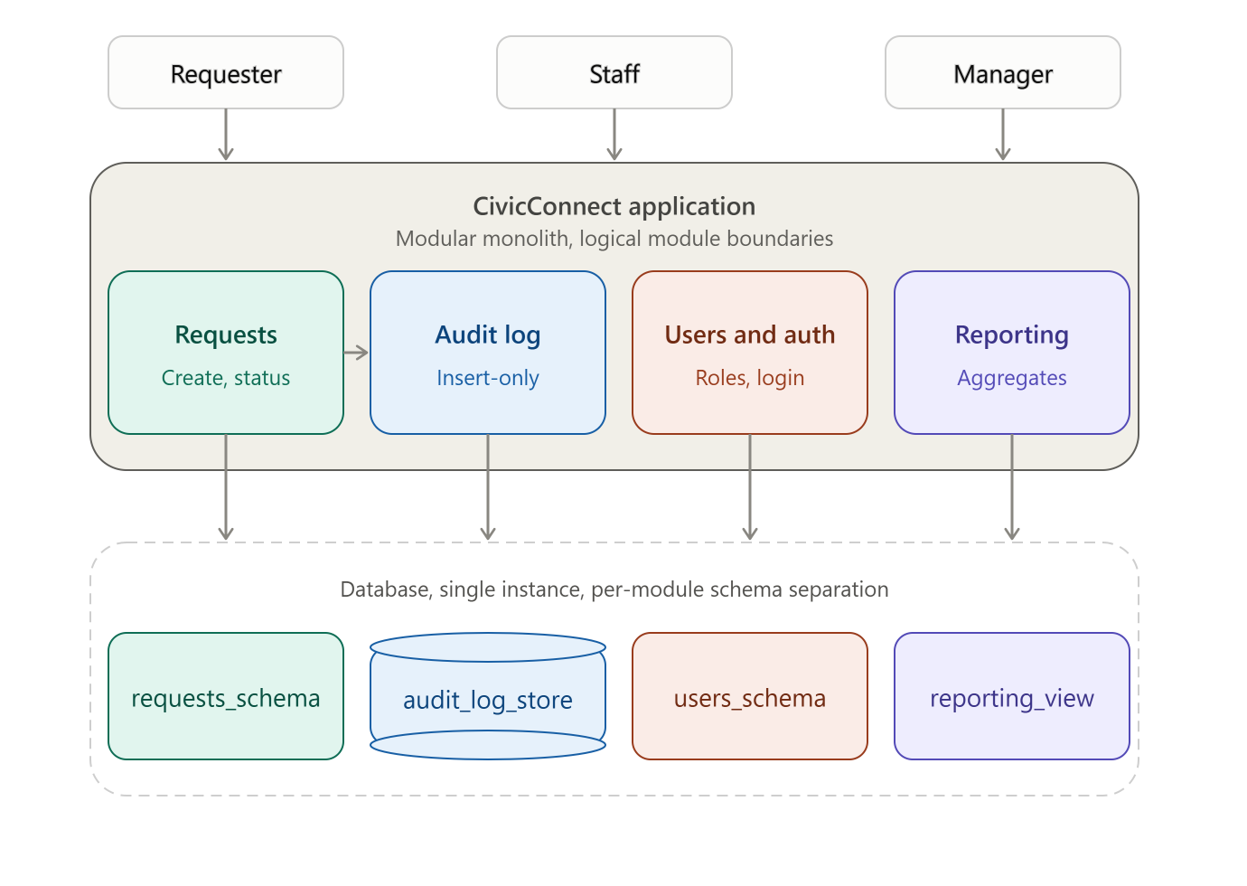

Architecture vs. technology, logical modules vs. physical deployment tiers
The architecture decisions in this section describes the logical structure, the modular monolith pattern and the module boundaries (Requests, Audit log, Users and auth, Reporting) independent of any specific programming language, framework, or hosting provider. Technology choices (e.g. ASP.NET Core, a specific database engine) are addressed in a separate section and constrained by this architecture, not the reverse.
Similarly, the module boundaries shown in the architecture diagram are logical, describing responsibility and data-ownership within the single deployable application. They are distinct from physical deployment tiers the actual runtime/hosting layout (e.g. one web-service instance, one database instance), which is addressed in Deployment compatibility. At this baseline, all four modules deploy together as one physical unit. The logical boundaries exist to keep responsibilities separated in code and data (supporting NFR-005's insert-only enforcement and NFR-008's access control), not to imply separate deployment today.

Architecture Decision Record(ADR)

Decision ID: ADR-001
Context: CivicConnect requires an architecture proportionate to a 3 person team, a fixed 4-milestone schedule, and free-tier hosting, while satisfying five ASRs (NFR-002, 003, 005, 007, 008) that materially constrain data handling, access control, and auditability.
Constraints: Cost/Resources (prefer free-tier hosting), Schedule (fixed milestone deadlines), Team capability (strongest shared skill is C#), Scope (avoid unjustified complexity).
Alternatives: Plain layered monolith, no enforced internal module boundaries. Modular monolith, single deployable, internally organized into bounded modules. Microservices, separately deployed services per domain.
Decision: Adopt a modular monolith, organized into four modules: Requests, Audit log, Users and auth, and Reporting.
Rationale: A plain monolith cannot structurally guarantee NFR-005's insert-only audit requirement, nothing prevents code elsewhere from writing directly to history data. Microservices introduce distributed-systems complexity (network calls, multiple free-tier hosting instances, distributed transactions) disproportionate to team size and schedule this also directly conflicts with the Cost constraint (evidenced by Render/Railway free-tier limitations). A modular monolith enforces module boundaries at the code level (e.g. Audit log only exposes an insert operation) while remaining a single deployable unit compatible with free-tier hosting and the team's strongest language (C#/ASP.NET Core).
Trade-offs: Single point of failure, if the one deployed instance goes down, all modules become unavailable simultaneously, unlike microservices where failures can be isolated per service.
Risks: Logged as RSK-008 (modular monolith SPOF); mitigated via documented uptime/restart behaviour (NFR-004) and an internal design that keeps modules loosely coupled enough to extract into a separate service later if justified.
Evidence: ASR evidence for NFR-002, 003, 005, 007, 008 , Cost constraint evidence (Render vs Railway free-tier comparison), Team capability (C# proficiency).
Later consequence: TBD, to be revisited at M3/M4 if load or availability requirements change materially.

Decision ID: ADR-002
Context: Request creation and its initial status record must be atomic; validation must hold regardless of entry point; near-simultaneous Staff edits to the same Request must not silently corrupt data.
Constraints: Quality constraint (measurable correctness), Security/Compliance (NFR-008), small team, limited capacity for complex concurrency infrastructure.
Alternatives: Application-layer-only enforcement, Database-layer-only enforcement, Hybrid both layers, different responsibilities. Concurrency: optimistic check vs. pessimistic locking.
Decision: Adopt hybrid enforcement (database constraints for structural integrity, application layer for transaction boundary and business rules) and optimistic concurrency control for status updates.
Rationale: Application-only enforcement risks a forgotten transaction wrap on an overlooked code path. Database-only enforcement produces SQL errors that are hard to translate into meaningful user feedback and struggles to express complex multi-conditional business rules. A hybrid gets structural guarantees that hold regardless of caller, plus readable, testable business logic. Optimistic concurrency is preferred over locking because CivicConnect's expected concurrent-edit rate on any single Request is low, and optimistic checks are simpler for a three-person team to implement and reason about correctly than pessimistic locking.
Trade-offs: Hybrid approach means integrity logic is split across two layers, requiring discipline to keep both in sync as requirements evolve. Optimistic concurrency means a legitimate second edit can be rejected and must be retried, rather than silently queued.
Risks: A developer could bypass the transaction wrapper on a new code path, a rejected concurrent edit needs clear UI feedback, so Staff aren't confused (deferred to M2/M3 UI implementation).
Evidence: Assignment 2, Task 2.2–2. NFR-005 (auditability); FR-011 (controlled transitions) (Pearce, et al., 2022) (Zhu, et al., 2021).
Later consequence: TBD.

Data and persistence baseline

Data Entities, Relationships and Ownership
Entity | Description | Ownership | Relationships
User | Any authenticated account (Requester, Staff, or Manager role). | Self-registered. | Referenced by Request (as requester and optionally as assigned staff), and by Comment (as author).
Category | Controlled, fixed list of request categories (FR-002). | Managed as reference/lookup data | Referenced by Request (many-to-one).
Request | A submitted service request, core transactional entity. | Created by the Requester (FR-001). | Belongs to one Requester, optionally one assigned Staff member, and exactly one Category, owns many RequestHistory entries and Comments.
RequestHistory | Append-only, immutable log of status changes (NFR-005, FR-011). | Written by the system on every valid status transition. | Belongs to exactly one Request, never updated or deleted.
Comment | Staff-authored action/resolution notes (FR-012). | Created by a Staff member | Belongs to one Request, references one User (author).

Foreign key structure
- Request.requester_id → User (required).
- Request.assigned_staff_id → User (nullable).
- Request.category_id → Category (required) .
- RequestHistory.request_id → Request (required).
- Comment.request_id → Request (required) .
- Comment.author_id → User (required).

Lifecycle implications
Request is the core entity, meaning its lifecycle drives the others. RequestHistory entries are permanent once written and are never deleted, even if the parent Request is later closed or archived, since immutability is the entire point of NFR-005. Comments are tied to their Request's lifecycle and are retained alongside it as part of the request's audit trail. Category, by contrast, is reference data rather than transactional data: a Category should not be deleted while active Requests reference it, requiring either a restrict-on-delete rule or a soft-delete/deprecation approach so historical Requests retain a valid category reference even if that category is later retired from the active list.

ERD diagram
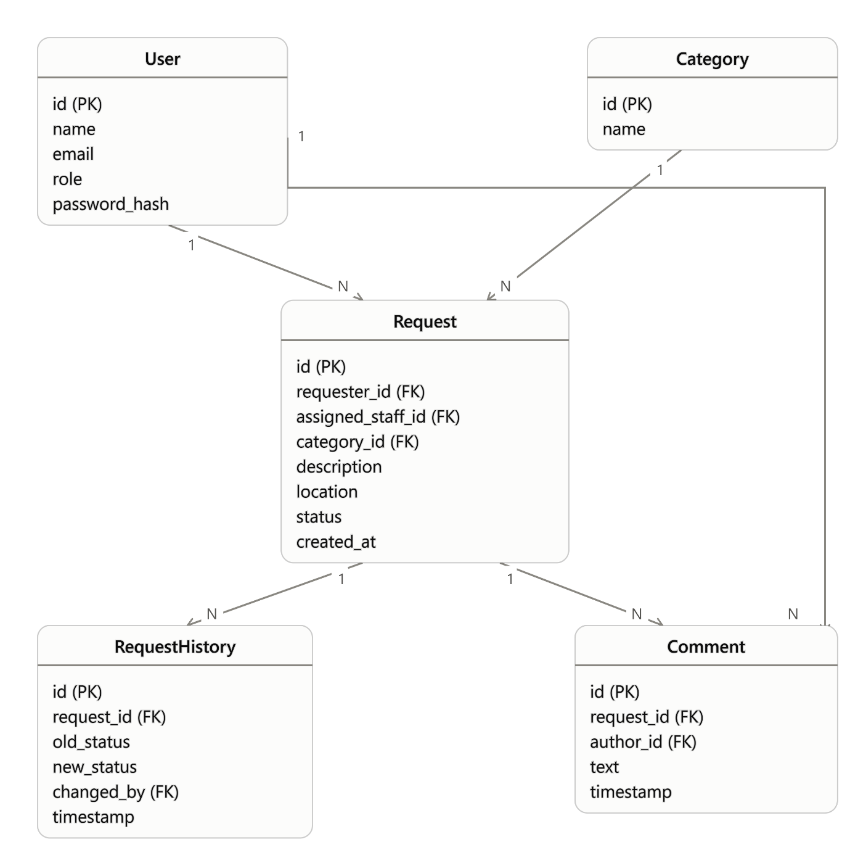

Persistence model classification
Structure and relationships
CivicConnect's data is highly relational, Request depends on User, Category, and owns many RequestHistory and Comment records via clear foreign-key relationships . This structure is naturally suited to a relational (SQL) database, where foreign-key constraints can enforce referential integrity at the schema level (e.g. preventing a Request from referencing a non-existent Category) rather than relying on application code alone.

Access patterns
The dominant read pattern is the Staff request queue (NFR-002) filtered, sorted lookups across Request by status/category/assignment. Relational databases support this well through standard indexing on foreign-key and status columns, without requiring denormalized or pre-aggregated data structures. The Manager oversight views (FR-014–FR-017) are aggregate queries (counts by status/category) a natural fit for SQL's native GROUP BY/aggregate functions, rather than requiring separate reporting infrastructure at this scale.

Integrity and consistency
Several requirements demand strong consistency guarantees a relational model provides directly: a Request must always reference a valid Category and Requester (FR-001, FR-002), a status transition must be validated against allowed states before being recorded (FR-011), and RequestHistory must never be altered once written (NFR-005). These are enforced through foreign-key constraints, check constraints on valid status values, and database-level permission restrictions (no UPDATE/DELETE grants on RequestHistory for the application's normal database role) pushing the immutability guarantee below the application layer, where it can't be bypassed by a coding mistake.

Sensitivity
Requester contact information (NFR-008) requires field-level access control, not just table-level restriction . A relational database with role-based query permissions or application-enforced field filtering supports this directly, since sensitive fields sit alongside non-sensitive ones in the same normalized User/Request structure rather than being scattered across denormalized documents.

Expected growth
As per NFR-007 and FEC-04 (uneven spikes after major events), the schema avoids fixed-size or hardcoded assumptions, foreign-key-indexed lookups scale predictably with row count, and the modular schema separation (ERD/architecture diagram) means growth in one area (e.g. RequestHistory volume) doesn't require redesigning unrelated modules like Category.

Conclusion
A relational database is justified over a document/NoSQL alternative specifically because CivicConnect's core value proposition: traceable, auditable, accountable request handling depends on enforced structural integrity and immutability guarantees that a schema-less model would have to reimplement entirely in application code, increasing the risk of the exact accountability gaps the project exists to solve.

A2-Informed Transaction and Validation Strategy
Assignment 2 research into CivicConnect's request-submission operation directly informs the persistence approach for Request and RequestHistory. Two locally coupled writes creating a Request and recording its initial status must succeed or fail together; a Request without an initial status breaks the staff queue, and an orphaned status record with no parent breaks the audit trail. This is the atomicity property of ACID transactions, and the M2 baseline adopts it directly: Request creation and the initial RequestHistory entry are wrapped in a single database transaction.
Rather than choosing purely application-layer or purely database-layer enforcement, the A2 comparison of both approaches recommends a hybrid model, which this baseline adopts:
- Database-layer carries non-negotiable structural constraints: NOT NULL on required fields (e.g. location), a foreign-key constraint from RequestHistory to its parent Request, and a CHECK constraint restricting status values to the approved workflow states.
- Application/service-layer owns the transaction boundary and business-rule validation (e.g. which status transitions are legal, feeding directly into NFR-005's controlled transition logic).
- UI-layer validation is treated as a convenience only, never the sole safeguard, since any other entry point (script, future API, integration) bypasses the client entirely.
For concurrency (two Staff members updating the same Request near-simultaneously) the A2 research recommends optimistic concurrency control over locking, given CivicConnect's low expected contention on any single Request and a small team's ability to reason about it more easily than pessimistic locking. This is adopted as the M2 baseline approach: Request includes a version/row-check field, and a conflicting concurrent update is rejected and surfaced to the second Staff member rather than silently overwritten.

Database-Level SPOF, Scalability, Availability and Backup/Recovery
Single point of failure (database-specific): Distinct from the application-instance SPOF logged as RSK-008 the database itself is a separate potential failure point even with multiple application instances, a single database instance means database downtime or data loss affects the entire system regardless of application redundancy. Given the free-tier hosting constraint, only one database instance is realistically provisioned, so this risk is accepted rather than solved architecturally at this stage.

Scalability
The relational schema avoids fixed-size or hardcoded row-count assumptions, and query patterns rely on indexed foreign keys rather than full-table scans. However, free-tier database services impose hard scalability ceilings independent of schema quality (e.g. Render's free-tier Postgres instance expires after 30 days and has storage/connection limits regardless of how well-indexed the schema is). This means CivicConnect's scalability is currently bounded by hosting tier, not application design.

Availability
No high-availability (multi-instance/replicated) database configuration is planned for M2 this would require paid infrastructure disproportionate to project scope. Availability at this stage depends entirely on the hosting provider's uptime for a single instance, and any outage is expected to be recorded as per NFR-004 ("uptime/availability strategy is recorded and every outage that occurs during demo or testing phase is noted along with the reason").

Backup/recovery
No automated backup strategy has been implemented at M2 this is recorded as a deliberately deferred decision, not an oversight. Free-tier database services typically don't include automated backups, and implementing custom backup tooling this early would be premature relative to M2's boundaries. This is flagged as a Forward Engineering Consideration for M3/M4, where staging/production deployment readiness is explicitly in scope.

Engineering decision log

Decision ID: DEC-001
Context: The team needed to decide how requesters would be notified when their request status changes, to satisfy the requester need for visibility without overloading Staff with manual update work.
Constraints: Cost/Resources constraint (prefer free/low-cost services), Scope constraint (avoid unjustified feature complexity)
Alternatives: (1) SMS notifications via a third-party gateway (e.g. Twilio), (2) In-app + email notifications only, (3) No automated notification, requester must manually check status.
Decision: Use in-app and email notifications only, SMS notifications excluded from scope.
Rationale: SMS requires a paid gateway service, which conflicts with the project's cost constraint of preferring free-tier services. Email and in-app notification satisfy the same underlying stakeholder need confirmation that a request wasn't lost without introducing a recurring operational cost or an external paid dependency. Option 3 (no automated notification) was rejected because it fails to address the core business problem of poor requester visibility identified in the problem statement.
Trade-offs: Requesters without regular access to email/the platform may experience slower awareness of status changes compared to SMS. This is accepted as a reasonable trade-off given the cost constraint.
Risks: Requesters who don't check email/app promptly may perceive the system as unresponsive even when status updates are occurring correctly.
Evidence: Cost/Resources constraint (PED Constraints), Scope Baseline exclusion (PED Scope, Out of Scope), Stakeholder need — Requester "know it wasn't lost" (Stakeholder Analysis).
Later consequences: To be revisited at M2 when notification implementation approach is selected, and at M4 if operational cost/usage evidence suggests SMS should be reconsidered.

Decision ID: DEC-002
Context: A quantifiable criterion was required for NFR-002, although the precise figure depends on hosting and infrastructure decisions that have not yet been decided (out of scope for M1).
Constraints: Technology-stack or architecture decisions are expressly prohibited under M1, although section 15 in the Milestone 1 document mandates that NFRs eventually be quantifiable and supported by evidence.
Alternatives:
- Select a random number at this point of the project.
- Wait until M2 to measure the NFR.
- Establish a temporary placeholder threshold with a clear label.
Decision: Instead of leaving it unmeasurable, set a temporary placeholder (<= 2 seconds for up to 200 requests), clearly marked as subject to adjustment once hosting/architecture is selected.
Rationale: A marked placeholder maintains testability while truthfully indicating the number is not final, an NFR with zero measurable targets is not testable at all.
Trade-offs: The NFR is still used in the RTM and defence at the time but, here is a chance that the placeholder number will be mistakenly regarded as final if it is not reviewed.
Risks: The acceptance criteria may become untestable against the actual environment if the team neglects to check the figure after deciding on the M2 architecture and hosting.
Evidence PED v1.0’s NFR-002 row in the NFR table and acceptance criteria table, this decision log item serves as the deferral’s record.
Later consequences: Once hosting has been selected, note the actual threshold and verify if 2 seconds/200 requests was reasonable.

Decision ID: DEC-003
Context: Stakeholder analysis identified two user classes — residents and municipal staff — with different access needs. The team must decide whether M1 requirements should assume a single shared login mechanism or anticipate role-based access, without committing to an implementation.
Options considered:(1) Treat all users identically with no role distinction; (2) Define requirements now assuming role-based access exists, deferring how it's implemented; (3) Defer the question entirely to M2.
Decision: NFRs and FRs will assume distinct resident/staff roles exist, but the authentication mechanism, technology and schema are explicitly not decided at this stage.
Rationale: Reflects genuine stakeholder conflict already surfaced in the stakeholder analysis. Not deciding this would leave requirements untestable and would risk rework of acceptance criteria later.
Trade-offs: Gained: requirements and acceptance criteria can be written now with testable role-based conditions, preventing a rewrite of FR/NFR wording at M2. Given up: the team cannot yet confirm how expensive or complex the eventual access-control implementation will be, so effort estimation for M2 carries more uncertainty. Choosing to specify roles now vs staying generic also means any late stakeholder request for a third role would require revisiting already-baselined requirements rather than starting clean.
Risks: R-004 — Unauthorized access to staff functions (linked): probability Medium, impact High if role boundaries are assumed in requirements but not enforced correctly later. R-007 — Requirements rework risk (new): if a stakeholder later requests a third user role, baselined FR-012/NFR-003 wording may need revision, consuming RTM traceability effort. Mitigation: both risks flagged for review at M2 architecture kick-off; contingency is to re-baseline the affected requirements under controlled change rather than informal edit.
Consequences: Influences NFR-003 (access control), FR-012 (staff status update), and will constrain M2 architecture decisions around session/role management. Flagged in Forward Engineering Considerations as "Access control model.”

References
MayaLogic, 2026. Mobile vs web: the decision most teams get wrong. [Online]
Available at: https://www.mayalogic.com/blog/mobile-vs-web-the-decision-most-teams-get-wrong
[Accessed 17 September 2026].
Pearce, H. et al., 2022. Asleep at the Keyboard? Assessing the Security of GitHub Copilot’s Code Contributions. Communications of the ACM, 68(2), pp. 95 - 105.
Twilio, 2026. SMS Pricing. [Online]
Available at: https://costbench.com/software/sms-api/twilio-sms/hidden-costs/
[Accessed 17 September 2026].
Zhu, Q.-H., Tang, H., Huang, J.-J. & Hou, Y., 2021. Task scheduling for multi-cloud computing subject to security and reliability constraints. IEEE/CAA Journal of Automatica Sinica, 8(4), pp. 848-865.

AI usage Register
Team Member | Artefact/Task |  | AI Tool Used | Nature of Assistance | What Was Verified/Changed/Rejected
MILESTONE 1
Paul Edward van Zyl | Drafting initial risk category and considerations list |  | Claude | Suggested a starting set of risk categories and example wording. Helped with engineering considerations list | Team cross-checked categories against CivicConnect's actual scope; rewrote 3 of 5 example risks as project-specific; removed one category
Freerk van den Bos | Drafting of initial FR/NFR tables and the RTM |  | Claude | Suggested FRs and NFRs along with an RTM. Helped with structure and wording. | Cross-checked with CivicConnect’s business needs.
Regardt Osler | Formatting of Project Scope, Risks, Constraints |  | Claude | Suggested possible order of Constraints and did general spell checking | Many of the suggested constraints were rejected due to not being applicable.
MILESTONE 2
Paul Edward van Zyl
Freerk van den Bos
Regardt Osler | Generating architecture & ERD diagrams | Claude |  | Generating architecture & ERD diagrams based on given information. | Checked the validity of diagrams and changed the diagrams to match overall look and feel of document. Changed the colors used in the diagram to match the overall look and feel of the document.

Sign off

New member of the development team.
Subject to change once hosting/architecture is selected in later milestones.

