­­

­­HANDS ON LAB  
Adobe Experience Manager Commerce Integration Framework

Omni Channel Experience

Student Workbook

By

Varun Venkataraman

[vvenkata@adobe.com](mailto:vvenkata@adobe.com)

&

Mark Szulc

[mszulc@adobe.com](mailto:mszulc@adobe.com)

twitter.com/mszulc

[www.markszulc.com](http://www.markszulc.com)

# Table of Contents

Table of Contents 3

1 Lesson 1 – AEM Commerce Integration Framework – Product Import Management 4

1.1 Overview 4

1.2 Setup 4

1.3 Observations 4

1.4 Task 4

1.5 Summary 4

2 Lesson 2 – AEM Commerce Page Rollout Mechanism Management 9

2.1 Overview 9

2.2 Setup 9

2.3 Observations 9

2.4 Task 9

2.5 Summary 9

3 Lesson 3 – Leverage AEM CIF for AEM Mobile On Demand 17

3.1 Overview 17

3.2 Setup 17

3.2.1 SETUP AEM Mobile on Demand Publishing Solution Client: 17

3.2.2 Back on Main AEM page, go to Tools > Operations > Cloud > Cloud Services. 18

3.3 Observations 18

3.4 Task 18

3.5 Summary 19

4 Lesson 4 – Leverage AEM CIF for AEM Screens 20

4.1 Overview 20

4.2 Setup 20

4.3 Observations 20

4.4 Task 20

4.5 Summary 20

5 References 21

5.1 Create your sample maven multi module project - https://github.com/Adobe-Marketing-Cloud/aem-project-archetype 21

# Lesson 1 – AEM Commerce Integration Framework – Product Import Management

## Overview

|  |  |
| --- | --- |
| Task | Add an additional properties for a product in PIM called **summit** and extending the scaffolding framework to add additional properties to be edited on the PIM from Touch UI. |
| Time | 10 minutes |
|  |  |

## Setup

1. Open terminal.
2. Navigate to **/Users/l322/Desktop/AEM-Commerce-Lab-WS/aem-commerce-framework-extensions**
3. Switch to git branch exercise1
   * 1. git checkout exercise1
4. Install packages
   * 1. mvn clean install –PautoInstallPackage

**Note: The above steps will install a sample product list scaffolding UI for managing the products.**

## Observations

**Observation 1**

Navigate to http://localhost:4502/libs/commerce/gui/content/products/properties.html/etc/commerce/products/summit-geometrixx-outdoors/equipment/running/eqsmmr

Take note of all the properties in Edit mode.

Note: This covers all the properties editable for the product catalog.

Exercise 1 –Observation 2

**Observation 2**

Now, to http://localhost:4502/crx/de/index.jsp#/etc/commerce/products/summit-geometrixx-outdoors/equipment/running/eqsmmr

Take note of all the properties in the JCR

Exercise 1 – Task

**Task** : Add an additional property to the product and make sure this is available for edit in scaffolding UI.

Steps to follow

Go to http://localhost:4502/crx/de/index.jsp

Locate in tree **/etc/scaffolding/summit-geometrixx-outdoors/product/jcr:content/cq:dialog/content/items/tabs/items/basic/items/titles/items**

Right click on items node and create a node with following properties (or copy paste **title** node and change accordingly)

Now navigate to any product for summit-geometrixx in product management window. Example: http://localhost:4502/libs/commerce/gui/content/products/properties.html/etc/commerce/products/summit-geometrixx-outdoors/equipment/running/eqsmmr

This will have the field created for edit and on filling the data, this is available for management.

Exercise 1 – Result 1

Exercise 1 – Result 2

Exercise 1 – Solution - Optional

Switch to git branch exercise1-solutions

git checkout exercise1-solutions

Install packages

mvn clean install –PautoInstallPackage

## Task

Exercise 1 – Summary and Key Takeaways

Agenda

Exercise 2 – Commerce Page Rollout Mechanism Management

Tasks :

Task 1: Create Website using catalog

Task 2: Add Price and see the change Reflected

Task 3 (Optional – Bonus Points) : Modify Section Template and Rollout

## Summary

# Lesson 2 – AEM Commerce Page Rollout Mechanism Management

## Overview

|  |  |
| --- | --- |
| Task |  |
| Time | 30 minutes |
|  |  |

## Setup

## Observations

## Task

## Summary

Extra time:

# Lesson 3 – Leverage AEM CIF for AEM Mobile On Demand

## 

## Overview

|  |  |
| --- | --- |
| Task |  |
| Time | 30 minutes |
|  |  |

## Setup

### SETUP AEM Mobile on Demand Publishing Solution Client:

In your AEM instance, go to Tools > Web Console. A new tab or window is opened.

* + Scroll down to “Adobe Digital Publishing Solution Client” and click the edit icon (pencil).
  + Enter the IMS Client ID and Client Secret in the “DPS Client Id” and “DPS Client Secret” fields and click Save. You can then close the Web Console tab or window.

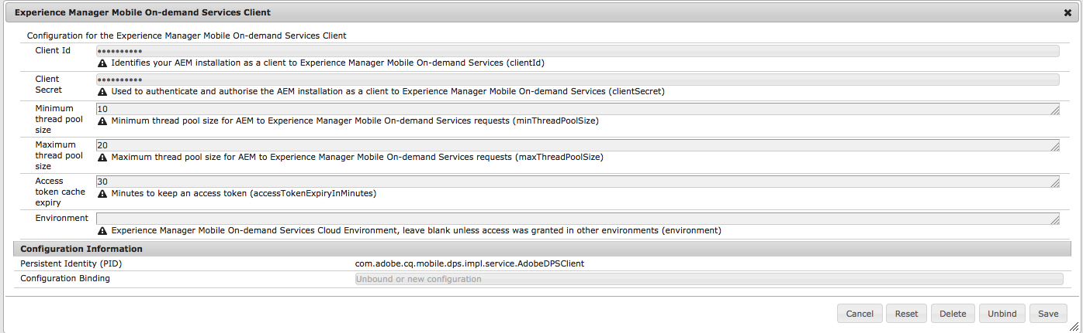

### Back on Main AEM page, go to Tools > Operations > Cloud > Cloud Services.

* + Scroll down to “Adobe Experience Manager mobile On-demand Services” (green icon, under “Adobe Creative Cloud”).
  + Click “Configure Now.”
  + In the “Create Configuration” pop-up window, enter a Title and Name, and click Create (Name should have no spaces).
  + In the Adobe Digital Publishing Solution Configuration pop-up window, enter the Device Id and Device Token from the IMS Device Token Generator used earlier.
  + Click “Test DPS Settings” to check this.
  + Click OK, and then navigate back to the Main AEM window.

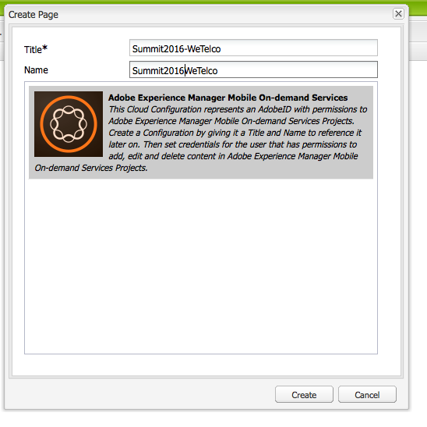

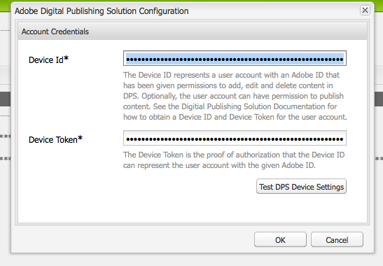

## Observations

## Task

## Summary

# Lesson 4 – Leverage AEM CIF for AEM Screens

## Overview

|  |  |
| --- | --- |
| Task |  |
| Time | 30 minutes |
|  |  |

## Setup

## Observations

## Task

## Summary

# References

## Create your sample maven multi module project - <https://github.com/Adobe-Marketing-Cloud/aem-project-archetype>

<https://helpx.adobe.com/digital-publishing-solution/how-to/get-started-digital-publishing.html?set=digital-publishing-solution--get-started--ready-to-use>