Copyright (c) 2018 Bounteous (previously HS2 Solutions).
Permission is hereby granted, free of charge, to any person obtaining a copy of this AEM runbook template (the “Document”), to deal in the Document without restriction, including without limitation the rights to use, copy, modify, merge, publish, distribute, sublicense, and/or sell copies of the Document, and to permit persons to whom the Document is furnished to do so, subject to the following conditions:
THE DOCUMENT IS PROVIDED "AS IS", WITHOUT WARRANTY OF ANY KIND, EXPRESS OR IMPLIED, INCLUDING BUT NOT LIMITED TO THE WARRANTIES OF MERCHANTABILITY, FITNESS FOR A PARTICULAR PURPOSE AND NONINFRINGEMENT. IN NO EVENT SHALL THE AUTHORS OR COPYRIGHT HOLDERS BE LIABLE FOR ANY CLAIM, DAMAGES OR OTHER LIABILITY, WHETHER IN AN ACTION OF CONTRACT, TORT OR OTHERWISE, ARISING FROM, OUT OF OR IN CONNECTION WITH THE SOFTWARE OR THE USE OR OTHER DEALINGS IN THE DOCUMENT.

AEM Dev/Ops Runbook Template

Legend
- Black text is text that can be included basically verbatim. It should be reviewed for the particular project to ensure it is applicable.
- Blue text is EXAMPLE text that should be REPLACED with content specific to the client. No blue text should remain in the final runbook.
- Red text is HELP text that should be REMOVED from the final runbook. No red text should remain in the final runbook.

======= start of runbook template =======

Runbook Overview
The purpose of this runbook is to provide a complete set of procedures and detailed information to help effectively manage the hosted Adobe AEM Instance. This information is designed to provide context to those who do not have intimate knowledge of the environment, but need to be able to quickly and efficiently troubleshoot and/or resolve potential issues that may arise, such as the Adobe NOC.

1. System Configuration

Environment Information List
When working with Adobe Managed Services, they should populate this section.
Env | Role | External IP | Zone | Size | Region | DNS Name
Prod | Load Balancer | 11.22.33.44 | us-west-2a | ELB | Oregon | client-prod-elb1uswe-AJLJEIFJELSJF-7832749834.us-west-2.elb.amazonaws.com
Prod | Dispatcher1 | 12.22.33.44 | us-west-2a | m3.medium | Oregon | client-prod-disp1.adobecqms.net
Prod | Dispatcher2 | 12.22.33.45 | us-west-2a | m3.medium | Oregon | client-prod-disp2.adobecqms.net
Prod | Publish1 | 13.22.33.44 | us-west-2a | m4.large | Oregon | client-prod-publish1.adobecqms.net
Prod | Publish2 | 13.22.33.45 | us-west-2a | m4.large | Oregon | client-prod-publish2.adobecqms.net
Prod | Author1 | 14.22.33.44 | us-west-2a | m4.xlarge | Oregon | client-prod-author1.adobecqms.net
Stage | Load Balancer | TBD | TBD | TBD | TBD | TBD
Stage | Dispatcher1 | TBD | TBD | TBD | TBD | TBD
Stage | Dispatcher2 | TBD | TBD | TBD | TBD | TBD
Stage | Publish1 | TBD | TBD | TBD | TBD | TBD
Stage | Publish2 | TBD | TBD | TBD | TBD | TBD
Stage | Author1 | TBD | TBD | TBD | TBD | TBD
QA | Load Balancer | TBD | TBD | TBD | TBD | TBD
QA | Dispatcher1 | TBD | TBD | TBD | TBD | TBD
QA | Publish1 | TBD | TBD | TBD | TBD | TBD
QA | Author1 | TBD | TBD | TBD | TBD | TBD
Dev | Load Balancer | TBD | TBD | TBD | TBD | TBD
Dev | Dispatcher1 | TBD | TBD | TBD | TBD | TBD
Dev | Publish1 | TBD | TBD | TBD | TBD | TBD
Dev | Author1 | TBD | TBD | TBD | TBD | TBD

Whitelisted IPs
When working with Adobe Managed Services, they should populate this section.
IP/Subnet | Owner | Security Group | Environment | Notes
11.22.33.44/32  22.33.44.55/32 | Implementor | client-dev-vpc1uswest2TopologySecurityGroup  client-qa-vpc1uswest2TopologySecurityGroup  client-stage-vpc1uswest2TopologySecurityGroup | client-dev  client-qa  client-stage
11.22.33.44/32 | Client | client-dev-vpc1uswest2TopologySecurityGroup  client-qa-vpc1uswest2TopologySecurityGroup  client-stage-vpc1uswest2TopologySecurityGroup | client-dev  client-qa  client-stage

Web Sites
Domain | Content Root
www.clientbrand1.com | /content/region-na/brand1
www.clientbrand2.com | /content/region-na/brand2
www.clientbrand1.co.uk | /content/region-emea/brand1

System Topology
Arrows originate from the entity initiating the request.
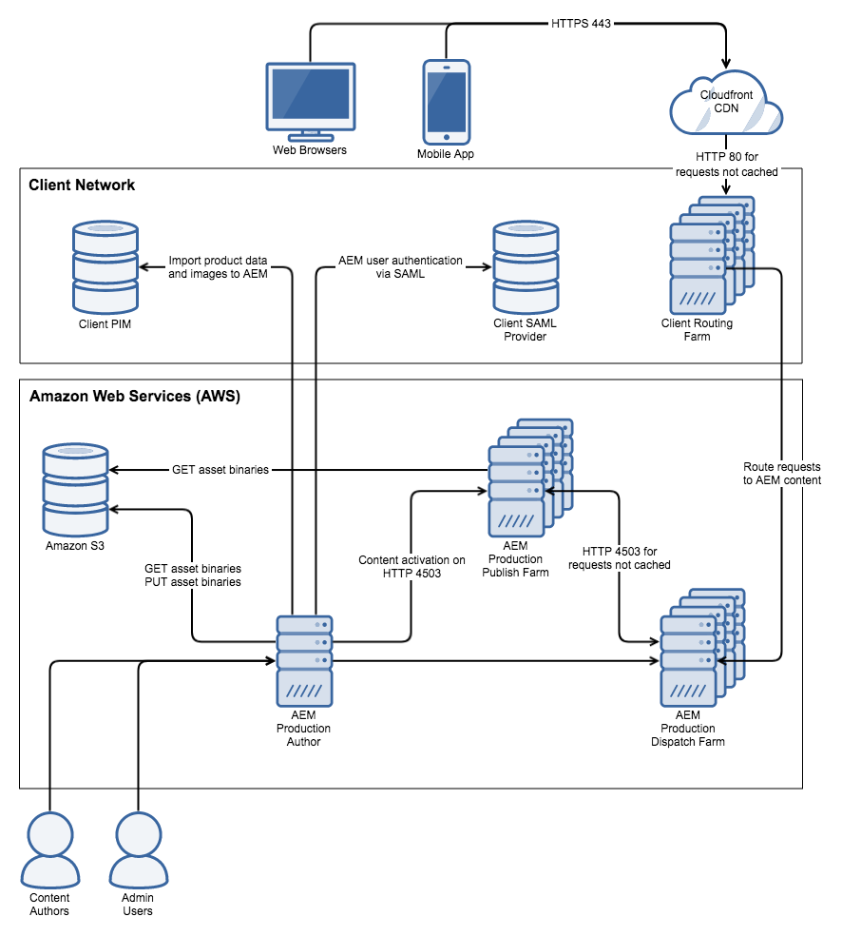

2. Customizations

Custom Packages
- client.ui.apps-1.0.5.zip
  - acs-aem-commons-content-3.14.6.zip
  - third-party-app-1.2.34.zip
- client.ui.content-1.0.5.zip

Custom Bundles
- ACS AEM Commons Bundle (com.adobe.acs.acs-aem-commons-bundle)
  - Installed via acs-aem-commons-content package
- Third Party App Bundle (com.thirdparty.bundle)
  - Installed via third-party-app package
- Client Bundle (com.client.bundle)
  - Installed via client.ui.apps package

Service Packs, Feature Packs, and Hotfixes
When working with Adobe Managed Services, check to see which Service Packs and Cumulative Fix Packs have been installed w/o specific request to ensure they are documented here and that developer machines are running the same.
Package Name | Type | Reason
aem-service-pkg-6.3.1.zip | Service Pack | Latest GA features
aem-6.3.1-cfp-2.0.zip | Cumulative Fix Pack | Latest GA bug fixes
cq-6.3.0-featurepack-19614-1.0.8.zip | Feature Pack | Enable AEM Core Components to output content in JSON format
cq-6.3.0-hotfix-20768-1.0.zip | Hotfix | Hotfix for repository update to Oak 1.6.8

Frameworks
On-Deploy Scripts Framework
- Purpose: Allows the client code bundle (client.ui.apps) to include one-time java scripts that run upon being deployed to AEM. This is used to execute content updates, potentially related to code updates in the deployment.
- Source: ACS AEM Commons, deployed by the acs-aem-commons-content package
- Details: The on-deploy scripts added for a given release will vary, and there may not always be any. The release verification plan for a given release will contain steps to verify the new on-deploy scripts were successful. An admin can verify that on-deploy scripts were successful by viewing status nodes in the JCR under /var/acs-commons/on-deploy-script-status on all author and publish servers.
- Additional Info: On-deploy scripts are generally never removed. To prevent an on-deploy script from running multiple times, a status node for each script is stored in the JCR under /var/acs-commons/on-deploy-script-status. An on-deploy script will run on deployment of the client.ui.apps code bundle unless it has a status node that indicates a status value of "success". Though developers strive to write the scripts in a way that running multiple times is harmless, these status nodes that prevent multiple runs should generally not be removed (else the jobs will run on next deployment).
Remote Assets
- Purpose: Synchronize assets from the production author instance to non-production environments
- Source: ACS AEM Commons, deployed by the acs-aem-commons-content package
- Details: All non-production author servers run a nightly job (see Scheduled Jobs) to sync the node structure of the DAM (/content/dam) from production author down to themselves. After that, the binary files associated with those assets are pulled "just in time" from the production author server when they are accessed by a non-admin user. Note that this can occasionally put additional load and network traffic on the production author instance. If this becomes a regular problem, the dev team will need to tune the remote assets configuration.

Scheduled Jobs
com.adobe.acs.commons.remoteassets.impl.RemoteAssetsNodeSyncJob
- Label: ACS AEM Commons - Remote Assets Sync Job
- Schedule: Daily at midnight (0 0 0 * * ?)
- Environments: Dev, QA, Stage
- Purpose: Synchronize asset node structure from /content/dam from the production author instance down non-production environments

Job Queues
com.adobe.acs.commons.remoteassets.impl.RemoteAssetsAsyncBinarySyncQueue
- Job Topic: com/adobe/acs/commons/remoteassets/asyncbinarysync/job
- Environments: Dev, QA, Stage
- Purpose: For assets larger than 10MB (configured) that are accessed for the first time on the server and need to be pulled from the production author instance, the queue is used to execute binary syncs one at a time to ensure the production author server is not overloaded.

OSGi Configs and Services
com.adobe.acs.commons.remoteassets.impl.RemoteAssetsConfigImpl.xml
- Name: ACS AEM Commons - Remote Assets - Config
- Servers: author
- Environments: Dev, QA, Stage
- Config Source:
  - Dev: /apps/client/config.author.dev
  - QA: /apps/client/config.author.qa
  - Stage: /apps/client/config.author.stage
- Purpose: Enable the Remote Assets feature from ACS AEM Commons.
com.adobe.acs.commons.wcm.properties.shared.impl.SharedComponentPropertiesImpl
- Name: (not configurable via Felix console)
- Servers: author, publish
- Config Source: /apps/client/config
- Purpose: Enable the Shared Component Properties feature from ACS AEM Commons.

Web Services
An exhaustive list of unique web service endpoints served from AEM is documented at https://dev.clientsite.com/docs/api.html. These APIs fall into the following categories:
Product Data APIs - /api/v1/products/*
- Purpose: Fetch product data and reports on performance
- Methods: GET
- Data Format: JSON or XML based on extension (e.g. /pim/products/popular.json vs. /pim/products/popular.xml)
- Authentication: None
User Profile APIs - /api/v1/profile/*
- Purpose: Create/Update user profile information
- Methods: GET, POST
- Data Format: JSON
- Authentication: Basic Auth via AEM

Integrations
AEM User Authentication via Client SAML
- Purpose: AEM author makes requests to client SAML provider within the client firewall
- Protocol: HTTP
- Details: This is a standard AEM/SAML authentication integration. See com.adobe.granite.auth.saml.SamlAuthenticationHandler OSGi configs.
Location Event Data Import
- Purpose: AEM fetches a CSV file daily from a 3rd-party provider (www.somelocationvendor.com) to get data on upcoming local events to show on the website.
- Protocol: SFTP
- Details: AEM will attempt to fetch the file every night at 12 AM (midnight). If the file transfer fails, AEM will try again every 30 minutes until 12 PM (noon) until the file transfer is successful.

Overrides of OOTB AEM
/apps/sling/servlet/errorhandler/404.jsp
- Purpose: Requests that result in HTTP 404 - Not Found are first checked to see if they can be redirected to a site-specific "not found" page. If not, a generic response is returned.
/apps/sling/servlet/errorhandler/default.jsp
- Purpose: Requests that result in an error other than HTTP 404 - Not Found are served a generic, branded error page.
/etc/workflow/launcher/config/update_asset_create/.content.xml
- Purpose: Disable the default OOTB workflow (i.e. rendition generation) that executes on Asset creation.
/etc/workflow/launcher/config/update_asset_mod/.content.xml
- Purpose: Disable the default OOTB workflow (i.e. rendition generation) that executes on Asset update.

Custom Key Stores
SAML Key Store
- Location: /home/users/system/authentication-service/keystore
- Password: (admin password)
- Keys: none
- Purpose: Empty keystore required for SAML integration.

Custom Trust Stores
SAML Trust Store
- User: admin
- Password: (admin password)
- Certificates: Client SAML public certificate
- Purpose: Required for SAML integration.

Service Users
acs-commons-on-deploy-scripts-service
- Source: /home/users/system/acs-commons/on-deploy-scripts-service
- Permissions:
  - / (entire repository) - read
  - /content - read/write/replicate
  - /etc - read/write
  - /var/acs-commons/on-deploy-script-status – read/write
- Purpose: Execute scripts for the On-Deploy Scripts framework, which generally involve JCR data updates.
client-commerce-service
- Source: /home/users/system/client/commerce-service
- Permissions:
  - /content - read
  - /etc/commerce - read/write
- Purpose: Execute the sync of PIM data into the JCR and allow PIM data to be accessed by background processes.

Custom Dispatcher Configs
This section covers only the differences from default Dispatcher configs.
/filter
- The following custom URLs are allowed: /api/v1/products/*, /api/v1/profile/*
- Access is allowed to font files (svg|eot|ttf|woff) under the /etc folder
- POST requests to /content/* with AEM "form" selector are allowed
/invalidate
- *.html is removed as an "allowed" rule, making it so that a path flush clears only itself, and not *.html for the entire cache
- *.json and .xml are added to enable caching of API return values
/enableTTL
- Set to "1" to enable AEM to set a TTL on pages

Dispatcher Rewrites and Redirects
Client has numerous rewrites/redirects configured in the dispatcher web server. These can be found on the dispatcher server under the /etc/httpd/conf.d/rewrites directory. Redirects and rewrites have been organized into the following files:
- all.conf - aggregate all of the redirect/rewrite files for a single import
- early-exit.conf - special case rules that should be checked before any other rules (e.g. redirect all http → https)
- redirects-brand1.conf - redirect rules for www.clientbrand1.*
- redirects-brand2.conf - redirect rules for www.clientbrand2.*
- rewrites.conf - rewrite rules

3. System Monitoring & Maintenance

Maintenance Schedule
When working with Adobe Managed Services, collaborate with them to populate this section.
Activity | Schedule | Notes
Backup | Daily @ 00:00 GMT
Virus Update | Every Sunday @ 00:00 GMT
Virus Scan | Every Sunday @ 00:00 GMT
Offline Tar Compaction and Blob GC | 1st day of every month @ 00:00 GMT
Version Purge | Every Sunday @ 00:00 GMT
Workflow Purge | Every Sunday @ 00:00 GMT

Custom AEM Log Files
- project-client.log
  - Logging for all client-specific code (com.client)
- saml.log (author server only)
  - Logging for all SAML-related code (com.adobe.granite.auth.saml) to a dedicated file

4. User Acceptance Testing and Documentation

Supported Browsers
- Internet Explorer 9+, EDGE
- Firefox (latest version)
- Chrome (latest version)
- Safari on Mac (latest version)
- ​Chrome for Android (latest version)
- Android browser (latest version)
- ​Safari for iOS (latest version)

Quality Assurance
Code Review and QA Testing is performed for every change made before it is approved for deployment to production. There is also an extensive QA regression test plan that is executed to varying degrees based on the extent and type of changes in a given code release. The test plan involves visual verification of page display and functionality across different sections of the sites in all supported browsers. That test plan can be found at https://some.testplan.com/client/testplan.

5. Post Production CAB
Any changes made to a Production Instance must follow a Change Advisory Board (CAB) process. The purpose of this process is to establish a clear understanding of the changes being applied to the environment and to ensure that each change has been properly vetted by the appropriate business, technical and operational members. The process by which a change request is submitted and then implemented ensures each change is applied in a consistent and reproducible way across each environment.

6. Events and Responses
Known potential exceptional events and how to address.
Event | Response | Notes
Broken product images on the site | Check the main error log file for schedule job class com.client.aem.services.SyncAssetsFromPIM for errors in the log file. Attempt to restart service from Felix console. | The service sometimes overloads from a large import of products from the PIM, and simply needs a restart in those cases.
Stores list on site is empty | Check vendor server status at https://www.somelocationvendor.com/serverstatus

7. Contacts and Contracts
Note that when working with Adobe Managed Services, this section should already have a template and sections that we should work within.
Name | Phone | Email | Contract Ref # | Company | Role
John Doe | 555-555-5555 (desk)  555-555-5555 (mobile) | john.doe@adobe.com |  | Adobe | Customer Success Engineer
Jane Doe | 555-555-5555 (desk)  555-555-5555 (mobile) | jane.doe@adobe.com |  | Adobe | Backup Customer Success Engineer
Adobe Support | 866-329-5273 (DAY-KARE) [US/Canada]  0800 032 9541 [UK] | dsupport@adobe.com;  entrsupp@adobe.com (for Connect)  Portal: http://helpx.adobe.com/marketing-cloud/experience-manager.html​ | 1234567 | Adobe | Standard Support Contract
Jim Doe | 555-555-5555 (desk)  555-555-5555 (mobile) | jim.doe@client.com |  | Company | Director of IT
Jack Doe | 555-555-5555 (desk)  555-555-5555 (mobile) | jack.doe@bounteous.com |  | Bounteous | Lead AEM Engineer

