CloudCore Solutions – WordPress Website Screenshots

# Home Page



Mockup of the home page with a cloud-inspired WordPress design.

# About Us Page

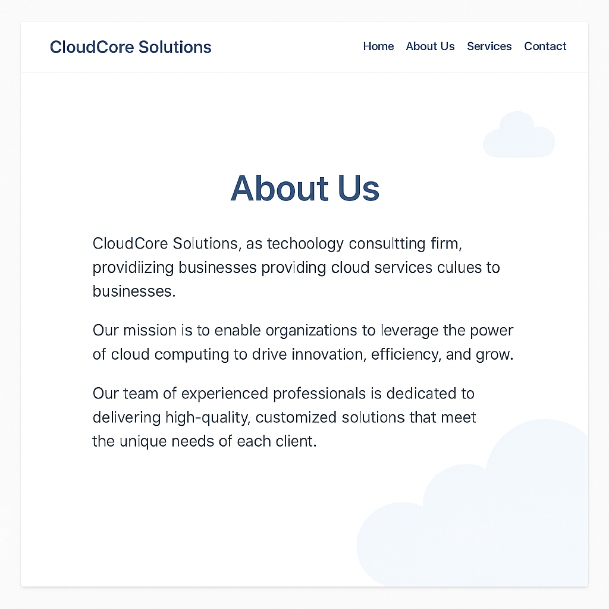

Mockup of the about us page with a cloud-inspired WordPress design.

# Services Page

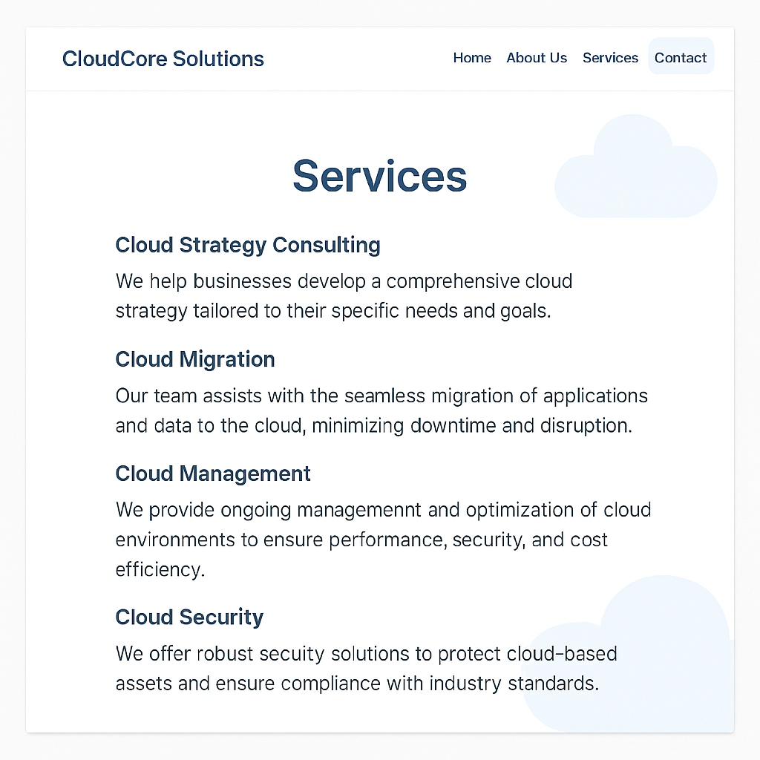

Mockup of the services page with a cloud-inspired WordPress design.

# Contact Us Page

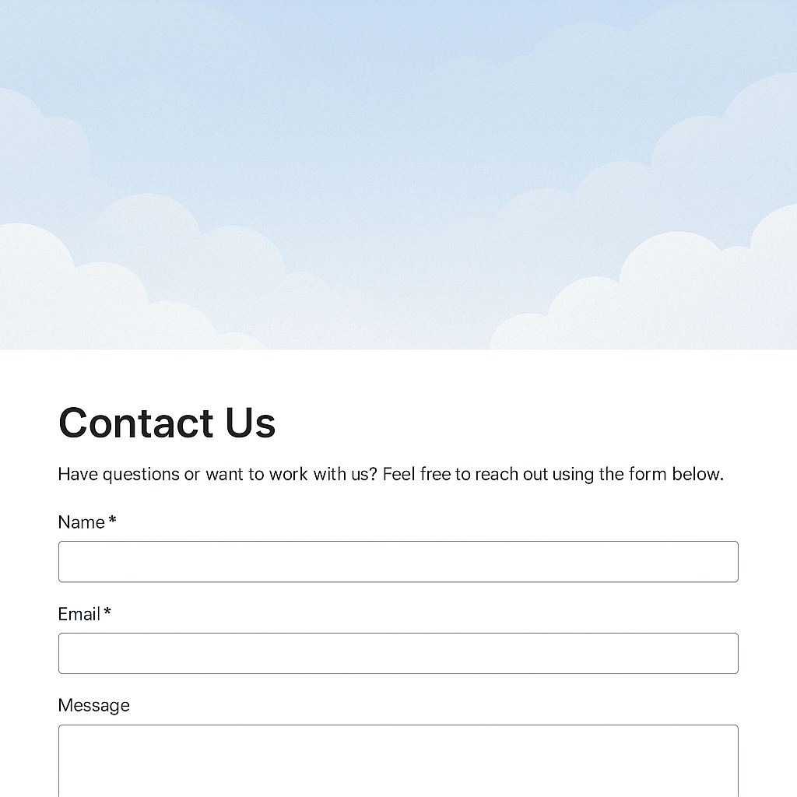

Mockup of the contact us page with a cloud-inspired WordPress design.