数据库开发技术

1.SQL作业

151250192张隽诚

第一题源码：

#Answer1  
#author Bourbon  
#1  
**DROP TABLE IF EXISTS** `order`;  
**CREATE TABLE** `order`(  
 oid **INT**(11) **NOT NULL AUTO_INCREMENT**,  
 cuid **INT**(11) **NOT NULL** ,  
 cid **INT**(11) **NOT NULL** ,  
 quantity **INT**(11) **NOT NULL** ,  
 totalPrice **DOUBLE NOT NULL** ,  
 orderTime **DATETIME NOT NULL** ,  
 **PRIMARY KEY** (oid)  
);  
  
#2  
**SELECT name**, price **FROM** clothes  
**WHERE** type = '衬衫' **AND** price >= 120 **AND** price <=180  
**ORDER BY** price;  
  
#3  
**SELECT name**, *ifnull*(*sum*(quantity),0) **FROM** (**SELECT** * **FROM** clothes  
 **WHERE** launchYear = 2015 **AND** brand = 'nike' **AND** type = '裤子') temp **LEFT  
JOIN** `order` **ON** temp.cid = `order`.cid  
**GROUP BY** temp.cid;  
  
#4  
**SELECT** *sum*(totalPrice) **as** total_custom **FROM** `order`  
**WHERE** `order`.cuid = (**SELECT** cuid **FROM** customer **WHERE** cname = 'jacky')  
**AND** *year*(orderTime) = 2014 **AND** *month*(orderTime) = 11;  
  
#5  
**SELECT** cname **FROM** customer **WHERE** cuid **IN** (  
 **SELECT** cuid  
 **FROM** `order`  
 **WHERE** cid =  
 (**SELECT** cid  
 **FROM** clothes  
 **WHERE** price =  
 (**SELECT** *max*(price)  
 **FROM** clothes  
 **WHERE** brand = 'nike' **AND** launchYear = 2015 **AND** type = '外套')  
 )  
)  
**AND** cuid **IN** (  
 **SELECT** cuid  
 **FROM** `order`  
 **WHERE** cid =  
 (**SELECT** cid  
 **FROM** clothes  
 **WHERE** price =  
 (**SELECT** *max*(price)  
 **FROM** clothes  
 **WHERE** brand = 'nike' **AND** launchYear = 2015 **AND** type = '裤子')  
 )  
);  
  
#6  
**SELECT name**, brand, *sum*(quantity) **as** total_quantity **FROM** clothes, `order`  
**WHERE** clothes.cid = `order`.cid  
**AND** *date_format*(orderTime, '%Y.%m.%d') = '2014.12.12'  
**GROUP BY** `order`.cid  
**ORDER BY** total_quantity **DESC LIMIT** 3;  
  
#7  
**SELECT** cname, phone **FROM** customer  
**WHERE** cuid =  
 (**SELECT** cuid **FROM** `order`  
 **WHERE** cuid **IN** (**SELECT** cuid **FROM** clothes, `order`  
 **WHERE** clothes.cid = `order`.cid **AND** *date_format*(orderTime, '%Y.%m.%d') = '2014.11.11' **AND** brand = 'nike')  
 **GROUP BY** cuid  
 **ORDER BY** *sum*(totalPrice) **DESC LIMIT** 1);  
  
#8  
**SELECT** * **FROM** customer  
**WHERE** cuid **NOT IN** (**SELECT** cuid **FROM** `order`  
 **WHERE** totalPrice <800 **AND** *date_format*(orderTime, '%Y.%m.%d') = '2014.12.12')  
**AND** cuid **IN** (**SELECT** cuid **FROM** `order`  
 **WHERE** *date_format*(orderTime, '%Y.%m.%d') = '2014.12.12');  
  
#9  
**DELETE FROM** customer  
**WHERE** cuid **NOT IN** (**SELECT** cuid **FROM** `order`  
 **WHERE** orderTime **BETWEEN** '2014.9.1' **AND** '2015.9.1');  
  
#10  
**GRANT UPDATE** ,**INSERT** ,**SELECT ON** customer **TO** Mike;  
**REVOKE DELETE ON** customer **FROM** Mike;

运行截图：

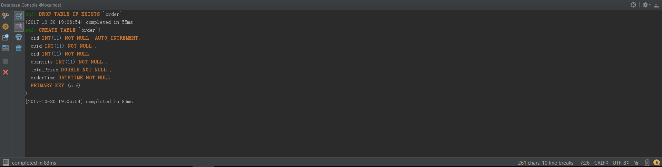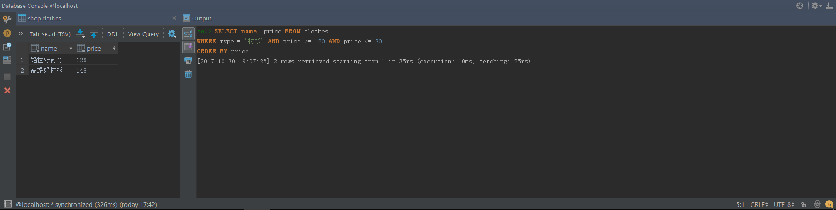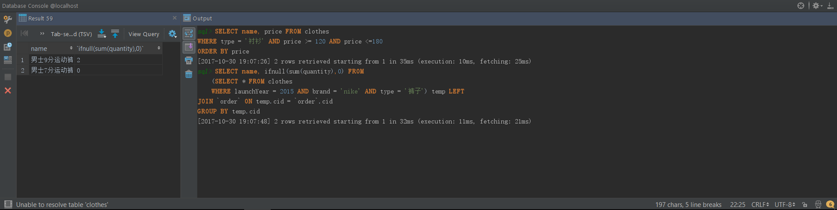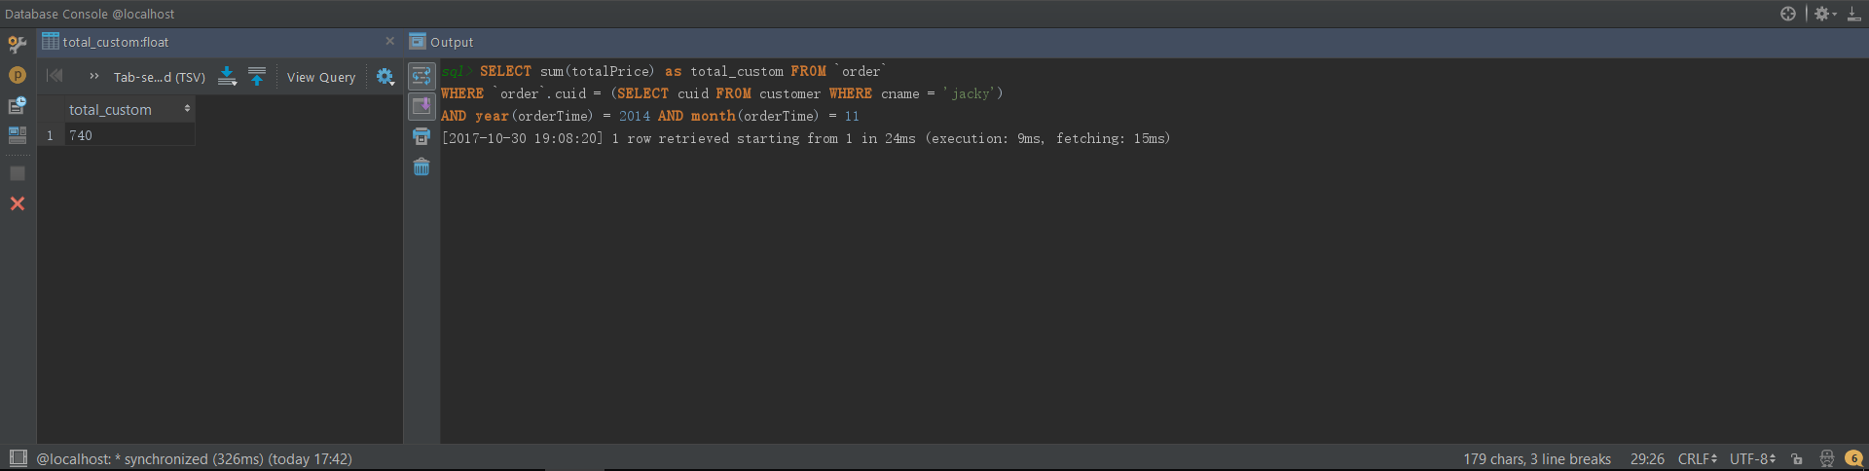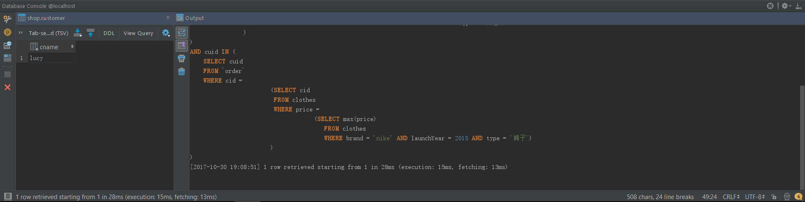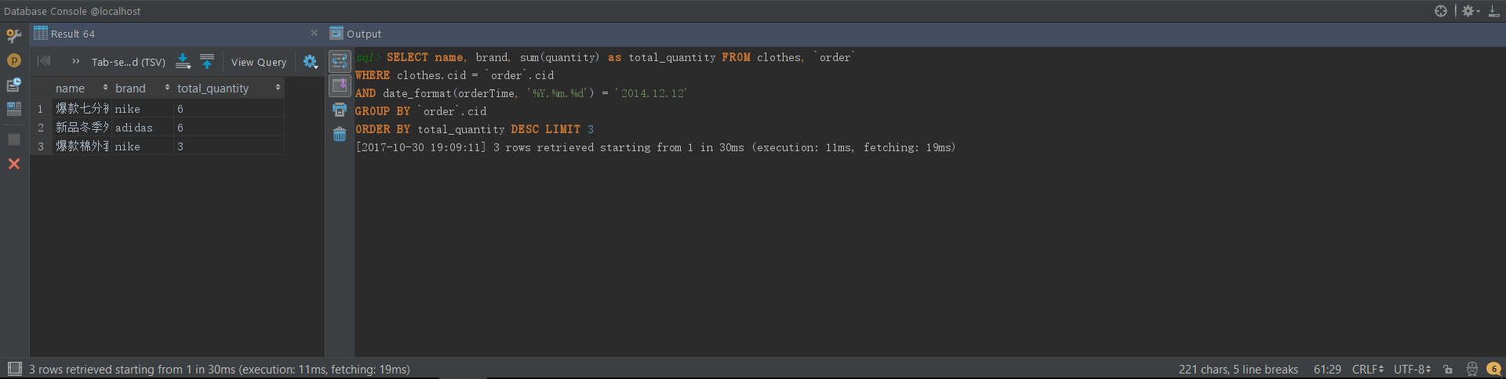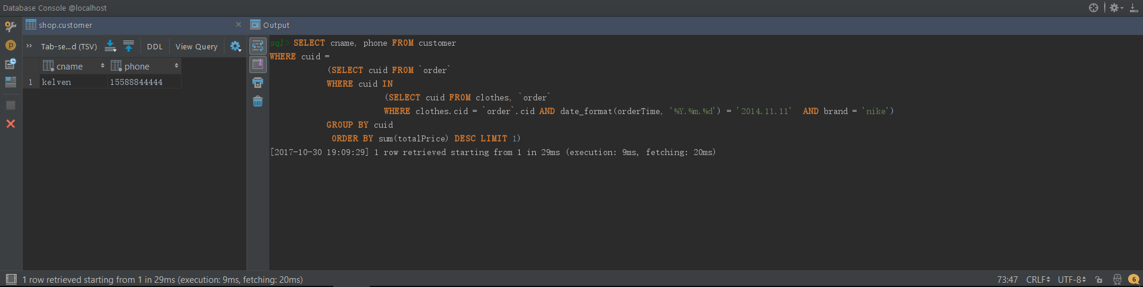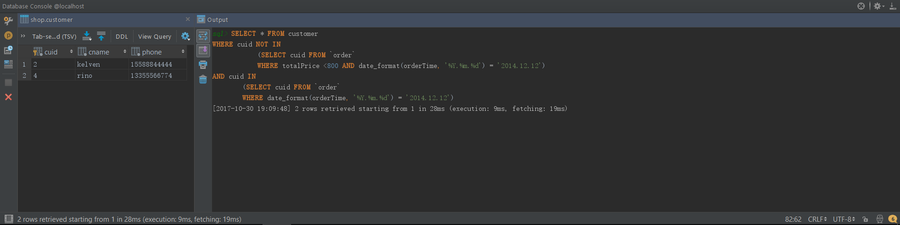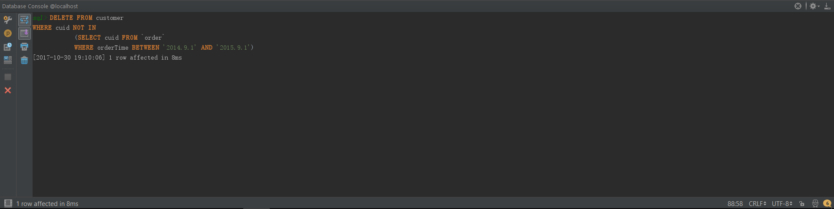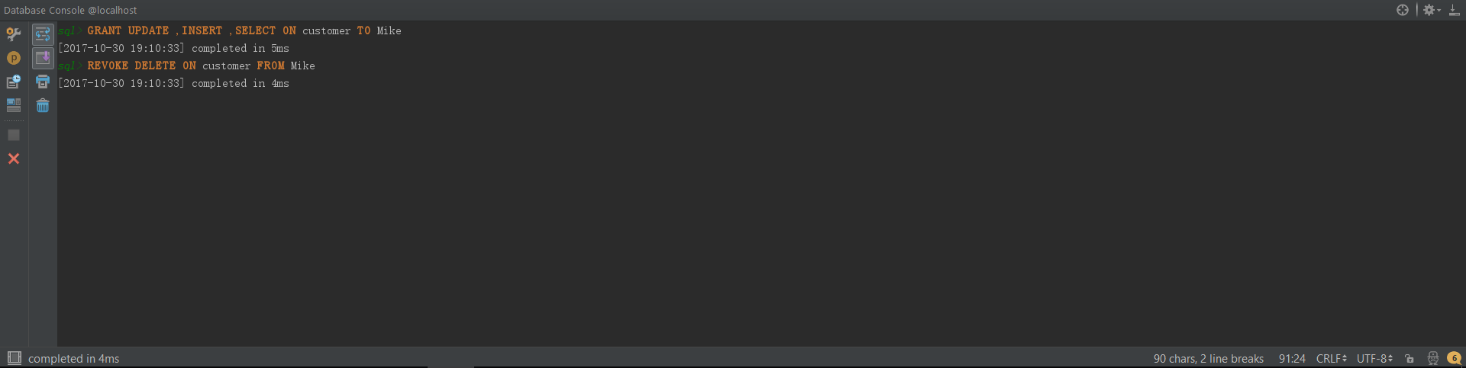

第二题源码：

#Answer2  
#author Bourbon  
#1  
**DELETE FROM commit WHERE** total_add > 5000 **AND** total_delete < 100;  
  
#2  
**SELECT** id, author, *sum*(total_add-total_delete) **AS** totalCode **FROM commit**, deadline  
**WHERE datetime BETWEEN** start_day **AND** end_day  
**GROUP BY** id, author;  
  
#3  
**SELECT** java_total/*count*(**DISTINCT** filename) **AS** percent, java_total, *count*(**DISTINCT** filename) **AS** total  
 **FROM file**,(**SELECT** *COUNT*(**DISTINCT** filename) **as** java_total  
 **FROM file  
 WHERE** filename **LIKE** '%.java') **AS** j;  
  
#4  
**SELECT** id, oneday, *max*(**count**) **FROM** (**SELECT** id, *date_format*(**datetime**, '%Y-%m-%d') **AS** oneday, *count*(*) **AS count FROM commit**, deadline  
**WHERE** *date_format*(**datetime**, '%Y-%m-%d') **BETWEEN** start_day **AND** end_day  
**GROUP BY** id, *date_format*(**datetime**, '%Y-%m-%d')) **AS** everyday  
**GROUP BY** id;  
  
#5  
**SELECT** filename, *sum*(add_line-delete_line) **AS** totalCode **FROM file  
WHERE** filename **LIKE** '%.java'  
**GROUP BY** filename  
**HAVING** totalCode > 200  
**ORDER BY** totalCode **DESC** ;  
  
#6  
**UPDATE** deadline  
**SET** end_day = *date_sub*(end_day, **INTERVAL** 1 **WEEK**)  
**WHERE** id = 3;

运行截图：

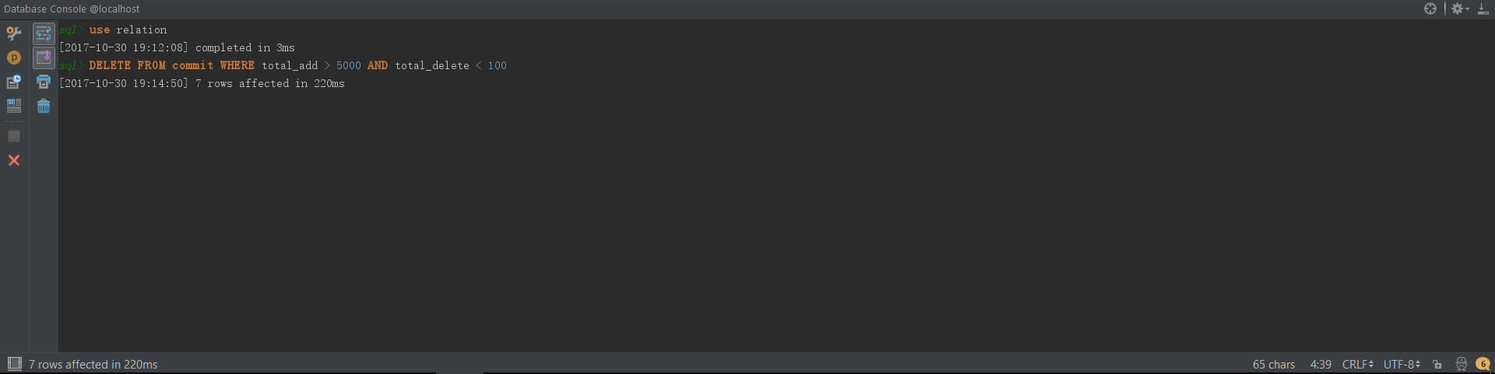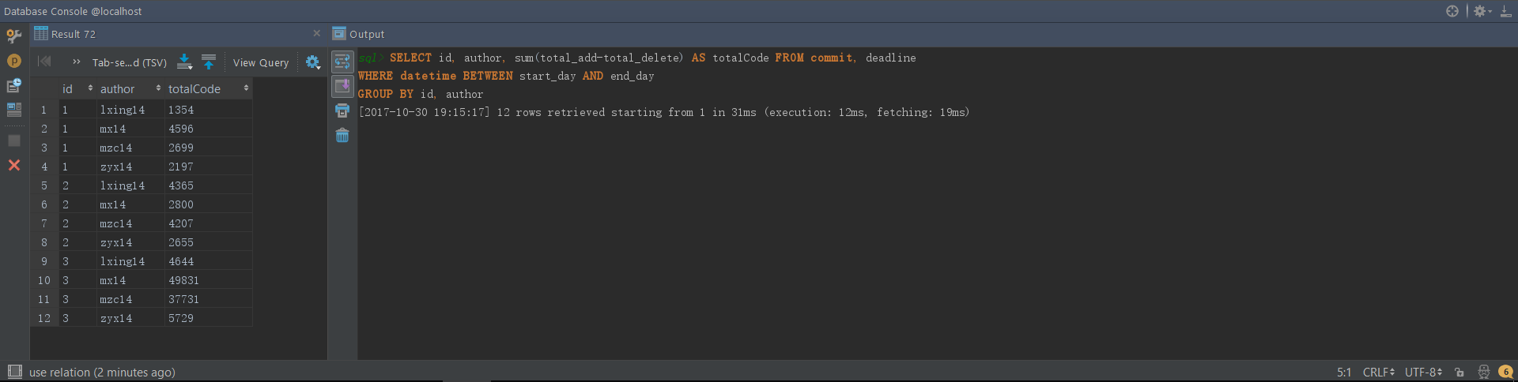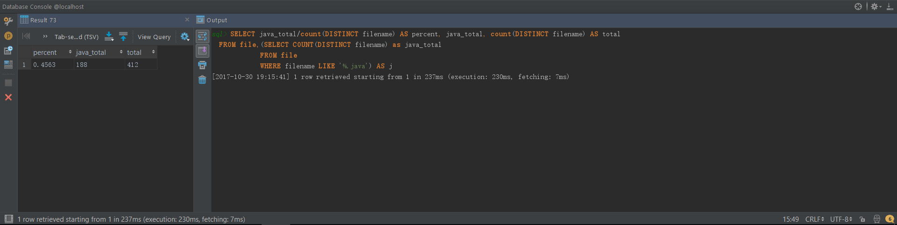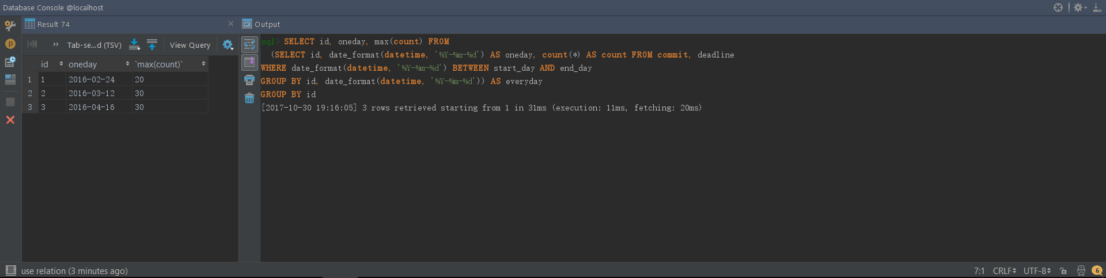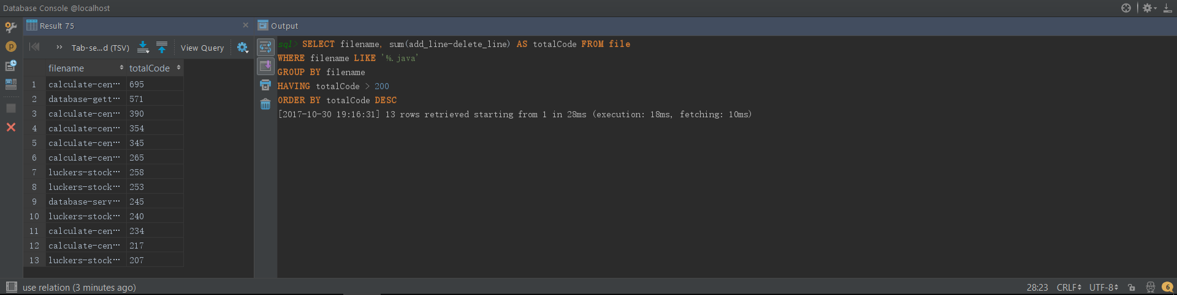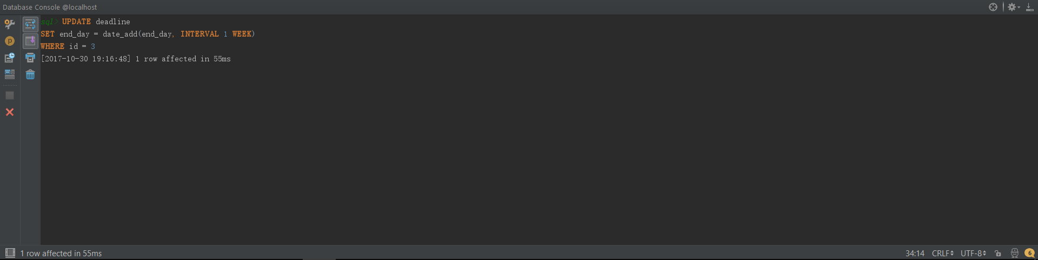

第三题源码：

#Answer3  
#author Bourbon  
#1  
**GRANT INSERT** ,**UPDATE** ,**SELECT ON** platform_writer  
**TO** writer@'120.55.91.83' **IDENTIFIED BY** 'writer';  
  
#2  
**SELECT** article_title, content, writer_id **FROM** platform_article, platform_deal  
**WHERE** reader_id = 'zoe'  
 **AND** platform_article.article_id = platform_deal.article_id  
**ORDER BY** platform_deal.create_time **DESC LIMIT** 3;  
  
#3  
**SELECT** article_title,pay_number,total_payment  
**FROM** platform_article,  
 (**SELECT** article_id,*count*(*) **AS** pay_number,*sum*(deal_payment) **AS** total_payment  
 **FROM** platform_deal  
 **GROUP BY** article_id  
 **ORDER BY** pay_number **DESC LIMIT** 3) **AS** temp  
**WHERE** platform_article.article_id = temp.article_id;  
  
#4  
**UPDATE** platform_writer **SET** writer_name = *concat*('w_',writer_name);  
  
#5  
**CREATE TRIGGER** pre_trigger  
**BEFORE INSERT  
 ON** platform_writer  
 **FOR EACH ROW  
 BEGIN  
 SET** NEW .writer_name = *concat*('w_', NEW .writer_name);  
 **END**;  
  
#6  
**SELECT** writer_name, *count*(platform_article.article_id) **AS** total_article,  
 *count*(**DISTINCT** reader_id) **AS** total_reader  
**FROM** platform_writer, platform_article, platform_deal  
**WHERE** platform_writer.writer_id = platform_article.writer_id  
 **AND** platform_article.article_id = platform_deal.article_id  
**GROUP BY** platform_writer.writer_id  
**ORDER BY** total_reader **DESC** ;  
  
#7  
**CREATE VIEW** article **AS  
SELECT** platform_article.article_id, platform_article.writer_id,  
 article_title, content, platform_article.create_time,  
 *sum*(deal_payment), writer_name, writer_email  
 **FROM** platform_writer, platform_article, platform_deal  
 **WHERE** platform_writer.writer_id = platform_article.writer_id  
 **AND** platform_article.article_id = platform_deal.article_id  
 **GROUP BY** platform_article.article_id;  
  
#8  
**SELECT** platform_deal.reader_id, reader_name, platform_deal.create_time,  
 *count*(deal_id) **AS** reading_num, *sum*(deal_payment) total_payment  
**FROM** platform_reader, platform_deal  
**WHERE** platform_reader.reader_id = platform_deal.reader_id  
**GROUP BY** platform_deal.reader_id,  
 *date_format*(platform_deal.create_time, '%Y-%m-%d')  
**ORDER BY** *date_format*(platform_deal.create_time, '%Y-%m-%d') **DESC** ;

运行截图：

