# ***Mediterranean chicken tray bake***

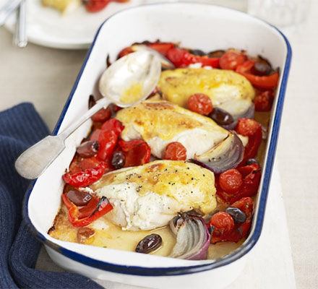

### *INGREDIENTS*

* 2 red peppers, deseeded and cut into chunks
* 1 red onion, cut into wedges
* 2 tsp olive oil
* 4 skin-on chicken breasts
* ½ x 150g pack full-fat garlic & herb soft cheese
* 200g pack cherry tomatoes handful black olives

### *INSTRUCTIONS*

1. Heat oven to 200C/180C fan/gas 6.
2. Mix the peppers and onion on a big baking tray with half the oil. Transfer to the oven and cook on the top shelf for 10 mins.
3. Meanwhile, carefully make a pocket between the skin and the flesh of each chicken breast, but don’t pull off the skin completely.
4. Push equal amounts of cheese under the skin, smooth the skin back down, brush it with the rest of the oil, season, then add to the tray along with the tomatoes and olives.
5. Return to the oven and cook for 25-30 mins more until the chicken is golden and cooked.
6. Serve with baked potatoes, if you like.

# ***Mediterranean Shrimp Orzo Salad***

### *INGREDIENTS*

* 1 package (16 ounces) orzo pasta
* 3/4 pound peeled and deveined cooked shrimp (31-40 per pound), cut into thirds
* 1 can (14 ounces) water-packed quartered artichoke hearts, rinsed and drained
* 1 cup finely chopped green pepper
* 1 cup finely chopped sweet red pepper
* 3/4 cup finely chopped red onion
* 1/2 cup pitted Greek olives
* 1/2 cup minced fresh parsley
* 1/3 cup chopped fresh dill
* 3/4 cup Greek vinaigrette

### *INSTRUCTIONS*

1. Cook orzo according to package directions. Drain; rinse with cold water and drain well.
2. In a large bowl, combine orzo, shrimp, vegetables, olives and herbs. Add vinaigrette; toss to coat. Refrigerate, covered, until serving.

# ***Slow-Cooked Moroccan Chicken***

# *INGREDIENTS*

* 3/4 pound peeled and deveined cooked shrimp (31-40 per pound), cut
* 4 medium carrots, sliced
* 2 large onions, halved and sliced
* 1 broiler/fryer chicken (3 to 4 pounds), cut up, skin removed
* 1/2 teaspoon salt
* 1/2 cup chopped dried apricots
* 1/2 cup raisins
* 1 can (14-1/2 ounces) reduced-sodium chicken broth
* *1/4 cup tomato paste*
* *2 tablespoons all-purpose flour*
* *2 tablespoons lemon juice*
* *2 garlic cloves, minced*
* *1-1/2 teaspoons ground ginger*
* *1-1/2 teaspoons ground cumin*
* *1 teaspoon ground cinnamon*
* *3/4 teaspoon pepper*
* *Hot cooked couscous*

*INSTRUCTIONS*

1. Place carrots and onions in a greased 5-qt. slow cooker.
2. Sprinkle chicken with salt; add to slow cooker.
3. Top with apricots and raisins.
4. In a small bowl, whisk broth, tomato paste, flour, lemon juice, garlic and seasonings until blended; add to slow cooker.
5. Cook, covered, on low until chicken is tender, 6-7 hours.
6. Serve with hot cooked couscous.

# ***Easy Moroccan Chickpea Stew***

# *INGREDIENTS*

* 1 tablespoon olive oil
* 2 cups cubed peeled butternut squash (1/2-inch cubes)
* 1 large onion, chopped
* 1 large sweet red pepper, chopped
* 1 teaspoon ground cinnamon
* 1/2 teaspoon pepper
* 1/4 teaspoon ground ginger
* 1/4 teaspoon ground cumin
* 1/4 teaspoon salt 1 can (15 ounces) chickpeas or garbanzo beans, rinsed and drained
* 1 can (14-1/2 ounces) diced tomatoes, undrained
* 1 cup water Chopped cilantro, optional

*INSTRUCTIONS*

1. In a Dutch oven, heat oil over medium-high heat. Add squash, onion and red pepper; cook and stir until onion is translucent and red pepper is crisp-tender, about 5 minutes.
2. Stir in seasonings until blended.
3. Add remaining ingredients; bring to a boil.
4. Reduce heat; cover and simmer until squash is tender, about 8 minutes.
5. If desired, top with cilantro.

# ***Mediterranean Hummus Nachos***

# *INGREDIENTS*

* 1/2 pound ground lamb or lean ground beef (90% lean)
* 1 tablespoon pine nuts
* 1/4 teaspoon salt
* 1/8 teaspoon pepper
* 6 tablespoons plain yogurt, divided
* 1 package (7.33 ounces) baked pita chips
* 1 cup prepared tabbouleh
* 1/2 cup hummus
* 1 large tomato, chopped
* 1/4 cup sliced ripe olives
* 1 tablespoon minced fresh parsley
* 1 tablespoon minced fresh mint
* Chopped red onion, optional

*INSTRUCTIONS*

1. In a small skillet, cook lamb over medium heat until no longer pink, breaking into crumbles, 4-6 minutes; drain.
2. Stir in pine nuts, salt and pepper; cool slightly.
3. Stir in 2 tablespoons yogurt.
4. Arrange pita chips on a serving platter.
5. Layer with lamb mixture, tabbouleh, hummus, tomatoes, olives, parsley, mint, remaining yogurt and, if desired, onions.
6. Serve immediately.

*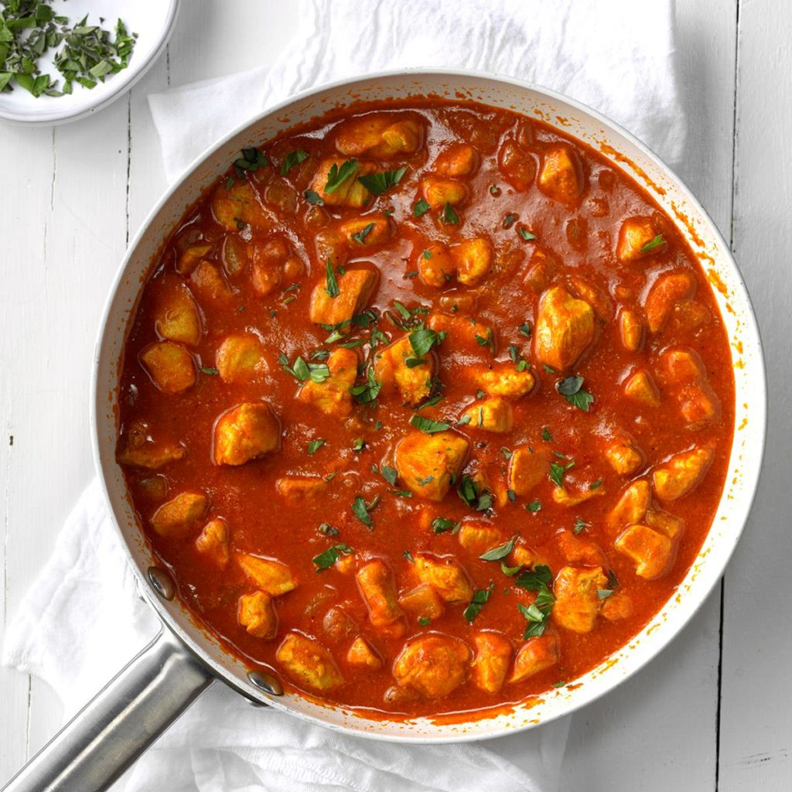****Saucy Mediterranean Chicken with Rice***

# *INGREDIENTS*

* 3/4 cup water
* 3 tablespoons tomato paste
* 2 tablespoons lemon juice
* 3/4 teaspoon salt
* 1 teaspoon chili powder
* 1/2 teaspoon garlic powder
* 1/2 teaspoon ground ginger
* 1/4 teaspoon ground fennel seed
* 1/4 teaspoon ground turmeric
* 1 teaspoon ground coriander, optional
* 3 tablespoons olive oil
* medium onion, chopped
* 1 pound boneless skinless chicken breasts, cut into 1-inch cubes cups hot cooked rice
* Minced fresh parsley, optional

*INSTRUCTIONS*

1. In a small bowl, mix the water, tomato paste, lemon juice, salt, chili powder, garlic powder, ginger, fennel, turmeric and, if desired, coriander until smooth.
2. In a large skillet, heat oil over medium-high heat. Add onions; cook and stir until tender. Stir in chicken; brown 3-4 minutes.
3. Pour water mixture into pan.
4. Bring to a boil. Reduce heat; simmer, uncovered, until chicken is no longer pink, 8-10 minutes.
5. Serve with rice.
6. If desired, top with parsley.

# ***Mediterranean Chicken Orzo Soup***

# *INGREDIENTS*

* 3/4 pound boneless skinless chicken breasts, cubed
* 2 celery ribs, chopped
* 2 medium carrots, chopped
* 1 small onion, chopped
* 1/2 teaspoon salt
* 1/2 teaspoon dried oregano
* 1/4 teaspoon pepper
* 1/4 cup white wine or additional reduced-sodium chicken broth
* 1 carton (32 ounces) reduced-sodium chicken broth
* 1 teaspoon minced fresh rosemary
* 1 bay leaf
* 1 cup uncooked whole wheat orzo pasta
* 1 teaspoon grated lemon zest
* 1 tablespoon lemon juice
* Minced fresh parsley, optional

*INSTRUCTIONS*

1. In a large saucepan, heat 1 tablespoon oil over medium-high heat.
2. Add chicken; cook and stir 6-8 minutes or until no longer pink. Remove from pan.
3. In same pan, heat remaining oil over medium-high heat. Add vegetables, salt, oregano and pepper; cook and stir 4-6 minutes or until vegetables are crisp-tender.
4. Add wine, stirring to loosen browned bits from pan.
5. Stir in broth, rosemary and bay leaf; bring to a boil.
6. Add orzo. Reduce heat; simmer, covered, 15-18 minutes or until orzo is tender, stirring occasionally.
7. Return chicken to pan; heat through.
8. Stir in lemon zest and juice; remove bay leaf.
9. If desired, top each serving with parsley.

# ***Greek Butter Crescents***

# *INGREDIENTS*

* 1 pound butter, melted and cooled
* 3-1/2 cups confectioners' sugar, divided
* 1 large egg yolk
* 1 teaspoon vanilla extract
* 6 cups all-purpose flour
* 1/4 teaspoon baking powder

*INSTRUCTIONS*

1. Preheat oven to 400°. In a large bowl, beat butter and 1/2 cup confectioners' sugar until blended.
2. Beat in egg yolk and vanilla. In another bowl, whisk flour and baking powder; gradually stir into creamed mixture until blended (mixture will be crumbly).
3. Shape heaping tablespoons of dough into crescents. Place 1 in. apart on ungreased baking sheets.
4. Bake 12-15 minutes or until edges are lightly browned. Remove from pans to wire racks to cool 15 minutes.
5. Place remaining sugar in a small bowl.
6. Toss slightly cooled cookies in sugar; return cookies to wire rack to cool completely.
7. Toss cookies in sugar once more before serving.
8. Store in an airtight container, adding any remaining confectioners' sugar to cover cookies.

# ***Mediterranean Artichoke and Red Pepper Roll-Ups***

# *INGREDIENTS*

* 1 can (14 ounces) water-packed artichoke hearts, rinsed, drained and finely chopped
* 4 ounces cream cheese, softened
* 1/3 cup grated Parmesan cheese
* 1/4 cup crumbled feta cheese
* 2 green onions, thinly sliced
* 3 tablespoons prepared pesto
* 8 flour tortillas (8 inches), warmed
* 1 jar (7-1/2 ounces) roasted sweet red peppers, drained and cut into strips

SAUCE:

* 1 cup sour cream
* 1 tablespoon minced chives

*INSTRUCTIONS*

1. In a small bowl, combine the artichokes, cream cheese, Parmesan cheese, feta cheese, green onions and pesto until blended.
2. Spread 1/4 cup mixture over each tortilla; top with red peppers and roll up tightly.
3. Place 1 in. apart on a greased baking sheet. Bake at 350° until heated through, 12-15 minutes.
4. Cut into thirds.
5. Meanwhile, in a small bowl, combine sour cream and chives.
6. Serve with rolls.

# ***Mediterranean Chicken***

# *INGREDIENTS*

* 4 boneless skinless chicken breast halves (6 ounces each)
* 1/4 teaspoon salt
* 1/4 teaspoon pepper
* 3 tablespoons olive oil
* 1 pint grape tomatoes
* 16 pitted Greek or ripe olives, sliced
* 3 tablespoons capers, drained

*INSTRUCTIONS*

1. Sprinkle chicken with salt and pepper.
2. In a large ovenproof skillet, cook chicken in oil over medium heat until golden brown, 2-3 minutes on each side.
3. Add the tomatoes, olives and capers.
4. Bake, uncovered, at 475° until a thermometer reads 170°,10-14 minutes.