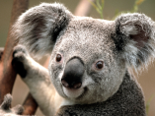This is text floating over image.

This is a second paragraph.