Lactation curve modelling to evaluate the impact of delayed milk ejection
Supplemental materials
Meike B. van Leerdam,¹* Matthias Wieland,² and Miel Hostens¹
¹Department of Animal Science, Cornell University, Ithaca, NY, 14853
² Department of Population Medicine and Diagnostic Sciences, Cornell University, Ithaca, NY,14853
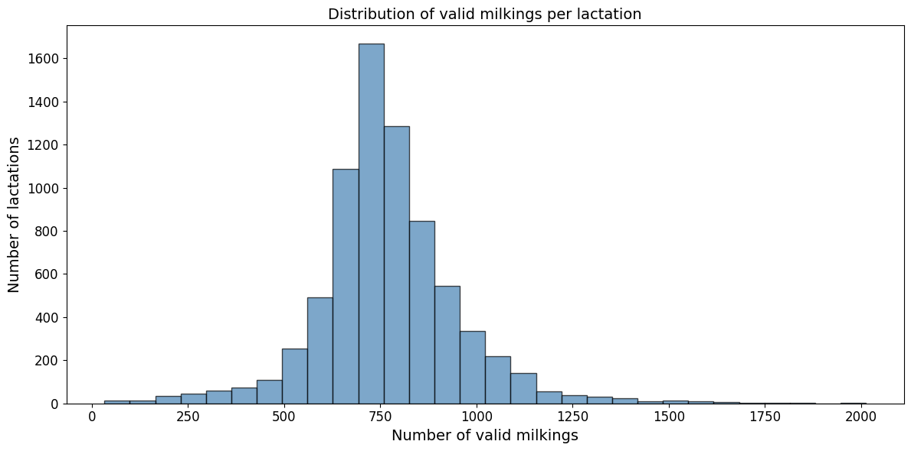
*Corresponding author: mbv32@cornell.edu
Supplemental Figure S1. Histogram of the number of available observations per lactation. The minimum number of observations was set to be 30.

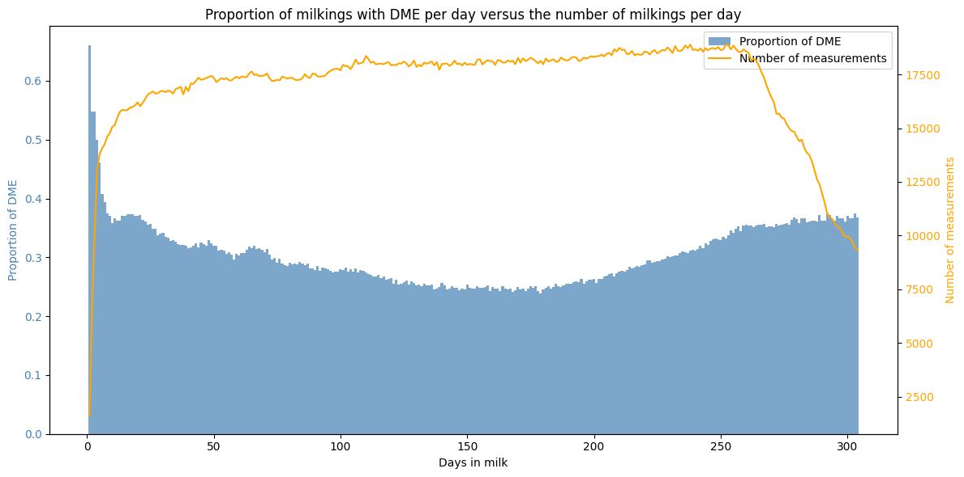
Supplemental Figure S2. Dual axis figure with the proportion of DME per DIM as a blue bar and the number of observations per DIM as an orange line.
Supplemental Figure S3. Histograms of time to peak separated by parity (1,2 and 3+). As most cows have had their peak at 150 DIM, this was chosen as the threshold for the part of the lactation representative for peak yield.
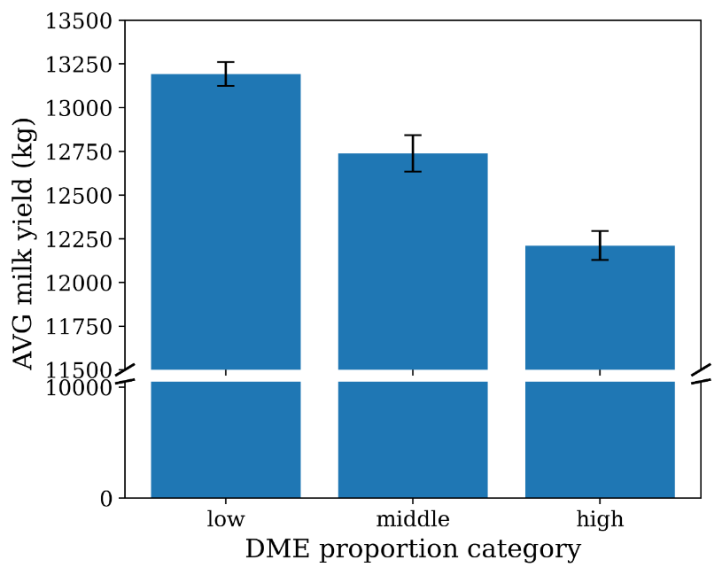
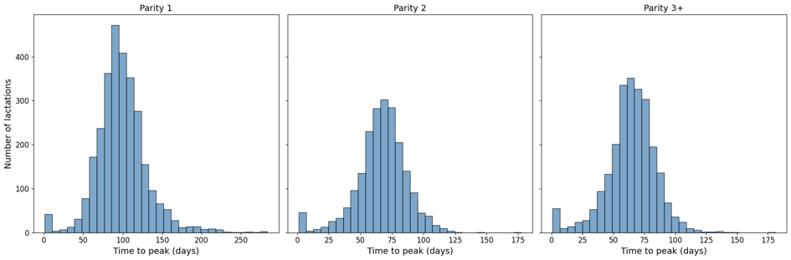

Supplemental Figure S4. Mean cumulative milk yield over 305 days for 7,435 lactations, categorized by the proportion of milkings with DME within each lactation: low (≤20%), middle (>20% to ≤40%), and high (>40%). Error bars represent the 95% confidence intervals of the mean cumulative milk yield.

Supplemental Tabel S1. Association of DME proportion during the lactation, parity, calving year and season with cumulative milk yield (m305).
Variable | DME as continuous variable¹ |  | DME as categorical variable¹
 | β ² | P -value |  | β ² | P -value
Parity 2 | 2,045  (1,936, 2,155) | < 0.001 |  | 2,087  (1,976, 2,198) | < 0.001
Parity 3 | 2,265  (2,132, 2,398) | < 0.001 |  | 2,337  (2,202, 2,471) | < 0.001
Parity 4+ | 2,304  (2,172, 2,437) | < 0.001 |  | 2,409  (2,275, 2,542) | < 0.001
DME proportion | -154  (-172, -136) | < 0.001
DME middle vs low |  |  |  | -206  (-326, -85) | 0.001
DME high vs low |  |  |  | -590  (-695, -485) | < 0.001
Calving year | 59  (-24, 143) | 0.16 |  | 93  (8, 177) | 0.03
Spring calving | 47  (-89, 183) | 0.45 |  | 37  (-100, 175) | 0.59
Summer calving | -44  (-174, 85) | 0.50 |  | -44  (-175, 87) | 0.51
Autumn calving | 24  (-107, 154) | 0.72 |  | 3  (-129, 135) | 0.97
¹Model categories include low (≤ 20%), middle (> 20, ≤40%), and high (>40%) DME proportion. The low DME proportion served as the reference category.
²The 95% confidence interval is given within brackets.

Supplemental Tabel S2. Association of DME proportion during the entire lactation, parity, calving year and season with Peak yield (ypeak).
Variable | DME as continuous variable¹ |  | DME as categorical variable¹
 | β ² | P -value | β ² | P -value
Parity 2 | 11.9  (11.4, 12.3) | < 0.001 | 12.0  (11.6, 12.5) | < 0.001
Parity 3 | 14.3  (13.8, 14.9) | < 0.001 | 14.5  (14.0, 15.1) | < 0.001
Parity 4+ | 14.1  (13.5, 14.6) | < 0.001 | 14.4  (13.9, 15.0) | < 0.001
DME proportion | -0.5  (-0.5, -0.4) | < 0.001
DME middle vs low |  |  | -0.3  (-0.7, 0.2) | 0.31
DME high vs low |  |  | -1.8  (-2.3, -1.4) | < 0.001
Calving year | -0.6  (-0.9, -0.2) | 0.001 | -0.5  (-0.8, -0.1) | 0.01
Spring calving | 0.6  (0.1, 1.2) | 0.03 | 0.6  (0.0, 1.1) | 0.04
Summer calving | -0.3  (-0.8, 0.2) | 0.26 | -0.3  (-0.8, 0.2) | 0.27
Autumn calving | -0.4  (-0.9, 0.1) | 0.14 | -0.44  (-1.0, 0.1) | 0.10
¹Model categories include low (≤ 20%), middle (> 20, ≤40%), and high (>40%). The low DME proportion served as the reference category.
²The 95% confidence interval is given within brackets

Supplemental Tabel S3. Association of DME proportion during the lactation, parity, calving year and season with time to peak (tpeak).
Variable | DME as continuous variable¹ |  | DME as categorical variable¹
 | β ² | P -value | β ² | P -value
Parity 2 | -33.3  (-34.9, -31.7) | < 0.001 | -33.2  (-34.8, -31.6) | < 0.001
Parity 3 | -35.9  (-37.8, -33.9) | < 0.001 | -35.6  (-37.6, -33.7) | < 0.001
Parity 4+ | -36.0  (-37.9, -34.0) | < 0.001 | -35.7  (-37.6, -33.7) | < 0.001
DME proportion | -0.5  (-0.8, -0.3) | < 0.001
DME middle vs low |  |  | -0.8  (-2.5, 0.9) | 0.38
DME high vs low |  |  | -2.2  (-3.7, -0.7) | 0.01
Calving year | 6.6  (5.3, 7.8) | < 0.001 | -0.5  (5.4, 7.9) | < 0.001
Spring calving | -4.2  (-6.2, -2.3) | < 0.001 | -4.3  (-6.3, -2.3) | < 0.001
Summer calving | -1.0  (-2.9, 0.9) | 0.31 | -1.0  (-2.9, 0.9) | 0.31
Autumn calving | 1.7  (-0.3, 3.6) | 0.09 | 1.6  (-0.3, 3.5) | 0.10
¹Model categories include low (≤ 20%), middle (> 20, ≤40%), and high (>40%). The low DME proportion served as the reference category.
²The 95% confidence interval is given within brackets

Supplemental Tabel S4. Association of DME proportion during the lactation, parity, calving year and season with log-transformed persistency. Percentage change was calculated by taking the exponential value of the model coefficient (e^{β}).
Variable | DME as continuous variable¹ |  |  |  | DME as categorical variable¹
 | β ² | P -value | % change³ | β ² |  | P -value | % change
Parity 2 | -0.97  (-1.02, -0.93) | < 0.001 | -62% | -0.98  (-1.02, -0.93) |  | < 0.001 | -62%
Parity 3 | -1.10  (-1.16, -1.05) | < 0.001 | -67% | -1.11  (-1.16, -1.05) |  | < 0.001 | -67%
Parity 4+ | -1.14  (-1.19, -1.09) | < 0.001 | -68% | -1.15  (-1.20, -1.09) |  | < 0.001 | -68%
DME proportion | 0.00  (-0.00, 0.01) | 0.40 | 0%
DME middle vs low |  |  |  | -0.05  (-0.10, -0.00) |  | 0.04 | -5%
DME high vs low |  |  |  | 0.00  (-0.02, 0.04) |  | 1.00 | 0%
Calving year | 0.10  (0.10, 0.14) | < 0.001 | 11% | 0.10  (0.07, 0.13) |  | < 0.01 | 10%
Spring calving | -0.01  (-0.06, 0.05) | 0.77 | -1% | -0.01  (-0.06, 0.05) |  | 0.79 | -1%
Summer calving | 0.02  (-0.03, 0.07) | 0.49 | 2% | 0.02  (-0.03, 0.07) |  | 0.51 | 2%
Autumn calving | 0.09  (0.04, 0.14) | 0.001 | 9% | 0.09  (0.04, 0.14) |  | 0.001 | 9%
¹Model categories include low (≤ 20%), middle (> 20, ≤40%), and high (>40%). The low DME proportion served as the reference category.
²The 95% confidence interval is given within brackets
³ Because persistency was log transformed, coefficients were exponentiated to obtain the percentage change in persistency associated with a one-unit increase or decrease in the predictor variable, or relative to the reference category.

Supplemental Tabel S5. Association of DME proportion during the first half of the lactation (less or equal than 150 days in milk), parity, calving year and season with Peak yield (ypeak).
Variable | DME as continuous variable¹ |  | DME as categorical variable¹
 | β ² | P -value | β ² | P -value
Parity 2 | 11.5  (11.0, 11.9) | < 0.001 | 11.7  (11.2, 12.1) | < 0.001
Parity 3 | 13.6  (13.0, 14.1) | < 0.001 | 13.9  (13.3, 14.4) | < 0.001
Parity 4+ | 13.6  (13.1, 14.2) | < 0.001 | 14.2  (13.7, 14.8) | < 0.001
DME proportion | -0.4  (-0.4, -0.3) | < 0.001
DME middle vs low |  |  | -0.7  (-1.2, -0.1) | 0.014
DME high vs low |  |  | -2.3  (-2.7, -1.9) | < 0.001
Calving year | -0.7  (-1.0, -0.3) | < 0.001 | -0.7  (-1.0, -0.3) | < 0.001
Spring calving | 0.8  (0.3, 1.4) | 0.003 | 0.8  (0.2, 1.3) | 0.005
Summer calving | -0.1  (-0.7, 0.4) | 0.601 | -0.2  (-0.7, 0.3) | 0.478
Autumn calving | -0.3  (-0.8, 0.2) | 0.254 | -0.4  (-0.9, 0.1) | 0.150
¹Model categories include low (≤ 20%), middle (> 20, ≤40%), and high (>40%). The low DME proportion served as the reference category.
²The 95% confidence interval is given within brackets

Supplemental Tabel S6. Association of DME proportion during the second half of the lactation (over or equal to 150 days in milk), parity, calving year and season with log-transformed persistency. Percentage change was calculated by taking the exponential value of the model coefficient (e^{β}).
Variable | DME as continuous variable¹ |  |  |  | DME as categorical variable¹
 | β² | P -value | % change³ | β² |  | P -value | % change³
Parity 2 | -0.97  (-1.01, -0.93) | < 0.001 | -62% | -0.97 (-1.01, -0.92) |  | < 0.001 | -62%
Parity 3 | -1.10  (-1.16, -1.05) | < 0.001 | -67% | -1.10 (-1.15, -1.05) |  | < 0.001 | -67%
Parity 4+ | -1.14  (-1.19, -1.09) | < 0.001 | -68% | -1.15  (-1.20, -1.09) |  | < 0.001 | -68%
DME proportion | -0.01 (-0.02, -0.01) |  | -1.1%
  <0.001
DME middle vs low |  |  |  | -0.07 (-0.12, -0.02) |  | 0.007 | -7%
DME high vs low |  |  |  | -0.08 (-0.12, -0.04) |  |  | -8%
  < 0.001
Calving year | 0.09 | < 0.001 | 10% | 0.09 (0.06, 0.13) |  | < 0.001 | 10%
  (0.06,
  0.13)
Spring calving | -0.01  (-0.07, 0.04) | 0.71 | -1% | -0.01  (-0.06, 0.05) |  | 0.75 | -1%
Summer calving | 0.01  (-0.04, 0.06) | 0.64 | 2% | 0.02  (-0.04, 0.07) |  | 0.57 | 2%
Autumn calving | 0.09  (0.04, 0.14) | 0.001 | 9% | 0.09  (0.04, 0.14) |  | 0.001 | 10%
¹Model categories include low (≤ 20%), middle (> 20, ≤40%), and high (>40%). The low DME proportion served as the reference category.
²The 95% confidence interval is given within brackets
³ Because persistency was log transformed, coefficients were exponentiated to obtain the percentage change in persistency associated with a one-unit increase or decrease in the predictor variable, or relative to the reference category.

Cumulative 305-d milk yield | Time to peak
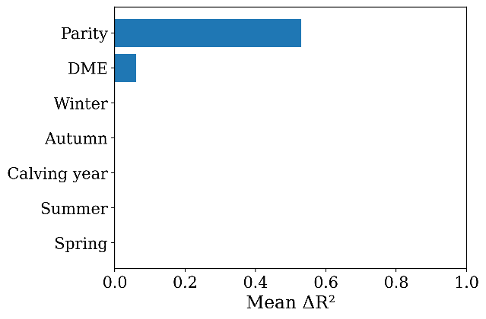 | 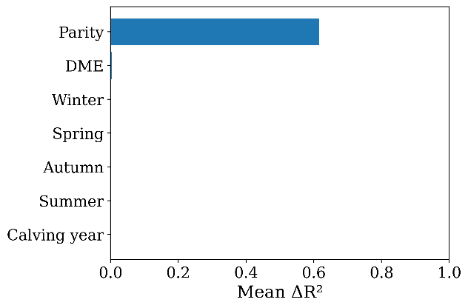
Peak yield | Persistency
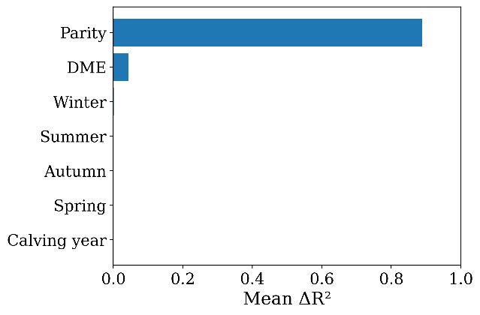 | 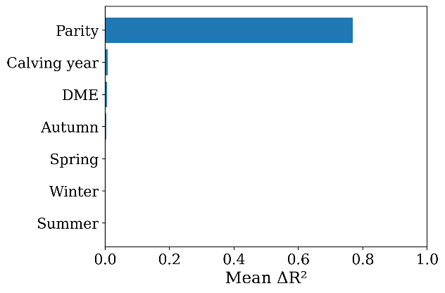
Peak yield (first half lactation DME)¹ | Persistency (second half lactation DME)²
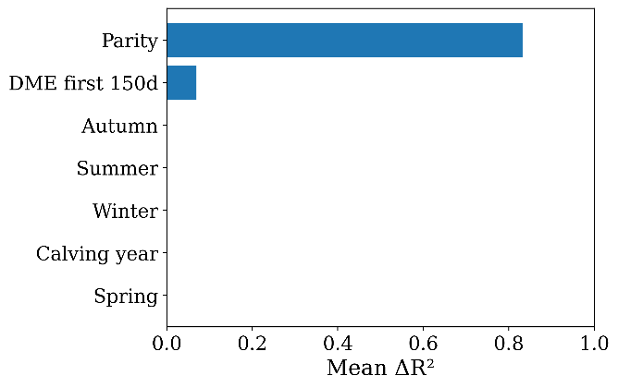 | 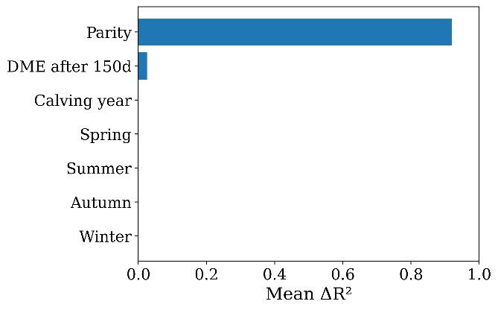
¹For this model, the proportion of milkings with DME was calculated only over the milking up to and including 150 days in milk.
²For this model, the proportion of milking with DME was calculated only over the milkings after and including 150 days in milk.

Supplemental Figure S5. Permutation feature importance of the random forest model for each lactation curve characteristic. This figure visualizes the decline in model performance, R² after random permutation of the predictor in the test set averaged over 30 permutations (∆R²). A bigger decline in R² signifies higher feature importance, while no reduction can be seen if the variable is not predictive for the outcome. The predictors are ordered based on the magnitude of the permutation effect.
Cumulative 305-d milk yield | Time to peak
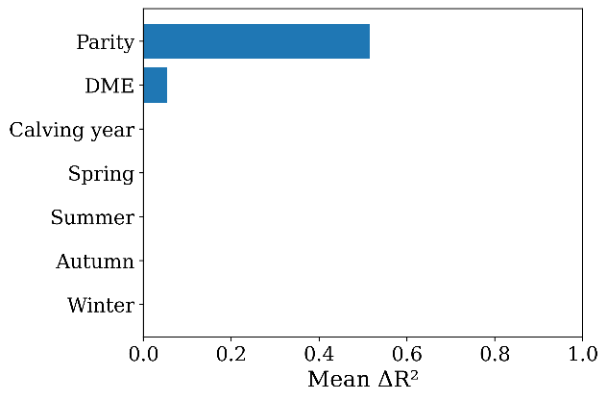 | 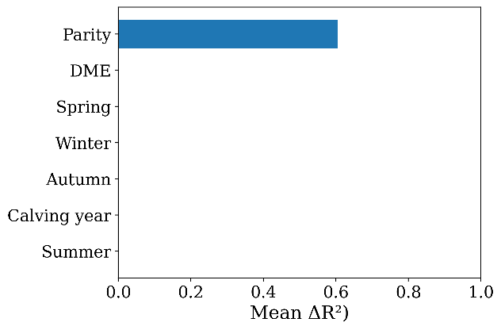
Peak yield | Persistency
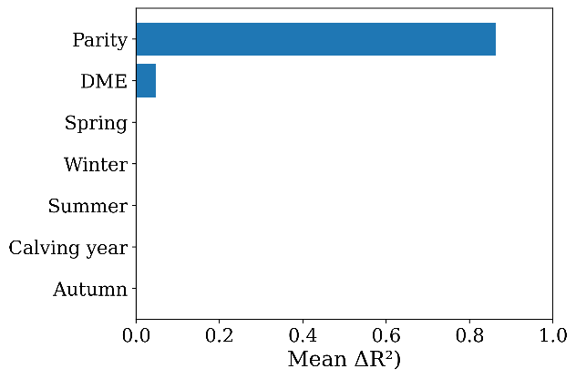 | 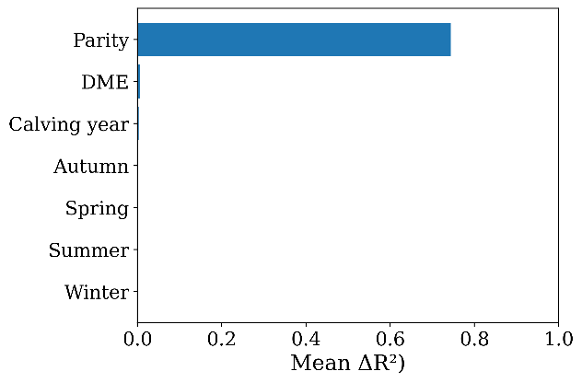
Peak yield (first half lactation DME)¹ | Persistency (second half lactation DME)²
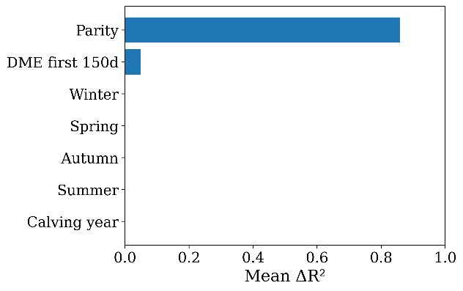 | 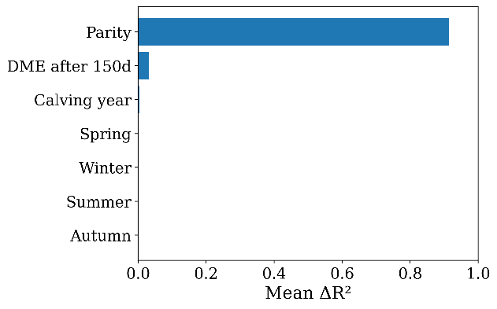
¹For this model, the proportion of milkings with DME was calculated only over the milking up to and including 150 days in milk.
²For this model, the proportion of milking with DME was calculated only over the milkings after and including 150 days in milk.

Supplemental Figure S6. Permutation feature importance of the XGBoost model for each lactation curve characteristic. This figure visualizes the decline in model performance, R² after random permutation of the predictor in the test set averaged over 30 permutations (∆R²). A bigger decline in R² signifies higher feature importance, while no reduction can be seen if the variable is not predictive for the outcome. The predictors are ordered based on the magnitude of the permutation effect.

Cumulative 305-d milk yield
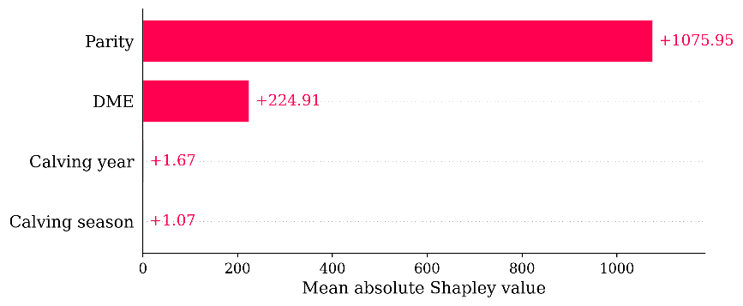

Time to peak
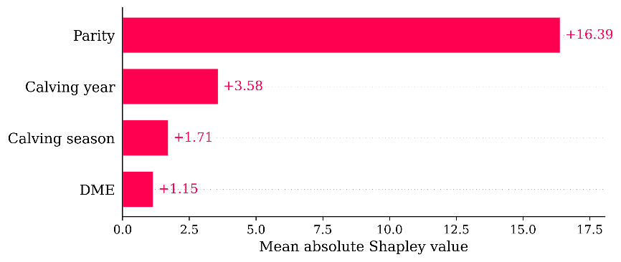
Peak yield
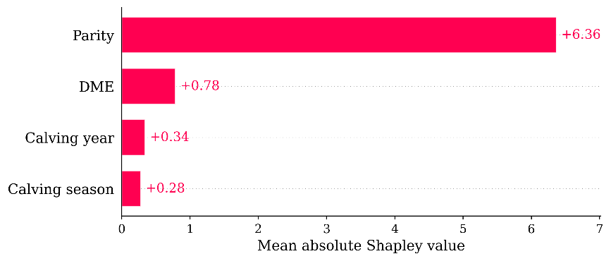
Peak yield (first half lactation DME)¹
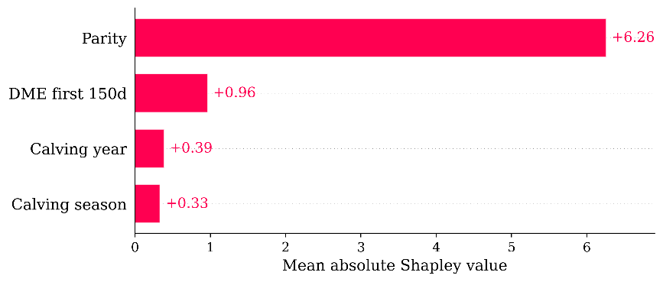
Persistency
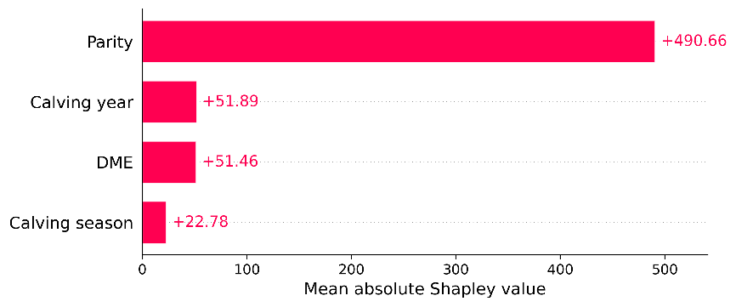
Persistency (second half lactation DME)²
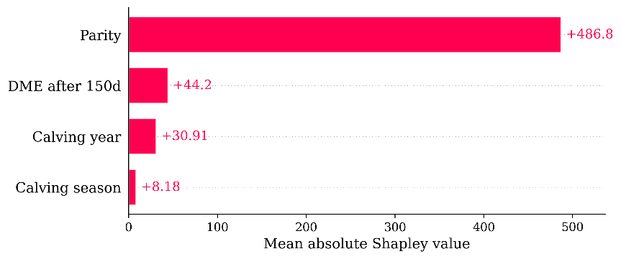
¹For this model, the proportion of milkings with DME was calculated only over the milking up to and including 150 days in milk.
²For this model, the proportion of milking with DME was calculated only over the milkings after and including 150 days in milk.

Supplemental Figure S7. Feature importance based on average absolute Shapley values for the random forest model. The Shapley value quantifies how much a predictor contributed to the final prediction and can therefore be used as a metric for feature importance. For all models parity was the most important feature. The importance of DME differed by LC characteristic, with the highest relative importance for cumulative milk yield. The predictors are ordered based on the magnitude of the permutation effect.
Cumulative 305-d milk yield
Time to peak
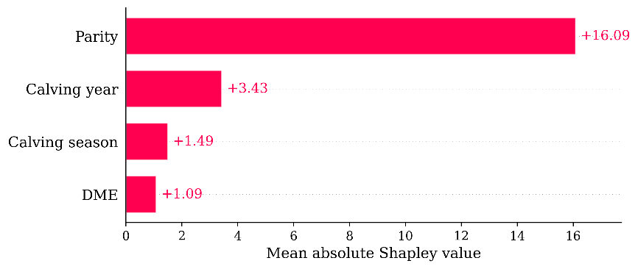
Peak yield
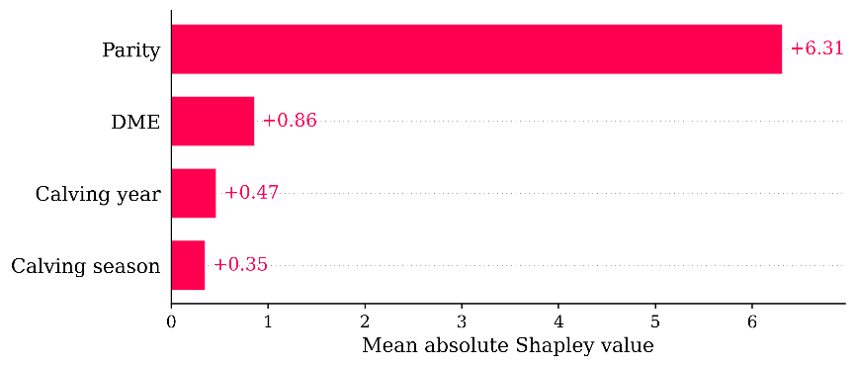
Peak yield (first half lactation DME)¹
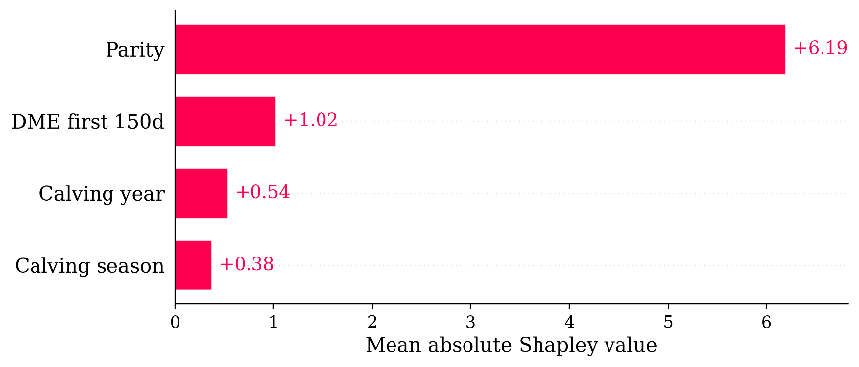
Persistency
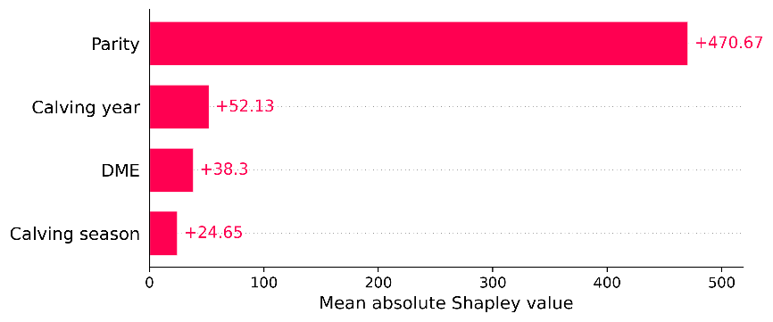
Persistency (second half lactation DME)²
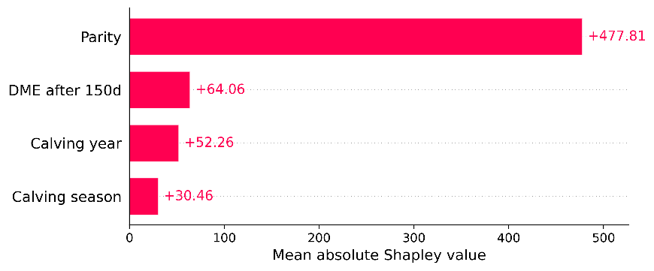
¹For this model, the proportion of milkings with DME was calculated only over the milking up to and including 150 days in milk.
²For this model, the proportion of milking with DME was calculated only over the milkings after and including 150 days in milk.

Supplemental Figure S8. Feature importance based on average absolute Shapley values for the XGBoost model. The Shapley value quantifies how much a predictor contributed to the final prediction and can therefore be used as a metric for feature importance. For all models parity was the most important feature. The importance of DME differed by LC characteristic, with the highest relative importance for cumulative milk yield. The predictors are ordered based on the magnitude of the permutation effect.
Cumulative 305-d milk yield | Time to peak
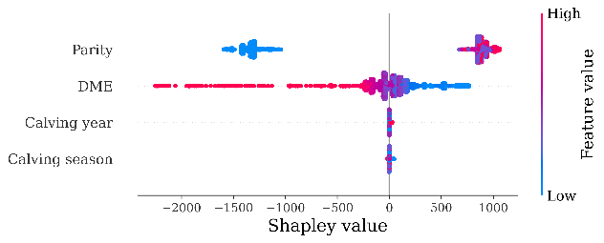 | 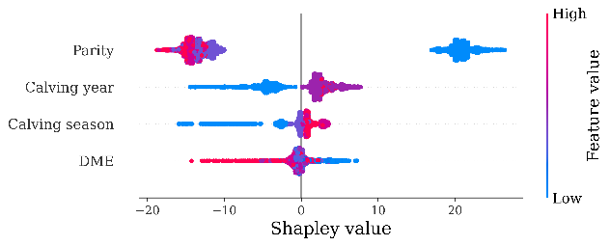
Peak yield | Persistency
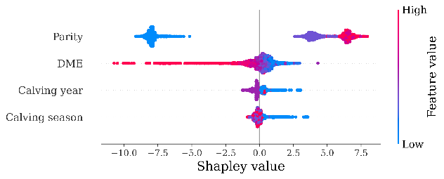 | 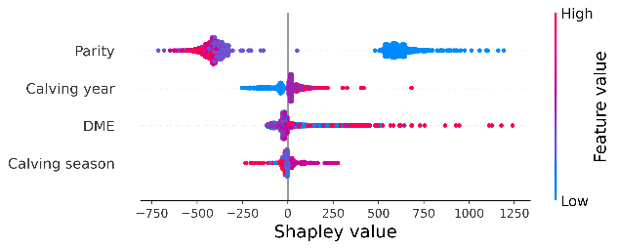
Peak yield (first half lactation DME)¹ | Persistency (second half lactation DME)²
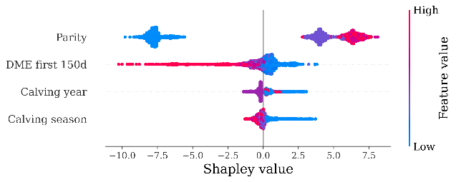 | 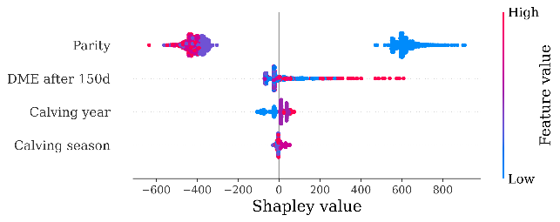
¹For this model, the proportion of milkings with DME was calculated only over the milking up to and including 150 days in milk.
²For this model, the proportion of milking with DME was calculated only over the milkings after and including 150 days in milk.

Supplemental Figure S9. Beeswarm plots for the random forest model. A Shapely value beeswarm plot depicts the distribution and magnitude of feature contributions across all model predictions, showing both the importance of each feature (x-axis) and how different feature values influence the prediction direction (color). The Shapely values of observations with a DME proportion on the outside of the distribution have a much bigger influence on the final predictions while average feature DME proportion has a Shapely value of almost zero in all the models.
Cumulative 305-d milk yield | Time to peak
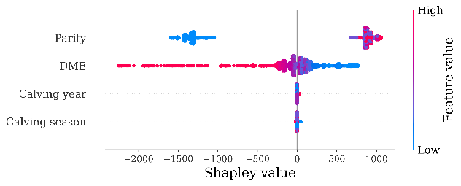 | 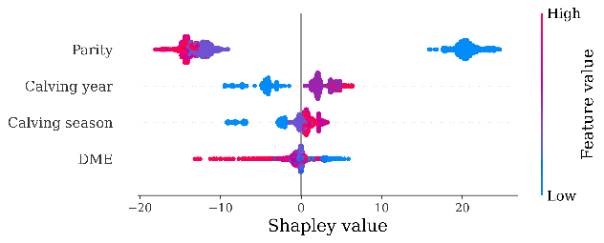
Peak yield | Persistency
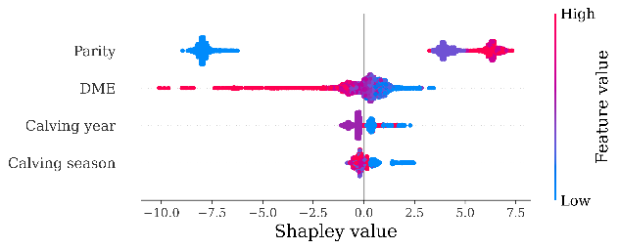 | 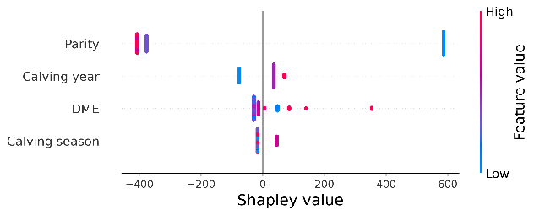
Peak yield (first half lactation DME)¹ | Persistency (second half lactation DME)²
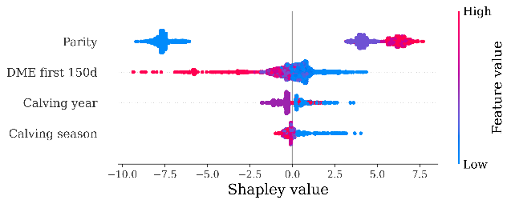 | 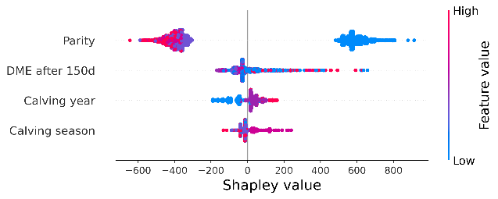
¹For this model, the proportion of milkings with DME was calculated only over the milking up to and including 150 days in milk.
²For this model, the proportion of milking with DME was calculated only over the milkings after and including 150 days in milk.

Supplemental Figure S10. Beeswarm plots for the random forest model. A Shapely value beeswarm plot depicts the distribution and magnitude of feature contributions across all model predictions, showing both the importance of each feature (x-axis) and how different feature values influence the prediction direction (color). The Shapely values of observations with a DME proportion on the outside of the distribution have a much bigger influence on the final predictions while average feature DME proportion has a Shapely value of almost zero in all the models

