Stock-Trading Application

Final Project Proposal

Erik Bowers and Nicholas Bouckaert

Proposal:

For our final project, we decide to implement a stock trading application that functions based on market updates (these updates will be pushed my us in the program). The user can update whether they want to buy or sell a stock at a certain value. If the value of that stock changes to that desired value during a market update the stock will automatically be brought or sold and the changes will be updated in that users account. For example, if the user buys 30 shares for 50 a piece, the amount in the user’s cash account (plus or minus) will be updated based on the total piece of all the shares. Updates will occur at set intervals. The goal is to have multiple users and to be able to allow users to create accounts during the programs execution.

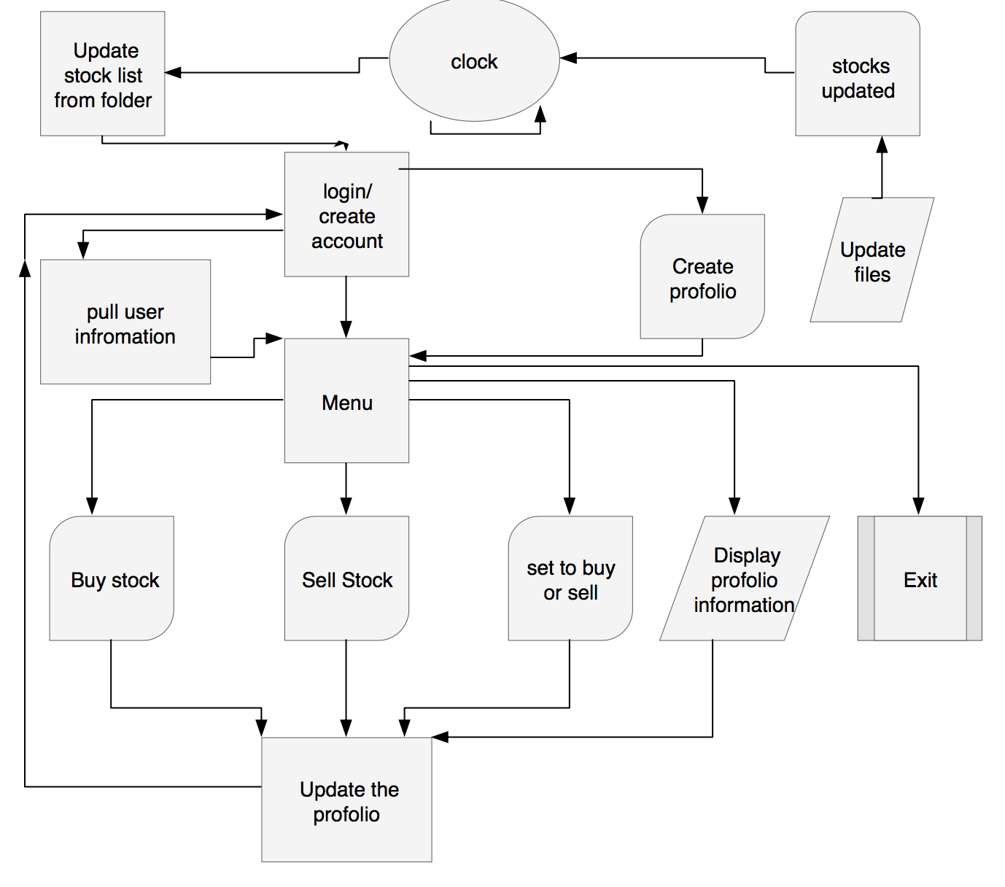

The program will run in the terminal. The user will enter account info such as a username and password to login. Once logged in the user can buy stocks or set the requirements to buy or sell stocks at set time intervals. The requirements can include the minimum or maximum price to buy or sell. The user can select these options using a menu. The user can also view their portfolio which will contain stocks owned along with their current value. They can also view their account balance and add or withdraw money. Whenever the user logs in, a file containing their portfolio info will be loaded. If this file is corrupted or deleted an error will be displayed telling the user their profile can’t be loaded. The system will update the stock values at set time intervals using the clock and user stocks will bought or sold based on those values.

Admin->

Will have full control over all of the accounts

User->

Will have control over their account only