LoadProfileGenerator: An Agent-Based Behavior Simulation for Generating Residential Load Profiles

04 April 2021

# Summary

A load profile contains a value for each step in time that describes how much energy was consumed in that time step. There are load profiles for example for electricity, gas, heat demand and other load types. This is critical input data for both energy system planners and researchers. For example, the car charging load profiles have a very strong influence on the self-consumption of a photovoltaic system. (Pflugradt and Muntwyler 2019).

This paper describes the LoadProfileGenerator (LPG), an application for creating synthetic residential load profiles. It uses a desire-driven agent simulation to model the behavior of the residents in detail and generate load profiles with a high temporal resolution of 1 minute for the residential energy consumption, primarily electricity and domestic hot water. Additionally, it generates behavior data, travel data and location data.

The LPG comes with 60 predefined households, validated for Germany. The households in the LPG are fully customizable and can be defined by specifying people and their traits. Examples for traits are “alarm at 7am”, “sleeps 8h” or “works at the office from 9-5”. There are over 400 traits predefined and more can be added by the user. To enable the modeling of a large number of households, the LPG contains functions to automatically create new household definitions from the traits. The LPG is written in C# and has about 60.000 lines of code. Unit test code coverage is greater than 70%.

The LPG does not currently contain a detailed heating demand simulation, since that field is already covered in detail by other tools such as TRNSYS, Polysun, tsib (Kotzur et al. 2020) or EnergyPlus.

# Statement of need

Load profiles are used by researchers, planners and others. They are used for modeling building energy systems, interactions with the electricity, gas or district heating grids, when trying to develop new technologies such as energy management systems or smart grid control algorithm and in many other applications.

Averaged profiles over a larger group of individual households are not an valid option for applications such as system simulations and analysis with a high spatial resolutions, since they have a significantly different shape than real individual load profiles, as shown in .

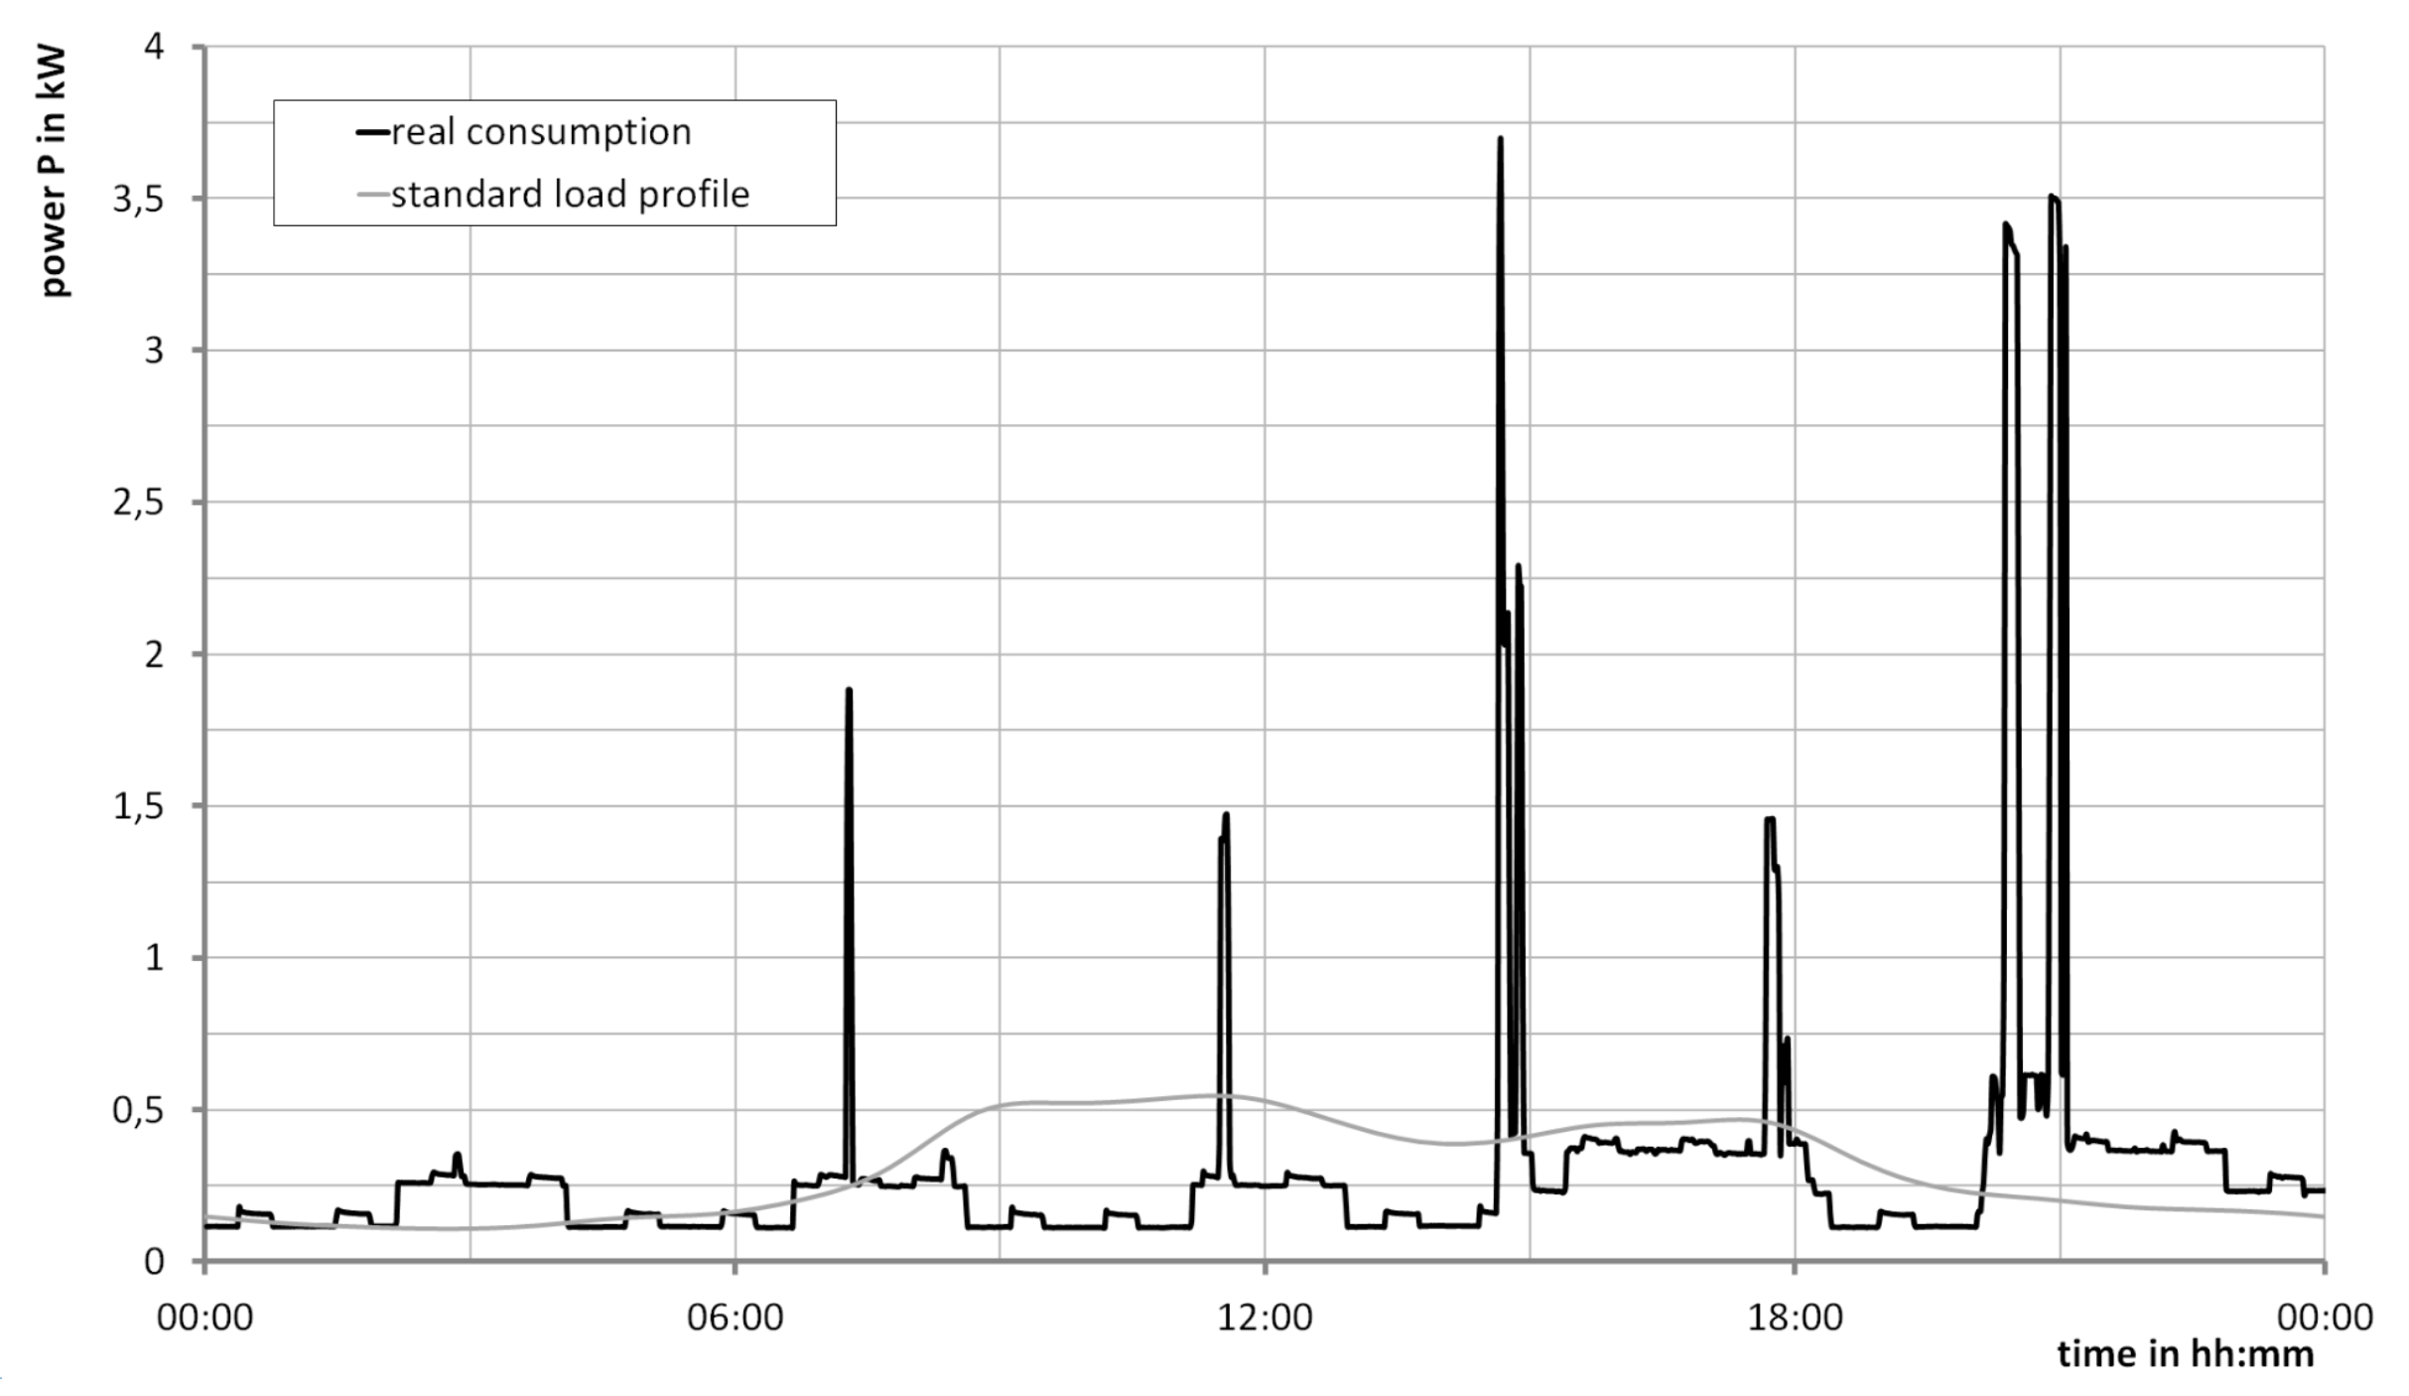

Difference between the average over many households and measurements from a single household. The high peaks are from cooking. (Pflugradt 2016) .

For most applications it would be ideal to have access to measured data. But such data is frequently not available. Reasons for that include privacy concerns, data availability, lack of instrumentation or, especially in research about future energy systems  
that the situation simply doesn’t exist yet and thus can’t be measured. Especially in the residential area privacy is a major concern since is easy to draw detailed conclusions about the life of the residents from the load profiles. If no measured data is available, then the creation of synthetic profiles is the only solution.

The LPG aims to solve these problems by providing a free and easy to use tool that enables researchers and planners to generate custom profiles very quickly.

There are numerous different tools for load profile synthesis available, such as CREST (McKenna and Thomson 2016) or SynPro (Fischer et al. 2016), but the LPG is to the best knowledge of the authors the most detailed and the only one using a full desire-driven behavior simulation based on a psychological model.

## Examples for Previous Usage

The LPG has been used in many papers for various applications:

* (Harder, Qussous, and Weidlich 2020) analyzed operating flexibility in electricity grids.
* (Böckl et al. 2019) generated load profiles for an evaluation of sector coupling.
* (Lovati, Zhang, et al. 2020) used the model to evaluate peer-to-peer electricity trading while considering the influence of lifestyle.
* (Boeckl and Kienberger 2019) evaluated the optimal size of photovoltaic systems for different load profiles.
* And building on that (Lovati, Dallapiccola, et al. 2020) evaluated the impact of the load profile on optimal photovoltaic system operation.
* (Haider and Schegner 2020) analyzed optimal ways of charging electric cars.

# Method

The LoadProfileGenerator (LPG) implements a desire-driven human behavior model to simulate the whereabouts and activities of the residents when people are doing what and where they are. The basic algorithm for selecting an activity is shown in .

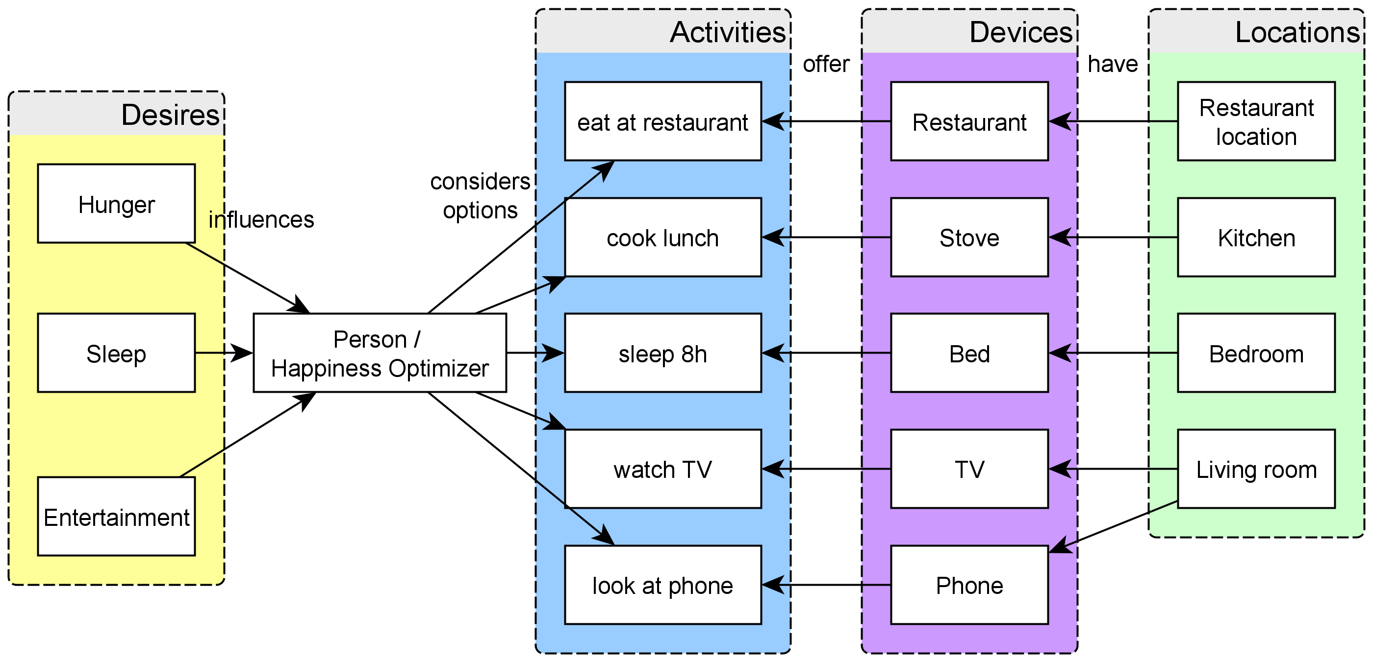

Basic idea behind the activity selection process.

The behavior of the residents is used to calculate energy consumption and generate the load profiles by combining synthetic and measured device profiles. This is combined with additional details for more realistic behavior modeling, such as illnesses, vacations, joint activities between multiple residents such as eating dinner together,

# Novelty of this publication

The LPG has been in development since 2010, originally in the context of a PhD-thesis (Pflugradt 2016). Since then it has been further extended and improved. An open access GUI based version was since the beginning available free of charge at http://www.loadprofilegenerator.de. In February 2020 the LPG was published open-source under the MIT-License. This is the first publication describing the LPG as an open-source tool, now available at https://github.com/FZJ-IEK3-VSA/LoadProfileGenerator. Contributions and merge requests are greatly appreciated.

# Acknowledgements

From 2010 to 2013 the development was supported by the Technische Universität Chemnitz, Professur Technische Thermodynamik in Germany. From 2016 to 2020 the development was supported by the Berner Fachhochschule, Laboratory for Photovoltaik Systems in the research project SimZukunft in Switzerland. Starting from March 2020 the development has been supported by the Forschungszentrum Jülich GmbH - Institute for Energy and Climate Research, Techno-econonomic Systems Analysis - IEK 3.

# References

Boeckl, Benjamin, and Thomas Kienberger. 2019. “‘Sizing of PV Storage Systems for Different Household Types’.” *Journal of Energy Storage* 24 (August): 100763. <https://doi.org/10.1016/j.est.2019.100763>.

Böckl, Benjamin, Matthias Greiml, Lukas Leitner, Patrick Pichler, Lukas Kriechbaum, and Thomas Kienberger. 2019. “HyFlow—A Hybrid Load Flow-Modelling Framework to Evaluate the Effects of Energy Storage and Sector Coupling on the Electrical Load Flows.” *Energies* 12 (5): 956. <https://doi.org/10.3390/en12050956>.

Fischer, David, Tobias Wolf, Johannes Scherer, and Bernhard Wille-Haussmann. 2016. “A Stochastic Bottom-up Model for Space Heating and Domestic Hot Water Load Profiles for German Households.” *Energy and Buildings* 124 (July): 120–28. <https://doi.org/10.1016/j.enbuild.2016.04.069>.

Haider, Sajjad, and Peter Schegner. 2020. “Data for Heuristic Optimization of Electric Vehicles’ Charging Configuration Based on Loading Parameters.” *Data* 5 (4): 102. <https://doi.org/10.3390/data5040102>.

Harder, Nick, Ramiz Qussous, and Anke Weidlich. 2020. “The Cost of Providing Operational Flexibility from Distributed Energy Resources.” *Applied Energy* 279 (December): 115784. <https://doi.org/10.1016/j.apenergy.2020.115784>.

Kotzur, Leander, Peter Markewitz, Martin Robinius, Gonçalo Cardoso, Peter Stenzel, Miguel Heleno, and Detlef Stolten. 2020. “Bottom-up Energy Supply Optimization of a National Building Stock.” *Energy and Buildings* 209 (February): 109667. <https://doi.org/10.1016/j.enbuild.2019.109667>.

Lovati, Marco, Mattia Dallapiccola, Jennifer Adami, Paolo Bonato, Xingxing Zhang, and David Moser. 2020. “Design of a Residential Photovoltaic System: The Impact of the Demand Profile and the Normative Framework.” *Renewable Energy* 160 (November): 1458–67. <https://doi.org/10.1016/j.renene.2020.07.153>.

Lovati, Marco, Xingxing Zhang, Pei Huang, Carl Olsmats, and Laura Maturi. 2020. “Optimal Simulation of Three Peer to Peer (P2P) Business Models for Individual PV Prosumers in a Local Electricity Market Using Agent-Based Modelling.” *Buildings* 10 (8): 138. <https://doi.org/10.3390/buildings10080138>.

McKenna, Eoghan, and Murray Thomson. 2016. “High-Resolution Stochastic Integrated Thermal–Electrical Domestic Demand Model.” *Applied Energy* 165 (March): 445–61. <https://doi.org/10.1016/j.apenergy.2015.12.089>.

Pflugradt, Noah. 2016. “Modellierung von Wasser Und Energieverbräuchen in Haushalten.” PhD, Chemnitz, Germany. <http://nbn-resolving.de/urn:nbn:de:bsz:ch1-qucosa-209036>.

Pflugradt, Noah Daniel, and Urs Muntwyler. 2019. “Impact of Behavior on Using Photovoltaics to Charge Electric Vehicles: Systematic Analysis.” In *EUPVSEC 2019 Marseille, France*. <https://doi.org/10.24451/arbor.9325>.