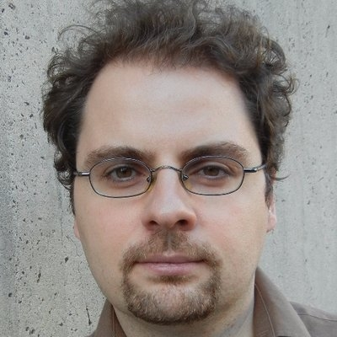

SuperUROP Showcase Fall 2018: Works in Progress

Current SuperUROP Scholars discussed their work at a well-attended poster session in December 2018.

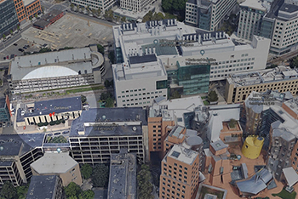

Aleksander Madry on building trustworthy artificial intelligence

The EECS faculty member spoke during a recent MIT symposium explores methods for making artificial intelligence systems more reliable, secure, and transparent.

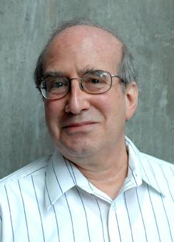

Building site identified for MIT Stephen A. Schwarzman College of Computing

The headquarters would replace Building 44, forming an “entrance to computing” near the intersection of Vassar and Main streets.

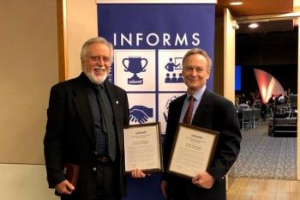

Professor Alan Willsky to be honored for achievements in signal processing

The long-time EECS faculty member will receive the IEEE’s 2019 Jack S. Kilby Signal Processing Medal.

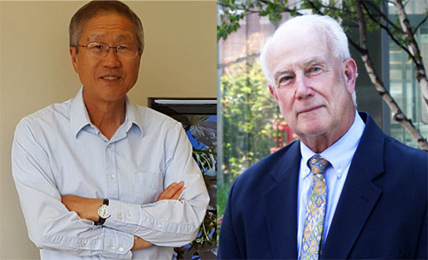

EECS faculty members receive INFORMS John Von Neumann Theory Prize

Professors Dimitri Bertsekas and John Tsitsiklis are honored for “tremendous impact” of their work in operations research and the management sciences.

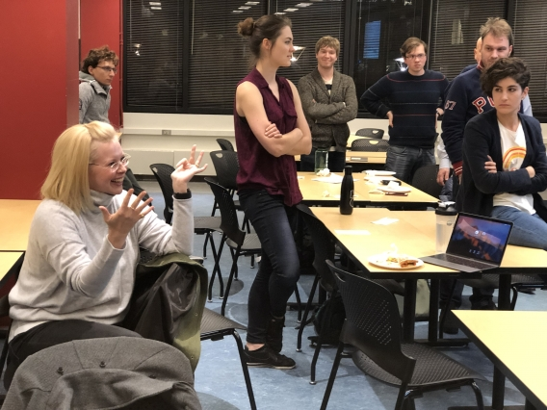

Jack Turner Entrepreneurship Award is established to support electronics research

EECS Professor Jae Lim's $1 million gift recognizes the collaboration by RLE and the Technology Licensing Office to develop MIT intellectual property.

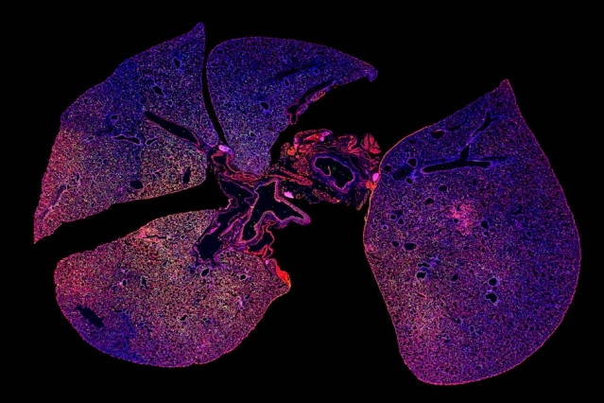

Group founded by EECS graduate students explores the ethical dimensions of artificial intelligence

The MIT AI Ethics Reading Group was created by students who saw firsthand how technology developed with good intentions could be problematic.

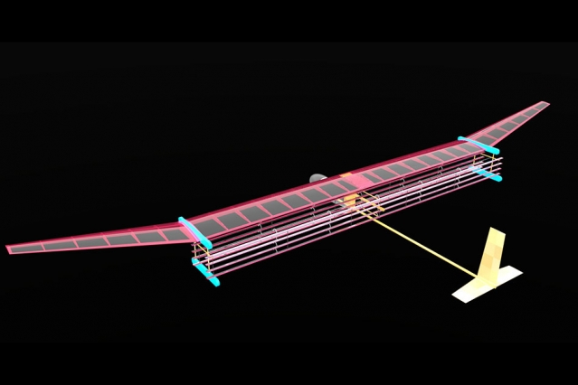

With these nanoparticles, a simple test could diagnose bacterial pneumonia

Results could also indicate whether antibiotics have successfully treated the infection.