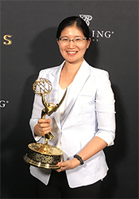

Associate Professor Vivienne Sze receives Engineering Emmy Award

The EECS faculty member and her teammates were honored for developing a new video-compression standard.

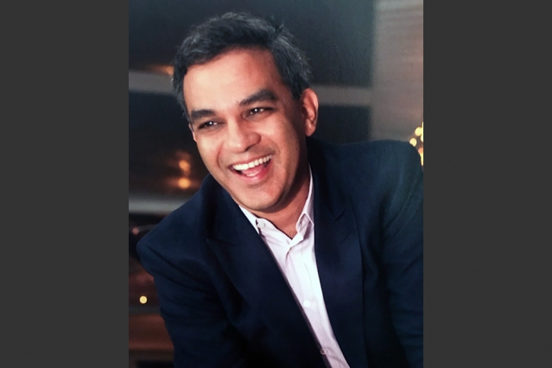

Vanu Bose, software pioneer and MIT Corporation member, dies at 52

The three-time EECS alumnus and CEO of Vanu, Inc. improved wireless networks, encouraged MIT research, and pursued humanitarian efforts.

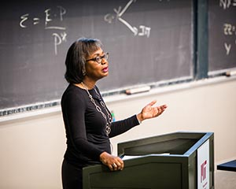

Visiting Professor Anita Hill continues the conversation about the past and future of Title IX

The attorney, author, and civil-rights advocate moderated "The Gender/Race Imperative," a series of talks about equality in education.

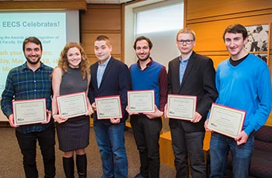

EECS presents awards for outstanding PhD and SM theses

Current and former EECS students were honored at a recent luncheon.

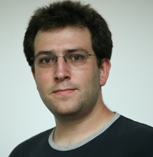

EECS professor honored for contributions to operating systems research

Nickolai Zeldovich receives 2017 ACM SIGOPS Mark Weiser Award.

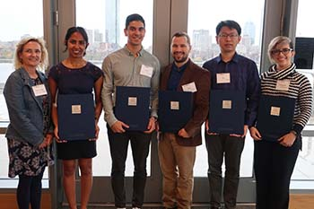

Five EECS students are among the MIT Siebel Scholars class of 2018

MIT graduate students from bioengineering, business, computer science, and energy fields received the prestigious awards.

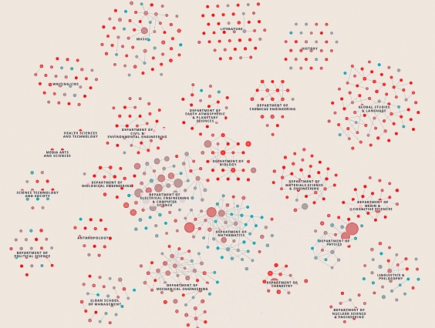

Mapping gender diversity at MIT

Data visualization map explores two decades of enrollment trends among female students at the Institute, including details for EECS.



3-D-printed device builds better nanofibers

MTL researchers describe a printed nozzle system that could make uniform, versatile fibers at much lower cost.

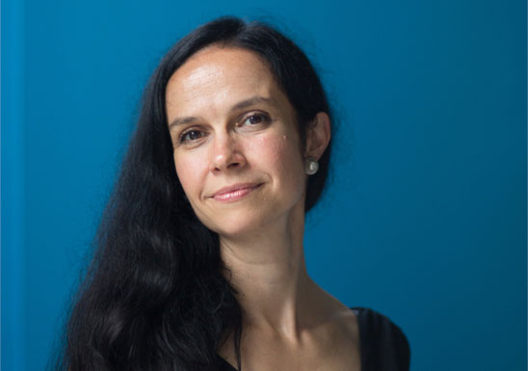

EECS professor to be recognized for 'pioneering work'

Muriel Medard will receive the IEEE Communications Society's Edwin Howard Armstrong Achievement Award.



Mohammad Alizadeh wins SIGCOMM Rising Star Award

EECS professor is honored for early-career contributions in large-scale data center network architectures and protocols.