Description
To consider the problem we can list the data as below:

- I use folium library to draw a map of Manhattan with all the neighborhoods on it.

- I used Forsquare API to get the most common venues of Manhattan.

- I found the average cost of rent in each neighborhood in Manhattan from a rental website (RentCafe)[1].

- I use geopy library to get the coordinate of Manhattan and each neighborhood.

Exp:
1. This is a histogram of average rent cost in Manhattan.
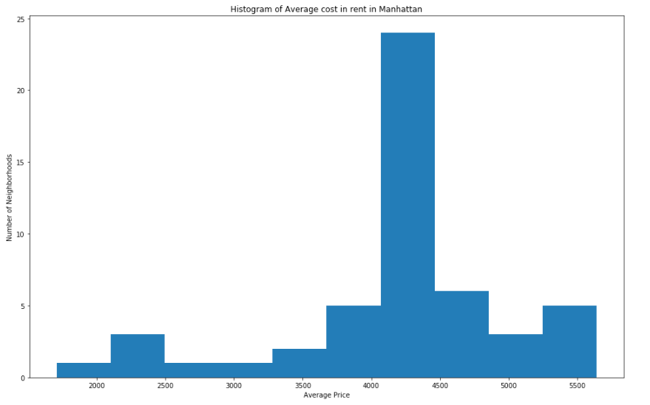
2. a map with the name of Neighborhoods on it
