Oracle GoldenGate 12c (12.2.0.1.1)

# Prepare firewall

|  |  |  |  |
| --- | --- | --- | --- |
| **Source** | **Port** | **Destination** | **justification** |
| Extract Server | 7809 | Replicat Server | for goldengate replication |
| Replicat Server | 7809 | Extract Server | for goldengate replication |
| Extract Server | 9001-9010 | Replicat Server | for goldengate replication |
| Extract Server/Replicat Server | 5502 | Monitor Server:sjprgldngtmon01 | for monitor agent |
| Monitor Server:sjprgldngtmon01 | 5555 | Extract Server/Replicat Server | for monitor agent |

# Prepare JDK for monitor agent

Jdk should not be lower than 1.8 and do not use openjdk

$java -version   
java version "1.8.0_121"  
Java(TM) SE Runtime Environment (build 1.8.0_121-b13)  
Java HotSpot(TM) 64-Bit Server VM (build 25.121-b13, mixed mode)

# Download Oracle GoldenGate 12c (12.2.0.1.1) binary “fbo_ggs_Linux_x64_shiphome.zip” (Already on sjengopdb01)

# Copy binary and unzip it

Software list:

fbo_ggs_Linux_x64_shiphome.zip : Golden Gate Manager for Oracle

fmw_12.2.1.2.0_ogg_Disk1_1of1.zip : Golden Gate Monitor Server and Agent

As oracle:

cd /home/oracle/OracleSoftware/Goldengate

scp oracle@sjengopdb01:/home/oracle/OracleSoftware/Goldengate/f*.zip ./

unzip fbo_ggs_Linux_x64_shiphome.zip

unzip fmw_12.2.1.2.0_ogg_Disk1_1of1.zip

ls -ltr

# Prepare directory

As oracle:

su - oracle

cd /u02/app/oracle/product/

mkdir -p /u02/app/oracle/product/12.2.0/ogg_12.2.0.1.1

mkdir -p /u02/app/oracle/product/12.2.0/oggagent_12.2.1.2.0

# Prepare Database

## Source database

### Prerequisite

Same charset, time zone

Source table must have a PK (constraint and index. Index must be ENABLE VALIDATE)

Better point directory to shared disk, i.e. /u02/dump

-- check existing directories

column name format a10

column owner format a10

column directory_name format a25

column directory_path format a70

set linesize 120

set pagesize 1000

select p.name, d.owner, d.directory_name, d.directory_path from cdb_directories d, v$pdbs p where d.con_id = p.con_id and p.name='PQA';

-- On Target (PRRSQA)

-- on sjdevdb06

As Oracle:

mdkir -p /u02/dump

svrmgrl

alter session set container=PRRSQA;

CREATE DIRECTORY EXPDIR AS ' /u02/dump';

-- check tnsnames

Dedicate

-- get table list to replicate

-- From source by permission

SELECT P.OWNER,

p.TABLE_NAME

FROM dba_tab_privs p

WHERE p.owner='EHADMIN'

AND p.GRANTEE LIKE '%RRS%'

AND P.PRIVILEGE= 'SELECT'

AND P.TYPE ='TABLE'

ORDER BY P.TABLE_NAME ;

-- From target by DB LINK

SELECT distinct s.table_owner,

s.table_name

FROM dba_synonyms s

WHERE s.db_link ='PQA'

AND s.table_owner= 'EHADMIN'

-- AND s.owner = 'RRSADMIN'

ORDER BY s.table_name;

|  |  |
| --- | --- |
| **TABLE_OWNER** | **TABLE_NAME** |
| EHADMIN | ALLIANCE_CATEGORY |
| EHADMIN | ALLIANCE_INFORMATION |
| EHADMIN | APPLICATION |
| EHADMIN | APPLICATION_STATUS |
| EHADMIN | APPLICATION_TRACKING |
| EHADMIN | CARRIER |
| EHADMIN | MEMBER |
| EHADMIN | PAYMENT_SOURCE |
| EHADMIN | PLAN |
| EHADMIN | PLAN_EXTENSION |
| EHADMIN | POLICY |
| EHADMIN | POLICY_HISTORY |
| EHADMIN | POLICY_MEMBER |
| EHADMIN | PRODUCT_CATEGORY |
| EHADMIN | RIDER |
| EHADMIN | RIDER_CATEGORY |
| EHADMIN | SELECTED_PLANS |
| ~~EHADMIN~~ | ~~SEQ_POLICY_ID~~ |
| EHADMIN | SG_APPLICATION |
| EHADMIN | SG_CARRIER |
| EHADMIN | SG_EE_APPLICATION |
| EHADMIN | SG_EE_APPLICATION_TRACKING |
| EHADMIN | SG_GROUP |
| EHADMIN | SG_GROUP_STATUS |
| EHADMIN | SG_GROUP_TRACKING |
| EHADMIN | SG_INSURANCE_TYPE |
| EHADMIN | SG_MEMBER_ENROLLMENT_SELECTION |
| EHADMIN | SG_PLAN |
| EHADMIN | SG_POLICY_HISTORY |
| EHADMIN | SG_RIDER |
| EHADMIN | SG_SELECTED_PLANS |
| EHADMIN | SG_SELECTED_RIDERS |
| EHADMIN | TEMP_RECOGNIZED_PAID_THRU_DATE |

Check tablespaces, map tablespace

COLUMN TABLE_NAME FORMAT A32

COLUMN OBJECT_NAME FORMAT A32

COLUMN OWNER FORMAT A10

SELECT

owner, TABLESPACE_NAME, segment_type, table_name, TRUNC(sum(bytes)/1024/1024) Meg

FROM

(SELECT segment_name table_name, owner, bytes, S.TABLESPACE_NAME, s.segment_type

FROM dba_segments S

WHERE segment_type = 'TABLE'

UNION ALL

SELECT i.table_name, i.owner, s.bytes, S.TABLESPACE_NAME, s.segment_type

FROM dba_indexes i, dba_segments s

WHERE s.segment_name = i.index_name

AND s.owner = i.owner

AND s.segment_type = 'INDEX'

UNION ALL

SELECT l.table_name, l.owner, s.bytes, S.TABLESPACE_NAME, s.segment_type

FROM dba_lobs l, dba_segments s

WHERE s.segment_name = l.segment_name

AND s.owner = l.owner

AND s.segment_type = 'LOBSEGMENT'

UNION ALL

SELECT l.table_name, l.owner, s.bytes, S.TABLESPACE_NAME, s.segment_type

FROM dba_lobs l, dba_segments s

WHERE s.segment_name = l.index_name

AND s.owner = l.owner

AND s.segment_type = 'LOBINDEX')

WHERE owner in ('EHADMIN')

AND table_name in ( 'ALLIANCE_CATEGORY',

'ALLIANCE_INFORMATION',

'APPLICATION',

'APPLICATION_STATUS',

'APPLICATION_TRACKING',

'CARRIER',

'PAYMENT_SOURCE',

'PLAN',

'PLAN_EXTENSION',

'POLICY_HISTORY',

'POLICY_MEMBER',

'PRODUCT_CATEGORY',

'RIDER',

'RIDER_CATEGORY',

'SELECTED_PLANS',

'SG_APPLICATION',

'SG_CARRIER',

'SG_EE_APPLICATION',

'SG_EE_APPLICATION_TRACKING',

'SG_GROUP',

'SG_GROUP_STATUS',

'SG_GROUP_TRACKING',

'SG_INSURANCE_TYPE',

'SG_MEMBER_ENROLLMENT_SELECTION',

'SG_PLAN',

'SG_POLICY_HISTORY',

'SG_RIDER',

'SG_SELECTED_PLANS',

'SG_SELECTED_RIDERS',

'TEMP_RECOGNIZED_PAID_THRU_DATE')

GROUP BY table_name, TABLESPACE_NAME, segment_type, owner

--HAVING SUM(bytes)/1024/1024 > 10 /* Ignore really small tables */

ORDER BY SUM(bytes) desc;

### Enable flashback

As Oracle

svrmgrl

**## CDB**

select name, flashback_on from v$database;

alter database flashback on;

### Enabling Minimum Database-level Supplemental Logging

Do this for each non CDB and PDB level

As oracle:

svrmgrl

**-- CDB. FOR EACH PDB**

alter session set container=**PQA**;

alter pluggable database **PQA** add supplemental log data;

column pdb_name format a20

select pdb_name, logging, force_logging, force_nologging from cdb_pdbs;

alter pluggable database **PQA** close immediate instances=all;

alter pluggable database **PQA** open read write restricted force;

alter session set container= **PQA**;

show con_name

alter pluggable database **PQA** enable force logging;

alter system disable restricted session;

select logins from v$instance;

alter pluggable database **PQA** open read write instances=all;

select inst_id, name, open_mode, restricted from gv$pdbs;

select pdb_name, logging, force_logging, force_nologging from cdb_pdbs;

alter session set container=CDB$ROOT;

alter system switch logfile;

**-- NON CDB**

SQL> SELECT name, supplemental_log_data_min, force_logging FROM v$database;

SUPPLEME FORCE_LOGGING

-------- ---------------------------------------

NO NO

ALTER DATABASE ADD SUPPLEMENTAL LOG DATA;

ALTER DATABASE FORCE LOGGING;

SQL> SELECT supplemental_log_data_min, force_logging FROM v$database;

SUPPLEME FORCE_LOGGING

-------- ---------------------------------------

YES YES

ALTER SYSTEM SWITCH LOGFILE;

### Enable goldenGate replication

svrmgrl

## on CDB$ROOT

alter system set enable_goldengate_replication = true scope=both sid='*';

(on source and target db)

alter system set streams_pool_size=1G scope=spfile sid='*'; -- (per integrated capture)

alter system set streams_pool_size=1G scope=spfile sid='*';

-- on sjqadb03

alter system set streams_pool_size=1G scope=memory sid='QA1';

-- on sjqadb04

alter system set streams_pool_size=1G scope=memory sid='QA2';

### Create ggadmin user on source and target.

Note: ggadmin for nonCDB, c##ggadmin for CDB

* CDB

create user c##ggadmin identified by XXXXXXXX default tablespace users;

grant create session, dba to c##ggadmin container=all;

execute dbms_goldengate_auth.grant_admin_privilege('C##GGADMIN',container=>'ALL',grant_optional_privileges=>'*');

grant flashback any table to c##ggadmin;

alter session set container=PQA;

alter pluggable database open;

* nonCDB

create user ggadmin identified by XXXXXXXX default tablespace users;

grant create session, dba to ggadmin;

execute dbms_goldengate_auth.grant_admin_privilege(‘GGADMIN’, grant_optional_privileges=>'*');

grant flashback any table to ggadmin;

## Target database

### Create REPUSER

As oracle:

* CDB

svrmgrl

alter session set container = PRRSQA ;

show con_name

create user repuser identified by XXXXXXXX ~~default tablespace users;~~

grant create session, dba to repuser container= current;

execute dbms_goldengate_auth.grant_admin_privilege('repuser',container=>'PRRSQA',grant_optional_privileges=>'*');

grant flashback any table to repuser;

* nonCDB

svrmgrl

create user repuser identified by XXXXXXXX ~~default tablespace users;~~

grant create session, dba to repuser;

execute dbms_goldengate_auth.grant_admin_privilege('repuser',grant_optional_privileges=>'*');

grant flashback any table to repuser;

### Create target schema

create user Ods_qa_ehi_ora_ehadmin identified by XXXXXXXX default tablespace RRS_DATA;

grant create session, resource to Ods_qa_ehi_ora_ehadmin;

### Enable goldenGate replication

svrmgrl

## on CDB$ROOT

alter system set enable_goldengate_replication = true scope=both sid='*';

(on source and target db)

# Install GoldenGate

## Connect to desktop

Connect to the serer via NoMachine, and then open a terminal windows:

[root@sjqadb04 ~]# echo $DISPLAY

:1001

[root@sjqadb04 ~]# xhost + local:oracle

non-network local connections being added to access control list

[root@sjqadb04 ~]# su - oracle

Last login: Tue Nov 1 14:24:40 PDT 2016 on pts/1

The Oracle base remains unchanged with value /u01/app/oracle

sjqadb04 QA2 > export DISPLAY=:1001

sjqadb04 QA2 > xclock

Warning: Missing charsets in String to FontSet conversion

## Run runInstaller

As oracle:

cd ~/OracleSoftware/Goldengate/fbo_ggs_Linux_x64_shiphome/Disk1/

./runInstaller

Run as following screens. Need change Software location for GoldenGate to /**u02/app/oracle/product/12.2.0/ogg_12.2.0.1.1**

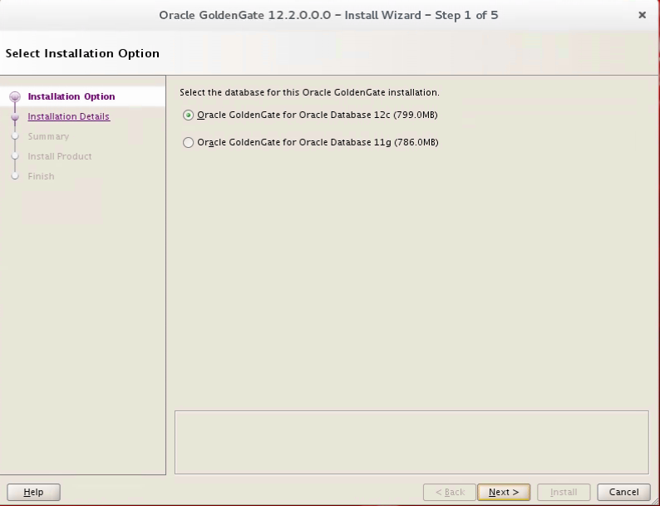

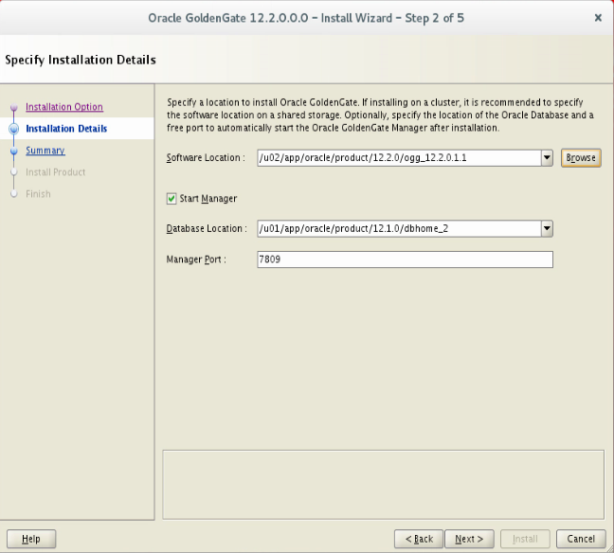

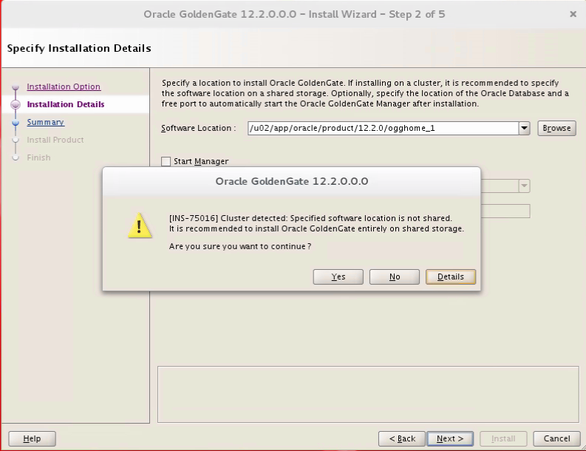

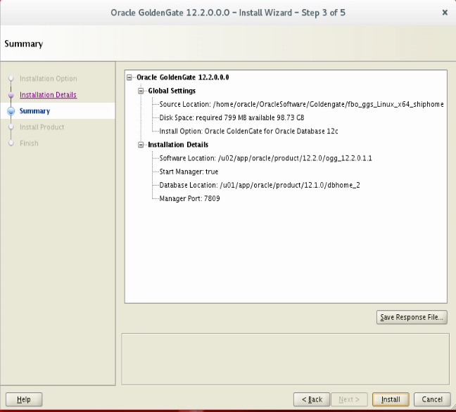

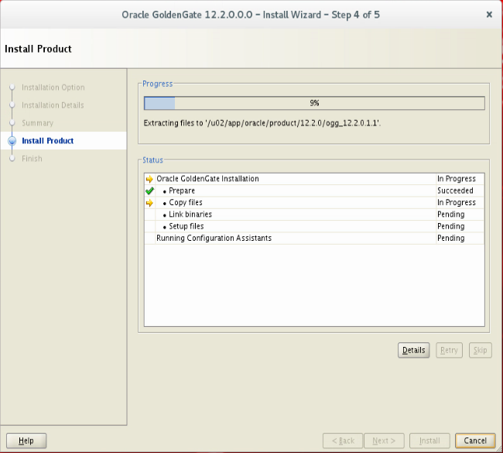

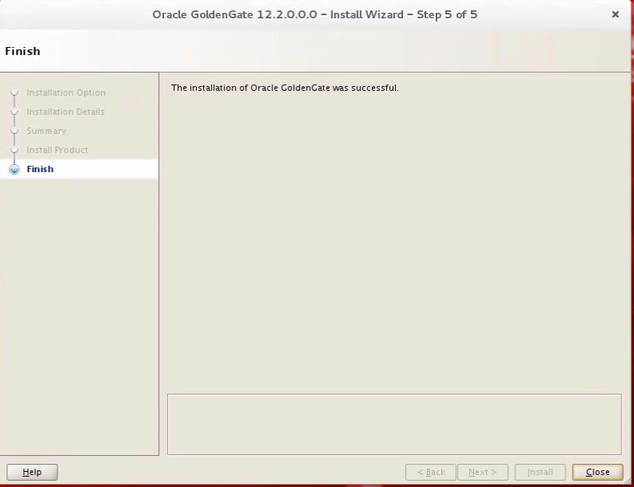

# Copy wallet

Master key

As oracle:

gh

cd dirwlt

scp [oracle@sjengopdb01:/u01/app/oracle/product/12.2.0/ogg_12.2.1.1/dirwlt/cwallet.sso ./](mailto:oracle@sjengopdb01:/u01/app/oracle/product/12.2.0/ogg_12.2.1.1/dirwlt/cwallet.sso%20./)

# .bash_profile

vi ~/.bash_profile

**...**

**## For GoldenGate**

**export GG_HOME=/u02/app/oracle/product/12.2.0/ogg_12.2.0.1.1**

**export PATH=$PATH:$GG_HOME**

**export LD_LIBRARY_PATH=$GG_HOME:$GG_HOME/lib:$LD_LIBRARY_PATH**

**export JAVA_HOME=/usr/java/default**

**export OGG_AGENT_HOME=/u02/app/oracle/product/12.2.0/oggagent_12.2.1.2.0**

**export OGG_AGENT_INST_HOME=/u02/app/oracle/oggagent_inst**

**...**

**alias gh='cd $GG_HOME;pwd'**

**alias gerr='less $GG_HOME/ggserr.log'**

**alias 2oggagent='cd $OGG_AGENT_HOME;pwd'**

**alias 2ogginst='cd $OGG_AGENT_INST_HOME;pwd'**

**alias ggsci='gh;ggsci'**

# Install monitor agent

## Install monitor agent software

java -jar -Xmx1024m /home/oracle/OracleSoftware/Goldengate/fmw_12.2.1.2.0_ogg.jar

Run as following screens. Need change **Oracle Home** to **/u02/app/oracle/product/12.2.0/oggagent_12.2.1.2.0**

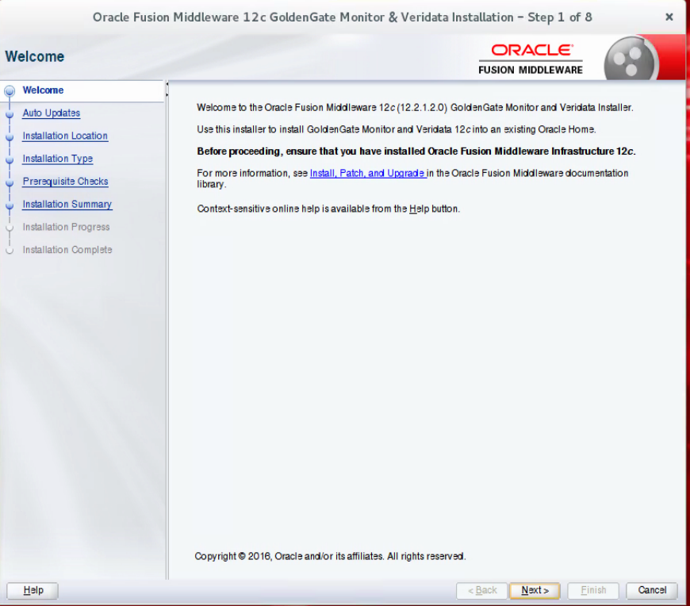

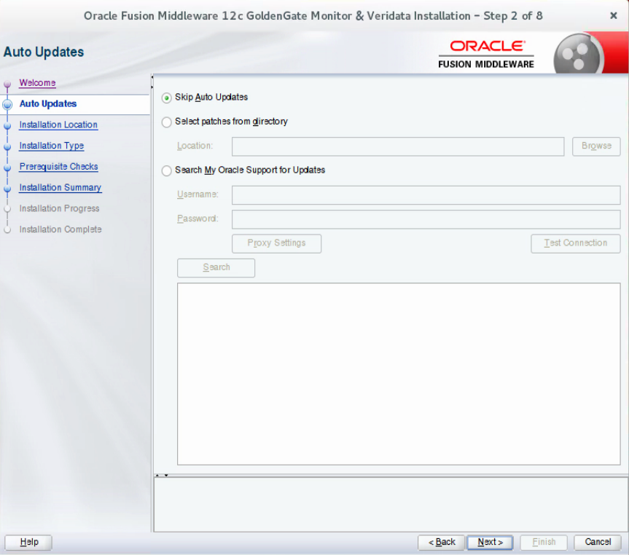

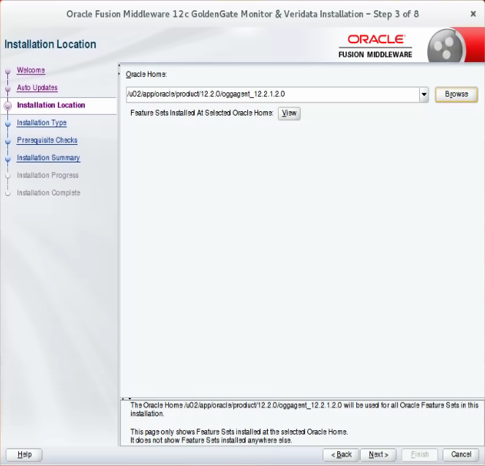

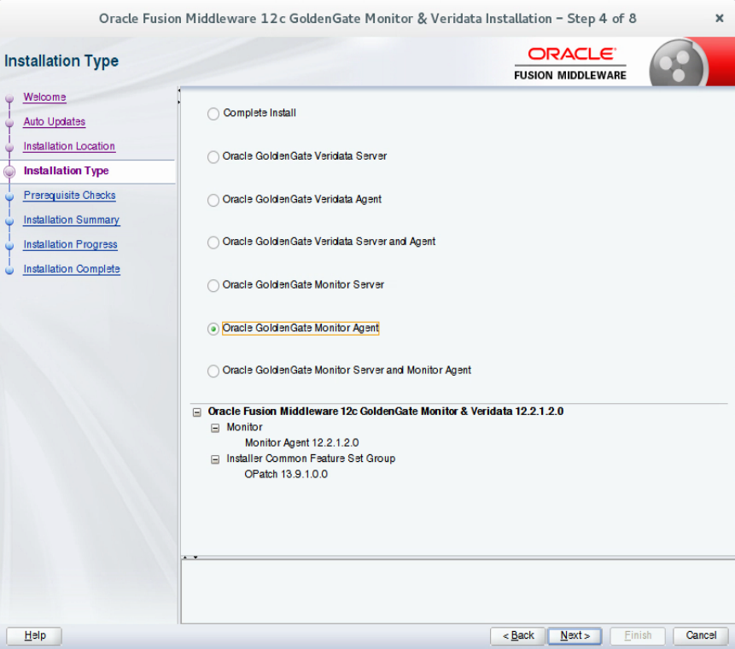

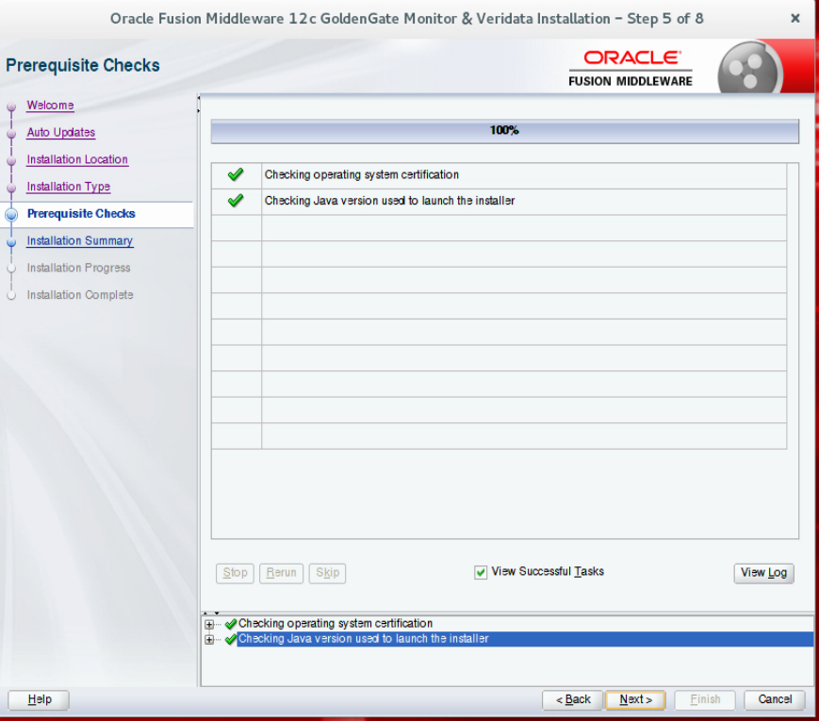

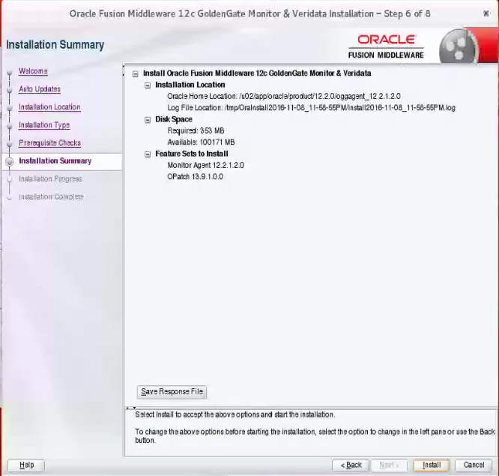

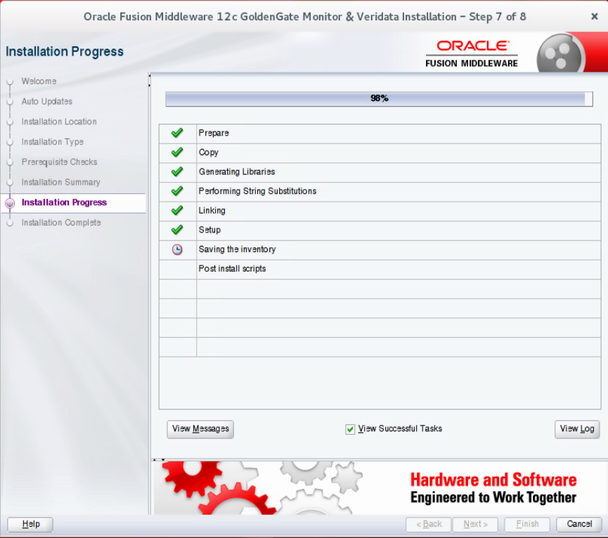

## Create monitor agent Instance

cd /u02/app/oracle/product/12.2.0/oggagent_12.2.1.2.0/oggmon/ogg_agent

./createMonitorAgentInstance.sh

Input following parameter one by one:

/u02/app/oracle/product/12.2.0/ogg_12.2.0.1.1

/u02/app/oracle/oggagent_inst

OGG

## Enable jagent in GOLBALS

ggsci

info all

stop manager

exit

gh

vi ./GLOBALS

ENABLEMONITORING

ALLOWNONVALIDATEDKEYS

start manager

## Setup agent

Stop Agent:

ggsci

info all

stop jagent

info all

Delete any existing dirwlt directory.

rm -rf /u02/app/oracle/oggagent_inst/dirwlt

# Copy the oggmon.properties file to the cfg directory of your Oracle GoldenGate Monitor Agent instance.

Copy following file from Monitor server sjprgldngtmon01: /u01/app/oracle/oggmon12.2.0_domain/config/monitorserver/cfg/oggmon.properties

to

/u02/app/oracle/oggagent_inst/cfg/

Start creating the wallet credentials:

sjdevdb06 DEV4 > cd /u02/app/oracle/oggagent_inst/bin

sjdevdb06 DEV4 > ./pw_agent_util.sh -create

Please create a password for Java Agent:

Please confirm password for Java Agent:

Please enter Monitor Server JMX password:

Please confirm Monitor Server JMX password:

Nov 30, 2016 4:26:52 PM oracle.security.jps.JpsStartup start

INFO: Jps initializing.

Nov 30, 2016 4:26:52 PM oracle.security.jps.JpsStartup start

INFO: Jps started.

Wallet is created successfully.

## Edit agent configure file:

vi /u02/app/oracle/oggagent_inst/cfg/Config.properties

jagent.host=<localhostname>

monitor.host=sjprgldngtmon01

Start Agent:

ggsci

info all

start jagent

info all

check log to make sure no error message in: /u02/app/oracle/oggagent_inst/logs/ogg_agent.log

## Add target on Golden Gate Monitor

# Setup replication

## Naming

Extract/Pump on Source

Relicat on Target

Naming: {e|p|r}{Env}{Product}{DBtype}

Maximum length: 8

e – Extract : e{Env}{alphabetInSequence}{Product}{DBtype}

p – Pump : p{Env}{SourceAlphabet}_{Env}{DestAlphabet}

r – Replicat : r{Env}{alphabetInSequence}{Product}{DBtype}

Trail file: dirdat/{env}{alphabetInSequence}

Env – D| Q | C | S | P | S

Product – Ehi | Rrs | Dw | Mc | …

DBtype – O | My | Ms | Mg ( O – Oracle; My – MySQL; Ms – MS SQL Server; Mg - MongoDB)

Examples:

Ps: We have applied ogg as following in blue.

|  |  |  |  |  |  |  |  |
| --- | --- | --- | --- | --- | --- | --- | --- |
| Env | Extract | E Trail | Pump | R Trail | Replicat | schema | source2dest |
| QA | eqaehio | Dirdat/qa | Pqa_qb | Dirdat/qb | Rqbehio | ods_qa_ehi_ora_ehadmin | ehiqa2dwdev |
| eqcehio | Dirdat/qc | pqc_qd | Dirdat/qd | Rqdrrso | ods_qa_rrs_ora_rrsadmin | rrsqa2dwdev |
| eqaehio | Dirdat/qa | Pqa_qe | Dirdat/qe | Rqeehio | ods_qa_ehi_ora_ehadmin | ehiqa2rrsqa |
| eqfmcmy | Dirdat/qf | Pqf_qg | Dirdat/qg | Rqgmcmy | ods_qa_mc_my_mcuser | mcqa2dwdev |
| eqhmcms | Dirdat/qh | Pqh_qi | Dirdat/qi | Rqimcms |  | msqa2dwdev |
| CM | ecaehio | Dirdat/ca | Pca_cb | Dirdat/cb | Rcbehio | ods_cm_ehi_ora_ehadmin | ehicm2dwtst |
| eccehio | Dirdat/cc | Pcc_cd | Dirdat/cd | Rcdrrso | ods_cm_rrs_ora_rrsadmin | rrscm2dwtst |
| ecaehio | Dirdat/ca | Pca_ce | Dirdat/ce | Rceehio | ods_cm_ehi_ora_ehadmin | ehicm2rrscm |
| ecfmcmy | Dirdat/cf | Pcf_cg | Dirdat/cg | Rcgmcmy |  | mccm2dwtst |
| echmcms | Dirdat/ch | Pch_ci | Dirdat/ci | Rcimcms |  | mscm2dwtst |
| PROD | epaehio | Dirdat/pa | Ppa_pb | Dirdat/pb | Rpbehio | ods_pr_ehi_ora_ehadmin | ehiprod2dwprod |
| epcehio | Dirdat/pc | ppc_pd | Dirdat/pd | Rpdrrso | ods_pr_rrs_ora_rrsadmin | rrsprod2dwprod |
| epaehio | Dirdat/pa | ppa_pe | Dirdat/pe | Rpeehio | ods_pr_ehi_ora_ehadmin | ehiprod2rrsprod |
| epfehimy | Dirdat/pf | Ppf_pg | Dirdat/pg | Rpgmcmy |  | mcprod2dwprod |
| ephehims | Dirdat/ph | Pph_pi | Dirdat/pi | Rpimcms |  | msprod2dwprod |

Note: parameter file name must be in lower case.

## Source:

### Add user alias for ggadmin

As Oracle:

gh

ggsci

open wallet

info masterkey

add credentialstore

alter credentialstore add user c##ggadmin@**qa** alias ggadmin

password : XXXXXXXX

info credentialstore

dblogin useridalias ggadmin

### Prepare parameter files

As Oracle:

gh

cd ./dirprm

# NOTE: lower case for parameter file name

vi eqaehio.prm

-- Change Date :

-- Changed By :

-- Extract group name.

extract eQaEhiO

-- Use the STATOPTIONS parameter to specify the information that is to be

-- included in statistical displays generated by the STATS EXTRACT or STATS

-- REPLICAT command. These options also can be enabled as needed as arguments to

-- those commands.

statoptions reportfetch

-- Report a count of transaction records that Extract or Replicat processed

-- since startup.

reportcount 15 minutes, rate

-- Use the ENCRYPTTRAIL and NOENCRYPTTRAIL parameters to control whether Oracle

-- GoldenGate encrypts or does not encrypt data that is written to a trail or

-- extract file.

encrypttrail AES128

-- USERIDALIAS enables you to specify an alias, rather than a user ID and

-- password, in the parameter file. The user IDs and encrypted passwords are stored

-- in a credential store. USERIDALIAS supports databases running on Linux, UNIX,

-- and Windows platforms.

useridalias ggadmin

-- For supplementally logged columns this automatically includes in the trail

-- record the before image for UPDATE operations before image of all supplementally

-- logged columns for both UPDATE and DELETE operations. It will also log columns

-- required to support CDR and Integrated Replicat.

logallsupcols

updaterecordformat compact

-- Trail to be read by data pump Extract or Replicat group on a local system.

exttrail ./dirdat/ehiora/qa

-- ddl include mapped

-- For 12c CDB only, specify the pdb name, otherwise, use 3 part name pdb.user.table in table

sourcecatalog pqa

table EHADMIN.MEMBER ;

vi pqaehio.prm

-- Change Date :

-- Changed By :

-- Extract group name.

extract pQaEhiO

-- Indicating that this Data Pump does not do column mapping.

passthru

-- Report a count of transaction records that Extract or Replicat processed

-- since startup.

reportcount 15 minutes, rate

-- Name or IP address of the remote host.

rmthost sjdevdb06, mgrport 7809, encrypt AES128

-- Target trail file name in remote host.

rmttrail ./dirdat/ehiora/qa

-- 12c CDB only

sourcecatalog pqa

table ehadmin.member;

### Setup extract and pump

As Oracle:

gh

ggsci

dblogin useridalias ggadmin

ADD TRANDATA pqa.ehadmin.policy PREPARECSN

ADD TRANDATA pqa.ehadmin.member PREPARECSN

EDIT PARAMS eQaEhiO

REGISTER EXTRACT eQaEhiO DATABASE CONTAINER(PQA)

2016-11-11 15:38:22 INFO OGG-02003 Extract EQA_EHI_ORA successfully registered with database at SCN 69831953609.

ADD EXTRACT eQaEhiO, INTEGRATED TRANLOG, BEGIN NOW

ADD EXTTRAIL ./dirdat/ehiora/qa, EXTRACT eQaEhiO, MEGABYTES 1000

ADD EXTRACT pQaEhiO, EXTTRAILSOURCE ./dirdat/ehiora/qa begin now

ADD RMTTRAIL ./dirdat/ehiora/qa, EXTRACT pQaEhiO, MEGABYTES 1000

start extract eQaEhiO

## Target:

### Add user alias for repuser

As Oracle:

gh

ggsci

add credentialstore

alter credentialstore add user repuser@prrsqa alias rep_prrsqa

password : XXXXXXXX

info credentialstore

dblogin useridalias rep_prrsqa

## Initial load

On source:

column CURRENT_SCN format 9999999999999

SELECT current_scn from v$database ;

CURRENT_SCN

--------------

69832399513

sjqadb04 QA2 > cd /home/oracle/exp

sjqadb04 QA2 > cat expdp_member_table.par

DIRECTORY=EHI

DUMPFILE=test_member.dmp

LOGFILE=test_member.log

TABLES=EHADMIN.member

INCLUDE=TABLE/TABLE, TABLE_DATA, INDEX:"IN (select upper(index_name) from dba_constraints c where c.constraint_type = 'P' and OWNER = 'EHADMIN')", CONSTRAINT:"IN (select upper(constraint_name) from dba_constraints c where c.constraint_type = 'P' and OWNER = 'EHADMIN')"

sjqadb04 QA2 >expdp system/${REPLY}@pqa2 parfile=expdp_member_table.par flashback_scn=69832399513

On target:

As Oracle:

cd /u02/dump

scp oracle@sjqadb04:/home/oracle/exp/test_member.dmp ./

sjdevdb06 DEV4 > cat impdb_member_table.par

DIRECTORY=EXPDIR

DUMPFILE=test_member.dmp

LOGFILE=test_member_import.log

TABLES=(EHADMIN.MEMBER

)

REMAP_TABLESPACE=EHI_ENCRYPT:RRS_DATA,EHI_APP:RRS_DATA,EHI_IDX:RRS_IDX

REMAP_SCHEMA=ehadmin:ODS_QA_EHI_ORA_EHADMIN

impdp system/${REPLY}@prrsqa parfile=impdb_member_table.par

## Add replicat process

As Oracle:

gh

cd ./dirprm

vi rqaehio.prm

sjdevdb06 DEV4 > view rqaehio.prm

-- Change Date :

-- Changed By :

replicat rQaEhiO

-- Oracle 11.2 after below

assumetargetdefs

-- Report a count of transaction records that Extract or Replicat processed

-- since startup.

reportcount 15 minutes, rate

-- USERIDALIAS enables you to specify an alias, rather than a user ID and

-- password, in the parameter file. The user IDs and encrypted passwords are stored

-- in a credential store. USERIDALIAS supports databases running on Linux, UNIX,

-- and Windows platforms.

useridalias rep_prrsqa

ddl include mapped

-- HANDLECOLLISIONS

-- DBOPTIONS ENABLE_INSTANTIATION_FILTERING integrates with DATAPUMP, no need to add --- filter anymore when add new tables

DBOPTIONS ENABLE_INSTANTIATION_FILTERING

map pqa.ehadmin.member,TARGET prrsqa.ods_qa_ehi_ora_ehadmin.member;

gh

ggsci

info all

ADD REPLICAT rQaEhiO, INTEGRATED, EXTTRAIL ./dirdat/ehiora/qa

start replicat rqaehio aftercsn 69832399513

info all

stats replicat rqaehio

## Start normal replication

On Target:

As Oracle:

gh

info all

stop replicat rqaehio

info all

start replicat rqaehio

info all

stats replicat rqaehio

# Add new table to existing replication

Add Policy Table

## Stop replication

On Target:

As Oracle:

gh

ggsci

info all

stop replicat rqaehio

info all

On Source:

As Oracle:

gh

ggsci

info all

stop er *

info all

## Add new table on source

As Oracle:

gh

cd ./dirprm

vi eqaehio.prm

-- Add below to eqaehio.prm

table EHADMIN.POLICY ;

vi pqaehio.prm

-- Add below to pqaehio.prm

table ehadmin.policy;

gh

ggsci

dblogin useridalias ggadmin

ADD TRANDATA pqa.ehadmin.policy PREPARECSN

start extract *

info all

stats extract eqaehio

stats extract pqaehio

## Initial load for new table

On source:

column CURRENT_SCN format 9999999999999

SELECT current_scn from v$database ;

CURRENT_SCN

--------------

69880675008

sjqadb04 QA2 > cd /home/oracle/exp

sjqadb04 QA2 > cat expdp_policy_table.par

DIRECTORY=EHI

DUMPFILE=test_policy.dmp

LOGFILE=test_policy.log

TABLES=EHADMIN.policy

INCLUDE=TABLE/TABLE, TABLE_DATA, INDEX:"IN (select upper(index_name) from dba_constraints c where c.constraint_type = 'P' and OWNER = 'EHADMIN')", CONSTRAINT:"IN (select upper(constraint_name) from dba_constraints c where c.constraint_type = 'P' and OWNER = 'EHADMIN')"

sjqadb04 QA2 >expdp system/${REPLY}@pqa2 parfile=expdp_policy_table.par flashback_scn=69880675008

On target:

As Oracle:

cd /u02/dump

scp oracle@sjqadb04:/home/oracle/exp/test_policy.dmp ./

sjdevdb06 DEV4 > cat impdb_policy_table.par

DIRECTORY=EXPDIR

DUMPFILE=test_policy.dmp

LOGFILE=test_policy_import.log

TABLES=(EHADMIN.POLICY

)

REMAP_TABLESPACE=EHI_ENCRYPT:RRS_DATA,EHI_APP:RRS_DATA,EHI_IDX:RRS_IDX

REMAP_SCHEMA=ehadmin:ODS_QA_EHI_ORA_EHADMIN

impdp system/${REPLY}@prrsqa parfile=impdb_policy_table.par

## Modify replicat paramter

As Oracle:

gh

cd ./dirprm

vi rqaehio.prm

-- Add below to rqaehio.prm

map pqa.ehadmin.policy,TARGET prrsqa.ods_qa_ehi_ora_ehadmin.policy

gh

ggsci

info all

start replicat rqaehio

info all

stats replicat rqaehio

check oggserr.log, you can find:

2017-04-05 18:54:47 INFO OGG-10155 Oracle GoldenGate Delivery for Oracle, rpbehio.prm: Instantiation CSN filtering is enabled on table EHADMIN.APPOINTMENT at CSN 71,966,464,491.