The Effect of Minimum Wage on Youth Employment in the United States

Bowen Zhao
Department of Economics, University of Washington, Seattle
Economics Honors Undergraduate Thesis
bowenz27@uw.edu

Abstract
Using annual data from 2010 to 2020 in the United States, this paper investigates the effect of minimum wage on youth employment and unemployment. The effect of minimum wage is examined under data from all fifty states in the united states and Washington D.C.. The estimation results show that an increase of $1 per hour in the minimum wage (in 2020 dollars) would be associated with a 0.35% increase in the youth unemployment rate, although no significant effect was found for the youth employment rate. However, the male unemployment rate shows a strong positive correlation with both youth employment and unemployment rates, indicating a broader economic influence. Similarly, the poverty rate is significantly associated with both dependent variables. The robustness of our models is underscored by high overall R-squared values and significant F-statistics for both model fit and poolability tests, reinforcing the reliability of our fixed-effects specification. This study contributes to the ongoing debate on the efficacy of minimum wage adjustments as a tool for economic policy, especially in contexts involving vulnerable demographic groups such as the youth.

Introduction
The relationship between minimum wage policies and employment outcomes continues to be a topic of significant policy debate and academic inquiry. This research focuses on understanding the effects of minimum wage adjustments on youth employment and unemployment rates in the United States, an area of economic study with profound implications for labor market policies and young workers' economic prospects.
From 2010 to 2020, the United States witnessed varying state-level changes in minimum wage laws, providing a rich dataset for analyzing the impacts across diverse economic environments. This period, characterized by economic recovery post the Great Recession followed by a period of growth, and ending with the economic disruptions caused by the COVID-19 pandemic, presents unique circumstances to explore how young workers are affected by wage regulations.
The central inquiry of this study addresses how changes in the minimum wage influence the employment and unemployment rates among youth—a demographic often at the margin in labor markets and potentially most responsive to wage legislations. While the conventional economic theory suggests that higher wages could reduce employment opportunities as employers may cut back on hiring, empirical analyses present mixed findings, underscoring the need for further study.
This paper employs panel data across all 50 states and Washington, D.C., using fixed-effect models to isolate the effect of minimum wage changes from other concurrent economic influences. This approach allows us to control for unobserved heterogeneity across states and over time, ensuring that the variations in employment metrics are primarily attributed to changes in minimum wage. By examining both employment and unemployment rates and considering additional variables such as the male unemployment rate and poverty levels, this study aims to offer nuanced insights into the direct and indirect effects of minimum wage policies on youth labor market outcomes.
In doing so, we contribute to a more comprehensive understanding of how minimum wage adjustments affect not only the theoretical labor supply but also the actual employment realities faced by young individuals in the United States.

Literature Review
The relationship between minimum wage laws and employment is a cornerstone of labor economics, yet it remains a complex and debated topic, especially when considering its impact on vulnerable populations such as youth. This section reviews theoretical perspectives, empirical findings, and the methodological nuances present in the literature on minimum wage effects.
- Theoretical Background
Economic theory presents two divergent views regarding the effects of minimum wage on employment. Classical economic theory, rooted in the work of Stigler (1946), suggests that any price floor above the equilibrium price, including minimum wage, should lead to excess supply, i.e., higher unemployment. This view posits that minimum wage laws compel employers to pay wages above the market rate, potentially leading to job losses or reduced hiring. Conversely, efficiency wage theories, as proposed by Shapiro and Stiglitz (1984), argue that higher wages can improve worker efficiency and morale, reduce turnover, and increase the quality of applicants, which might mitigate the negative effects on employment.
- Empirical Evidence on Youth Employment
Empirical studies on the impact of minimum wage on youth employment offer mixed results, which might be attributed to differences in methodologies, data sets, and economic conditions during the study periods. Neumark and Wascher (2004) conducted a comprehensive review and found that most studies report a negative impact of minimum wage on youth employment. However, Card and Krueger (1994) challenged this consensus with their study on the fast-food industry in New Jersey and Pennsylvania, finding no negative employment effects from a minimum wage increase. This study sparked a significant shift in how researchers approach the minimum wage debate, highlighting the importance of natural experiments and case studies.
Following this, more refined methodologies have been applied to study this relationship. Allegretto et al. (2011) utilized a border-pair technique, comparing employment outcomes in adjacent counties across state lines with different minimum wage levels. Their findings suggested that minor to no negative effects on teen employment could be directly linked to increases in minimum wage. Similarly, Dube, Lester, and Reich (2010) adopted a spatial correlation model that controlled for regional heterogeneity and also found minimal impact on employment.
Besides these, Chuang, Y. C. (2006) even found that a 10% jump in the minimum wage would increase the youth employment rate and the youth labor participation rate by 0.47%, although no significant effect was found for the youth unemployment rate. Moreover, a more recent analysis by Belman and Wolfson (2019) suggested that moderate increases in minimum wage could lead to higher income without reducing employment, potentially increasing participation as workers are drawn to better-paying jobs.
Thus, it appears that there is no clear, universally applicable answer regarding the impact of minimum wage on employment. The diversity in findings primarily results from variations in methodologies, datasets, and economic conditions during the periods of study. This highlights the importance of understanding and selecting appropriate methodologies when examining complex economic issues. It also suggests why both academics and policymakers need to consider a range of empirical studies and theoretical frameworks when evaluating minimum wage policies.
- Role of Macro-Economic Variables
Neumark and Wascher (2004) specifically address how macroeconomic conditions, such as GDP growth rate and unemployment rates, can modify the employment effects of minimum wage increases. In this research, the poverty rate and unemployment rate of male are used as macro-economic variables.
- Methodological Consideration
Recent literature has increasingly focused on improving the methodologies used to estimate the true effects of minimum wage. Techniques such as difference-in-differences, panel data models, and instrumental variable approaches have been utilized to better control for unobserved heterogeneity and potential endogeneity issues. This study employs fixed-effect models to robustly isolate the impact of minimum wage on youth employment, accounting for both temporal and entity-specific variations.

Data
The empirical analysis in this study utilizes two primary data sources to evaluate the effects of minimum wage adjustments on youth employment and unemployment rates across the United States from 2010 to 2020.
- Census Data on Employment and Unemployment
The first dataset is derived from the U.S. Census Bureau, accessed through its online platform. This comprehensive dataset provides annual employment and labor force statistics at the state level, encompassing various metrics of employment status. For this study, the focus was on the employment and unemployment rates among youth, defined as individuals aged 16 to 19. The data allows for an accurate depiction of the labor market conditions that young workers face across different states and years (all fifty states and Washington D.C. from 2010 to 2020). (U.S. Census Bureau)
- Minimum Wage Data
The second dataset is obtained from Kaggle, a platform hosting a wide array of datasets provided by users. The dataset titled "US Minimum Wage by State from 1968 to 2020" offers detailed information on the minimum wage levels in each U.S. state over several decades, compiled from the U.S. Department of Labor’s records. For this study, I use data with the column name “Effective.Minimum.Wage.2020.Dollars”, which means the actual adopted minimum wage adjusted in 2020 dollars, from 2010 to 2020 (Kaggle, 2017).
- Data Integration and Analysis
Both datasets were merged based on the state and year identifiers, allowing for a dynamic panel data analysis. The integration of these datasets facilitates a robust analysis of the impact of minimum wage changes on the labor market outcomes of youth, controlling for both spatial and temporal heterogeneities.

The Empirical Model
This study utilizes fixed-effect models to explore the effects of minimum wage on youth employment and unemployment rates, leveraging panel data across U.S. states over the period from 2010 to 2020. Fixed-effect models are particularly apt for this analysis as they control for time-invariant characteristics at the state level and over time, thus isolating the impacts of the explanatory variables on the dependent variables.
Model Specifications
Specifically, in this research, two fixed-effect models are employed to analyze different aspects of the labor market:
- Youth Employment Rate Model
The employment rate model is designed to assess the logarithm of the youth employment rate (ER), with the hypothesis that it is influenced by the poverty rate, male unemployment rate, and the real minimum wage. The model is specified as follows:
${ER}_{i,t}$=$α_{1}{POV}_{i,t} + α_{2}{UMALE}_{i,t}+α_{3}{WAGE}_{i,t}+β_{i}+ τ_{t}+ ϵ_{i,t}$
where:
- ${ER}_{i,t}$ is the natural logarithm of the youth employment rate in state i in year t
- ${POV}_{i,t}$ represents the poverty rate in state i in year t
- ${UMALE}_{i,t}$ is the unemployment rate of males in state i in year t
- ${WAGE}_{i,t}$ is the real effective minimum wage in 2020 dollars in state i in year t
- $β_{i}$ is the state-specific fixed effect
- $τ_{t}$ is the year-specific fixed effect
- $ϵ_{i,t}$ is the idiosyncratic error term
- Youth Unemployment Rate Model
Similarly, the unemployment rate model investigates the impact of the same set of explanatory variables on the youth unemployment rate (UR):
${UR}_{i,t}$=$α_{1}{POV}_{i,t} + α_{2}{UMALE}_{i,t}+α_{3}{WAGE}_{i,t}+β_{i}+ τ_{t}+ ϵ_{i,t}$
where:
- ${UR}_{i,t}$ is the unemployment rate of youth in state i in year t
- Other variables and effects are defined as in the employment rate model
Estimation Technique
Both models are estimated using Panel Ordinary Least Squares (PanelOLS), with robust standard errors clustered at the state level. This approach addresses serial correlation and potential heteroskedasticity within states over time. The fixed effects capture all invariant characteristics of each state and overarching time trends, focusing the analysis on how variations in minimum wage, poverty, and unemployment rates across states and over time influence youth employment and unemployment rates.
Rationale for Model Choice
The choice of fixed effects models is motivated by the need to account for potentially confounding state-specific characteristics and macroeconomic trends that could influence youth employment outcomes independently of the explanatory variables. By controlling for these fixed factors, the models aim to provide a clear assessment of how changes in minimum wage, poverty, and unemployment rates affect youth employment and unemployment rates in a nuanced and statistically robust manner.

Estimation Results
Overall, there are (11 years) * (50 states + 1 Washington D.C.) = 561 observations for both ER (employment rate) and UR (unemployment rate) models.

TABEL 1: THE EFFECT OF MINIMUM WAGE ON YOUTH EMPLOYMENT
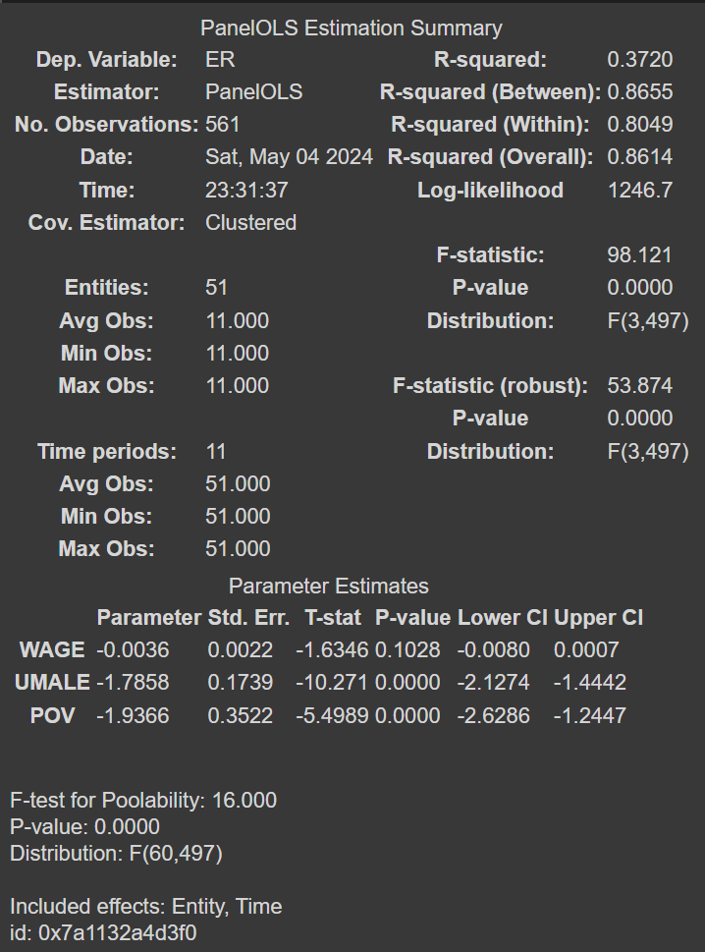
In examining the effects of minimum wage, male unemployment rate, and poverty rate on the log of the youth employment rate across U.S. states from 2010 to 2020, the first model provides a nuanced understanding of these dynamics. The results indicate that while the impact of the minimum wage on employment rates is not statistically significant, other factors play a critical role in influencing employment outcomes for youth.
The coefficient for the minimum wage (WAGE) is -0.0036 with a standard error of 0.0022, resulting in a t-statistic of -1.6346. This suggests that changes in the minimum wage have a minimal and statistically insignificant effect on the employment rate of youth, with a p-value of 0.1028. This finding aligns with some strands of the literature that argue minimum wage increases do not necessarily harm youth employment rates, possibly due to the lower incidence of minimum wage jobs among youth or the ability of the labor market to absorb wage increases through other mechanisms such as reduced turnover or increased productivity.
In contrast, the male unemployment rate (UMALE) shows a significant negative impact on youth employment rates, with a coefficient of -1.7858 and a t-statistic of -10.271. This result is highly significant statistically (p-value = 0.0000) and suggests that higher general unemployment rates, particularly among males, are associated with lower employment opportunities for youth. This could be due to increased competition for available jobs or a general slowdown in hiring when broader economic conditions are poor.
Additionally, the poverty rate (POV) also negatively affects the youth employment rate, with a coefficient of -1.9366 and a t-statistic of -5.4989. This strong negative relationship is statistically significant (p-value = 0.0000) and indicates that higher poverty levels within a state are correlated with lower employment rates among youth. This may reflect broader socio-economic challenges that hinder job access and economic participation among younger populations. In other words, this reflects that in times of poor socioeconomic conditions, it is harder for young people to find jobs.
The model’s explanatory power is substantial, with an R-squared Within of 80.49% and an Overall R-squared of 86.14%, indicating that it effectively captures the variance in employment rates across states and over time. The robustness of these results is further evidenced by the significance of the F-statistic (98.121) for the model and the F-test for poolability (16.00) with a p-value of 0.0000, confirming that both state-specific and time-specific effects are crucial and appropriately modeled.
In conclusion, while minimum wage does not exhibit a significant impact on youth employment rates within the study's context, the economic environment, reflected by male unemployment and poverty rates, plays a critical role. These findings contribute to the broader discussion on the economic levers affecting youth employment and highlight the importance of addressing overall economic conditions alongside wage policy.

TABEL 2: THE EFFECT OF MINIMUM WAGE ON YOUTH UNEMPLOYMENT
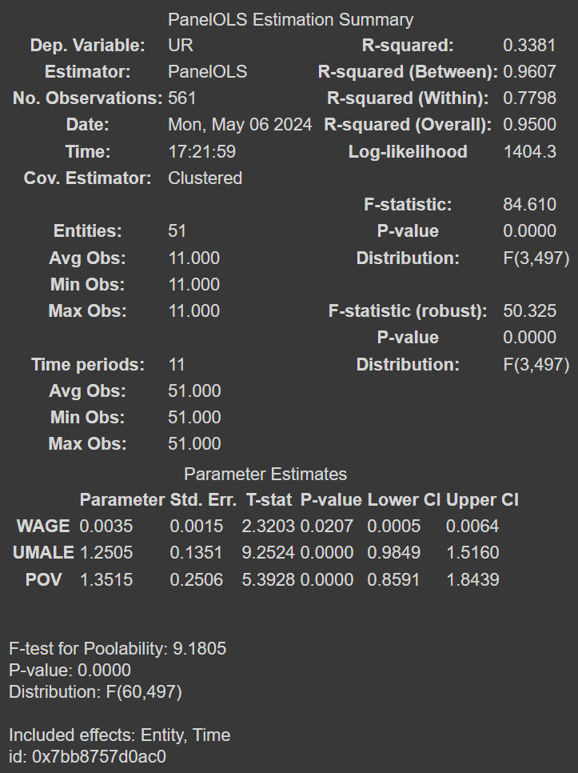
The second model in this study analyzes the impact of minimum wage, male unemployment rate, and poverty rate on the youth unemployment rate across U.S. states from 2010 to 2020. The findings reveal a nuanced landscape where minimum wage increases show a statistically significant but small effect on increasing youth unemployment rates.
The minimum wage (WAGE) coefficient is 0.0035, with a standard error of 0.0015 and a t-statistic of 2.3203. This result is significant with a p-value of 0.0207, indicating a direct relationship where higher minimum wages are associated with a slight increase in the unemployment rates among youth. This could suggest that while minimum wage increases are intended to raise income for working youth, they may also result in some barriers to entry into the job market for others, possibly due to increased labor costs leading to reduced hiring.
Moreover, the male unemployment rate (UMALE) is also significantly associated with youth unemployment, with a coefficient of 1.2505 and a t-statistic of 9.2524. This significant positive relationship suggests that higher unemployment rates among males are a strong indicator of increased youth unemployment, potentially reflecting overall economic downturns that disproportionately affect younger workers who are often less experienced.
The poverty rate (POV) similarly shows a significant positive effect on the youth unemployment rate, with a coefficient of 1.3515 and a t-statistic of 5.3928. This indicates that higher poverty levels within states correlate with higher unemployment rates among youth, underscoring the broader economic challenges that can exacerbate unemployment among younger populations.
The model's explanatory power is robust, with an R-squared Within of 77.98% and an Overall R-squared of 95.00%, suggesting a strong fit to the data. The high explanatory power indicates that the model captures a substantial proportion of the variations in youth unemployment rates across different states and over the observed period. The robustness of these findings is further supported by the significant F-statistic (84.610) and the F-test for poolability (9.1805) with a p-value of 0.0000, which validate the inclusion of fixed effects for states and years in the model. These tests confirm that controlling for invariant characteristics across states and over time is crucial for isolating the effects of the studied variables.
These results highlight the complex interactions between wage policies, economic conditions, and labor market outcomes for youth. While minimum wage increases are shown to slightly elevate unemployment rates, the broader economic indicators of male unemployment and poverty are also crucial in understanding the full scope of factors that influence youth unemployment. This comprehensive approach provides valuable insights into the economic forces shaping the job market experiences of young individuals in the United States.
This study's analysis through two fixed-effects models explores the effects of minimum wage, male unemployment, and poverty rates on youth employment and unemployment across the U.S. states. The first model shows no significant impact of minimum wage increases on youth employment rates, aligning with Card and Krueger (1995) who found minimal negative employment effects from wage adjustments. In contrast, the second model reveals a small but significant increase in youth unemployment rates following minimum wage hikes, supporting findings by Neumark and Wascher (2004) that suggest potential adverse effects on younger, less-experienced workers.
Both models consistently highlight significant influences from male unemployment and poverty rates, indicating broader economic factors play crucial roles in shaping youth labor market outcomes. These findings underscore the complexity of wage policy impacts, suggesting that while minimum wage increases do not deter youth employment, they may slightly elevate unemployment among this group.

Limitation
This study provides insights into the effects of minimum wage policies on youth employment and unemployment but faces several limitations. Firstly, the analysis is confined to the period from 2010 to 2020, which includes significant economic disruptions such as the post-recession recovery and the COVID-19 pandemic, potentially affecting the generalizability of findings to other periods or under different economic conditions. Additionally, the study focuses solely on formal employment, omitting the informal sector, which often employs a substantial number of youth. The use of fixed-effects models assumes constant effects of unobserved variables over time and across states, which might not capture all dynamic interactions or the true effects of changes in economic growth, technology, and labor policies. Finally, the study’s findings, based on U.S. state-level data, may not be directly applicable to other countries with different economic structures, labor market regulations, and demographic profiles. Future research could address these issues by extending the study period, including data from the informal sector, employing dynamic modeling approaches, and examining other geographic contexts to enhance the robustness and applicability of the results.

Concluding Remarks
This study has examined the impact of minimum wage on youth employment and unemployment rates across U.S. states from 2010 to 2020 using two fixed-effects models. The analysis reveals nuanced insights into how minimum wage policies interact with labor market dynamics for younger workers.
Our findings suggest that increases in the minimum wage do not significantly impact the employment rates of youth, indicating that minimum wage adjustments may not detrimentally affect youth employment as some theoretical models predict. This aligns with the research by Card and Krueger (1995), which challenges traditional economic perspectives suggesting that higher minimum wages lead to lower employment levels. However, our analysis also indicates that minimum wage increases are associated with a slight but statistically significant rise in youth unemployment rates. This supports the arguments made by Neumark and Wascher (2004), who found negative effects on employment among younger populations following minimum wage hikes.
Moreover, the significant impacts of male unemployment rates and poverty rates on both employment and unemployment outcomes highlight the importance of broader economic conditions in determining labor market opportunities for youth. These results suggest that policy makers should consider these wider economic factors when designing interventions to improve youth labor market outcomes.
In conclusion, while minimum wage policies are intended to improve the earnings of workers, their effects on youth labor markets are complex and multifaceted. Our study contributes to the understanding of these dynamics, suggesting that while raising the minimum wage does not necessarily harm youth employment rates, it does slightly increase unemployment among this demographic. Future research should continue to explore these relationships, perhaps focusing on the long-term effects of minimum wage changes and how these dynamics play out in different economic contexts.

REFERENCES
Chuang, Yih-Chyi. "The effect of minimum wage on youth employment and unemployment in Taiwan." Hitotsubashi Journal of Economics (2006): 155-167.

Stigler, George J. "The economics of minimum wage legislation." The American Economic Review 36.3 (1946): 358-365.

Shapiro, Carl, and Joseph E. Stiglitz. "Equilibrium unemployment as a worker discipline device." The American economic review 74.3 (1984): 433-444.

Neumark, David, and William Wascher. "Minimum wages, labor market institutions, and youth employment: a cross-national analysis." Ilr Review 57.2 (2004): 223-248.

Card, David, Lawrence F. Katz, and Alan B. Krueger. "Comment on David Neumark and William Wascher,“Employment effects of minimum and subminimum wages: Panel data on state minimum wage laws”." ILR Review 47.3 (1994): 487-497.

Allegretto, Sylvia A., Arindrajit Dube, and Michael Reich. "Do minimum wages really reduce teen employment? Accounting for heterogeneity and selectivity in state panel data." Industrial Relations: A Journal of Economy and Society 50.2 (2011): 205-240.

Dube, Arindrajit, T. William Lester, and Michael Reich. "Minimum wage effects across state borders: Estimates using contiguous counties." The review of economics and statistics 92.4 (2010): 945-964.

Wolfson, Paul, and Dale Belman. "15 years of research on US employment and the minimum wage." Labour 33.4 (2019): 488-506.

I would like to thank Professor Stephen J. Turnovsky, my thesis advisor, for his invaluable guidance and support. I am also grateful to econometric consultant Jorge Rivero for his helpful advice. Additionally, I would like to thank Professor Michelle Turnovsky and Professor Alan Griffith for their roles in conducting this honor program.
U.S. Census Bureau. (2020). Employment and Labor Force Status. Retrieved from https://data.census.gov/table?t=Employment:Employment%20and%20Labor%20Force%20Status&g=010XX00US$0400000&y=2020 Data from different years can be accessed by adjusting filters directly.
Kaggle. (2017). US Minimum Wage by State from 1968 to 2020. Retrieved from https://www.kaggle.com/datasets/lislejoem/us-minimum-wage-by-state-from-1968-to-2017
For the python code used to build these two models, please check https://colab.research.google.com/drive/1vuYiITqx5xT3fXgvICusOisuZTnlD5V5?usp=sharing
For detailed integrated dataset, please check https://drive.google.com/file/d/1AESgoEEe4IRM6Fm5zuIny4DUEM5w9OyS/view?usp=sharing

