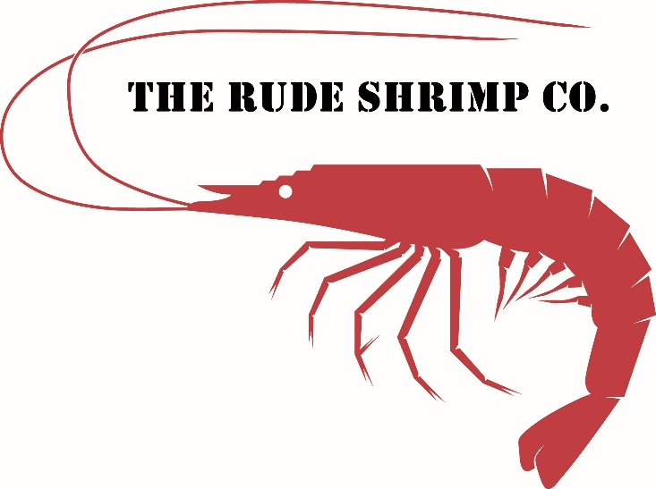

1. Shrimp Taco

Flour tortilla, lime rice, spicy shrimp, cheese, lettuce, pineapple salsa, marinated red onion.

1. Triple Stack

Flour tortilla, lime rice, spicy shrimp, cheese, tortilla, lime rice, pork green chili, cheese, tortilla, queso, lettuce, pineapple salsa, marinated red onion.

1. Peel & eat shrimp

Spicy shrimp, Lime rice, drawn butter. Suck, peel, dip, eat, repeat.

1. Garlic Shrimp

Garlic, white wine, butter, lime rice, lemon wedge.

1. Boom boom shrimp

Fried shrimp tossed in a chili honey sauce served with lime rice.

1. Mac & Cheese Sammie

7 cheese macaroni, spicy shrimp, stuffed in buttered bread, dipped in egg, panko, and fried golden.