Bellabeat Case Study
Smart Device Usage Analysis and Marketing Recommendations

1. Business Task
The objective of this case study is to analyze smart device usage data from Fitbit users in order to identify behavioral trends that can help guide Bellabeat's marketing strategy. The analysis focuses on how consumers use wearable devices, how those patterns may apply to Bellabeat customers, and what actions Bellabeat could take in response.

2. Data Sources
The analysis uses the Fitbit Fitness Tracker Data dataset from Kaggle (Mobius). The dataset includes activity and sleep information from 30 users over approximately one month in 2016. The following tables were used in the project:
- dailyActivity_merged
- sleepDay
- hourlySteps
- hourlyCalories
- hourlyIntensities
Google Sheets was used for initial inspection, BigQuery and SQL were used for cleaning and analysis, and Tableau was used for dashboard design and visualization.

3. Data Cleaning and Processing
Several CSV files were difficult to import cleanly because date, datetime, and numeric fields were initially interpreted as text. The data was uploaded into BigQuery and then cleaned using SQL.
- Converted Id columns to numeric values using SAFE_CAST.
- Parsed datetime fields such as SleepDay and ActivityHour using SAFE.PARSE_DATETIME.
- Converted step counts, calories, and intensity values into numeric data types.
- Removed header rows that were accidentally imported as data during CSV upload.
- Created cleaned tables for sleep and hourly activity datasets.

4. Analysis Findings

4.1 Are people actually using the device consistently?
Yes, most users appear to use the device consistently. About 24 users recorded activity for roughly 30 to 31 days, which suggests regular engagement and repeated syncing. However, usage was not equally consistent across all users. A small number of users recorded far fewer days of activity, with one user only recording 4 days. This indicates that although most users were engaged, some users either stopped wearing the device or stopped syncing data early.

4.2 Are users mostly sedentary?
Yes. Average sedentary minutes were much higher than very active minutes. The data showed roughly 991 sedentary minutes on average compared with about 21 very active minutes. This suggests that users spend most of their day inactive, with relatively little time spent doing intense physical activity.

4.3 When do people actually move?
Hourly step data showed that movement generally starts around 7:00 and continues through the day. Activity rises during the day and remains present into the evening. Even so, average step levels per hour rarely exceeded 600 steps, which suggests that the users were moderately active rather than highly active. The pattern likely reflects movement tied to work routines, commuting, and evening activity.

4.4 Are users sleeping enough?
Not quite. Average sleep duration was about 6.99 hours per night, which is slightly below the common recommendation of 7 to 9 hours. This suggests an opportunity for Bellabeat to position sleep tracking and sleep improvement features as part of a broader wellness message.

4.5 Do more active users sleep better?
No strong relationship was clearly visible in the initial analysis. A more advanced analysis could explore this further, but based on the current work there was no obvious pattern showing that users with more steps consistently slept longer or better.

5. Answers to the Bellabeat Business Questions

5.1 What are some trends in smart device usage?
- Most users record activity consistently over the month.
- Users are mostly sedentary during the day.
- Movement tends to occur between morning and evening hours.
- Average sleep is slightly below recommended levels.
- Engagement varies across users, with a few low-usage outliers.

5.2 How could these trends apply to Bellabeat customers?
These trends suggest that Bellabeat customers may rely heavily on wearable devices for day-to-day activity tracking but still struggle with movement consistency, sedentary habits, and sleep quality. Bellabeat customers are likely to benefit from reminders, goal-setting tools, and simple health insights that help them improve everyday routines rather than only focus on intense workouts.

5.3 How could these trends help influence Bellabeat marketing strategy?
The findings support a marketing strategy that focuses on practical wellness improvement. Bellabeat can position its products as daily companions that help users move more, sleep better, and stay more aware of their routines.

6. Top Recommendations
- Promote daily movement goals. Bellabeat can encourage users to break sedentary patterns through step goals, movement reminders, and progress tracking.
- Highlight sleep health features. Since average sleep is slightly below recommended levels, Bellabeat can emphasize sleep monitoring, sleep insights, and bedtime support features.
- Target engagement during active hours. Since users are most active during commute, Bellabeat can time app prompts, challenges, and reminders around these windows.

7. Dashboard
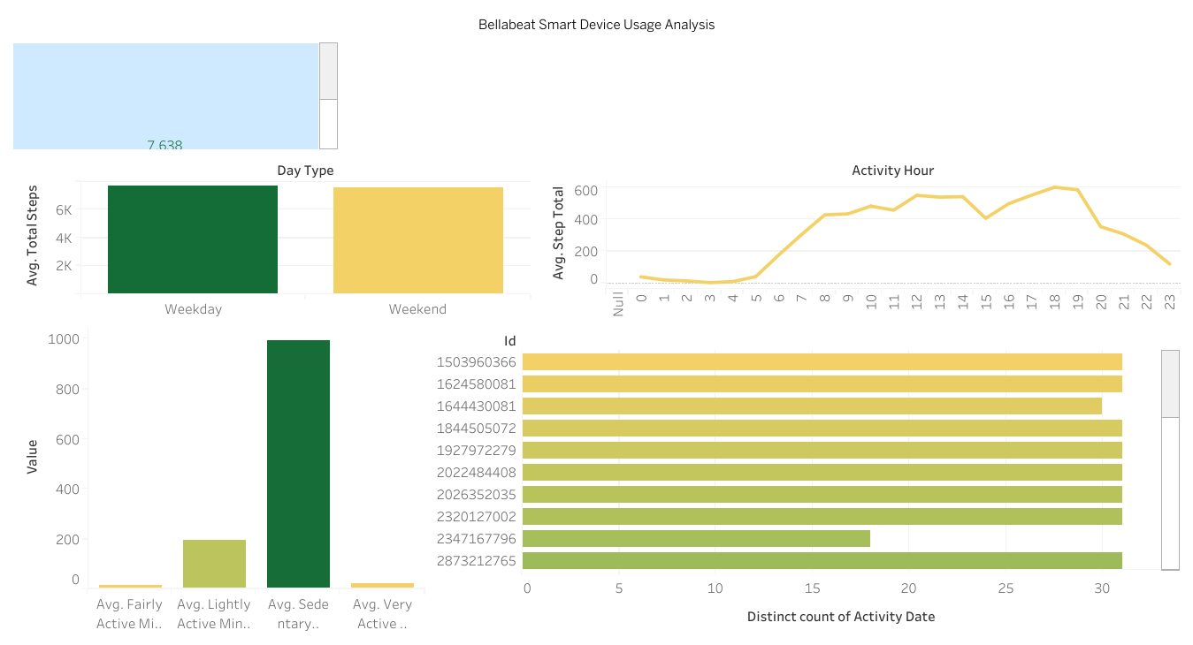

8. Conclusion
This analysis shows that most users wear and use their devices consistently, but their overall behavior still reflects sedentary lifestyles, only moderate movement, and slightly inadequate sleep. These insights create a strong case for Bellabeat to market its products as tools for practical daily wellness improvement rather than only fitness tracking. The project also demonstrates the full analysis workflow, including data cleaning, SQL analysis, and dashboard preparation.

