Project Management Pert

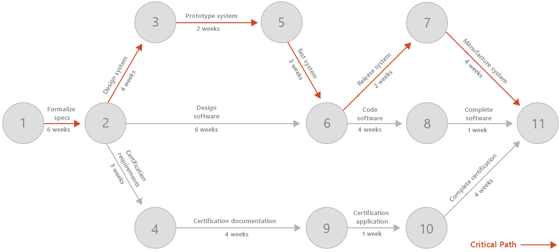

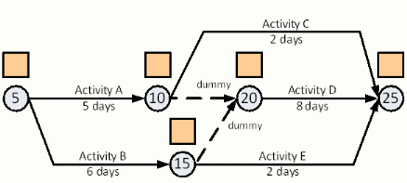

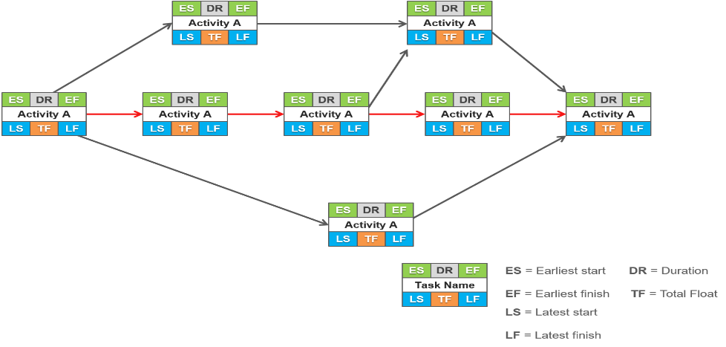

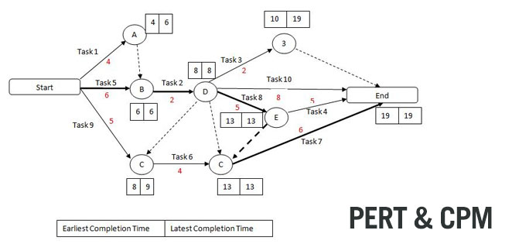

**This is the default project to be insert in code**

General

* Build a Pert or CPM system (A project management system) with Python OOP, demonstrating the essential facts and functionalities of managing project.
* You can add any methods helper to the project.
* The homework is for two students. Deliver it only once to the modle site (One student record).
* The solution must be on Python file or files(.py).
* Give meaning names to the variable.
* Remarks every before any method, what going on in the method.
* Logger is a must for each method. All logs will be written to a file. And eventually read the file for Python cortex (for convenience).
* Unit Test is not mandatory (no points) but nice to have.

1. Initializes a project object if no dictionary or None is given, an empty dictionary will be used
2. Build method that add activity to the project, Activity must have at least two fields: name, duration.
3. Build method for removing activity from the project
4. Build method that validate the project, this method reveals a circle's activities in the project, and display them (You can find the algorithm in the internet).
5. Build method to find isolate activities. An activity without following or ascending another activity.
6. Overwrite __str__ method for any project’s class, with clear detail.
7. Build method that find critical path of the project (Showing the edges of the critical pass with their length (20 point).
8. Show slack's time for all activities in descending order. Don’t show the critical activities in the list (By definition, critical path has activities with a zero-slack time)
9. Add property that show what is the duration of the project.