Maitland Andrus

9/16/2023

CS 3550

For the Northwind database, the customer places an order. What happens to order right now if a customer is deleted?

* Right now, its set to No Action.

If you are asked to propose a different strategy, what will it be? Implement it.

* I would propose that instead of using No Action, they instead use Cascade.
* 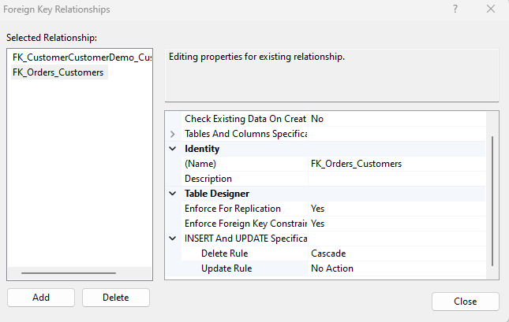

Do the same for the relationship "Shipper fulfills an order." What happens if a shipper is deleted? If you are asked to propose a different strategy, what will it be? Implement it.

* Currently its set to No Action. I propose the same as before and believe a better strategy is to perform a cascade.
* A screenshot of a computer

  Description automatically generated