Maitland Andrus

9/16/2023

CS 3550

Delete and Update Rules for Student:

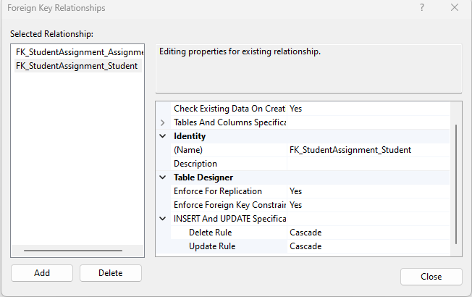

Delete and Update Rules for Assignment:

Assignment:

Max Possible Grade 200

Least possible Grade 0

Submission Type:

Assignment Name:

Student:

Dept_No

Student Assignment:

\

Grade Max 200

Grade No more 0

