Maitland Andrus

SQL 3550

Part 1 Select:

1)

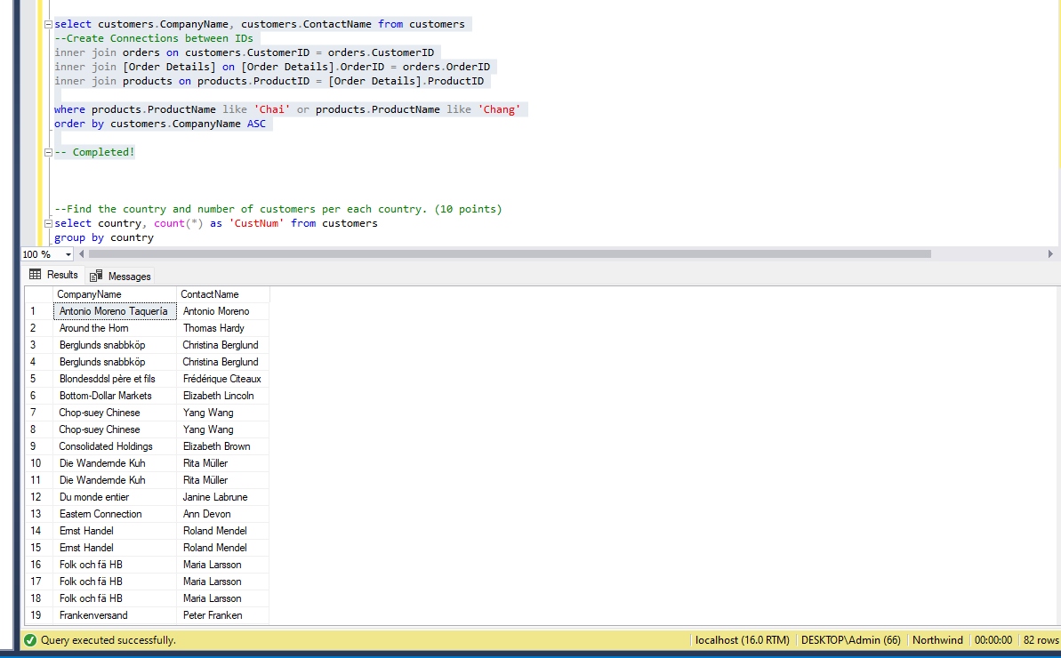

2)

3)

4)

5)

6)

7)

8)

