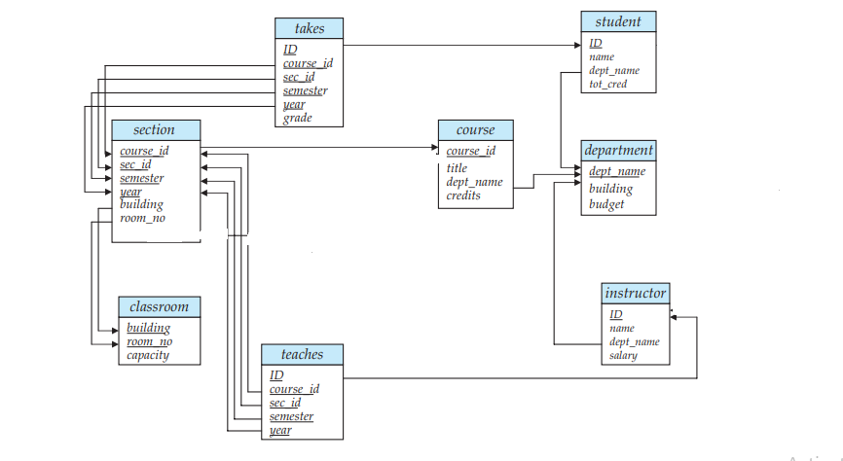
Instructor table:
ID | name | Dept_name | salary
22222 | Einstein | Physics | 95000
33333 | Korth | Computer Science | 75000
45454 | Mozart | Music | 60000
55555 | Navathe | Computer Science | 100000

Department table:
dept_name | building | budget
Physics | AB-I | 100000
Computer Science | AB-II | 150000
Maths | AB-III | 80000

Section table:
course_id | sec_id | semester | year | building | room_number
CS-2201 | CS-21 | 1 | E2 | AB-II | 112
Ph-101 | PUC-11 | 1 | P1 | AB-I | 111
MA-201 | CS-21 | 1 | E2 | AB-II | 112
CS-3201 | CS-31 | 1 | E3 | AB-II | 101

Teaches table:
ID | course_id | sec_id | semester | year
22222 | CS-2201 | CS-21 | 1 | E2
22222 | CS-3201 | CS-31 | 1 | E3
45454 | MA-201 | CS-21 | 1 | E2

Student table:
ID | name | dept_name | tot_cred
1000 | Kshitiz | Computer Science | 80
1001 | Mike | Computer Science | 70
2000 | Virtuos | Maths | 60

Takes table:
ID | course_id | sec_id | semester | Year | grade
1000 | CS2201 | CS-21 | 1 | E2 | A
1001 | CS3201 | CS-31 | 1 | E3 | A
1000 | MA-201 | CS-21 | 1 | E2 | B
1001 | CS2201 | CS-21 | 1 | E2 | A

Course table:
course_id | title | dept_name | credits
CS-2201 | DBMS | Computer Science | 4
CS-3201 | OS | Computer Science | 4
MA-201 | PS | Maths | 3
Ph-101 | Physics-1 | Physics | 3

Classroom table:
building | room_no | capacity
AB-II | 112 | 100
AB-I | 111 | 80
AB-II | 101 | 70

- Find the names of the instructors(other than computer science) whose salary is greater than at least one instructor in the computer science department
- Increase the salary of instructors by 3% whose salary is less than average salary of their departments.
- Display the course titles and instructor names taken by the student named ‘kshitiz’
- Display the course titles and department name conducted in building ‘AB-II’ class room ‘112’
- Display the student name who have taken all the courses in Computer Science department
- Display the highest credit subjects in each year-semester
- Display ids and titles of courses which are offered in computer science department in either semester1 or semester 2 of ‘E2’
- Find the number of students who have taken course sections taught by instructor ‘Korth’
- Display the details of the students who got ‘A’ grade in all the courses he has taken

