DiD

Planning Phase

Names / Student ID:

Younis Fehaid
202202515

Ali Naser
202202522

Hamad Ebrahim
202304769

Abdulrahman Elsayed
202302340
Contents
Introduction: 3
2.0 Part A: Planning Phase 3
2.1 Task 1: Incident Response Cycle Stages 3
2.1.1 Description of IR Stages: 3
2.1.2 Alignment and Improvements: 4
2.2 Task 2: Information Security Risk Management 5
2.2.1 Risk Analysis: 5
2.2.2 Zero Trust in Risk Assessment: 7
2.3 Task 3: Threat Detection and Remediation Solutions 9
2.3.1 Recommended Detection Systems: 9
2.3.2 Remediation Strategies 10
2.4 Task 4: Hierarchical Network Security Design 10
2.4.1 Logical Network Diagram: 11
2.4.2 Design Justification: 14
2.5 Task 5: VPN Solutions Analysis 14
2.5.1 VPN Evaluation 14
2.5.2 Proposed Hybrid Model: 16
2.6 Task 6: Emerging Cybersecurity Trends 16
2.6.1 Analysis of Trends: 16
2.6.2 ZTA and DiD Complementation 17
3.0 Conclusion and Recommendations 17
4.0 Reflection Table 19
5.0 References 19

Introduction:
In today’s digital scene, companies are increasingly vulnerable to cyber-attacks, with attacks getting more complex by the day to bypass traditional security boundaries. Gulf Tech Solutions, operating across the Gulf countries, faces complex cybersecurity threats and challenges. Outdated security measures in the company, such as outdated firewalls and weak VPNs, can expose the company to cyber-attacks that can lead to the leakage or compromisation of critical information.

This project aims to strengthen the Gulf Tech Security measures by applying a Defense in Depth (DiD) plan, which applies multiple layers of security measures and by exploring the future of integration of Zero trust Architecture (ZTA). The goal of this project is to design and implement a complete cybersecurity framework to enhance threat detection and mitigation controls.

2.0 Part A: Planning Phase

2.1 Task 1: Incident Response Cycle Stages

2.1.1 Description of IR Stages:
The Incident Response lifecycle provides organizations with a systematic approach to detect and handle and restore operations after cybersecurity incidents occur. The system enables Gulf Tech Solutions to handle situations through planned responses instead of impulsive reactions. The following description details the seven essential stages of development.
- Preparation: The organization needs to create its incident response system during this initial stage which establishes all necessary resources for future incident management. The process requires organizations to establish their Computer Security Incident Response Team (CSIRT) while developing communication strategies and providing training to staff members and implementing security tools including firewalls and endpoint protection systems.
- Detection: Security teams active in this phase monitor network traffic to identify both security threats and potential security risks. The main objective is to determine whether an incident has started or is currently taking place. The system depends mainly on security alerts which IDS systems and firewalls and SIEM logs generate.
- Analysis: The team needs to establish the extent of the detected threat along with its source and the resulting effects. The process requires triage to identify actual threats from false alarms while analyzing system logs and determining the attack type which could be ransomware or phishing.
- Containment: The main objective of containment involves preventing the threat from expanding while it continues to harm the system. The process includes two stages of containment which involve short-term network isolation of infected hosts and long-term system protection through temporary vulnerability patching.
- Eradication: The process of containment needs to be followed by complete removal of the incident source which represents the root cause. The process requires malware deletion and disabled access to compromised user accounts and vulnerability patching and complete network protection from the attacker.
- Recovery: The system returns to its typical functioning state after completing the recovery process. The process requires data recovery from backup systems and system verification and network surveillance to detect any remaining threats or new infections.
Post-Incident Activity: The final phase of post-incident activities includes conducting a "Lessons Learned" meeting. The team examines incident documentation to identify successful elements and failed components. The research results will help organizations modify their policies and enhance their detection systems and develop better incident response protocols for upcoming security events.

2.1.2 Alignment and Improvements:
The company faces major security risks because its outdated systems lack centralized security management. The current system needs to follow the IR lifecycle through these strategic improvements which will bring it into alignment.
- Aligning the Current Setup:
  - Preparation: Gulf Tech faces two major security issues because it operates with outdated firewalls and insufficient multi-level protection systems. The organization needs to concentrate its efforts on replacing outdated systems while implementing the "Defense-in-Depth" strategy which management has made mandatory.
  - Detection & Analysis: The current "legacy IDS/IPS systems" fail to protect against contemporary cyber threats. The organization needs to implement sophisticated detection systems which will identify the ransomware and phishing attacks that threaten its security.
  - Containment: The current weak VPN links which support "inter-branch connectivity" make it hard to implement containment. The new design requires network segmentation to separate R&D from other areas because this approach will stop attackers from moving between systems during an incident.
- Suggested Improvements:
  - Centralized Logging: The system lacks centralized AAA because access control exists in separate disconnected systems. The company needs to establish a centralized SIEM solution which will collect logs from all its branches located in Bahrain, Dubai, Riyadh and Doha. The system provides investigators with complete WAN traffic visibility during the Analysis phase.
  - Documentation: The organization needs to create official Incident Response Plans (IRP) which should focus on protecting high-risk areas including the R&D department based in Manama. The documentation process requires network diagrams which need to be exact because the existing diagrams might contain outdated information to facilitate quick Containment decision-making.
  - Playbook Automation: Gulf Tech needs to establish SOAR (Security Orchestration Automation and Response) as a solution to handle the absence of immediate threat identification capabilities. The system enables automated playbooks which perform immediate host isolation and malicious IP address blocking without requiring human involvement to speed up Detection and Containment phase operations.

2.2 Task 2: Information Security Risk Management
2.2.1 Risk Analysis:

Part 1: Risk Management analysis

- Finding Vulnerabilities

- Think of vulnerabilities as easy spots in your system where things could go wrong by hackers getting control of them, there are great tools to sniff out vulnerabilities such as Nessus or OpenVas, whether it’s old software that never got updated, sloppy settings, or anything else that open doors to vulnerabilities these tools can help lessen the chances of your system being hacked.

2. Assessing threats

- Threats come in a lot of different methods. Sometimes it’s a hacker trying to break in, other times it’s a system or a software crashing unexpectedly. Splunk is a SIEM tool that watches everything as it happens, it keeps an eye on any unusual activities like someone poking around where they shouldn't be or somebody slipping past the firewall.

3. Applying Mitigation Controls

- After finding risks, you should start applying controls such as patching systems or updating old software patches. you should start adding firewalls, encryption and enforcing access controls to block unauthorized users and protect sensitive data.

Mitigation Controls methods

ACL (Access Control Lists) | Utilize ACLs to restrict access based on IP address or protocols, ACLs can be used to limit access to network resources. This aids in limiting  Unauthorized access.
Security Zones | Dividing network access across zones and enhancing the overall level of security can be achieved by network segmenting into various security zones such as DMZ, internal and external.
Firewall | The firewall is a barrier between inner and outer networks and it controls and monitors traffic based on security rules.
IPS/IDS (Intrusion Prevention/Detection System) | Network activities are monitored by IDS for unusual activities and threats generating alerts. IPS blocks potential and upcoming threats in real time before they cause harm to the network.

Risk assessment matrix

This matrix aims to prioritize security risks within the gulf tech solutions, By showing and explaining the impact, likelihood and Risk level of potential threats to the company infrastructure with mitigation controls.

Risk Assessment Criteria

Impact Scale:
- Low (1): Minimal impact on operations.
- Medium (2): Moderate impact on operations.
- High (3): Severe impact on operations.
Likelihood Scale:
- Low (1): Unlikely to happen.
- Medium (2): Occasional threat.
- High (3): Likely to occur based on the current security measures

Risk Level Calculation:
Risk Level = Impact × Likelihood

Risk Level:
- Low (1-3): Minimal risk.
- Medium (4-6): Moderate risk.
- High (7-9): High risk.

Threat/Vulnerability | Impact | Likelihood | Risk level | Mitigation
Weak VPN Connectivity | High (3) | High (3) | High Risk (9) | Upgrade the VPN for a better one to get strong connectivity.
Outdated Firewalls | High (3) | High (3) | High risk (9) | Remove the outdated firewall patches by installing the new ones if there are any. If not upgrade the firewall to a different enhanced and up to date firewall.
Fragmented Access Controls | Medium (2) | High (3) | Medium (6) | Install an AAA system such as TACACS+ and enforce role-based access controls (RBAC).
Legacy IDS/IPS | High (3) | Medium (2) | Medium (6) | Implement a better and up-to-date IPS/IDS system.
Unpatched Software | Medium (2) | Medium (2) | Medium (4) | Create a regular patching procedure by updating software regularly.

2.2.2 Zero Trust in Risk Assessment:

Part 2: Zero Trust and Risk Assessment

Zero trust model follows a rule of never trusting anyone always verify, it assumes that no one is trusted by default whether it’s inside or outside the network, especially in high-risk areas.

Key Elements of Zero Trust

User ID Validation | Every User is authenticated when they access the system
Device Health Scan | Devices must meet the security standards by applying the latest security patches and are continuously monitored.
Controlled Access | Users get only the permissions required for their role, reducing risks if an account is hacked.

Why Zero Trust Matters

Zero Trust doesn’t stop checking. It keeps checking users who are asking for access
it checks if devices are safe, and it never gives out more privileges than needed. If someone tries to access sensitive data from a sketchy device, they get blocked out, the extra layer of verification goes a long way especially when you have sensitive data.

In summary, Zero Trust enhances security by treating every access request as a potential threat.

ddThis image displays the Zero Trust architecture in a really simple way.
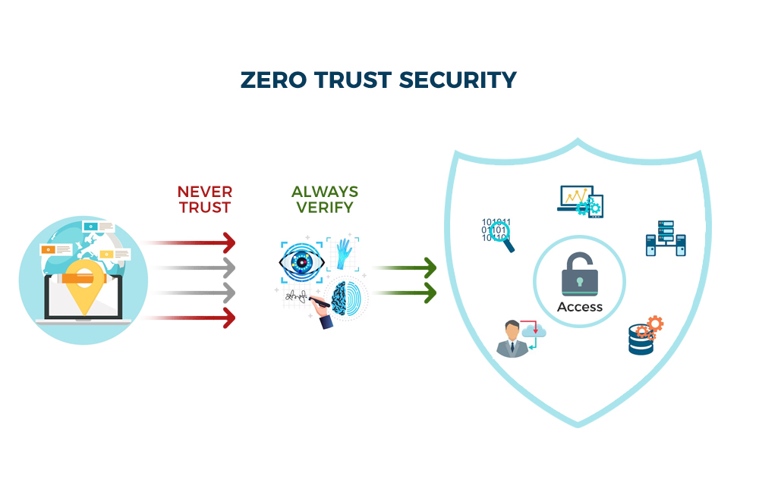
Figure 1 Zero Trust Security

2.3 Task 3: Threat Detection and Remediation Solutions
2.3.1 Recommended Detection Systems:

- Machine learning-based Detection:

- Anomaly Detection: Machine learning algorithms such as clustering and classification. Can be utilized to find unusual network activities. By training from historical data, the system can detect changes that may indicate threats.

- Tools: Tools like Darktrace Uses AI and machine learning for real time detection to monitor behavior and flag suspicious activities.

2. Behavior Analytics:

- User Behavior analytics (UBA): This technology tracks user behavior to detect unusual actions, such as a user accessing data that they don't have access to or even at odd hours on the day.

- Tools: Varonis and Splunk offer user analytics by monitoring usual user activities and flagging unusual activities that might signal suspicious alerts.

3. User and Entity Behavior Analytics (UEBA):

- UEBA Systems: Analyze user, device and application to identify and evaluate any upcoming threats in real time. This system can flag any signs of compromised credentials or data exfiltration by combining data from many sources.

- Tools: UEBA capabilities are provided by tools such as logic, splunk and logrythm. To continuously monitor unusual and suspicious activities even in their early stages.

2.3.2 Remediation Strategies:

- Automated Isolation: If an upcoming threat is detected compromised network entities can be isolated from it to help prevent the spread of malware or unauthorized access and it also help reduce the risk of further data loss while the incident is still being investigated.

- Alert Escalation: High level security alerts are sent to security specialists or the responsible team for the responses to ensure that threats receive immediate attention. Enhancing response times and mitigation before upcoming threats.

- Ticketing Workflows: after the events happen they are logged into case management systems to make sure that their properly tracked and managed so that upcoming threats receive action immediately for faster management and mitigation.

2.4 Task 4: Hierarchical Network Security Design

This task presents a network architecture for the hierarchical network, emphasizing layered security controls to mitigate risks at multiple points. The design incorporates segmentation by department to isolate sensitive resources, an IP address scheme optimized for scalability, VLAN assignments for logical grouping, access control lists (ACLs) for traffic filtering, and network hardening strategies to reduce attack surfaces. Security devices,including intrusion detection systems (IDS), intrusion prevention systems (IPS), firewalls, and email/web security appliances, are strategically placed across network layers. The architecture follows a three-tier hierarchical model (access, distribution, and core/edge), with justifications provided for Layer 2 (L2) and Layer 3 (L3) segmentation decisions based on security, routing efficiency, and scalability needs.
Logical diagrams (see Figure 3 Cisco Design Network Architecture), it illustrate the overall topology and security placements. Figure 3 Cisco Design Network Architecture depicts the high-level hierarchical structure.

2.4.1 Logical Network Diagram:

The architecture is divided into three primary zones: Outside (untrusted WAN/Internet), DMZ (semi-trusted for public-facing services), and Inside (trusted internal network). This zoning enforces DiD by applying controls at each boundary and within layers.
- Outside Zone: Connects to the Internet and branch sites (Dubai, Riyadh, Doha) via the edge router using DMVPN for secure site-to-site VPNs over public links. Public IPs (e.g., 201.10.0.0/30 for branch links, 209.10.0.0/28 for router-firewall connections) are used here.
- DMZ Zone: Hosts public-facing servers (HTTP, email) and monitoring devices, isolated to prevent lateral movement if compromised.
- Inside Zone: Contains departmental segments, management resources, and core routing/switching.
The hierarchical layers are:
- Access Layer: End-user devices (e.g., PCs in HR, Sales) connect via access switches with port-level security.
- Distribution Layer: Aggregates access traffic, enforces inter-VLAN routing, and applies ACLs/IPS.
- Core/Edge Layer: Handles high-speed routing to branches/Internet via the edge router and firewalls.
Security devices are placed as follows:
- Firewalls: Cisco ASA in active/standby failover mode with multiple contexts (CTX-MAIN for primary traffic, CTX-EXTRA for additional DMZ resources). Positioned between the edge router (Outside) and IPS (Inside/DMZ) to inspect and filter zone-to-zone traffic.
- IPS: Inline at the distribution layer (post-firewall, pre-inside switches) to actively block malicious traffic across VLANs.
- IDS: In the DMZ, monitoring traffic in promiscuous mode for anomaly detection without blocking.
- Email and Web Security Appliances: Integrated in the DMZ as SMTP relay/mail gateway for email filtering (anti-spam, anti-malware) and web proxy/reverse proxy for HTTP/HTTPS inspection, ensuring secure inbound/outbound web/email traffic.
This placement ensures threats are detected and mitigated at the perimeter (firewalls), inline (IPS), and via monitoring (IDS), with appliances handling application-layer threats.
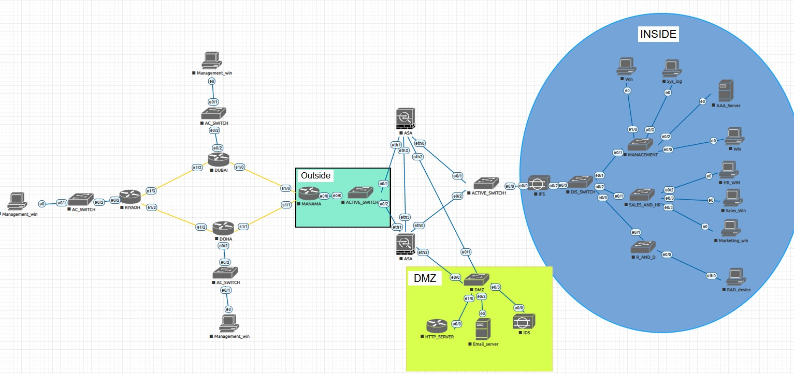
Figure 3 Cisco Design Network Architecture

Departmental Segmentation: Departments are isolated to limit blast radius in case of compromise. HR, Marketing, Sales, R&D, and Management are separated logically.
VLAN ID | Description | Subnet (Manama) | Subnet (Dubai) | Subnet (Riyadh) | Subnet (Doha)
10 | HR Department | 10.10.10.0/24 | 10.20.10.0/24 | 10.30.10.0/24 | 10.40.10.0/24
20 | Marketing Department | 10.10.20.0/24 | 10.20.20.0/24 | 10.30.20.0/24 | 10.40.20.0/24
30 | Sales Department | 10.10.30.0/24 | 10.20.30.0/24 | 10.30.30.0/24 | 10.40.30.0/24
40 | R&D Department (Isolated) | 10.10.40.0/24 | 10.20.40.0/24 | 10.30.40.0/24 | 10.40.40.0/24
50 | Management/AAA/SIEM | 10.10.50.0/24 | 10.20.50.0/24 | 10.30.50.0/24 | 10.40.50.0/24
100 | DMZ (Public-Facing Services) | 10.10.100.0/24 | 10.20.100.0/24 | 10.30.100.0/24 | 10.40.100.0/24
ACLs:
- On IPS: Restrict access to prevent unauthorized entry except from Management VLAN 50. For example, signatures (e.g., 2004/0) produce alerts, reset TCP connections, and deny packets inline for non-management traffic. Communication to DMZ uses secure ports (e.g., HTTPS/443 for web, SMTP/25 for email), with all other traffic blocked (e.g., signatures 3040/0 and 3041/0 deny ICMP and other probes).
- On Firewalls: Zone-based (e.g., OUTSIDE-IN-EXTRA permits ICMP to DMZ hosts like 10.10.100.50 but denies broader access; INSIDE-OUT permits Management to DMZ but restricts R&D).
- On Switches: ARP ACLs (e.g., permit specific IP-MAC bindings like 10.10.10.10 to 50:00:00:0C:00:00).
Network Hardening Strategies:
- Switches: Enable DHCP snooping (vlan 10,20,30,40,50,100), dynamic ARP inspection, IP source guard, port security (sticky MAC, max 30 addresses, violation restrict/shutdown), BPDU guard, loop guard, and STP priority 4096 on distribution switches.
- Routers/Firewalls: No IP domain-lookup, CEF enabled, ISAKMP policies with AES/SHA, IPsec transforms for DMVPN.
- General: Logging to Syslog/AAA server (10.10.50.20), timestamps, HTTP/SSH management restricted to Management VLAN, NAT/PAT for inside-to-outside (dynamic interface) and static for DMZ servers.

2.4.2 Design Justification:
- Departmental Subnets (VLANs 10,20,30,40,50): L2 segmentation via VLANs on access/distribution switches. Justification: Enhances security by containing broadcast domains and preventing L2 attacks within departments; simplifies routing as inter-VLAN traffic is handled at L3 by the IPS/router subinterfaces; scalable for adding hosts without rerouting, as each /24 supports growth.
- DMZ Subnet (VLAN 100): L2 segmentation on DMZ access switch. Justification: Isolates servers/appliances at L2 for security (limits direct access from inside); routing to inside/outside occurs at L3 via firewall, ensuring inspected traffic; scalable for adding DMZ resources without impacting internal routing tables.
- Firewall Zones (Outside, Inside, DMZ): L3 segmentation via ASA interfaces (example- Ethernet0: Inside 10.10.1.2/29, Ethernet1: Outside 209.10.0.2/29, Ethernet2: DMZ 10.10.100.1/24). Justification: Provides stateful inspection and NAT at L3 for security (e.g., denies unsolicited inbound); efficient routing with static/default routes, highly scalable for multi-context failover, supporting branch expansion without performance degradation.
- WAN/Branch Links: L3 segmentation via router serial interfaces and DMVPN tunnels (no VLANs). Justification: Secures remote access with IPsec encryption at L3, optimizes routing via OSPF (area 0) for low-latency branch connectivity; scalable for adding sites via dynamic NHRP mapping, avoiding L2 extension overhead.
This segmentation balances security (isolation), routing (efficient paths), and scalability (modular growth).

2.5 Task 5: VPN Solutions Analysis

2.5.1 VPN Evaluation

- GET VPN (Group Encrypted Transport VPN)

- Encryption: GET VPN utilizes IPsec with AES for end to end encryption to ensure that the traffic remains confidential during transit.

- Ease Of Deployment: The vpn installment is a bit complex due to its reliance on specific hardware such as cisco routers and configurations. It also requires setting up a central key server for group management which could add complexity.

- Performance: High performance, it's optimized for large deployments with low latency and high throughput capabilities which makes it suitable for high bandwidth applications, less overhead which enhances its ability for better performance sensitive applications

2. SSL VPN (Secure Sockets Layer VPN)

- Encryption: SSL VPN uses SSTL/TLS protocols such as AES and 3DES. To encrypt traffic at the transport layer.

- Ease Of Deployment: SSL vpn’s are very easy to deploy particularly for remote access or client to server connections. Since it operates via a web browser.

- Performance: Moderate performance, in comparison to IPsec. Since SSL VPN’s handles traffic at the application layer making it less suitable for high bandwidth applications.

3. IPsec VPN (Internet Protocol Security VPN)

- Encryption: IPsec VPN utilizes AES and 3DES encryption to encrypt IP packets. It operates at the network layer.

- Ease Of Deployment: Moderate Complexity requires configuration on both client and server side and its more complex than SSL VPN due to the need for the manual key exchange or a dedicated security gateway.

- Performance: It has high performance capabilities for both site to site and remote access use cases and it has low latency and high throughput which makes it suitable for low latency applications. Less overhead compared to ssl vpn which is a key advantage for performance.

4. DM VPN (Dynamic Multipoint VPN)

- Encryption: uses IPsec with AES encryption to secure GRE tunneling and communications for dynamic multipoint connectivity.

- Ease Of Deployment: It offers scalability in deployment It uses a stabilized structure. Which eases management and eliminates the need for static routing however it needs a specific configuration on routers and VPN concentrators.

- Performance: High performance, with low latency and high throughput, making it suitable for large scale deployments. It handles dynamic connection efficiently between multiple remote sites and its performance is optimized for scenarios where there is the need for high availability and redundant scenarios.

2.5.2 Proposed Hybrid Model:

To meet Gulf Tech communication needs, we need to implement a Hybrid VPN model by combining GET VPN, SSL VPN and IPsec VPN.

- GET VPN: is used for site to site between GulfTech’s branches. It ensures high performance and low latency. It encrypts traffic across large scale networks.

- SSL VPN: Used by employees for remote access. It provides easy browser based secure access to internal systems without the need for a client software.

- IPsec VPN: It serves as a backup for both site to site and remote access communication in case of a failure in the vpn’s.

Benefits:

- High Availability: Redundant VPN solutions ensure minimal interference.
- Scalability: Easy to scale as Gulf Tech grows, adding more branches or remote users.
- Enhanced Security: Multiple layers of security (VPN’S) to protect GulfTech’s data.

This proposed hybrid vpn model when implemented will help with better security levels and availability and scalability, it combines the most important aspect of each vpn

2.6 Task 6: Emerging Cybersecurity Trends
2.6.1 Analysis of Trends:
The cybersecurity field of 2025 shows fast development because of AI system integration with cloud computing and adaptive security system designs. Defense strategies face transformation because of three main trends which are:
- Zero Trust Architecture (ZTA): Operates as a standard which implements "never trust, always verify" through ongoing authentication and network segmentation into small segments. The solution protects against complex cyber threats through network segmentation and multi-factor authentication which has become standard practice for organizations using hybrid infrastructure.
- Cloud-Native Security Approaches: CSPM tools perform automated cloud configuration monitoring to detect and resolve security misconfigurations while CWPP protects workloads through runtime defense of containers and VMs. Zero-trust for cloud workloads implements detailed security rules which protect changing resources across multiple cloud environments to prevent multi-cloud security threats.
- Cybersecurity Automation: SOAR platforms orchestrate responses by integrating tools for automated incident handling, reducing MTTR. AI/ML-based automation enhances this with predictive analytics, auto-quarantining threats, and playbook execution.
- Internet of Things (IoT) Protection: With IoT proliferation, trends focus on device segmentation, firmware scanning, and AI-driven anomaly detection to mitigate vulnerabilities in connected ecosystems.
- AI-Based Threat Detection: AI or ML underpins proactive defenses, using behavioral analytics to spot zero-day attacks and automate responses, evolving from signature-based to predictive models.
By moving from perimeter-based protection to data-centric protection, these trends make strategies more proactive.

2.6.2 ZTA and DiD Complementation:
ZTA improves DID by supplementing conventional multitier defenses with dynamic identity-focused layers. It allows for context-aware decision-making (time restrictions), dynamic trust scoring (for example, based on device health or behavior) and fine-grained access policies (role-based per session). ZTA could improve DID in later stages for Gulf Tech's high-sensitivity zones such as R&D and by confirming each access request, lowering the impact of breaches beyond static firewalls and VLANs. Adaptive resilience is improved/enhanced by this synergy, making it the perfect for multibranch configurations.

3.0 Conclusion and Recommendations

Gulf Tech Solutions' critical cybersecurity issues across its multi-branch infrastructure were successfully addressed by this project's design and implementation of a thorough Defense-in-Depth (DiD) security framework. The project produced a layered security architecture that integrates people, processes, and technology by examining current vulnerabilities like antiquated firewalls, poor VPN connectivity, disjointed access controls, and legacy IDS/IPS systems.

Using formal risk assessment matrices for risk management, machine learning, behavioral analytics, and UEBA, as well as structured incident response lifecycle alignment, the planning phase built a solid foundation. By employing VLANs, DMZ isolation, ACL enforcement, and hardened L2/L3 controls for efficient segmentation, the suggested hierarchical network design greatly reduced the attack surface and restricted lateral network movement.

The deployment of high-availability firewalls, centralized AAA with role-based access control, secure inter-branch VPN connectivity, and sophisticated IDS/IPS systems during the implementation phase showed how DiD principles can be applied in a real-world business setting. Furthermore, the investigation of Zero Trust Architecture (ZTA) demonstrated its potential as a future improvement to further reinforce access control, particularly for high-risk areas like the R&D department.

All things considered, the suggested and executed solution greatly enhances Gulf Tech Solutions' availability, confidentiality, and integrity, guaranteeing resilience against contemporary cyberthreats while preserving scalability and operational effectiveness.

Actionable Recommendations
To further enhance and sustain the security posture of Gulf Tech Solutions, the following actionable recommendations are proposed:
- Adopt Zero Trust Architecture Incrementally
Enforce continuous authentication, device posture validation, and least-privilege access policies when implementing ZTA controls, beginning with high-risk environments like the R&D network. This will lessen the risk of insider and credential-based attacks and enhance current DiD controls.
- Enhance Security Automation and SOAR Integration
Automate incident response playbooks like host isolation, credential revocation, and malicious IP blocking by integrating SOAR platforms with SIEM, IDS/IPS, and endpoint tools. Mean Time to Detect (MTTD) and Mean Time to Respond (MTTR) will decrease as a result.
- Regular Vulnerability Scanning and Patch Management
To guarantee prompt remediation of vulnerabilities found across all branches, implement a formal patch management lifecycle in conjunction with a scheduled vulnerability assessment program utilizing tools such as Nessus or OpenVAS.
- Strengthen Monitoring and Log Correlation
Increase the scope of centralized logging by continuously optimizing UEBA models and SIEM correlation rules to enhance the detection of anomalous activity, insider threats, and zero-day attacks throughout the WAN.
- Periodic Incident Response Testing and Training
To verify incident response preparedness, regularly conduct tabletop exercises and simulated cyberattack drills. After each significant infrastructure change, update the network diagrams and incident response documentation.
- Review and Optimize VPN and Firewall Policies
Audit firewall rules, VPN configurations, and encryption standards on a regular basis to make sure best practices are being followed and to eliminate any rules that are unnecessary or unduly permissive and could pose a risk.
- Future Expansion and Scalability Planning
As Gulf Tech Solutions grows, future branches and cloud resources should follow the same hierarchical and segmented design principles to maintain consistent security controls without compromising performance.

4.0 Reflection Table
Student ID | Name | % of Workload Assigned | Completion of workload assigned % | Main Task | Peer Review Remarks
202202515 | Younis Fehaid | 25% | 100% | Part A: Task 4  Part B: Task 2,3 | Leadership, Reliable, Fast
202202522 | Ali Saleh | 25% | 100% | Part B: Task 1,5,6 | On time, reliable, good coordination
202302340 | Abdulrahman Elsayed | 25% | 100% | Part A: Task 1,2,5  Part B: Task 4 | Reliable, Very fast, Good planner
202304769 | Hamad Ebrahim | 25% | 100% | Part A: Task 3,6  Part B: Task 7 | On time, thinking outside the box
Total |  | 100% | 100%

5.0 References
- Awati, R., & Parmenter, T. (n.d). Dynamic multipoint VPN (DMVPN). TechTarget. https://www.techtarget.com/searchnetworking/definition/dynamic-multipoint-VPN-DMVPN techtarget.com
- Awati, R., & Parmenter, T. (n.d.). Dynamic multipoint VPN (DMVPN). TechTarget. https://www.techtarget.com/searchnetworking/definition/dynamic-multipoint-VPN-DMVPN
- Check Point Software. (n.d.). What is defense in depth? https://www.checkpoint.com/cyber-hub/cyber-security/what-is-defense-in-depth/
- Cisco Systems. (2024). Cisco ASA Configuration Guide.
- Cisco Systems. (2024). Cisco ASA configuration guide. https://www.cisco.com/c/en/us/support/security/asa-5500-series-next-generation-firewalls/products-installation-and-configuration-guides-list.html
- Cisco. (n.d.). What is defense in depth? https://www.cisco.com/c/en/us/products/security/what-is-defense-in-depth.html
- Cloudflare. (n.d.). What is IPsec? https://www.cloudflare.com/learning/network-layer/what-is-ipsec/
- Cloudflare. (n.d.). What is IPsec?. Retrieved from https://www.cloudflare.com/learning/network-layer/what-is-ipsec/
- CrowdStrike. (2025). Defense in depth [Beginner’s guide]. https://www.crowdstrike.com/en-us/cybersecurity-101/exposure-management/defense-in-depth/
- Fortinet. (n.d.). SSL VPN. https://www.fortinet.com/resources/cyberglossary/ssl-vpn
- Fortinet. (n.d.). SSL VPN. Retrieved from https://www.fortinet.com/resources/cyberglossary/ssl-vpn
- Fortinet. (n.d.). What is defense in depth? Defined and explained. https://www.fortinet.com/resources/cyberglossary/defense-in-depth
- GeeksforGeeks. (n.d.). Types of Virtual Private Network (VPN) and its Protocols. Retrieved from https://www.geeksforgeeks.org/computer-networks/types-of-virtual-private-network-vpn-and-its-protocols/
- GeeksforGeeks. (n.d.). Types of virtual private network (VPN) and its protocols. https://www.geeksforgeeks.org/computer-networks/types-of-virtual-private-network-vpn-and-its-protocols/
- IBM. (n.d.). What is defense in depth? https://www.ibm.com/topics/defense-in-depth
- ISACA. (n.d.). Information technology audit framework (ITAF): A professional practices framework for IT audit (4th ed.). https://www.isaca.org/resources/frameworks-standards-and-models
- Microsoft. (2025). Introduction to Azure security. https://learn.microsoft.com/en-us/azure/security/fundamentals/overview
- National Institute of Standards and Technology. (2009). Guidelines on firewalls and firewall policy (Special Publication 800-41 Rev. 1). https://doi.org/10.6028/NIST.SP.800-41r1
- Palo Alto Networks. (n.d.). What is a next-generation firewall (NGFW)? https://www.paloaltonetworks.com/cyberpedia/what-is-a-next-generation-firewall
- Provided project configurations (e.g., IPS signatures, switch hardening).
- SentinelOne. (2025). 10 Cyber Security Trends For 2025. https://www.sentinelone.com/cybersecurity-101/cybersecurity/cyber-security-trends/
- VPN Gate. (n.d.). About VPN Gate. Retrieved from https://www.vpngate.net/en/about.aspx

