
Assessment Cover Sheet

Due Date
15/5/2025
Course Code
IT7003
Assessment Title
Practical Project
Course Title
Networking and Data Communications 2
Internal Moderator’s Name
Rizalito Lampitoc
External Examiner’s Name

Not must-pass
Group
Uncontrolled
Assessment Type

Instructions:
- This cover sheet must be completed (section in blue below) and attached to your assessment before submission in soft copy.
- This assessment carries 100 marks (20% of the course assessment) distributed to a total of 16 tasks assessing CILO 1, CILO 2, CILO 3, CILO 4, and CILO 5.
- The materials allowed for use in this assessment are open.
- The use of generative AI tools is strictly prohibited.
- References consulted (if any) must be properly acknowledged and cited.
- The assessment has a total of 4 pages.

Programme Title
Learner ID
202304764, 202305182, 202202515, 202302312, 202202514
Date
18/5/2025
Learner Name
IT7003 - Networking and Data Communications 2
IT7003
Husain Naser, Mohamed Ahmed, Younis Fehaid, Hasan Albuainain, Abdulrahman Alshoubaili

Programme Code
Lecturer’s Name

By submitting this assessment for marking, I affirm that this assessment is my own work.
Learner Signature

Do not write beyond this line. For assessor use only.
Assessor’s Name

Marking Date

Maks Obtained

Comments:

Table of Contents
Table of Contents 2
Introduction 4
Task 1: IPv4 Addressing and Routing Protocol 4
A. Site-Level Subnetting 4
B. Department-Level Subnetting (Manama HQ) 4
C. Department-Level Subnetting (Riyadh Branch) 5
D. Department-Level Subnetting (Kuwait Branch) 5
E. Router Connections 5
F. Public IP Scheme 6
Routing Protocol 6
Key Advantages: 6
Comparison table with OSPF's advantages highlighted: 7
Task 2: LAN Configuration and Network Optimization 7
VLAN to Department Mapping 7
Switch Configuration 8
Optimized Broadcast Domains via VLAN Segmentation 8
Revised VLAN Trunking Protocol (VTP) Configuration 9
Key Benefits of Separate VTP Domains 10
Spanning Tree Protocol (STP) 10
Task 3: Design Security and Redundancy Measures on the LAN 11
Security Measures 11
Redundancy Measures 12
Task 4: Secure Wireless Access 13
Wireless Design 13
Security Implementation 13
Additional security used 13
Configurations 14
Diagram with justification (showcases the wireless AP in the actual simulated network): 15
Task 5: WAN Technology and Data Link Layer Encapsulation 15
WAN Technology Selection 15
Key Advantages of Point-to-Point Leased Lines: 15
Data Link Layer Encapsulation 15
Advantages of the Implemented Approach 16
Network Topology Summary 16
Task 6: PAT + Static NAT 16
NAT Types Used 16
Static NAT Configuration (HQ - Bahrain) 17
PAT Configuration (All Sites) 17
Static NAT Mappings (Manama HQ) 17
PAT Mapping (BH - Bahrain HQ) 18
PAT Mapping (SA - Saudi Arabia) 18
PAT Mapping (KW - Kuwait) 18
Task 7: Access Control Lists (ACLs) 19
IT Staff SSH Access 19
ACL Configuration 19
Explanation 19
Block ICMP to Servers 19
ACL Configurations 19
Explanation 19
Restrict HR and Finance Internet Access 19
ACL Configurations 19
Explanation 20
Server Access from Internet 20
ACL Configurations 20
Explanation 20
References 20

Introduction
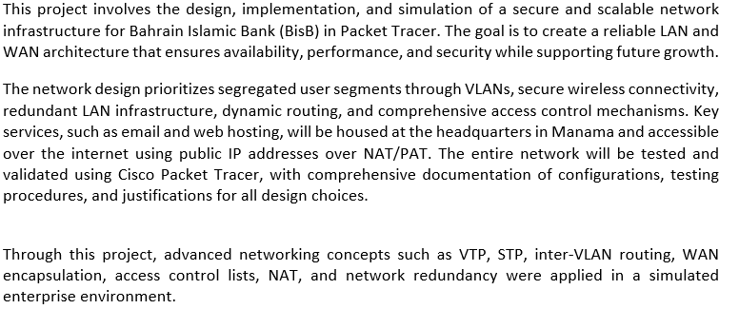

Task 1: IPv4 Addressing and Routing Protocol

Site-Level Subnetting
Site | Private Block | Subnet Mask | Usable Hosts | Note
Manama (HQ) | 10.1.0.0/16 | 255.255.0.0 | 65,534 | Central services, Internet/NAT at HQ
Riyadh | 10.2.0.0/16 | 255.255.0.0 | 65,534 | Branch 1; projected to double in 5 years
Kuwait | 10.3.0.0/16 | 255.255.0.0 | 65,534 | Branch 2; projected to double in 5 years

Department-Level Subnetting (Manama HQ)
Department | Current Hosts | Subnet Mask | Subnet ID | Usable Hosts | IP Range
Management | 35 | 255.255.255.192 | 10.1.1.0/26 | 62 | 10.1.1.0 – 10.1.1.63
Administration | 40 | 255.255.255.192 | 10.1.2.0/26 | 62 | 10.1.2.0 – 10.1.2.63
Marketing | 45 | 255.255.255.192 | 10.1.3.0/26 | 62 | 10.1.3.0 – 10.1.3.63
Human Resources | 20 | 255.255.255.224 | 10.1.4.0/27 | 30 | 10.1.4.0 – 10.1.4.31
Finance | 65 | 255.255.255.128 | 10.1.5.0/25 | 126 | 10.1.5.0 – 10.1.5.127
IT | 35 | 255.255.255.192 | 10.1.6.0/26 | 62 | 10.1.6.0 – 10.1.6.63
Loan Services | 20 | 255.255.255.224 | 10.1.7.0/27 | 30 | 10.1.7.0 – 10.1.7.31
Legal | 20 | 255.255.255.224 | 10.1.8.0/27 | 30 | 10.1.8.0 – 10.1.8.31
Servers (Web/Email) | 4 | 255.255.255.248 | 10.1.9.0/29 | 6 | 10.1.9.0 – 10.1.9.7
Wi-Fi VLAN | 280 | 255.255.254.0 | 10.1.10.0/23 | 510 | 10.1.10.0 – 10.1.11.255

Department-Level Subnetting (Riyadh Branch)
Department | Current → Future | Subnet Mask | Subnet ID | Usable Hosts | IP Range
Management | 10 → 20 | 255.255.255.224 | 10.2.1.0/27 | 30 | 10.2.1.0 – 10.2.1.31
Administration | 20 → 40 | 255.255.255.192 | 10.2.2.0/26 | 62 | 10.2.2.0 – 10.2.2.63
Marketing | 10 → 20 | 255.255.255.224 | 10.2.3.0/27 | 30 | 10.2.3.0 – 10.2.3.31
Human Resources | 8 → 16 | 255.255.255.224 | 10.2.4.0/27 | 30 | 10.2.4.0 – 10.2.4.31
Finance | 20 → 40 | 255.255.255.192 | 10.2.5.0/26 | 62 | 10.2.5.0 – 10.2.5.63
IT | 15 → 30 | 255.255.255.192 | 10.2.6.0/26 | 62 | 10.2.6.0 – 10.2.6.63
Loan Services | 33 → 66 | 255.255.255.128 | 10.2.7.0/25 | 126 | 10.2.7.0 – 10.2.7.127
Legal | 10 → 20 | 255.255.255.224 | 10.2.8.0/27 | 30 | 10.2.8.0 – 10.2.8.31
Servers (Web/Email) | 4 | 255.255.255.248 | 10.2.9.0/29 | 6 | 10.2.9.0 – 10.2.9.7

Department-Level Subnetting (Kuwait Branch)
Department | Current → Future | Subnet Mask | Subnet ID | Usable Hosts | IP Range
Management | 10 → 20 | 255.255.255.224 | 10.3.1.0/27 | 30 | 10.3.1.0 – 10.3.1.31
Administration | 15 → 30 | 255.255.255.192 | 10.3.2.0/26 | 62 | 10.3.2.0 – 10.3.2.63
Marketing | 10 → 20 | 255.255.255.224 | 10.3.3.0/27 | 30 | 10.3.3.0 – 10.3.3.31
Human Resources | 8 → 16 | 255.255.255.224 | 10.3.4.0/27 | 30 | 10.3.4.0 – 10.3.4.31
Finance | 15 → 30 | 255.255.255.192 | 10.3.5.0/26 | 62 | 10.3.5.0 – 10.3.5.63
IT | 15 → 30 | 255.255.255.192 | 10.3.6.0/26 | 62 | 10.3.6.0 – 10.3.6.63
Loan Services | 55 → 110 | 255.255.255.128 | 10.3.7.0/25 | 126 | 10.3.7.0 – 10.3.7.127
Legal | 5 → 10 | 255.255.255.240 | 10.3.8.0/28 | 14 | 10.3.8.0 – 10.3.8.15
Servers (Web/Email) | 4 | 255.255.255.248 | 10.3.9.0/29 | 6 | 10.3.9.0 – 10.3.9.7

Router Connections
Subnet ID | Subnet Mask | Usable Hosts | Notes | IP Range
10.1.100.0/29 | 255.255.255.248 | 6 | BH routers to MLS (right) | 10.1.100.0 – 10.1.100.7
10.1.100.8/29 | 255.255.255.248 | 6 | BH routers to MLS (left) | 10.1.100.8 – 10.1.100.15
10.2.100.0/29 | 255.255.255.248 | 6 | SA routers to MLS (right) | 10.2.100.0 – 10.2.100.7
10.2.100.8/29 | 255.255.255.248 | 6 | SA routers to MLS (left) | 10.2.100.8 – 10.2.100.15
10.3.100.0/29 | 255.255.255.248 | 6 | KW routers to MLS (right) | 10.3.100.0 – 10.3.100.7
10.3.100.8/29 | 255.255.255.248 | 6 | KW routers to MLS (left) | 10.3.100.8 – 10.3.100.15

Public IP Scheme
Assigned Block: 192.124.249.32/27
Usable IPs: 192.124.249.33 – 192.124.249.62
Reserved: 192.124.249.32 (Network), 192.124.249.63 (Broadcast)
Purpose | Subnet | Usable IPs | Assignments
Bahrain Active WAN | 192.124.249.32/30 | 192.124.249.33–34 | ISP: 33, bh-m-active-router: 34
Bahrain Standby WAN | 192.124.249.36/30 | 192.124.249.37–38 | ISP: 37, bh-m-standby-router: 38
Kuwait Active WAN | 192.124.249.40/30 | 192.124.249.41–42 | ISP: 41, kw-k-active-router: 42
Kuwait Standby WAN | 192.124.249.44/30 | 192.124.249.45–46 | ISP: 45, kw-k-standby-router: 46
Saudi Active WAN | 192.124.249.48/30 | 192.124.249.49–50 | ISP: 49, sa-r-active-router: 50
Saudi Standby WAN | 192.124.249.52/30 | 192.124.249.53–54 | ISP: 53, sa-r-standby-router: 54
HQ Server (Web/Email) | N/A | 192.124.249.56 | Static NAT for internal IP 10.1.9.4
Remaining Usable IPs | N/A | 192.124.249.57–62 | Reserved for future services

Routing Protocol
In our network topology, we chose OSPF (Open Shortest Path First) as the routing protocol because it provides the best combination of performance, scalability, and reliability for our enterprise environment. Here are the key advantages that made OSPF the right choice:

Key Advantages:
- Fast Convergence – Uses LSAs for immediate topology updates.
- Scalable Design – Multi-area structure optimizes large networks.
- Smart Routing – Bandwidth-based cost selects fastest paths.
- Efficient Updates – Only sends changes, reducing overhead.
- Advanced Features – Supports load balancing and secure authentication.
- Vendor Neutral – Works across all network devices.

Comparison table with OSPF's advantages highlighted:
Feature | OSPF | RIP | EIGRP
Protocol Type | Link-state (smarter routing) | Distance-vector (outdated) | Hybrid (Cisco-only)
Security | Strong (MD5/SHA auth) | Weak (plaintext) | Good (MD5 only)
Standards | Open RFC (multi-vendor) | Open but obsolete | Cisco proprietary
Convergence | Fastest (LSA flooding) | Slowest (30-180s delays) | Fast (but Cisco-dependent)
Scalability | Unlimited (area hierarchy) | Max 15 hops | Large (but no multi-vendor)

Task 2: LAN Configuration and Network Optimization

VLAN to Department Mapping
Each site has been assigned VLANs to separate departments logically while maintaining consistency across locations:
Manama HQ VLAN Assignments
VLAN ID | Department | Subnet ID | IP Range
10 | Management | 10.1.1.0/26 | 10.1.1.1-10.1.1.62
20 | Administration | 10.1.2.0/26 | 10.1.2.1-10.1.2.62
30 | Marketing | 10.1.3.0/26 | 10.1.3.1-10.1.3.62
40 | Human Resources | 10.1.4.0/27 | 10.1.4.1-10.1.4.30
50 | Finance | 10.1.5.0/25 | 10.1.5.1-10.1.5.126
60 | IT | 10.1.6.0/26 | 10.1.6.1-10.1.6.62
70 | Loan Services | 10.1.7.0/27 | 10.1.7.1-10.1.7.30
80 | Legal | 10.1.8.0/27 | 10.1.8.1-10.1.8.30
90 | Servers (Web/Email) | 10.1.9.0/30 | 10.1.9.1-10.1.9.2
100 | Access Point | 10.1.10.0/23 | 10.1.10.0 - 10.1.11.255

Riyadh Branch VLAN Assignments
VLAN ID | Department | Subnet ID | IP Range
10 | Management | 10.2.1.0/27 | 10.2.1.1-10.2.1.30
20 | Administration | 10.2.2.0/26 | 10.2.2.1-10.2.2.62
30 | Marketing | 10.2.3.0/27 | 10.2.3.1-10.2.3.30
40 | Human Resources | 10.2.4.0/27 | 10.2.4.1-10.2.4.30
50 | Finance | 10.2.5.0/26 | 10.2.5.1-10.2.5.62
60 | IT | 10.2.6.0/26 | 10.2.6.1-10.2.6.62
70 | Loan Services | 10.2.7.0/25 | 10.2.7.1-10.2.7.126
80 | Legal | 10.2.8.0/27 | 10.2.8.1-10.2.8.30
90 | Servers | 10.2.9.0/30 | 10.2.9.1-10.2.9.2

Kuwait Branch VLAN Assignments
VLAN ID | Department | Subnet ID | IP Range
10 | Management | 10.3.1.0/27 | 10.3.1.1-10.3.1.30
20 | Administration | 10.3.2.0/26 | 10.3.2.1-10.3.2.62
30 | Marketing | 10.3.3.0/27 | 10.3.3.1-10.3.3.30
40 | Human Resources | 10.3.4.0/27 | 10.3.4.1-10.3.4.30
50 | Finance | 10.3.5.0/26 | 10.3.5.1-10.3.5.62
60 | IT | 10.3.6.0/26 | 10.3.6.1-10.3.6.62
70 | Loan Services | 10.3.7.0/25 | 10.3.7.1-10.3.7.126
80 | Legal | 10.3.8.0/27 | 10.3.8.1-10.3.8.14
90 | Servers | 10.3.9.0/30 | 10.3.9.1-10.3.9.2

Switch Configuration
Each access port connecting to end devices is configured as an access port with the appropriate VLAN assignment:
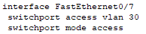
Trunk ports between switches are configured to allow all necessary VLANs:
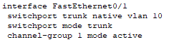

Optimized Broadcast Domains via VLAN Segmentation
The IPv4 scheme ensures efficient broadcast control by:
- Strict VLAN-Subnet Alignment
  - Each department (e.g., 10.1.0.0/26 for Management) is a separate VLAN, isolating broadcasts.
- Right-Sized Subnets
  - No wasteful /24s—smaller subnets (e.g., /27 for HR) reduce broadcast traffic.
  - Larger subnets (e.g., /25 for Finance) only where growth demands it.
- Security & Scalability
  - Departments can’t communicate without Layer 3 routing.
  - Spare /24 blocks (e.g., 10.1.3.0/24) allow new VLANs without disruption.
Result: Minimal broadcasts, no IP waste, and clean isolation—exactly as the subnetting plan intended.

Revised VLAN Trunking Protocol (VTP) Configuration
- Manama HQ (Primary Site)
- VTP Mode: Server
- Domain: bh-manama
- Password: BHs3cur3P@ss
- Purpose: Central VLAN management for HQ. All other switches in Bahrain are clients.
Switch Configuration Example:
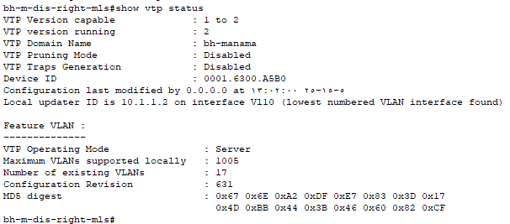
- Riyadh Branch
- VTP Mode: Server
- Domain: sa-riyadh
- Password: SAs3cur3P@ss
- Purpose: Isolates VLAN database to Riyadh-only switches. Prevents accidental synchronization with other branches.
Switch Configuration Example:
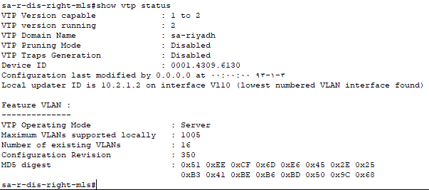
- Kuwait Branch
- VTP Mode: Server
- Domain: kw-kuwait
- Password: KWs3cur3P@ss
- Purpose: Ensures Kuwait’s VLAN changes stay local. No interference from other branches.
Switch Configuration Example:
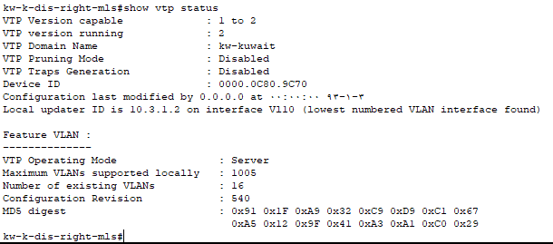

Key Benefits of Separate VTP Domains
- Security:
  - Prevents accidental VLAN propagation across branches (e.g., a misconfigured switch in Riyadh won’t affect Kuwait).
  - Unique passwords per domain add a layer of protection.
- Administrative Control:
  - Each branch manages its own VLANs independently.
  - Local network teams can make changes without coordinating with HQ.
- Fault Isolation:
  - Corrupted VLAN databases in one branch won’t impact others.
- Compliance:
  - Meets regulatory requirements for data segregation (e.g., financial data in Kuwait stays within Kuwait’s domain).

Spanning Tree Protocol (STP)
STP is implemented to prevent switching loops while maintaining redundancy:
- Root bridge elected for each VLAN
- BPDU guard enabled to prevent unauthorized switches

Task 3: Design Security and Redundancy Measures on the LAN

Security Measures

Redundancy Measures

Task 4: Secure Wireless Access

Wireless Design
Hardware type: AP-PT (Access-point PT)
Justification:
- Compatibility: Firstly, it’s designed for large-scale enterprise networks. Secondly, it supports WPA2 and VLAN tagging. It is also compatible with WLC.
- Range: It’s sufficient in terms of covering entire floor segments in a branch office. The AP can also provide features like dual-band coverage such as 2.4 GHZ and holds a bulky user support.
- Enterprise suitability: It supports controller-based deployments, which allows the organization to deploy wireless in centralized, scalable set-ups.
SSID: BisB-Manama-Wi-Fi
VLAN assignment: The wireless network is assigned to VLAN 100 - WIFI

Security Implementation
WPA2-Personnal Security mode: This protocol prevents any unauthorized access by requesting authentication that’s issued by the administrator. Therefore, to ensure secure wireless communication at the Manama branch, this protocol is used as it can provide 802.1X authentication. By enforcing a unique authentication per user, the network will have an advanced security.
AES Encryption: This encryption protocol is very robust and government-graded which secures all wireless traffic by making them more resistant to cyber-attacks such as brute-force and eavesdropping. In addition, it ensures that data maintains its CIA triad by having its confidentiality and integrity focused on more, subsequently enhancing availability.

Additional security used
Mac-filtering: Mac filtering is a security method used to control the devices connecting to the network based on only their MAC address. If the MAC address doesn’t exist in the mac address table, then it won’t be able to connect.
Reason: It provides an additional security layer by restricting their access only to pre-approved devices such as laptops or IoT devices. So regardless of whether the device was able to possess valid credentials, it needs to pass the mac-address validation.
Hidden SSID: This security method prevents the wireless access point from broadcasting/sharing the network name beyond the authorized zone by hiding its SSID. This reduces the visibility of the SSID when doing normal WI-FI scans.
Reason: The justification of using this security is to prevent or reduce the network’s exposure to unauthorized users and any other threat actors by making the SSID only discoverable to them if they successfully do a manual entry instead of a regular scan.

Configurations
On AP:
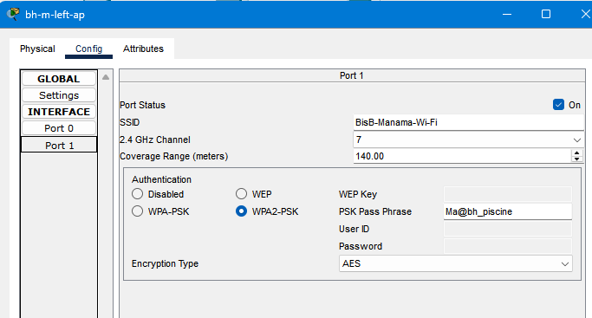
On wireless device:
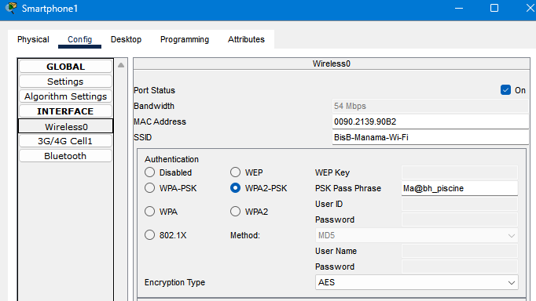

Diagram with justification (showcases the wireless AP in the actual simulated network):
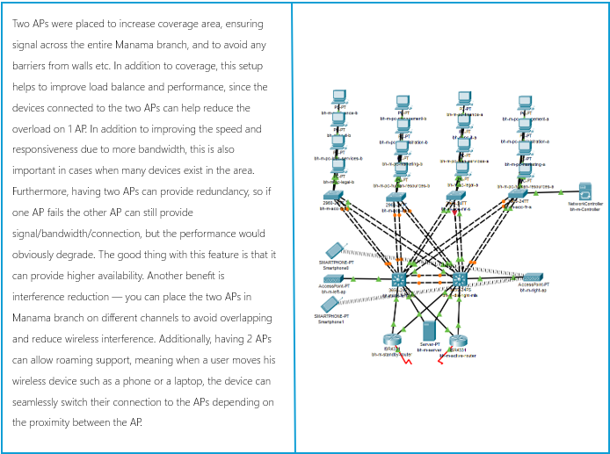

Task 5: WAN Technology and Data Link Layer Encapsulation

WAN Technology Selection
The chosen WAN technology is point-to-point leased line provided by Batelco. This dedicated connection offers multiple advantages for BisB's network needs and requirements.

Key Advantages of Point-to-Point Leased Lines:
- Dedicated bandwidth: provides exclusive, uncontended bandwidth for consistent performance.
- Low Latency: Ideal for real-time banking transactions and financial applications.
- High Security: Physically isolated connection reduces exposure to external threats.
- Predictable Performance: Fixed path ensures consistent network behaviour.

Data Link Layer Encapsulation
For the serial link connection between the ISP Batelco and the HQ/branch routers, PPP is selected due to its advantages:
- Error Detection & Correction: Ensuring the data integrity over the WAN links.
- Authentication Support: Uses CHAP protocol for secure the ISP's router connections.
- Multi-Protocol Support: works with ipv4 and future IPv6 deployments.
- No Proprietary Restrictions: unlike the protocol HDLC, PPP is vendor-neutral so it's ensuring the compatibility with Batelco infrastructure.

Advantages of the Implemented Approach
- Redundancy: Each branch has active and standby routers, ensuring failover if the primary link fails.
- Efficient IP Utilization: /30 subnets for WAN links minimize IP wastage while providing necessary addresses.
- Static NAT for HQ Server: Ensures secure and reliable public access to web/email services (HTTP/HTTPS/SMTP).
- Future-Proofing: Unused IPs (192.124.249.57–62) allow for additional services or branches.

Network Topology Summary
- Bahrain (HQ):
  - Active Router: bh-m-active-router (192.124.249.34)
  - Standby Router: bh-m-standby-router (192.124.249.38)
  - Batelco Gateway Router: bh-batelco-router (connects to ISP via PPP)
- Kuwait:
  - Active Router: kw-k-active-router (192.124.249.42)
  - Standby Router: kw-k-standby-router (192.124.249.46)
- Saudi Arabia:
  - Active Router: sa-r-active-router (192.124.249.50)
  - Standby Router: sa-r-standby-router (192.124.249.54)

Task 6: PAT + Static NAT
To enable Internet access across BisB sites, Network Address Translation (NAT) and Port Address Translation (PAT) are implemented at each site’s edge router. Manama site HQ Hosts both web and mail services which require static NAT mappings.

NAT Types Used
- Static NAT (at HQ only):
Translates internal server IP addresses to public IP addresses, allowing external users to access HQ services such as HTTP, HTTPS, SMTP, and POP3.
- PAT (Overload) (All sites):
Enables internal users from each site to access the Internet using a single public IP address by translating multiple internal addresses to one external IP with unique port numbers.

Static NAT Configuration (HQ - Bahrain)
The internal server 10.1.9.4 hosts multiple services and is mapped to the public IP 192.124.249.56:
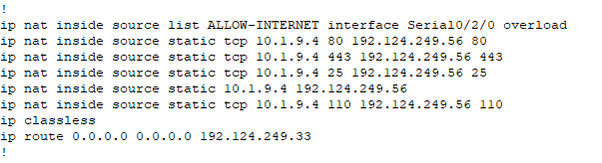

PAT Configuration (All Sites)
Each router overloads internal traffic to its public-facing interface using standard ACLs:
Manama HQ (BH):
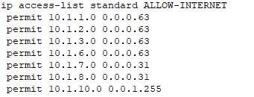
Saudi Arabia (SA):
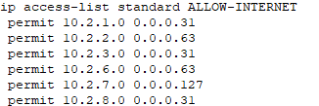
Kuwait (KW):
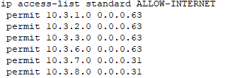

Static NAT Mappings (Manama HQ)
Service Name | Private IP (Inside Local) | Public IP (Inside Global)
Web Server (HTTP) | 10.1.9.4 | 192.124.249.56
Web Server (HTTPS) | 10.1.9.4 | 192.124.249.56
Mail Server (SMTP) | 10.1.9.4 | 192.124.249.56
Mail Server (POP3) | 10.1.9.4 | 192.124.249.56

PAT Mapping (BH - Bahrain HQ)
User Department | Private IP Range | Public IP Used
Management | 10.1.1.0/26 | 192.124.249.34
Administration | 10.1.2.0/26 | 192.124.249.34
Marketing | 10.1.3.0/26 | 192.124.249.34
Finance | 10.1.6.0/26 | 192.124.249.34
IT | 10.1.7.0/27 | 192.124.249.34
Loan Services | 10.1.8.0/27 | 192.124.249.34
Legal | 10.1.10.0/23 | 192.124.249.34

PAT Mapping (SA - Saudi Arabia)
User Department | Private IP Range | Public IP Used
Management | 10.2.1.0/27 | 192.124.249.50
Administration | 10.2.2.0/26 | 192.124.249.50
Marketing | 10.2.3.0/27 | 192.124.249.50
Finance | 10.2.6.0/26 | 192.124.249.50
IT | 10.2.7.0/25 | 192.124.249.50
Loan Services | 10.2.8.0/27 | 192.124.249.50

PAT Mapping (KW - Kuwait)
User Department | Private IP Range | Public IP Used
Management | 10.3.1.0/26 | 192.124.249.42
Administration | 10.3.2.0/26 | 192.124.249.42
Marketing | 10.3.3.0/26 | 192.124.249.42
Finance | 10.3.6.0/26 | 192.124.249.42
IT | 10.3.7.0/27 | 192.124.249.42
Loan Services | 10.3.8.0/27 | 192.124.249.42

Task 7: Access Control Lists (ACLs)

IT Staff SSH Access
Allow only the IT department VLAN (60) to access SSH (port 22) via network devices (routers/switches)

ACL Configuration
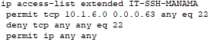
Explanation
- Enhanced security by limiting users' access to IT departments, which are the only authorized users to control network devices.
- Adding ACL to the SSH prevents non-IT insiders and external attackers from accessing critical network devices.

Block ICMP to Servers
Deny ICMP traffic to email and web servers.

ACL Configurations
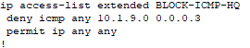

Explanation
- Blocking ICMP traffic like ping (ICMP Echo Request/Reply) and traceroute, as well as other ICMP message types.
- To prevent discovering, mapping the servers (reconnaissance), or ping flooding attacks

Restrict HR and Finance Internet Access
Block HR and Finance departments from Internet access but allow intra-network access.

ACL Configurations
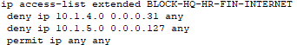

Explanation
- Blocking the HR and Finance Department from accessing the internet mitigates the risk of data leaks or unauthorized external communications, as these departments often handle sensitive information.
- Allowing the internal network only to communicate with those sensitive departments

Server Access from Internet
Allow external access to email and web servers for specific services (e.g., HTTP, SMTP) and block other traffic.

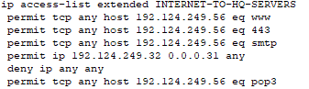
ACL Configurations

Explanation
- ensuring the internet can only access the server’s services (email and web only) in our network.
- reducing attacks by blocking unauthorized access attempts to any other ports or protocols.

References
- Cisco Systems. (n.d.). Cisco IOS IP Configuration Guide, Release 12.4. Retrieved from:
https://www.cisco.com/c/en/us/td/docs/ios-xml/ios/ipaddr_basic/configuration/12-4t/ipaddr-basic-12-4t-book.html
- Cisco Networking Academy. (2023). CCNA: Introduction to Networks v7 Course Material. Cisco Press.
- Cisco Networking Academy. (2023). CCNA: Switching, Routing, and Wireless Essentials v7 Course Material. Cisco Press.
- Oracle. (n.d.). What Is NAT (Network Address Translation)? Retrieved from:
https://www.oracle.com/networking/what-is-nat/
- Packet Tracer Help Documentation. (n.d.). Available within Cisco Packet Tracer software under Help > Contents.
Note: Cisco Networking Academy course materials are only accessible to enrolled students through NetAcad.com.

