If you are having problems compiling the program you might have a wrong connection string.

* Open Web.config

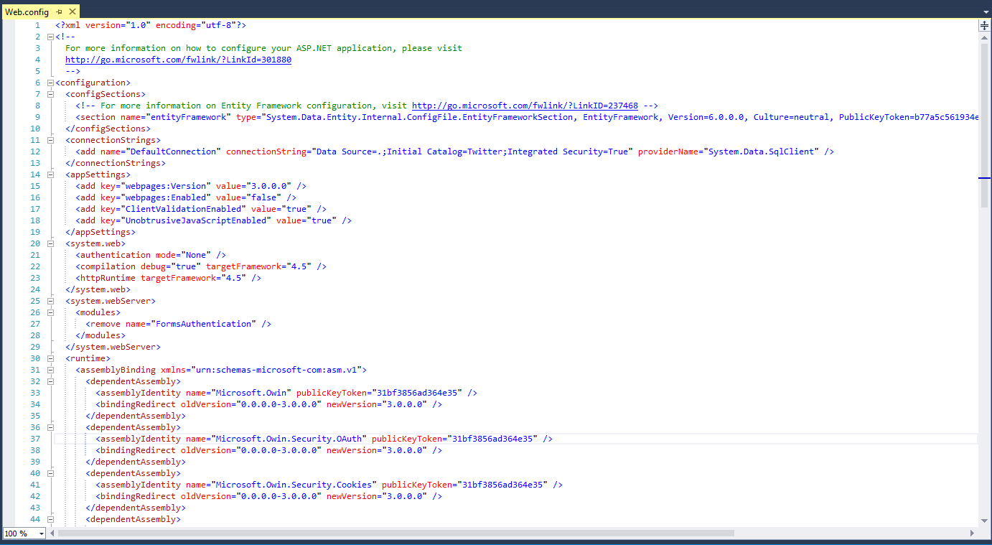

* Find the connection string



* Find “connectionString="Data Source=.;”



* Now just change “.” with your connection string