# Exam Preparation – Expenses Tracker

*Expenses Tracker is an application that allows you to create your own profile (name and budget), create, edit, delete expenses and track your budget. You are also able to edit your profile data and delete your profile.*

## Skeleton

You are provided with all the **html pages**, all the **images** and the **CSS** for the project.

## Database

You will need **2 models**:

* **Profile**
  + **first_name** - Character field with **max length** of **15 characters**
  + **last_name** - Character field with **max length** of **15 characters**
  + **budget** – Integer field
* **Expense**
  + **title** - Character field with **max length** of **50 characters**
  + **image_url** - URL field
  + **description** - Text field
  + **price** - Float field

## Routes

* <http://localhost:8000/> - home page
* <http://localhost:8000/create> - create expense page
* <http://localhost:8000/edit/:id> - edit expense page
* <http://localhost:8000/delete/:id> - delete expense page
* <http://localhost:8000/profile> - profile page
* <http://localhost:8000/profile/edit> - profile edit page
* <http://localhost:8000/profile/delete> - delete profile page

## Pages

### Home Page

If there is **no profile** created yet:

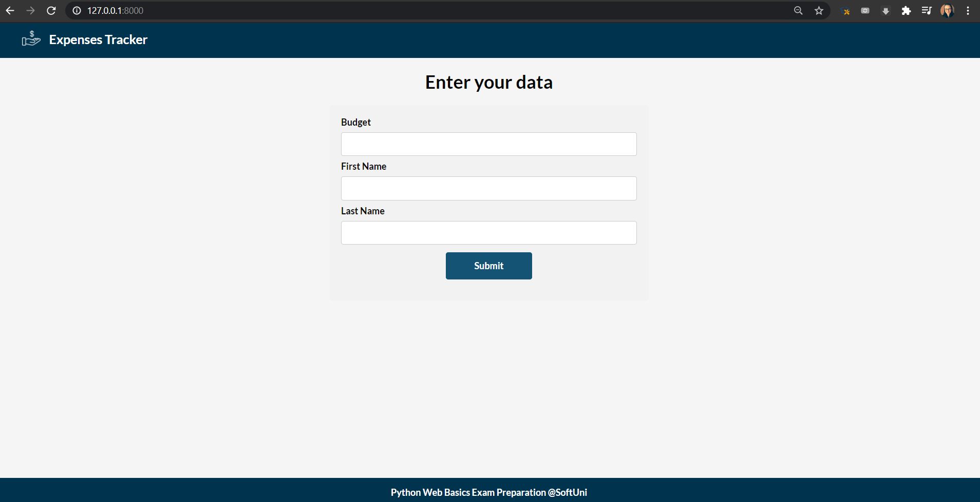

If a profile **has been created** and there are **no expenses**:

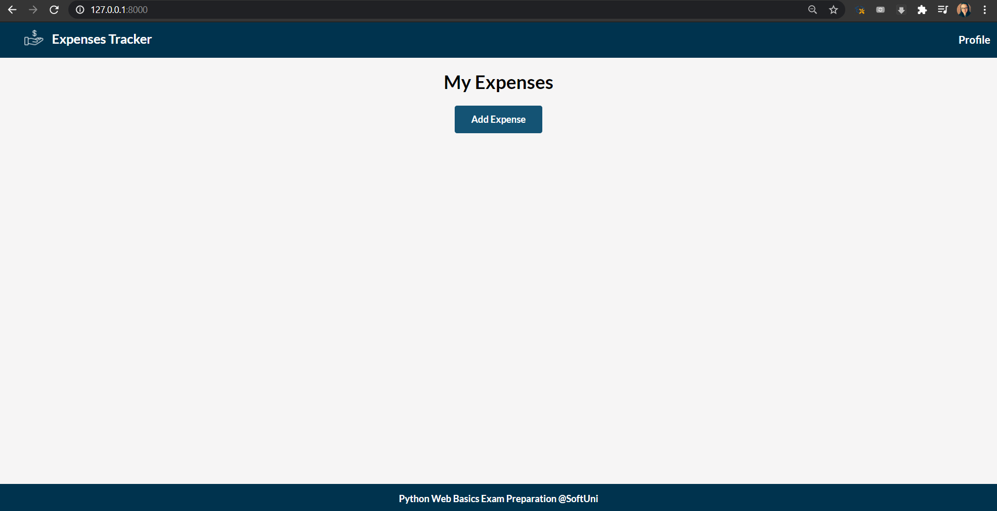

There is a **profile** and **expenses**:

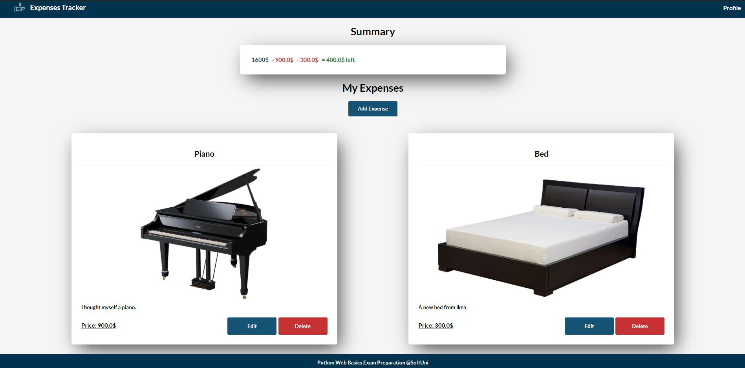

### Create Expense Page

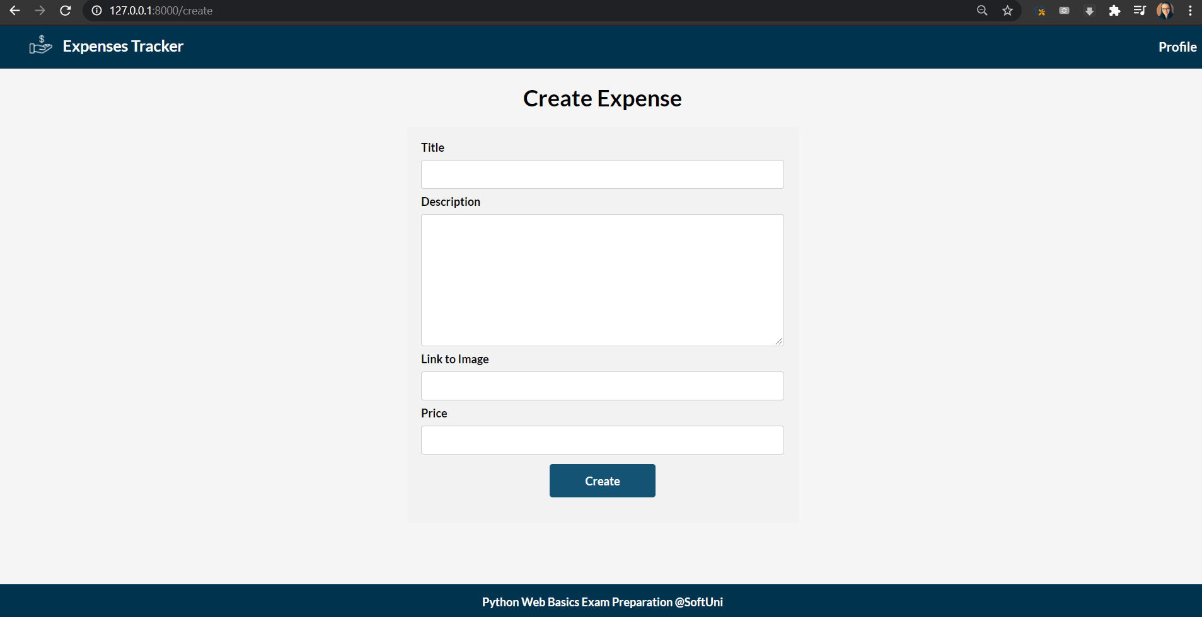

### Edit Expense Page

On the page the form must be **filled** with the **data** of the **expense** we want **to edit**

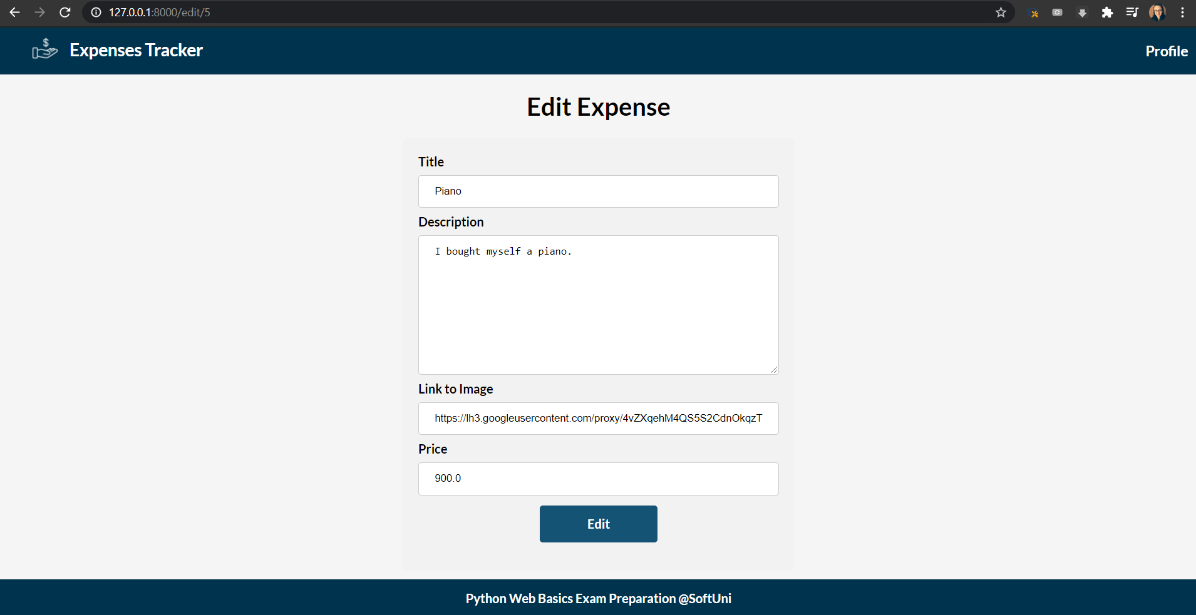

### Delete Expense Page

On the page the form must be **filled** with the **data** of the **expense** and the **fields** should be **disabled**

***Hint***: check [here](https://stackoverflow.com/questions/4945802/how-can-i-disable-a-model-field-in-a-django-form) how to disable fields

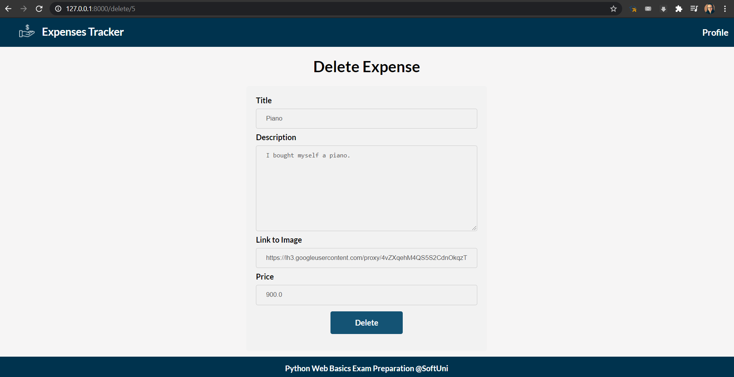

### Profile Page

The **budget** displayed on the profile page should be after **subtracting the expenses**

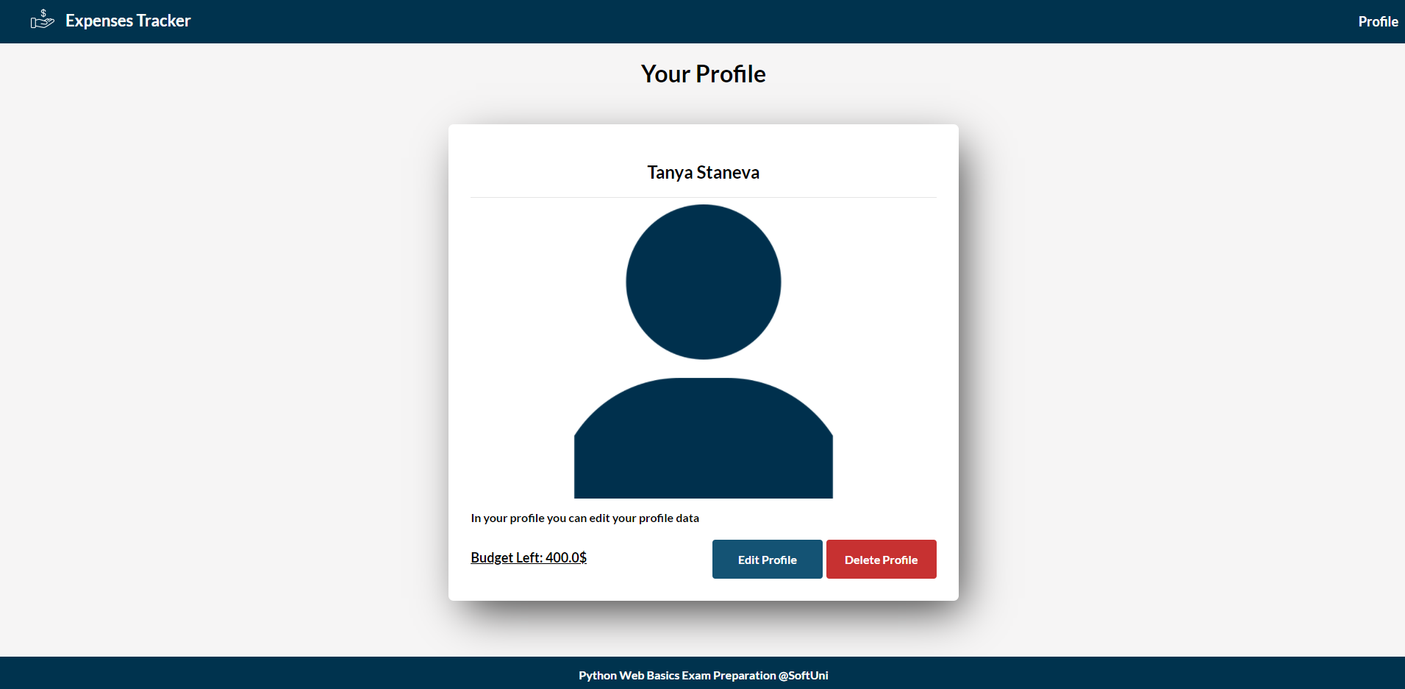

### Edit Profile Page

On the page the **form** must be **filled** with the **data** of the **profile**

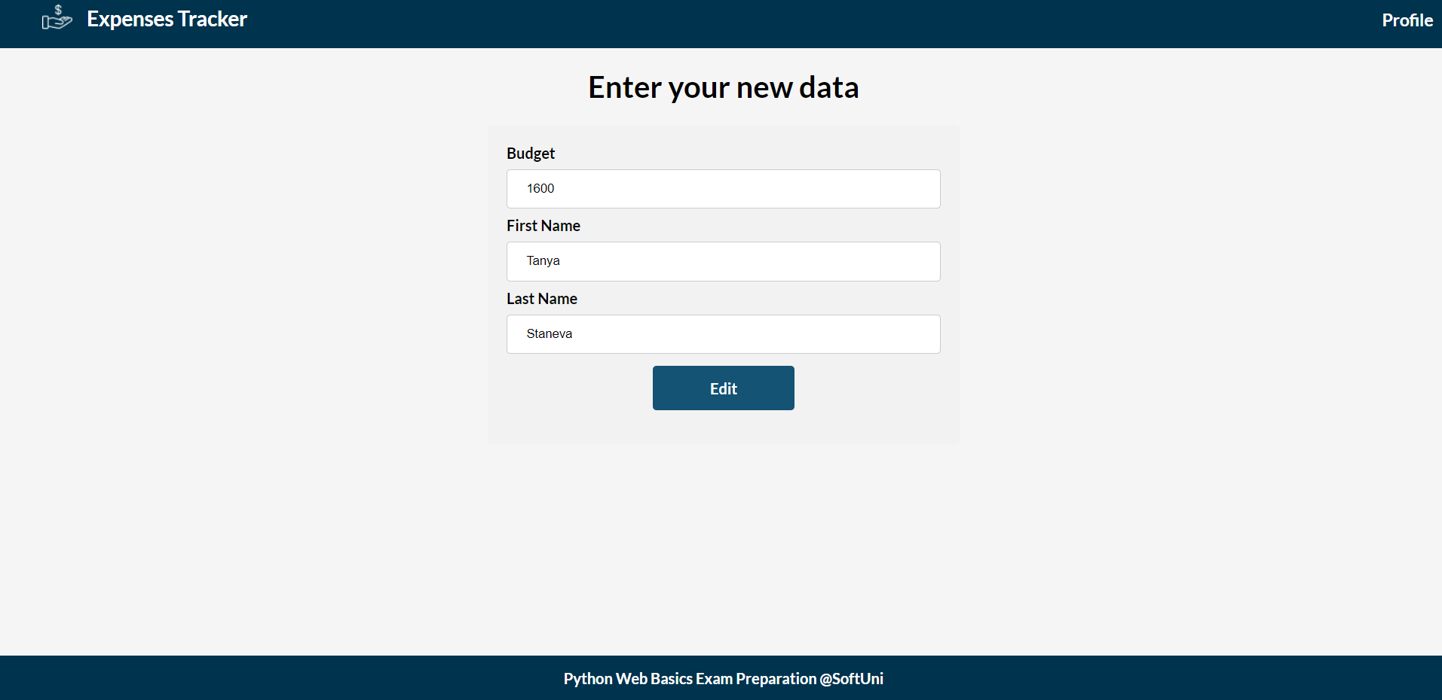

### Delete Profile Page

Deleting a profile should delete not only the **profile** info, but also **all expenses**

