Chapter 2.2 Report for A* planning algorithms by ROS
User ID: rabbit5024

1. Algorithm Flowchart
When the main() function in demo_note.cpp calls “_astar_path_finder->AstarGraphSearch(start_pt, target_pt);”, the planning function receive the start and end points of planning task.

Then the “AstarGraphSearch” fuction in “Astar_searcher.cpp” start.

- Recode current time time_1
- Initial the start point pointer startPtr
- Main loop for expanding
  - if open list is empty or reach the goal, finish the cicle
  - get the minimum f node from the open list, delete it and mark it as visited
  - get all the neighbours of current node
  - decide whether to put the neighbours to the open list or change the g value in the open list
- Get current time time_2 and print the search time
- Track the path back from the terminatePtr to the start
- Show the path at RVIZ interface

2. Planning Results

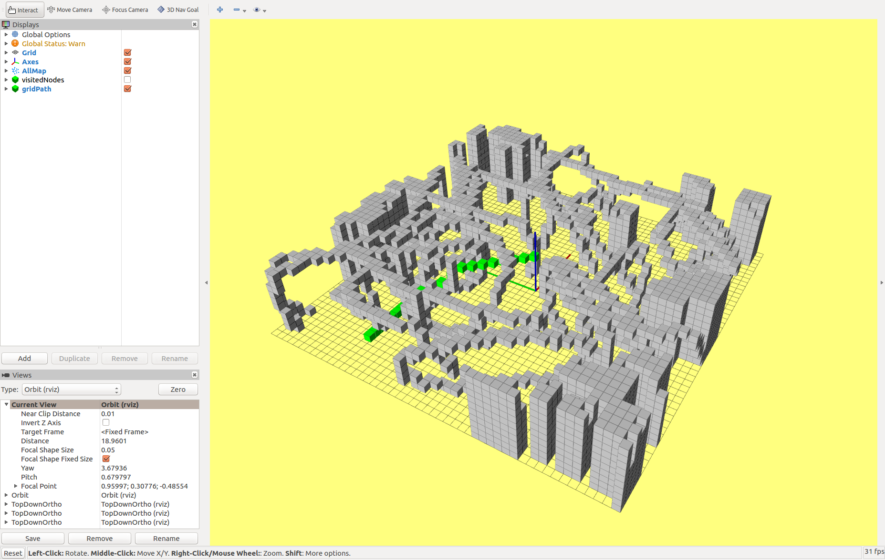

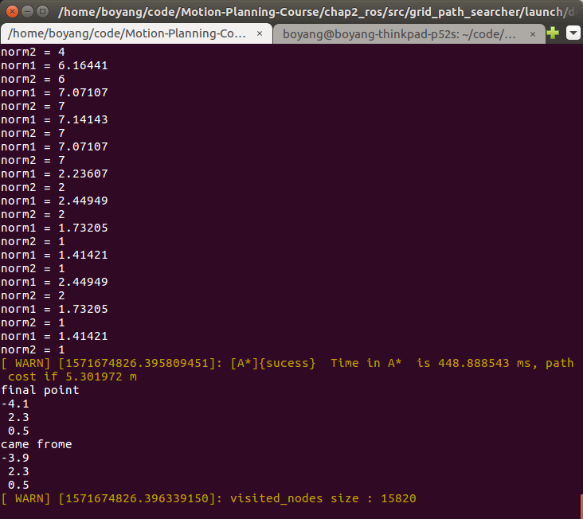

3. Comparison of different heuristic functions for the performance of A star planning

3.1 Euclidean

3.2 Manhattan

3.3 Diagonal Heuristic

3.4 The effect of Tie Breaker

4. The comparison of A* and JPS (when to use A* and when to use JPS)

Optional: finish src/grid_path_searcheer/src/readonly/JPS_searcher.cpp (void JPSPathFinder::JPSGraphSearch(...))

