## Online Payments Fraud Detection with

## Machine Learning

# **InfsysInfosys Internship 5.0**

**By Sreya Boyapati**

**4th year, CSE**

## Contents

**Sl. No. Title Page**

**1** Introduction 3

**2** Project Scope 4

**3** Requirements 6

**4** Technical Stack 9

**5** Architecture/Design 11

**6** Development 13

**7** Testing 15

**8** Deployment 20

**9** User Guide 23

**10** Conclusion 28

## **1.Introduction** The **Online Payments Fraud Detection with Machine Learning** project aims to address the growing risks of fraudulent activities in digital payment systems. By analyzing historical transactional data and applying state-of-the-art machine learning techniques, the system identifies patterns, detects anomalies, and accurately classifies transactions as either legitimate or fraudulent. This end-to-end solution includes critical phases like data preprocessing, model selection, hyperparameter tuning, and rigorous evaluation to ensure optimal performance. The project not only focuses on accuracy and reliability but also provides an intuitive, user-friendly web interface using Streamlit, enabling seamless interaction with the predictive system. This holistic approach ensures that stakeholders can easily input data, obtain insights, and act on predictions, making it an invaluable tool for enhancing security in online transactions.

## ****Objectives:****

1. Develop a highly accurate model to distinguish between fraudulent and non-fraudulent transactions.
2. Enhance the security of online payment systems by providing proactive fraud detection mechanisms.
3. Build a scalable and efficient solution capable of processing large datasets and handling real-time predictions.
4. Deliver a streamlined, user-friendly web application for stakeholders to access predictions and insights easily.

**Significance:**  
Fraudulent activities in online payment systems can lead to substantial financial losses and erode customer trust. This project demonstrates the potential of machine learning to tackle these challenges by providing a scalable and efficient fraud detection system. By enabling financial institutions to identify and mitigate fraud promptly, this solution not only reduces financial risks but also contributes to the overall reliability and safety of digital transactions.

## 2.Project Scope

The project focuses on developing a machine learning-based fraud detection system for online payment transactions. It involves data collection, preprocessing, model training, evaluation, and deployment of a user-friendly application for real-time fraud detection.

**Key Elements:**

**Data Collection & Preprocessing:**

* + Gathering historical transaction data and preparing it for model training.
  + Data cleaning, handling missing values, normalizing numerical data, and encoding categorical variables.
  + Addressing class imbalance to improve model performance.

**Model Training:**

* + Training various machine learning algorithms to classify transactions as fraudulent or legitimate.
  + Selecting the best-performing model based on metrics like accuracy, precision, recall, and F1-score.
  + Serializing the trained model for integration into the web application.

**Evaluation & Optimization:**

* + Evaluating model performance on a test dataset.
  + Hyperparameter tuning and cross-validation for model accuracy and generalization.
  + Optimization techniques to improve performance and efficiency.

**Deployment:**

* + Deploying the system as a real-time web application using Streamlit.
  + Enabling users to input transaction data, receive fraud predictions, and download results.
  + Cloud deployment ensures scalability and accessibility, with the trained model integrated into the backend for real-time fraud detection.

**Limitations:**

**Historical Data Constraints:**

* + The system relies on historical transaction data, which may not fully capture emerging fraud patterns, limiting the model's ability to detect new forms of fraud.

**Class Imbalance:**

* + Fraudulent transactions are typically underrepresented in the dataset, which can lead to biases in predictions.
  + Techniques like undersampling help address this issue, but the model’s performance may still be impacted by class imbalance.

**Model Generalization:**

* + The model may struggle to generalize to new, unseen transaction behaviors, requiring periodic retraining with updated data to maintain accuracy.

**Complexity in Fraud Detection:**

* + Fraud detection is complex, and the model might produce false positives or false negatives.
  + Continuous evaluation and updates are necessary to improve accuracy.

## ****3.Requirements****

This section outlines the functional and non-functional requirements for the Online Payments Fraud Detection with Machine Learning project, which drives the development of the fraud detection system.

#### 3.1 Functional Requirements

**Data Handling**

* Accepts input transaction data in CSV format for fraud detection.
* Cleanses and preprocesses data by handling missing values, normalizing numerical features, and encoding categorical variables.
* Stores processed datasets securely in cloud storage for efficient retrieval and future use.

**User Interaction**

* Allows users to upload transaction datasets through a web-based interface.
* Provides real-time fraud prediction results displayed directly on the interface.
* Enables users to download predictions in CSV format, including input data and corresponding fraud labels.

**Visualization and History Management**

* Displays fraud detection results alongside transaction details for clarity and traceability.
* Offers graphical insights such as heatmaps for model evaluation (e.g., confusion matrices) and bar charts highlighting trends in fraudulent activity.
* Maintains a log of processed datasets with timestamps for user reference and audit purposes.

**Alerts**

* Incorporates a notification mechanism to alert users about potential fraudulent transactions immediately.
* Provides actionable recommendations to mitigate fraud risks based on model outputs.

#### 3.2 Non-Functional Requirements

* **Performance**: Ensures transaction data is processed, and predictions are generated in less than five seconds, even for large datasets.
* **Scalability**: The solution is designed to handle large-scale transaction datasets as user demands and data volume grow.
* **Security**: Adopts secure protocols for data transfer and encryption for sensitive transaction information in storage and during processing.
* **Usability**: The interface is user-friendly, with clear instructions for dataset uploads, result interpretation, and downloads.
* **Availability**: Operates 24/7 with minimal service interruptions for updates or maintenance tasks.
* **Compatibility**: Functions across major browsers and supports both desktop and mobile devices for versatile access.

#### 3.3 Technical Requirements

**Data Requirements**

* A dataset containing at least 10,000 transaction records is required, including the following fields:
  + **Step**: Represents the time step or interval of the transaction.
  + **Type**: Identifies the type of transaction (e.g., PAYMENT, CASH_OUT).
  + **Amount**: Specifies the monetary value of the transaction.
  + **NameOrig**: Denotes the customer initiating the transaction.
  + **OldBalanceOrg**: The balance of the origin account before the transaction.
  + **NewBalanceOrig**: The balance of the origin account after the transaction.
  + **NameDest**: Denotes the recipient of the transaction.
  + **OldBalanceDest**: The initial balance of the destination account.
  + **NewBalanceDest**: The updated balance of the destination account.

**Model Training and Evaluation**

* Incorporates multiple machine learning models, such as Random Forest, Logistic Regression, and Decision Trees, to evaluate effectiveness.
* Performs hyperparameter optimization using Grid Search for enhanced model accuracy and performance.
* Utilizes evaluation metrics, including precision, recall, F1-score, and confusion matrices, to measure model effectiveness and address misclassifications.

**Analysis Requirements**

* Provides analytical tools to visualize data trends, such as transaction volume distribution and fraud patterns.
* Error analysis highlights recurring patterns in misclassified transactions, aiding in model refinement.
* Supports real-time performance monitoring to ensure continuous improvement in detection accuracy.

**Deployment and System Requirements**

* Leverages cloud storage solutions like AWS S3 for scalable and secure data storage.
* Uses frameworks like Streamlit for building an interactive and responsive user interface.
* Ensures integration with Python libraries like Pandas, Scikit-learn, and Matplotlib for seamless data processing, modeling, and visualization.

## ****4.Technical Stack****

This section provides an overview of the technologies, tools, and platforms used in the development of the Online Payments Fraud Detection with Machine Learning project.

## ****Programming Languages****:

* **Python**: The primary language used for developing machine learning models, data processing, and building the web application. Python is chosen for its extensive support for data science libraries and ease of integration with machine learning frameworks.

## ****Frameworks/Libraries****:

* **TensorFlow/Keras**: Used for building and training machine learning models. TensorFlow’s robust ecosystem enables the creation of complex models like Random Forest and other classification algorithms.
* **Scikit-learn**: A Python library used for data preprocessing, model evaluation, and other machine learning tasks. Scikit-learn provides useful tools for splitting data, evaluating performance, and calculating metrics such as accuracy, precision, recall, and F1-score.
* **Streamlit**: An open-source framework used to build the user interface. It allows for rapid prototyping and deployment of machine learning applications, making it ideal for creating interactive, real-time applications for fraud detection.
* **Pandas**: A library used for data manipulation and analysis. It helps in loading, cleaning, and transforming the data, making it ready for model training.
* **Matplotlib/Seaborn**: Libraries used for visualizing data and model performance metrics. They are essential for creating charts, graphs, and confusion matrices to understand model effectiveness.

## ****Databases****:

* **AWS S3**: Amazon Simple Storage Service (S3) is used to store and retrieve the transaction dataset. This cloud storage solution offers scalability and ease of access to large datasets.

## ****Tools/Platforms****:

* **Jupyter Notebook**: An interactive web-based IDE used for data exploration, model building, and visualization. It supports Python and is commonly used for prototyping and experimentation in machine learning projects.
* **VS Code:** was used as the main development environment, offering tools for coding, debugging, and version control, essential for building the fraud detection system.
* **Git/GitHub**: Version control tools used for managing the project code and collaborating with team members. GitHub is also used for hosting the project repository and tracking changes.
* **AWS EC2**: Cloud infrastructure used to deploy and run the application, ensuring scalability and high availability.

## ****5.Architecture/Design****

This section provides an overview of the architecture and design decisions made for the Online Payments Fraud Detection with Machine Learning project. The system architecture ensures a smooth flow from data collection to prediction and result evaluation, maintaining scalability and robustness at every stage.

## ****5.1 System Architecture Overview****:

The system architecture for this project is designed to facilitate the entire workflow, from ingesting transaction data to presenting actionable insights through the user interface. Below is a high-level view of the architecture:

• **Data Collection and Preprocessing Layer**:

* Input Data: The system starts by collecting the transaction data in CSV format, which is then stored on **AWS S3** for easy access and retrieval.
* Preprocessing: The data is cleaned and preprocessed using **Pandas** to handle missing values, outliers, and normalization. Categorical data is transformed using techniques such as one-hot encoding, and numerical features are normalized to ensure uniformity.

• **Model Training and Evaluation Layer**:

* Model Architecture: A **Random Forest** model, implemented using **TensorFlow** and **Scikit-learn**, is trained on the preprocessed dataset. The model is optimized by tuning hyperparameters such as tree depth and the number of trees.
* Evaluation: The model’s performance is assessed using standard metrics such as accuracy, precision, recall, and F1-score. The evaluation results are visualized through **Matplotlib** and **Seaborn** to analyze its effectiveness and identify areas for improvement.

• **Prediction Layer**:

* Real-Time Prediction: Once the model is trained, the system can predict whether a new transaction is fraudulent or non-fraudulent by using the trained model.
* Cross-Validation: Cross-validation is performed to ensure the model generalizes well on unseen data.

• **User Interface Layer**:

* Streamlit Application: The user interface is built using **Streamlit** to create a web application. This allows users to interact with the fraud detection system by inputting transaction data, viewing the prediction results, and downloading the predictions as CSV files.
* Alert Mechanism: If fraud is detected, an alert is raised to notify users, allowing them to take immediate action.

## ****5.2 Design Decisions****:

• **Model Selection**: After evaluating multiple machine learning algorithms, including **KNN**, **Logistic Regression**, **Naive Bayes**, **Decision Trees**, and **Random Forest**, the **Random Forest** algorithm was chosen. It offers superior performance in terms of accuracy and can handle high-dimensional data effectively, making it a good fit for fraud detection tasks.  
• **Cross-Validation and Hyperparameter Tuning**: Various model evaluation techniques, including **cross-validation** and **grid search**, were used to tune hyperparameters and select the best-performing model.

## ****5.3 Design Trade-offs****:

• **Complexity vs. Interpretability**: While **Random Forest** models tend to be more accurate, they can lack interpretability compared to simpler models like decision trees. However, the complexity was justified due to the importance of accurately detecting fraud and minimizing false positives.  
• **Cloud Storage vs. Local Storage**: Using cloud-based storage (AWS S3) introduces an additional dependency, but the benefits of scalability and accessibility outweighed the potential drawbacks of using local storage.

## 6.Development

The project commenced with the collection and inspection of a structured dataset containing online transactions, which included fields such as step, type, amount, isFraud, and other relevant details. Initially, the dataset comprised columns like step, type, amount, NameOrig, OldBalanceOrg, NewBalanceOrig, NameDest, OldBalanceDest, and NewBalanceDest. The dataset was examined for outliers, missing values, and anomalies to ensure it was suitable for training a reliable model. During the data cleaning process, unnecessary columns such as step, NameOrig, NameDest, OldBalanceDest, and NewBalanceDest were removed, leaving only type, amount, OldBalanceOrg, NewBalanceOrig, and the target variable isFraud. Missing data was handled using imputation techniques, and categorical features like type were converted into numerical representations via one-hot encoding. Numerical columns like amount, OldBalanceOrg, and NewBalanceOrig were normalized to ensure consistency. To address the class imbalance in the isFraud target variable, undersampling techniques were applied.

AWS integration played a key role in the project, which involved setting up an S3 bucket for storing and retrieving datasets. The boto3 library was used for seamless uploading and retrieval of preprocessed data, ensuring secure and efficient cloud storage. The preprocessed data was then retrieved from the S3 bucket and divided into training (70%), validation (15%), and testing (15%) sets using Scikit-learn's train_test_split(). Various machine learning models, including K-Nearest Neighbors, Random Forest, Naive Bayes, Logistic Regression, and Decision Trees, were evaluated. Random Forest was selected for its robustness in handling large datasets, resistance to overfitting, and high accuracy. Hyperparameter tuning was performed using Grid Search to optimize key parameters such as the number of trees, maximum depth, and feature split criteria. The Random Forest model was implemented using Scikit-learn, with training and validation metrics tracked to ensure generalization and prevent overfitting. Model checkpoints and performance metrics were logged for further analysis.

The trained Random Forest model was used for making predictions on the test dataset, with evaluation metrics like accuracy, precision, recall, and F1-score computed. A confusion matrix was generated to evaluate true positives, false positives, true negatives, and false negatives. Visualization techniques such as bar charts and Seaborn’s heatmap were employed to assess the evaluation metrics and misclassifications, highlighting the model's strong performance in distinguishing fraudulent transactions. Error analysis was conducted to identify patterns in misclassified transactions, particularly those involving small amounts and low balances.

The project’s user interface was developed using Streamlit, featuring a Home page to introduce the project and its purpose, a Prediction page allowing users to upload CSV files for predictions, and an option to download results in CSV format. A fraud alert mechanism was also implemented to notify users of predicted fraudulent transactions. Comprehensive testing ensured seamless integration between modules, including AWS, the model, and the UI, by addressing edge cases, typical scenarios, and high-stress conditions. Bug fixes were applied to resolve issues like data type mismatches during preprocessing, AWS S3 connectivity for large datasets, and Streamlit input validations for invalid file formats.

The entire system was thoroughly reviewed to ensure all components—preprocessing, model training, and UI development—functioned correctly. All findings, challenges, and steps were documented, supplemented with sample code snippets and visual diagrams for clarity. The Git repository was finalized with a structured update, which included a zip file containing dependencies, configuration files, and setup instructions, marking the successful completion of the project.

## 

## **Basic UI of home page**

## ****7.Testing****

The testing phase is essential to ensure the reliability, accuracy, and usability of the fraud detection system. It focuses on validating individual components and verifying the system's overall performance, functionality, and user experience.

## ****Testing Approach****:

* **Unit Testing**: Focuses on testing individual components of the system, such as the functions for data preprocessing, model training, and prediction. Ensures each part works as expected.
* **Integration Testing**: Verifies that all components (data processing, model training, prediction, and UI) work together properly. It ensures smooth data flow across the system.
* **System Testing**: Involves testing the full system to ensure everything works as expected, including verifying input handling, model predictions, and output generation.

## ****Key Areas of Testing****:

* **Data Preprocessing**: Ensures the dataset is handled correctly, including missing data imputation, feature scaling, and categorical encoding. Any issues in data transformation or errors in the dataset format are identified and corrected during this phase.
* **Model Evaluation**: In this phase, the trained model is evaluated using a test dataset. Key performance metrics like accuracy, precision, recall, and F1-score are calculated to assess how well the model performs in detecting fraudulent transactions.
* **UI Testing**: The **Streamlit** user interface is tested for usability, ensuring that users can easily input transaction data, view prediction results, and download the results as CSV files. This phase also checks the responsiveness and proper display of the application.

## ****Results****:

* **Bug Fixes**: Testing helped identify and fix issues related to data handling, including incorrect transformations and minor bugs in the UI, such as issues with form validation and alignment.
* **Model Performance**: The **Random Forest** model outperformed other algorithms tested, such as KNN and Naive Bayes, by providing better accuracy and more reliable fraud detection. Precision and recall metrics indicated a strong ability to detect fraud while minimizing false positives.
* **UI Usability**: The **Streamlit** interface proved to be intuitive, allowing users to easily input data, view predictions, and download results. The UI was thoroughly tested to ensure it functioned without issues, providing a seamless experience.

## ****Testing Tools****:

* **PyTest**: Used for unit testing the backend logic, ensuring that each function operates correctly.
* **Scikit-learn**: Utilized to evaluate the model’s performance using classification metrics like accuracy, precision, recall, and F1-score.

**Results:**

**For types of trsancations which are used:**

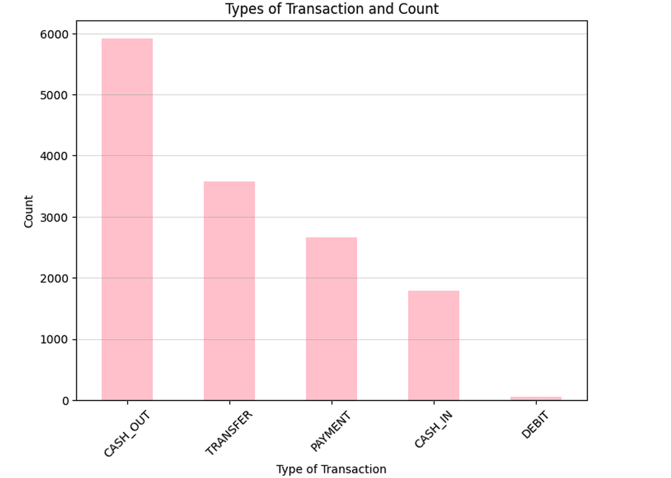

**After Balancing the Fraud and non-Fraud in dataset**

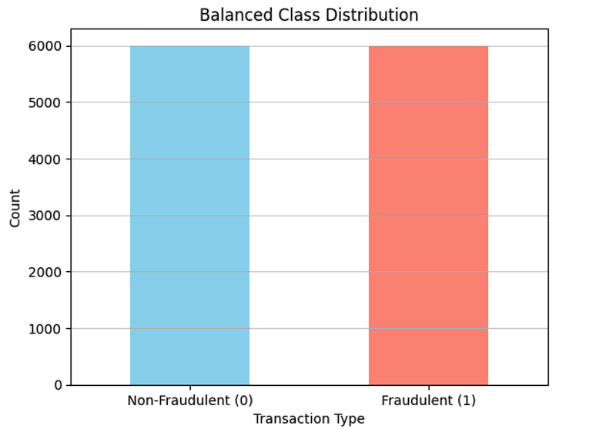

**Here is the model preformace of different algorithms:**

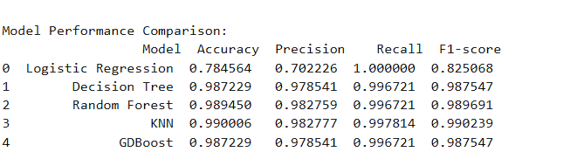

**K-Nearest Neighbors gives the best accuracy and F1 score (0.99 accuracy) But if you want the model with potentially even better generalization on unseen data and flexibility in tuning**

**Random Forest would also be a strong choice. It provides good performance too in comparision to Knn (0.989 accuracy) and is more robust to overfitting compared to KNN, especially on larger datasets.**

**I have chosen RANDOM FOREST after doing cross validation and avoid overfitting the model**

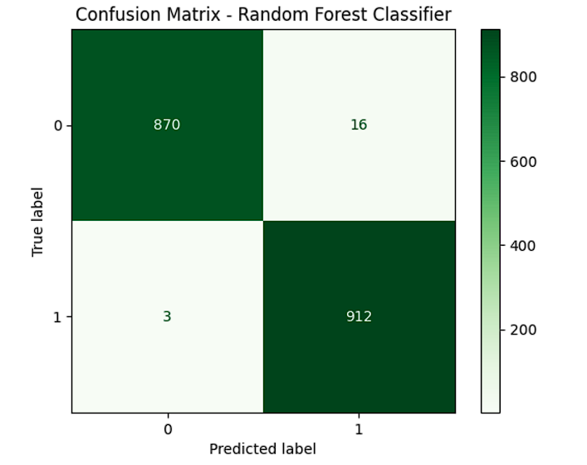

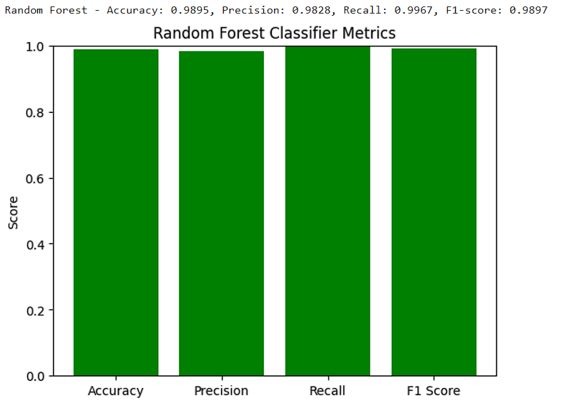

**For Random Forest before and after Hyperparamter Tuning:**

**Before Hyperparameter Tuning accuracy : 0.9894503053858967**

**After Hyperparameter Tuning Accuracy: 0.9916666666666667**

**8.Deployment**

The deployment process ensures that the fraud detection system becomes accessible for real-world usage, allowing users to interact with the application and enabling the trained machine learning model to perform real-time fraud predictions effectively.

**8.1 Model Deployment**  
The trained machine learning model is serialized and saved using file formats such as .pkl (Pickle) or .h5 (TensorFlow/Keras), depending on the framework used. This model file is then integrated into the web application's backend, ensuring that the system can quickly load and use the model for predictions. The model is tested in a simulated production environment to ensure that the inference process works efficiently with the actual user inputs, maintaining high accuracy and low latency.

**8.2 Web Application Deployment**  
The web application, which serves as the user interface for the system, is deployed on cloud platforms such as AWS, Google Cloud, or Microsoft Azure. These platforms are chosen for their scalability and reliability, allowing the system to handle varying levels of user traffic. The frontend of the application is developed using Streamlit, offering a simple and intuitive interface where users can input transaction data and receive fraud detection predictions in real-time. The backend processes these inputs, runs them through the machine learning model, and displays the results to the users.

Cloud hosting platforms are selected for their ease of scalability, ensuring that as the number of users or data volume increases, the application can be expanded to meet demand without significant performance degradation. By leveraging cloud services, the system also benefits from high availability, redundancy, and automatic scaling.

**8.3 Deployment Process**

* **Setup Cloud Instance:** A cloud instance (AWS EC2, Google Cloud App Engine, or similar) is configured to host the application. This instance is provisioned with sufficient resources (CPU, memory, storage) based on expected user traffic.
* **Install Dependencies:** All necessary libraries and dependencies, including Python, Streamlit, Scikit-learn, Pickle, and other relevant packages, are installed on the cloud instance. This ensures the cloud server is ready to handle the application’s runtime needs.
* **Deployment Scripts:** Deployment scripts such as a Dockerfile or a cloud-specific configuration file (e.g., Procfile for Heroku) are created to automate the setup process. These scripts define the necessary environment configuration, including the system’s software stack and how it should be run on the cloud.
* **Push to Cloud:** The application code is pushed to the cloud platform using Git or through continuous integration/continuous deployment (CI/CD) pipelines, enabling smooth and automated deployment processes. Tools like Jenkins or GitLab CI can be used to trigger deployments automatically upon code changes.

**8.4 Testing and Monitoring**  
Once the application is deployed, extensive testing is carried out to ensure it functions as expected in the real world. This includes:

* **Functional Testing:** Ensures that all user interactions (e.g., data input, prediction results, file downloads) work as intended.
* **Performance Testing:** Tests how the system handles multiple users and large datasets under heavy load. This is essential to ensure that the system remains responsive and fast, even when faced with high traffic volumes.
* **Security Testing:** Ensures that sensitive user data, such as transaction details, is securely handled, protecting against potential data breaches. Security measures like HTTPS, data encryption, and user authentication are tested thoroughly.
* **Monitoring:** After deployment, performance monitoring tools such as AWS CloudWatch, Google Cloud Monitoring, or New Relic are used to track system performance in real-time. These tools allow developers to monitor server health, track latency, and ensure uptime.
* **Bug Fixes:** Any issues discovered post-deployment (e.g., incorrect predictions, server crashes, user interface bugs) are promptly addressed. The application is continuously monitored for signs of degradation, with fixes and updates rolled out as needed.

**8.5 Post-deployment Maintenance**

* **Model Updates:** The machine learning model is periodically retrained with updated transaction data, incorporating new patterns of fraud detection to ensure the system remains accurate. Any improvements in model performance are deployed immediately to production.
* **Feature Enhancements:** Based on user feedback, new features or improvements to existing ones may be developed. For example, additional alert mechanisms or new data visualization features might be added to the frontend.
* **Bug Fixes and Patches:** The system will be maintained with regular bug fixes. When issues arise in the production environment, patches are developed and pushed to the cloud to resolve them.
* **User Feedback and Optimization:** Feedback is collected from end-users about their experience with the system. This feedback is analyzed to make necessary adjustments to the user interface, improve the fraud prediction process, or refine data input methods. Additionally, performance optimizations are made based on system usage statistics to reduce latency and improve overall user satisfaction.

**8.6 Scalability and Reliability**  
The cloud-based deployment architecture ensures that the system can easily scale as demand grows. Horizontal scaling (e.g., adding more instances) or vertical scaling (e.g., upgrading instance size) is implemented based on traffic patterns. Load balancing is used to distribute incoming requests across multiple servers, ensuring that the system remains responsive even during periods of high traffic. The use of cloud-based infrastructure also guarantees high reliability, as cloud providers offer redundancy, backups, and failover mechanisms to minimize the risk of downtime.

By implementing these deployment processes, the fraud detection system is able to perform effectively in production, offering users an efficient, scalable, and reliable service that meets the performance and security standards required for real-world applications.

## 9.User Guide

The User Guide provides instructions for using the fraud detection web application, including setup, configuration, and troubleshooting tips.

**Application Overview**:  
The application allows users to input transaction data and receive fraud detection predictions. It offers a user-friendly interface where users can enter transaction details, view predictions, and download results.

**Getting Started**:

* **System Requirements**:
  1. Python 3.12
  2. Necessary Python libraries such as **Streamlit**, **Pickle**, **Scikit-learn**, **TensorFlow**, etc.
* **Installation Instructions**:
  1. Clone the repository to your local machine.
  2. Create and activate a virtual environment.
  3. Install dependencies using the command:  
     pip install -r requirements.txt
  4. Run the application using the command:  
     streamlit run app.py
  5. The web application will be accessible via a browser at localhost:8501.

**Using the Application**:

1. **Home Page**:  
   The home page introduces the fraud detection application and its purpose.

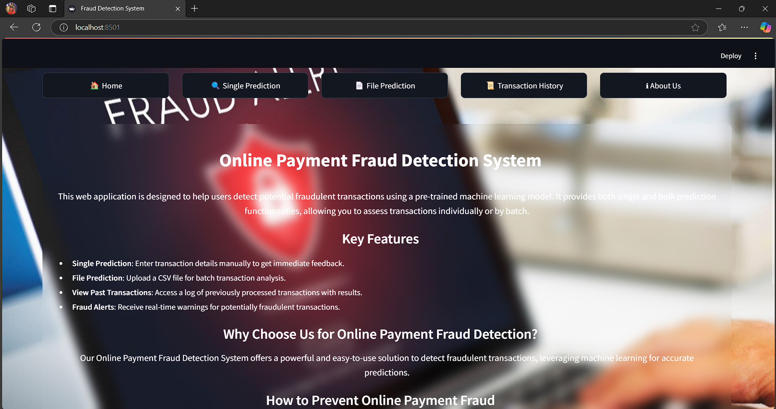

1. **About Page**:  
   The about page provides more information about the application, its goals, and the team behind it.

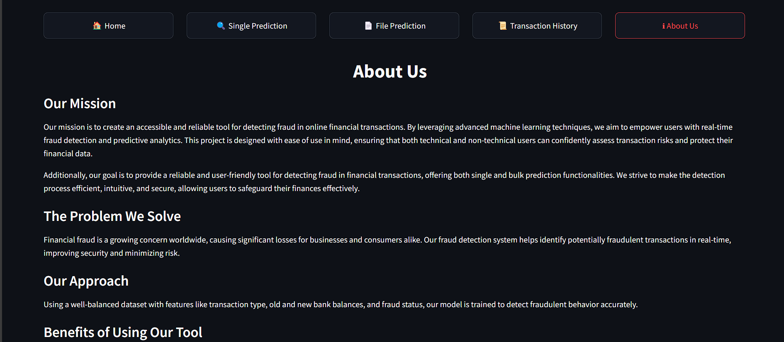

1. **Prediction Page**:  
   On the prediction page, users can enter the following transaction details:
   1. **Type**: The type of online transaction (e.g., PAYMENT, CASH_OUT).
   2. **Amount**: The amount of the transaction.
   3. **OldBalanceOrig**: The origin account balance before the transaction.
   4. **NewBalanceOrig**: The origin account balance after the transaction.
2. After entering the data, click **Submit** to receive the fraud prediction result.
3. The result will indicate whether the transaction is **fraudulent** or **non-fraudulent** (represented by 1 and 0, respectively).

**Single Predication page:**

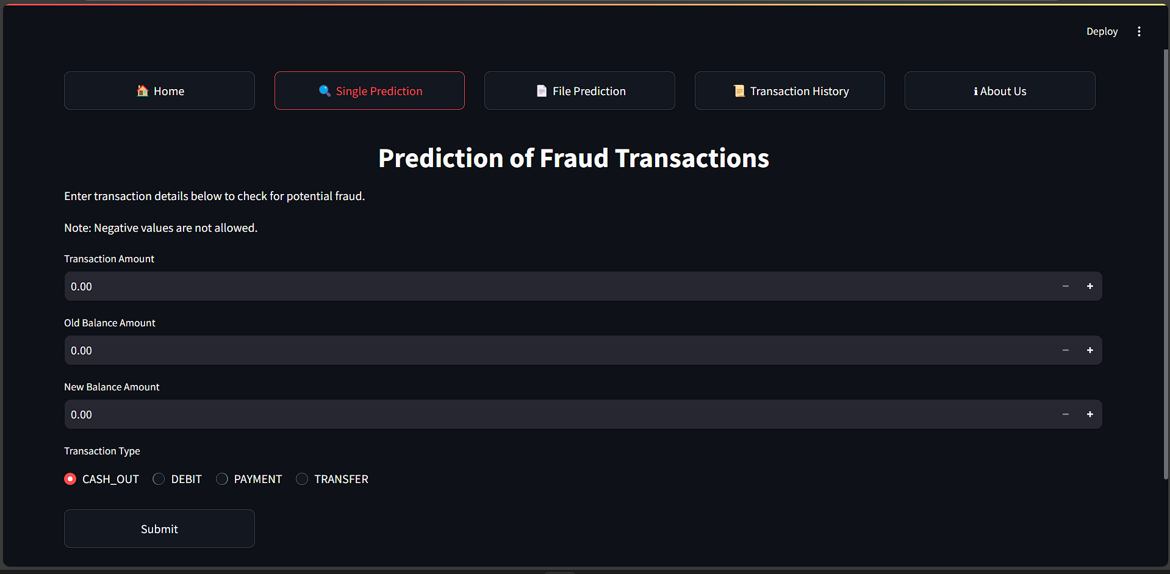

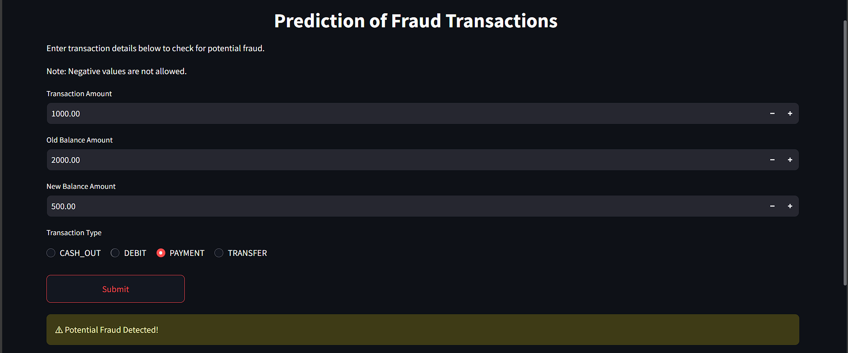

**File pedication Page:**

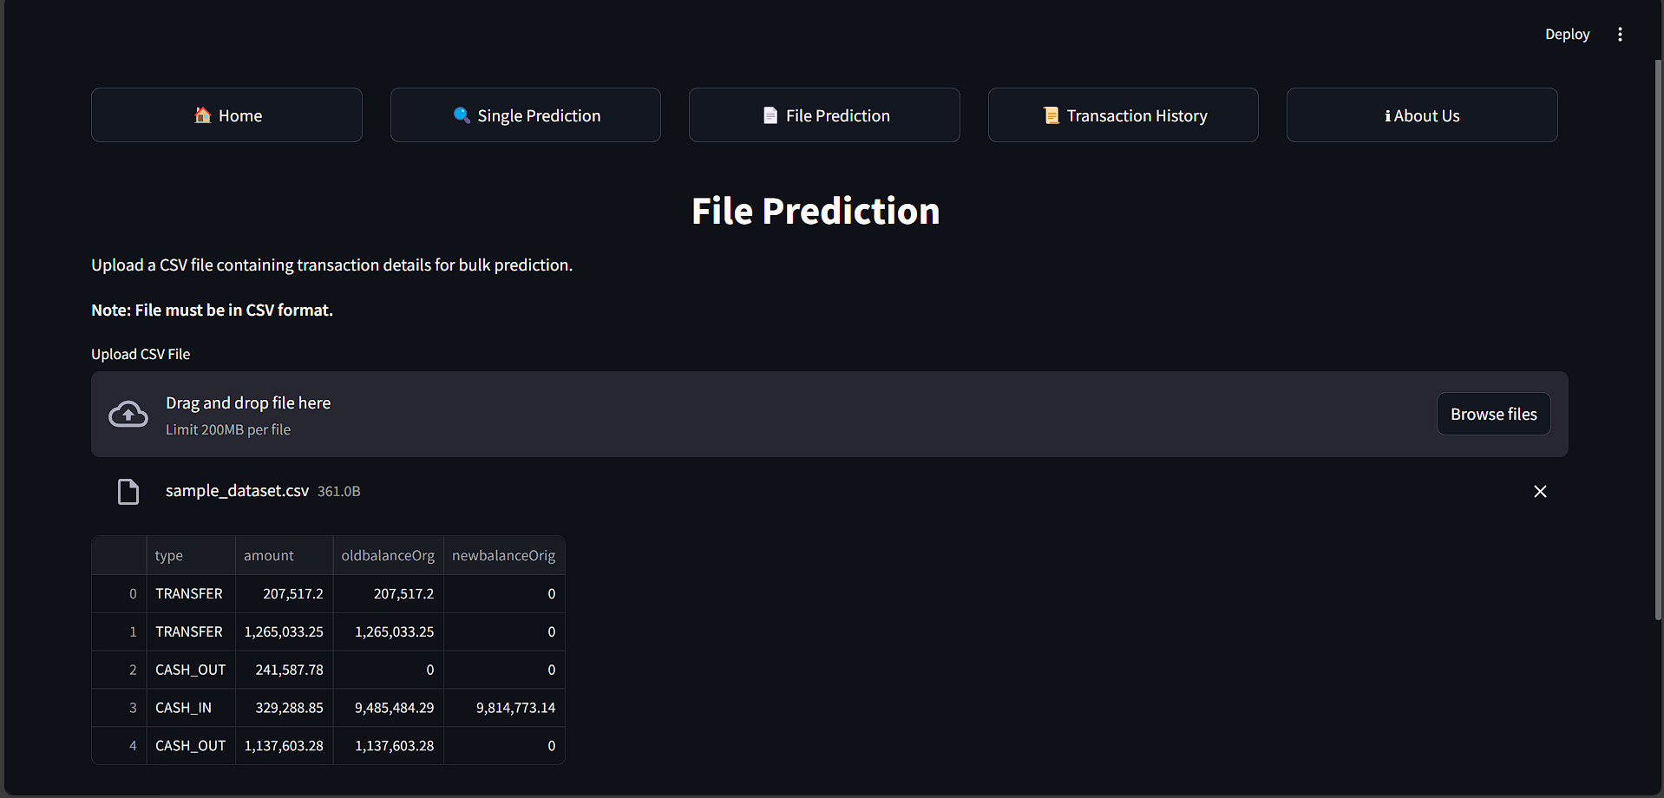

**Download Results**:

* Users can download the prediction results, including the **isFraud** field, in a CSV format by clicking the
* 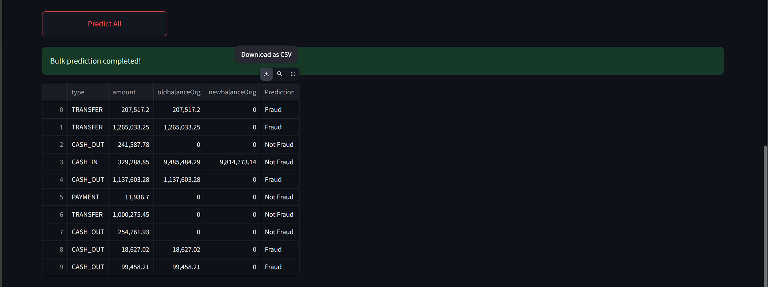**Download Results** button after submission.

## Trsancation History page:

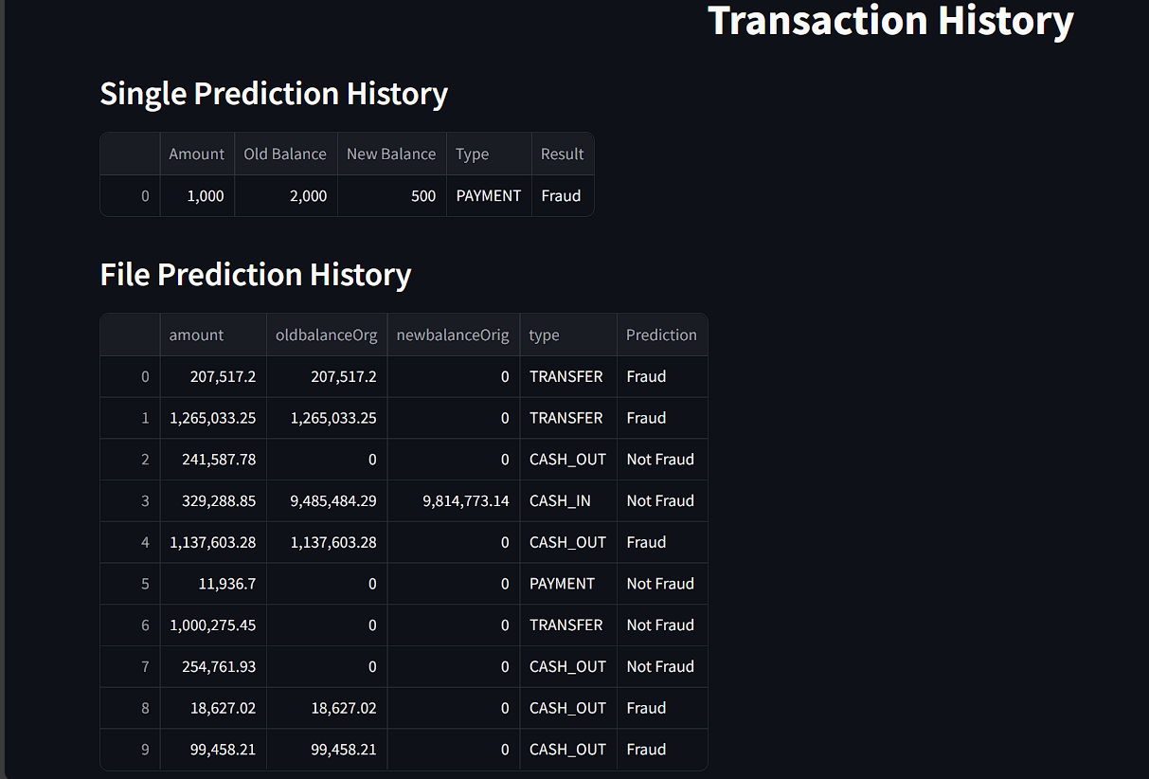

## 10.Conclusion

The **Online Payments Fraud Detection with Machine Learning** project successfully developed an intelligent system capable of identifying fraudulent transactions in online payment systems. By employing advanced machine learning techniques, such as Random Forests, and integrating the model into a user-friendly web application, this project addressed the growing concern of financial fraud in digital transactions.

The system demonstrated effective data preprocessing, model training, and evaluation, producing accurate fraud predictions. The choice of **Random Forest** as the machine learning algorithm proved to be beneficial due to its high accuracy and ability to handle large datasets with complex patterns.

Key achievements include:

* A robust model capable of classifying transactions as fraudulent or non-fraudulent.
* A user-friendly interface built using **Streamlit**, providing real-time predictions and data management features.
* Integration of cloud-based services (such as AWS) for efficient data storage and retrieval.

**Reflections and Lessons Learned:**  
While the system performed well, there are areas for improvement. The model's performance could be further enhanced by exploring additional algorithms, **Neural Networks**, and optimizing data preprocessing techniques. Further testing with more varied datasets could help fine-tune the model's generalization ability.

In the future, the system could be expanded to handle a wider range of fraud detection scenarios, incorporate additional features like transaction metadata, and be deployed at scale to serve financial institutions and e-commerce platforms.

Ultimately, this project provides a solid foundation for building secure, reliable, and scalable fraud detection systems using machine learning.