## Introduction

In this report there will be presented the methodology used to find a location for best burger points nearby hotel Park Plaza, London.  
  
**Problem Statement:**When we visit a new place, first thing that we look for is food, nearby best restaurants and places to vist. So using the For square dataset we going to solving the problem for finding best burger corner nearby and best places to visit under 500 meters of location.

**Target Audience:**

In this Problem our target audience Travelers’ who travels from one place to another either for business work, or exploring the new places, so for finding the best and trending places in nearby location is too hectic. Our solution we help the unknows people to get burger in their nearby location.

## Data

For exploring the best nearby spots, we will use Four Square API dataset, using which will get the list of top burger points and explore the nearby trending places. Due to covid-19 trending places data is not accurate as it’s real-time, but still we can get the best burger points.  
  
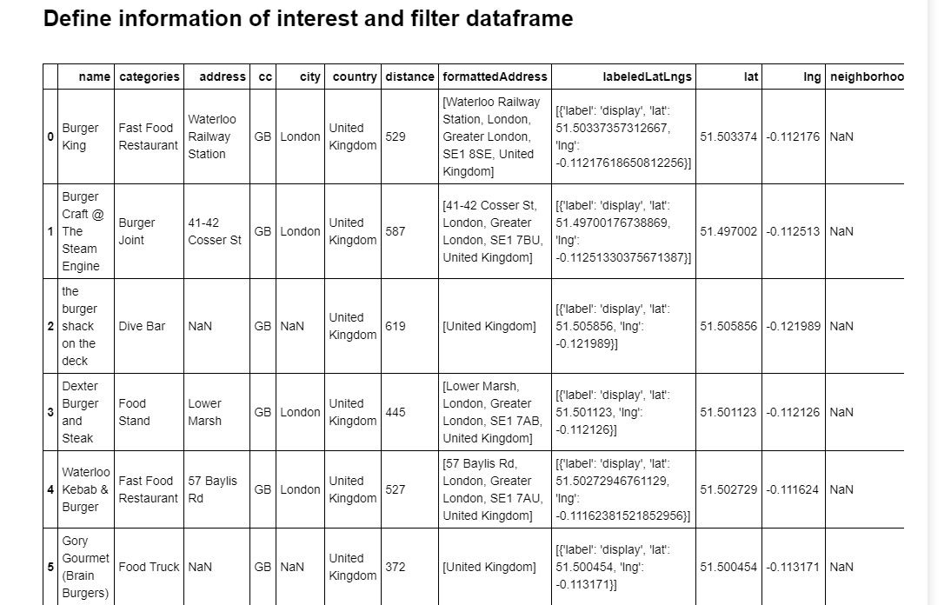

* **Visualize the list of best nearby 8 burger places:**  
    
  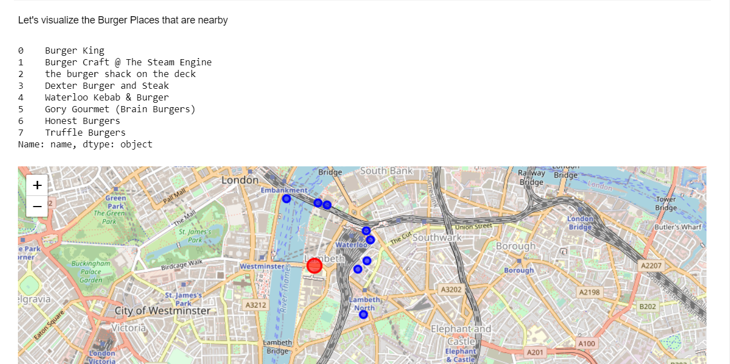

**Exploring the Trending venues:**

