Solution to create a function only once

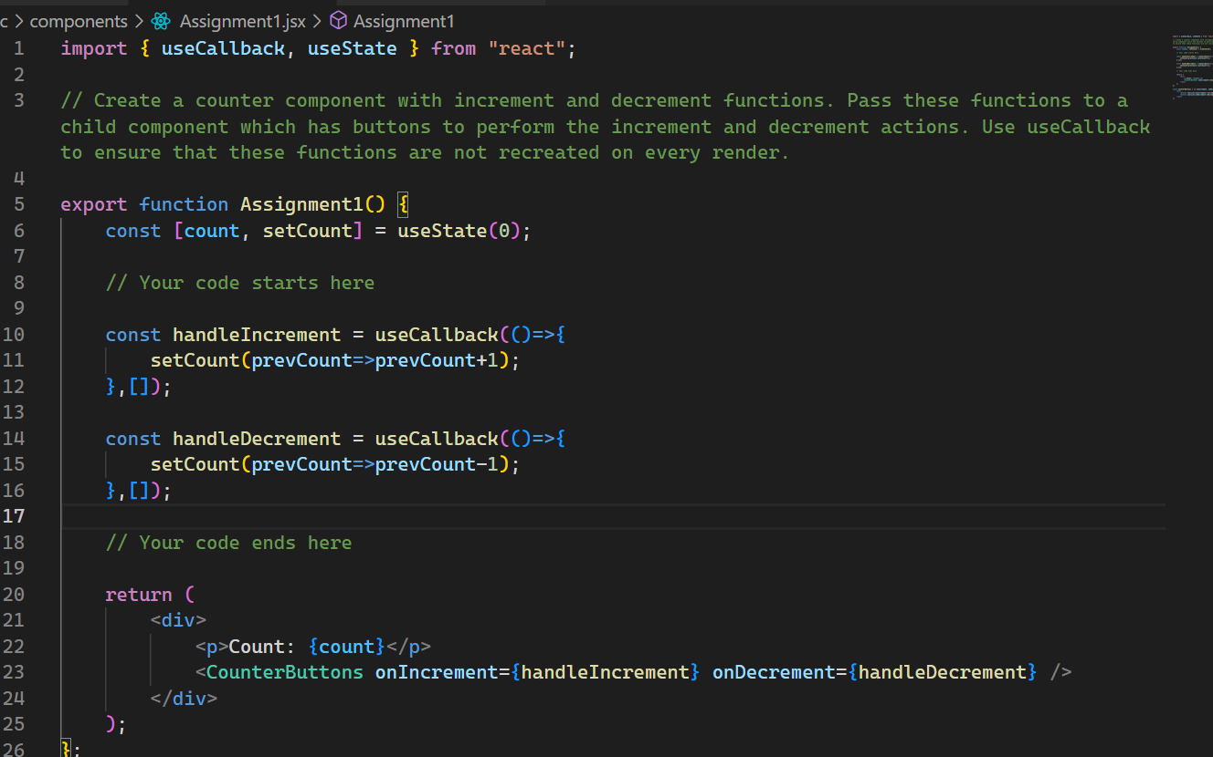

With the help of useCallback